Guide Dogs Victoria’s On the Move – September 2016 Bulletin

# 

# Tips for reading this newsletter

If you would like to increase the text size on your screen:

* Using the keyboard
  + 1. Press ALT+W, and then press Q.
    2. Press the TAB key repeatedly until the **Percent** box is selected, and then type a percentage or press UP ARROW or DOWN ARROW to select a percentage.
* Using the mouse
  + 1. On the View tab, in the Zoom group, click Zoom.
    2. Click the zoom setting that you want or type a percentage in the Percent box.

Skip to contents

Contents

Tips for reading this newsletter 1

Editor’s update 2

Upcoming programs and events for your diary 3

What’s Up Doc – Update from the GDV Vet Clinic 6

Reading Dog Food Labels 6

The Achilles Running Club 8

We want your feedback! Introducing Clickability 11

Helping clients navigate the NDIS 12

Support Coordinator profile 13

Share your story 14

Feedback 15

Return to contents

# Editor’s update

Welcome to the new monthly bulletin format of ‘On the Move’ – gathering together key event news and announcements all in one place. We hope that this will be easier than multiple emails from Guide Dogs Victoria about individual events.

We are keen to keep in touch with all our clients and let them know about our upcoming programs and information, but for many of you we don’t have an email, or an up to date preferred format. Available preferred formats are: Email, Audio CD, Large print, Braille. We would love to gather this information.

To make sure you receive future Guide Dogs Victoria communications in your preferred format please contact us by emailing [CSAdmin@guidedogsvictoria.com.au](mailto:CSAdmin@guidedogsvictoria.com.au)

or phoning 9854 4467.

If we do not hear from you with your email address or preferred format then we will assume you do not want to receive future copies of our client newsletter ‘On the Move’ and remove you from its mailing list. We will continue to send you any essential communications, updates and program information in this large print format.

All bulletins including On the Move are also available on our website.

Finally, we wish a big ‘good luck’ to all Paralympians, especially our very own Jaryd Clifford who has been selected to represent Australia in the 1500m and 5000m races in Rio this September.

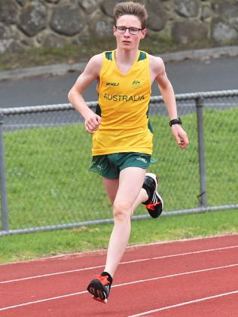 (Photo of Jaryd Clifford running in Australian green and gold kit)

Cheers

Sophie Wild

Bulletin Editor

# Upcoming programs and events for your diary

**All clients:**

* **Making life easier:** Come and learn about Australia’s new $5 banknotes, and the new Albert EFTPOS payment terminal– Thursday8th September, 9:30am-11:30am at the Multicultural Hub, Orange Room. Level 1, 506 Elizabeth St, Melbourne. Contact [CSAdmin@guidedogsvictoria.com.au](mailto:CSAdmin@guidedogsvictoria.com.au)
* **Live Safe Travel Smart – Travel Series**: Three-part series – Tuesday 20th September, Wednesday 12th October, and Thursday 10th November. Contact [CSAdmin@guidedogsvictoria.com.au](mailto:CSAdmin@guidedogsvictoria.com.au)
* **Try before you ride:** Learn about how you can travel more safely using our public transport system – Wednesday 12th October, 10:00am-2:00pm. Meet at the Box Hill Interchange, corner Whitehorse Road and Station Street. Registrations will open soon; for further information visit: <http://ptv.vic.gov.au/getting-around/accessible-transport/try-before-you-ride/>
* **Save the Date – International White Cane Day client walk:** Join us for a walk in Melbourne CBD as we celebrate independence and access for people with blindness and vision loss – Friday 14th October. Meet at Federation Square at 10am. Contact [CSAdmin@guidedogsvictoria.com.au](mailto:CSAdmin@guidedogsvictoria.com.au)
* **Ballarat and surrounds Client Information Workshops**: The latest tech, meet our Occupational Therapist, learn about the NDIS – Wednesday 19th October, 10:30am. Contact [CSAdmin@guidedogsvictoria.com.au](mailto:CSAdmin@guidedogsvictoria.com.au)
* **Living with Acquired Brain Injury and Vision Impairment** – Wednesday 9th November. Contact [CSAdmin@guidedogsvictoria.com.au](mailto:CSAdmin@guidedogsvictoria.com.au)
* **South East Coffee Club:** Join us for a series of coffee mornings and meet new friends in the Frankston area, hosted by one of our Orientation and Mobility specialists. Meet at Frankston Station at 9:45am sharp. Orientation provided from Frankston Station to café. Complimentary coffee (please bring money for additional food/cake) – Friday 2nd September, Friday 9th September, Friday 23rd September (NDIS discussion). Contact [csadmin@guidedogsvictoria.com.au](mailto:csadmin@guidedogsvictoria.com.au) or call 9854 4467. If leaving a message, please indicate which session(s) you’ll be attending.

**Dog Handlers:**

* **Cane to Canine** – Wednesday 14th September. Contact [CSAdmin@guidedogsvictoria.com.au](mailto:CSAdmin@guidedogsvictoria.com.au)
* **Guide Dog Handler’s Traffic Refresher workshops** – Friday 16th September or Friday 25th November, 9.30am-3pm. Cost $10. Numbers are limited so enquire direct with Jenny Black – 9854 4473 or [jennyb@guidedogsvictoria.com.au](mailto:jennyb@guidedogsvictoria.com.au)
* **Dog Guide Handlers Australia 2016 Conference Attendance, Expressions of Interest:** This year, on Saturday 22nd and Sunday 23rd October, at the Sage Hotel Adelaide in South Australia, Dog Guide Handlers Australia will hold its second National Conference. Financial assistance of up to $500 is available for a limited number of current Dog Guide Handlers on low incomes, to help cover conference registration, travel and accommodation. Applications for financial assistance close on 21st September. For further information see <http://dgha.org.au/dgha/dgha-2016-national-conference/>

**Children’s and Youth Services:**

* **Young Adults Program (YAP):** Connecting young people (approximate age 18-25) with vision impairments for discussions and fun activities. Next event is Friday 6th October – judo and dinner in Fitzroy. Contact [rachelh@guidedogsvictoria.com.au](mailto:rachelh@guidedogsvictoria.com.au) for more information.

# What’s Up Doc – Update from the GDV Vet Clinic

## Reading Dog Food Labels

Dogs are omnivores. Their bodies cannot manufacture vitamin C, 10 essential amino acids and essential fatty acids. Commercial food is not regulated well enough to prevent misleading food labels.

For example, these terms have no legal definition: *natural, premium, holistic, super, premium*. They may not be balanced or have good nutritional value. Low fat often means more fibre.

Diets that state complete and balanced should be balanced and can be used a sole diet.

**Things to look out for:**

1. Listed ingredients: By law the food manufacturer has to list the most common ingredient in order. If ‘by-products’ are listed first, then the food is of poorer quality.
2. Guaranteed minimums: Look at minimum protein and fats, and maximum fibre and water content. The daily recommended protein is >27% and fat is <17%. The minimum daily protein should be no less than 22% and fat 5.5%.
3. Meat by-products: Acceptable by-products are cleaned intestines, brains, hearts, and bone. (These are not considered premium food if listed as main ingredient.) By-products must not contain beaks, hooves and teeth.
4. Chicken meal or meat meal: Concentrated protein from meat and by-products with most of the fat and water removed.
5. Chicken digest: not good! May not be chicken at all!
6. Fillers: You pay for what you get. The cheaper foods have a lot of fillers. Fillers are straw, peanut shells, weeds, corn cobs, feathers.
7. Preservatives: All dry pet foods have preservatives. It’s illegal not to list preservatives (unless in fish and meat products from overseas). The natural preservatives are better i.e. vitamin E, vitamin C, and rosemary extract, but the food does not last as long.

**You know you’ve got the ideal diet for your dog if you are seeing these results:**

* Good firm faeces – NOT too much volume. Voluminous faeces mean that a lot of the food is indigestible!
* Your dog maintains its weight including muscles.
* A consistently shiny coat with no dander.
* Clean teeth.

Remember, you get what you pay for. Buy the more expensive complete and balanced dry food with high quality meat or fish proteins. They are much better quality and value. With cheaper, poorer quality food, you have to feed more in terms of quantity.

Dr Elaine Ong

Principal Veterinarian for Guide Dogs Victoria

Principal of Box Hill Veterinary Hospital

AVASA Accredited Hospital Of Excellence

Return to contents

# The Achilles Running Club

It’s a brisk morning on Sunday and we are off to the Tan track to run a leisurely 10kms. So what’s so unusual about that? Well my Guide Dog probably isn’t that keen on running with me; it's a bit beyond their responsibility. The last time I tried to run without assistance, I met – at pace – a pole with an unwavering stance. Luckily there were no other collisions with people, cars or other inanimate objects.

Well, is it time to hang my running shoes up and retire? But wait – what’s that in the distance coming out of the sunrise? An entourage of volunteer Guide Dog minders, runners and walkers keen to run or walk for fitness with people with low vision and blindness.

Achilles Running Club Melbourne follows the international group that has chapters in Melbourne, Sydney and Canberra. So how does it work? Where possible, volunteers are matched with similar paced runners or walkers. There is a strap that is held by both runner and guide. The guide verbally indicates a series of signals to avoid any obstacles that are coming.

Surprisingly and happily, I can tell you it works. I have the opportunity to get fit while someone watches over my Guide Dog Victoria hero, Khan. He can be a mischievous handful when he is out of his harness, but fortunately the sight of a ball makes him instantly yours! It’s a hard life being a Guide Dog watcher…

My run takes around 50 minutes to an hour and it makes the perfect day. The volunteers are essential and amazing people who assist with achieving my fitness goals. Where possible, they sometimes pick up us intrepid runners and take us to the venue. Some volunteers are starting to meet up with runners in their area for mid-week runs in addition to regular Sunday training. This makes it possible for me to work towards my goal, which is to do 21kms at Run Melbourne in July, then take on the 42.5km run at the Melbourne Marathon in October. Sounds difficult, but one thing is for sure: I am travelling with the best people who can make it happen.

Achilles Running Club Melbourne meets every Sunday morning at 8:30am at the Tan running track in Melbourne CBD. Contact Amanda Kwong at [achillesmelbourne@gmail.com](mailto:achillesmelbourne@gmail.com); 0468 373 373; <http://www.achilles-sydney.org.au/melbourne.html>, or on Facebook (Achilles Melbourne) for further information about running/walking with us or volunteering with us.

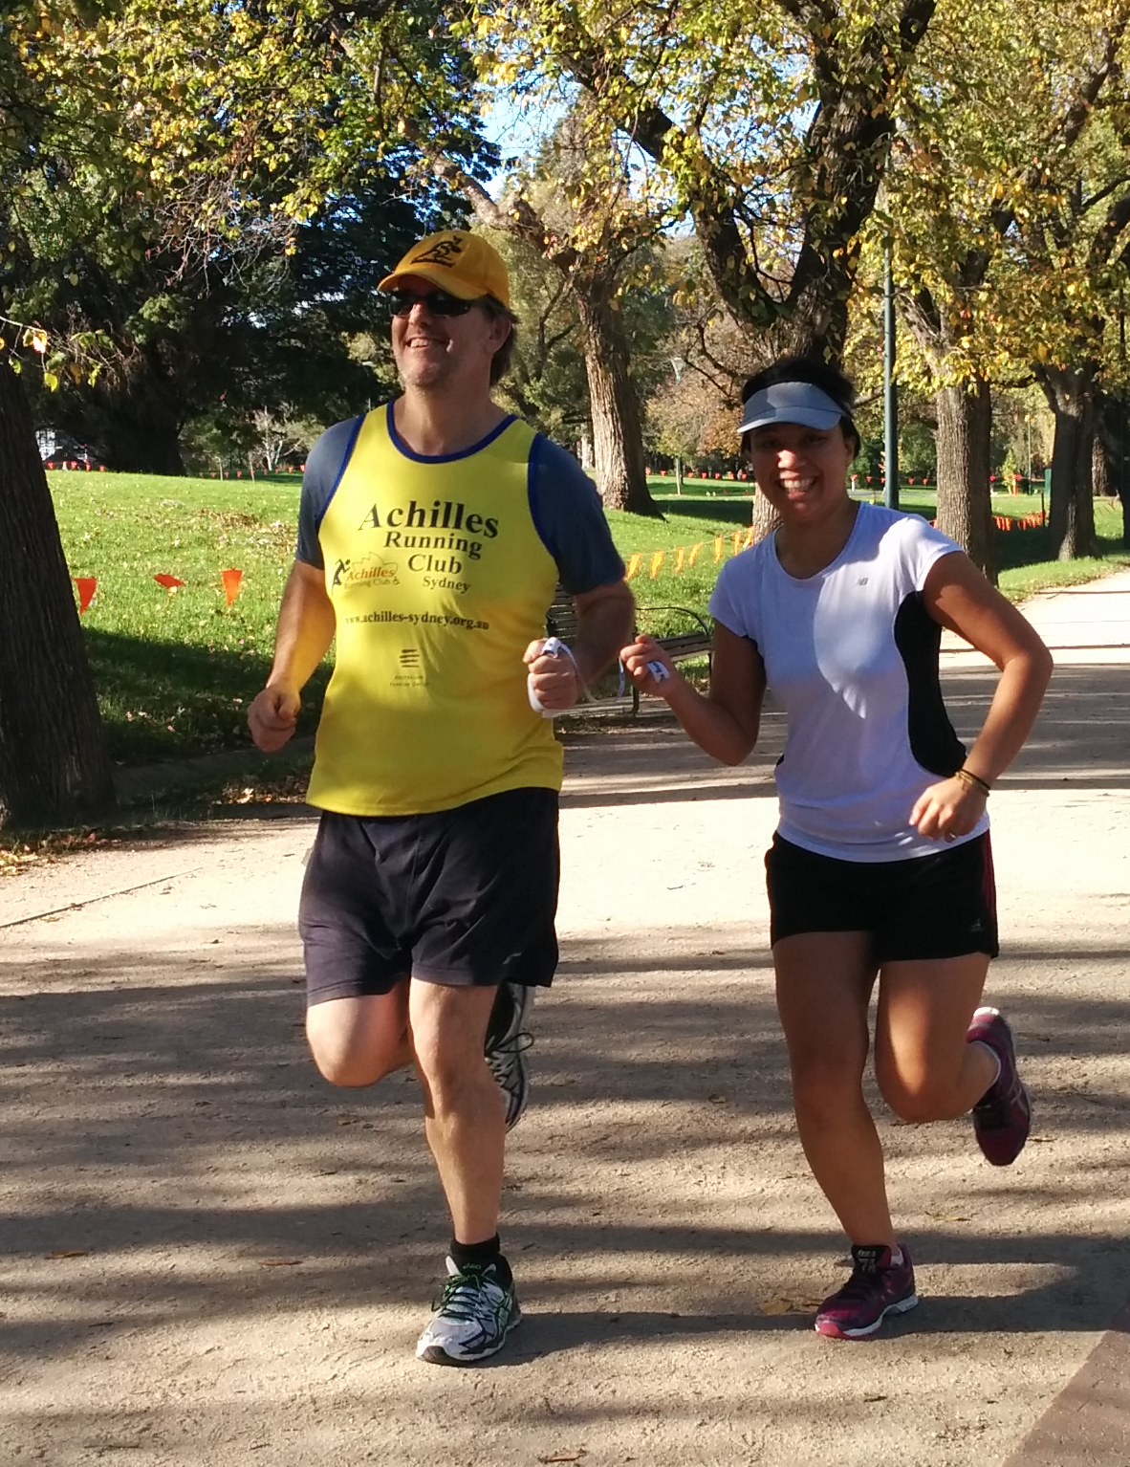

(Photo of runner and sighted guide)

Return to contents

# We want your feedback! Introducing Clickability

At GDV we welcome feedback from clients, families, donors, referral sources and volunteers. We aim to acknowledge all feedback and act on feedback. Feedback is an opportunity for GDV to understand client needs and make improvements where necessary. Feedback can be provided:

* in person
* via phone
* via email
* via letter
* via GDV client satisfaction survey
* and now via Clickability, which you can find at <https://clickability.com.au>!

Clickability is a Disability Service Directory, providing reviews from people who have used a service. It is an opportunity to give anonymous feedback. The feedback lodged through Clickability leads to the disability service provider receiving a rating. You can then read the reviews, compare with a similar service provider and then make a choice of who you may wish to receive services from. GDV aims to provide excellent customer service. You can help us do that by providing constructive feedback.

Return to contents

# ****Helping clients navigate the NDIS****

The National Disability Insurance Scheme is now available to eligible clients in the local government areas of Banyule, Darebin, Nillumbik, Whittlesea, Yarra, Greater Geelong, Colac, Otway, Surf Coast and Queenscliff. Clients in Ararat, Ballarat, Golden Plains, Hepburn, Moorabool and Pyrenees will be able to apply from January 2017 and should be thinking about their eligibility and plan.

We at Guide Dogs Victoria believe that this funding model will be a good thing for many of our clients, who will be able to receive financial help towards a wider range of supports – from help with food and vet fees for Guide Dog users, to assistive technology or gym fees to help achieve life goals like going to uni, rediscovering a hobby or getting fitter.

You can check your eligibility on the NDIS website (<http://www.ndis.gov.au/ndis-access-checklist>).  
  
Guide Dogs Victoria has specialised staff available to help you understand the NDIS and prepare. You can visit our website <https://www.guidedogsvictoria.com.au/about-us/the-ndis-and-disability-care/> or arrange a one-on-one discussion by calling 03 9854 4467.

Return to contents

# Support Coordinator profile

**Guide Dogs Victoria’s Support Coordinators are** here to help you understand the NDIS, prepare for the NDIS and put your NDIS plan into action if you require support to do so. This means we help connect you with the services you require to fulfil your goals.

**Tim Carter**

Having come from a background working as a Homelessness Case Manager, Tim has brought the same passion and energy required in that work to our organisation. Tim will be working closely with all areas of GDV to ensure that our clients are receiving the best service delivery possible to help them improve their lives.

 (Photo of Tim Carter)

**Sabrina Donlic**

Sabrina has come from a background of working with individuals with acquired brain injuries, mental health issues and a range of disabilities. Sabrina is passionate about equality for people with a disability and opportunities for full community participation.  (Photo of Sabrina Donlic)

# Share your story

If you have a story you’d like to share about your vision loss, your experiences with our services or being matched with your Guide Dog, we’d love to hear from you. The marketing team are always on the lookout to feature our client’s stories in the media, to help spread the word about the wonderful work of Guide Dogs Victoria and to increase public awareness about people living with vision loss or blindness. If you are comfortable with sharing your story, please email the marketing team at [marketing@guidedogsvictoria.com.au](mailto:marketing@guidedogsvictoria.com.au)to get in touch.

Return to contents

# Feedback

If you have anything to contribute to this newsletter, please feel free to contact us with your piece. We welcome all contributions.

Please either contact or email our client services administration team with your contributions as below:

[csadmin@guidedogsvictoria.com.au](mailto:csadmin@guidedogsvictoria.com.au) or phone 9854 4467

Return to contents