On the Move – 4th Edition

# Tips for reading this newsletter

1. If you would like to increase the text size on your screen:

* Using the keyboard
  + 1. Press ALT+W, and then press Q.
    2. Press the TAB key repeatedly until the **Percent** box is selected, and then type a percentage or press UP ARROW or DOWN ARROW to select a percentage.
* Using the mouse
  + 1. On the View tab, in the Zoom group, click Zoom.
    2. Click the zoom setting that you want or type a percentage in the Percent box.

1. The contents below are hyperlinked. Some versions of word require you to press CTRL and click to access the link.

Skip to contents

Contents

Tips for reading this newsletter 1

Upcoming Programs: 2

Editor’s update 3

Alastair Stott, the new General Manager for Client and Guide Dog Services updates us on the Client and Guide Dog Services Re-organisation 5

What’s Up Doc - Update from the GDV Vet Clinic 6

Understanding Pancreatitis 6

Public Transport Access Committee and V-Line Accessibility Reference Group by David Simmonds 7

Living with Acquired Brain Injury and Vision Impairment 9

Technology Review 11

Afterschokz Bone-Conduction headphones 11

A new way to pay at retail outlets – the CBA ‘Albert Terminal’ gets voice-over accessibility features 13

News from the International Guide Dogs Federation Conference in Hvar, Croatia 14

Report from Paula Foote: ‘Can Guide Dogs facilitate social inclusion for children who are blind and vision impaired in main stream schools’. 15

We want your feedback! Introducing Clickability 17

Bendigo Client Information Workshops – Save the Date 17

Dialogue in the Dark Employment Opportunities Session – Register your Interest 18

Join in: Victoria B-League! 19

Tell us your preferred format for communication from GDV 19

Share your story 20

Feedback 20

# Upcoming Programs:

* Bendigo and surrounds Client Information Workshops – The latest Tech, Meet our Occupational Therapist, Learn about the NDIS:Thursday 18th August 7pm, or Friday 19th August at 10:30am
* Cane to Canine: Wednesday 14th September 2016
* Living with Acquired Brain Injury and Vision Impairment: Wednesday 3rd August and Wednesday 9th November 2016
* Live Safe Travel Smart – Travel Series: Three part series – Tuesday 20th September, First week of October (day TBC), and Thursday 10th November.

Please register your interest for any of these events by emailing [CSAdmin@guidedogsvictoria.com.au](mailto:CSAdmin@guidedogsvictoria.com.au) or calling 03 9854 4467.

Skip to contents

# Editor’s update

Hello ‘On the Move’ Readers,

Welcome to another edition of the Guide Dogs Victoria (GDV) client services newsletter On the Move. 2016 has been a busy year so far with the kennel development continuing and the completion of the Intake block. I recently trialled this new facility with my new group of intake assessment dogs and enjoyed the openness of the new facility and efficiency with which I could move my dogs around. Adorned with large, colour coded paw prints, it was easy with a quick glance to know exactly where I should be placing my dogs as I moved to and from kennel yards with them. This block has a new therapy pool for dogs undergoing post-surgery rehabilitation, a hydro-bath, and easy access to the GDV Vet Clinic.

The National Disability Insurance Scheme (NDIS) has officially been rolled out in the North East-Melbourne region this month. Many of you in that region will be undergoing the process of planning, meeting with Local Area Coordinators and specialists to bring together a package that supports your various needs. It is important to remember to look into all areas of your life, not just mobility. Guide Dogs Victoria has been supporting clients in the Barwon Region since mid-2013 so has developed valuable experience where the NDIS is concerned. Remember you will be able to contact the GDV Client Services Team to support you in terms of planning, and possibly the implementation of your plan. We have also employed two dedicated Support Services Coordinators who will be able to help you with your plan implementation and put you in contact with other specialists if you require. Tim Carter has already started at GDV and Sabrina Donlic will start with GDV on July 18th.

We are also fortunate to welcome 2 new Occupational Therapists to the GDV Team. Krystle Prentice and Leah Hamilton will be available to work with you to hone and adapt independent daily living skills. Both Leah and Krystle come to GDV with a wealth of experience in their field and fit beautifully into the culture of GDV.

Dogs Unite was held on April 17th in Kew, Geelong, Ballarat, Bendigo and Gisborne. In total this event raised $80,000! This was a fantastic day and exceeded our expectations, particularly in the regional areas where the event was being held for the first time. A huge thankyou to any clients who were able to join in this walk.

We all hope that 2016 continues to be an exciting and successful year for you. All the very best from the GDV team.

Cheers,

Pete Tomlins

Editor

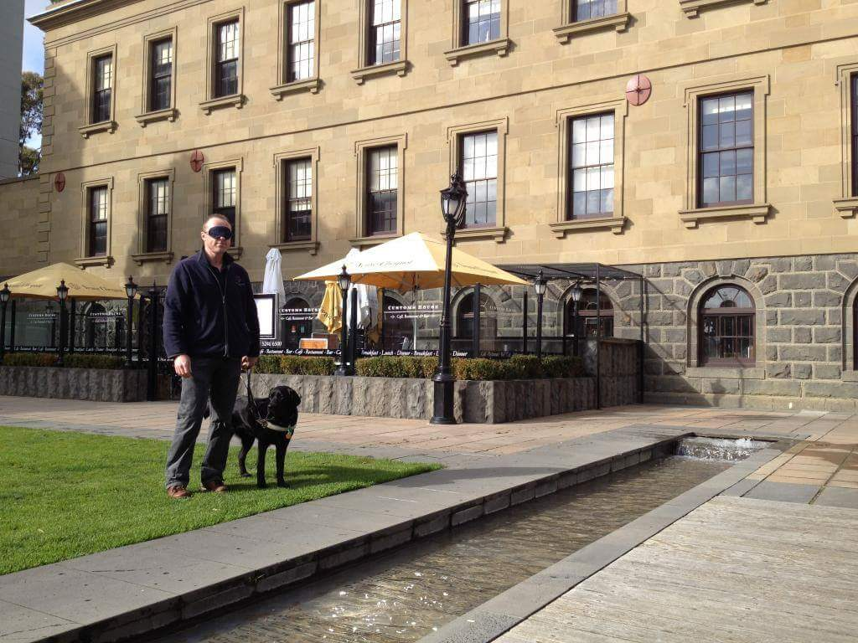

**Photo: Pete Tomlins doing a blind-fold walk with a Guide Dog**

Skip to contents

# Alastair Stott, the new General Manager for Client and Guide Dog Services updates us on the Client and Guide Dog Services Re-organisation

The National Disability and Insurance Scheme (NDIS) and My Aged Care (MAC) reforms offer a great opportunity for GDV to expand our service offering for blind and vision impaired Victorians. A significant number of our clients will be eligible for the NDIS individualised packages (tier 3) and Information Linkages and Capacity building (tier 2).

Client and Guide Dog Services have been re-organised in light of these reforms, making sure we are providing the best possible experience and quality of service to all our clients, whether funded or not.

There will be a ‘flatter’ structure ensuring greater accountability and authority of all managers, cutting away red tape and simplifying reporting lines.

You may notice you are being asked your opinion of our services more as we try to understand your experience and needs as much as possible to tailor our services better.

The reorganisation will also examine ways to:

1. Successfully bring innovative new products and services to market
2. Better match dog production to future client demand to enable elimination of waiting lists for our services and products
3. Commit to developing a learning and innovative culture by partnering with global centres of excellence and implementing evidence-based best practice

Alastair Stott (new General Manager, Client and Guide Dog Services)



**Photo: Alastair in the Guide Dogs Victoria Office**

Return to contents

# What’s Up Doc - Update from the GDV Vet Clinic

## Understanding Pancreatitis

**What is pancreatitis?** The pancreas is an organ that secretes digestive enzymes and also insulin. Pancreatitis is inflammation of the pancreas. This condition affects young adult dogs, and it can be fatal if not treated early enough.

**What causes pancreatitis?** The cause is unknown although there are some risk factors to watch out for: obesity, diabetes mellitus, Cushing’s disease, hypothyroidism, prior gastrointestinal tract disease, and epilepsy. Other potential risk factors include high fat diets (don’t let your dog steal hot chips!), malnutrition, toxins (organophosphates), hypercalcemia, duct obstruction, reflux of duodenal content into the pancreatic duct, pancreatic trauma and parasites (flukes). Contrary to popular belief pancreatitis is not triggered by the use of cortisone.

**What are the symptoms to look out for?** The symptoms are abdominal pain, anorexia, vomiting and fever.

If your dog shows these symptoms, immediate veterinary attention must be given.

Dr Elaine Ong

Principal Veterinarian for Guide dogs Victoria Principal of Box Hill Veterinary Hospital

AVASA accredited hospital of excellence

Return to contents

# Public Transport Access Committee and V-Line Accessibility Reference Group by David Simmonds

Since coming on board with GDV approximately 12 months ago I have been focusing on a number of key areas, one of which is access and advocacy.

Aside from facilitating access and advocacy workshops for new and existing Guide Dog Handlers training at Arnold Cook House and responding to and resolving access refusals reported to GDV, I have also made a concerted effort to become involved with a number of public service providers such as Public Transport Victoria, Yarra Trams, V-Line, Vic Police and the Taxi Services Commission, to tackle access issues from a systemic perspective.

I am very pleased to announce that I have recently been appointed to V-Line’s Accessibility Reference Group (ARG). This group is made up of individuals, of varying physical and mental abilities, who regularly utilise V-Line’s network. Our inclusion in this group represents a great opportunity for us to be involved at the design stage of many new initiatives and to be able to offer advice and guidance to V-Line’s accessibility team on how best to address specific access related issues.I would encourage you to contact me with any V-Line related accessibility issues or ideas you would like to have raised in this forum.

Public Transport Victoria has also recently re-formed its Public Transport Access Committee (PTAC). The purpose of this committee is to provide strategic advice and direction to the Minister for Transport for any accessibility related issues. I am very proud to advise that I was successful in my application to this committee and we are currently planning for our first meeting with the Minister to discuss the priorities that our committee has identified, and to establish any specific consultation with the community the Minister wishes us to undertake.

Our presence on this committee represents another forum in which we are able to contribute to a more accessible public transport network for ALL. One of the key priorities I proposed and had accepted at our first planning meeting was the need to ensure that all train platforms throughout Victoria have hazard tactiles affixed. Late last year I became aware that of the 640 odd train platforms throughout Victoria, approximately 170 of these do not have any hazard tactiles on the platform edge. Clearly this represents a very real safety risk to anyone using these stations who is either blind or vision impaired and I am very much looking forward to discussing this priority directly with the Transport Minister in the coming weeks.

Please feel free to advise me of any PTV access related issues you would like me to raise with this committee.

David Simmonds

[davids@guidedogsvictoria.com.au](mailto:davids@guidedogsvictoria.com.au)

Business Development and Advocacy Manager



**(Photo of David Simmonds sitting at his desk, with his Guide Dog Olga)**

Return to contents

# Living with Acquired Brain Injury and Vision Impairment

Did you know that people who have experienced changes to their vision following an acquired brain injury (ABI) can attend a client information day at Guide Dogs Victoria?

This one day workshop – Living with Acquired Brain Injury and Vision Impairment – can assist clients and their family to better understand changes that may follow brain trauma and the variety of support services available.

Presenters include:

* Guide Dogs Victoria’s low vision Occupational Therapist (OT) Leah Hamilton who shares strategies for daily activities, such as pouring a drink.
* Orthoptist Marnie Roth who speaks about the eye, its functions and how vision really works
* Neuro-Physiotherapist Geoff Bell who demystifies the brain and its many functions
* ABI Counsellor and Speech Pathologist Liz Chard who discusses strategies for cognitive, behavioural and emotional changes
* Carers Australia who provides information on the supports available to our valuable carers

Sessions are held quarterly at Guide Dogs Victoria. To learn more please call Client Services Administration 9854 4467

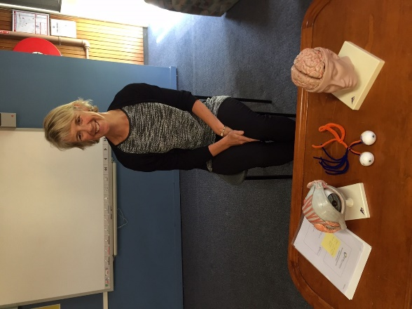**(Photo: presenter Liz Chard with models of a brain, an eye and the visual pathway on the desk in front of her)**

Return to contents

# Technology Review

## Afterschokz Bone-Conduction headphones

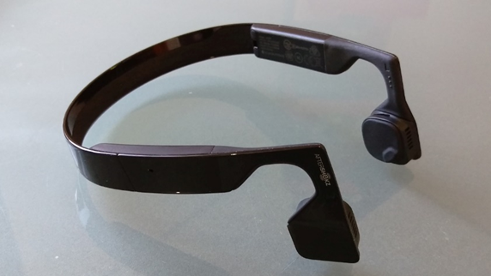

**(Photo of black bone-conducting headphones)**

Are you sick of not hearing cars or other audio clues while travelling and using your headphones? Bone conduction headphones may be the solution for you!

Aftershokz makes two different types of bone conduction headphones – one wired and one wireless. Both work in the same way – instead of little tiny speakers that are jammed into your ears, the headphones have large rubber pads that rest against the bones of your skull. Playing music or listening to instructions from your smartphone sets them vibrating and the fun begins.

Listening to things via bone conduction is weird in so many ways. It’s important to nestle the headphone pads right up against the bone in front of your ear, otherwise you won’t get the full effect. It does take a bit of experimentation to find the best spot, especially if you wear glasses.

At first it may seem as though the sound is only inside your head – like standing in a room full of music that only you can hear. But it turns out if you crank up the volume the headphones are actually very audible to people nearby. While bone conduction does the heavy lifting, a lot of sound does make it into your ears the usual way. Ultimately the sound quality is not really better or worse than normal headphones — just different.

While music sounds a little odd compared to normal, voices (such as when using the headphones as a hands free for your phone) actually sound better than normal. This is particularly handy if you are into audio books.

The main benefit is that the headphones leave your ears totally free and don’t block any outside noise at all. If you have the volume cranked up you could still miss what’s going on around you, but you’re not as cut off as with ear buds. Walking with headphones can be dangerous if you can’t hear what’s going on around you. With bone conduction, you can be a lot more aware of your surrounds.

There are many brands of bone conduction headphones and they are not cheap (approx. $120) but they may be the difference between hearing that car reversing out of the driveway or not.

John-Ross Baressi

## A new way to pay at retail outlets – the CBA ‘Albert Terminal’ gets voice-over accessibility features



**(Photo of Albert Eftpos Terminal with someone using credit card)**

Last year The Commonwealth Bank rolled out their “Albert” touch screen eftpos terminals across Australia. Originally these were not accessible for people with vision impairments at all however they now have a voice-over feature making them more accessible. It might still be a bit tricky in a noisy environment like a cafe, but it is certainly a lot more do-able than previously for people with vision impairments.

Check the retailer has loaded the 'Albert payment App' on their Albert terminal. If they have then you should be able to complete a voice-guided PIN entry with in-built voice narration guiding you through every step. The PIN entry is just as secure as standard PIN entry.

Guide Dogs Victoria has been given an Albert terminal by the Commonwealth Bank, to support people to feel confident accessing this new terminal prior to using it out in the community. The Occupational Therapists here at GDV are happy to assist people with this, as well as other areas of community access. To make an appointment to discuss, please contact our friendly customer service team on 9854 4467.

Return to contents

# News from the International Guide Dogs Federation Conference in Hvar, Croatia

Five GDV staff members attended the International Guide Dog Federation (IGDF) Conference in Hvar, Croatia in late May 2016. It was a great networking opportunity with more than 300 representatives from 35 schools participating.

Paula Foote from GDV prepared an excellent paper on the important role of Guide Dogs in facilitating social inclusion for blind and vision impaired children, which is covered in more detail in the next article.

The conference covered a wide array of topics. We gained significant insights to what is being done in schools around the world particularly around the use of positive reinforcement training and the use of innovative technology to support vision impaired people.

## Report from Paula Foote: ‘Can Guide Dogs facilitate social inclusion for children who are blind and vision impaired in main stream schools’.

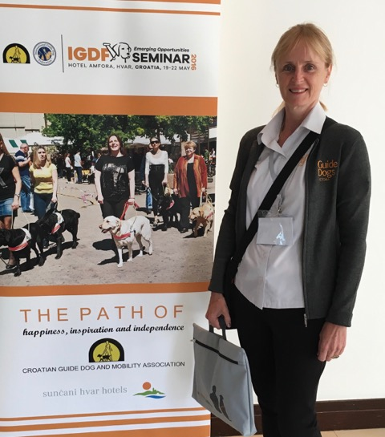

**(Photo: Guide Dog Victoria’s Paula Foote standing in front of a Croation Guide Dog poster)**

As a presenter at this year’s IGDF Conference I was on a roller coaster of mixed emotions. Fear, for having to stand in front of an audience of people that I didn’t know, excitement at having an opportunity to share my passion for children’s Guide Dog mobility and pride at representing my Guide Dog school.

The conference was held in a resort at Hvar. Hvar pronounced ‘Var’ is a beautiful town on an island off the Dalmatian Coast of Croatia. The setting was idyllic with the beautiful blue of the Adriatic Sea and clear sunny skies as a back drop to ancient buildings constructed of locally sourced white stone. I could get used to this place.

My conference paper was entitled ‘Can Guide Dogs facilitate social inclusion for children who are blind and vision impaired in main stream schools’. My presentation looked at the difficulties children who are vision impaired have with learning social skills and the impact that it has on their ability to form friendships. We know that friendships are vitally important for children as they are the main motivator for kids wanting to attend school. When children who have a vision impairment are not explicitly taught social skills and they have difficulty in making friends, their likelihood for employment and developing future relationships is diminished.

Enter the Guide Dog.

We know that adults report feelings of social inclusion and greater social interactions when they are matched with a Guide Dog, so why not provide children with Guide Dog mobility at an earlier age to help them develop vital social skills. As it turns out, there is no evidence to suggest that children can’t be successful Guide Dog handlers. In fact, a Guide Dog school in Canada called the Mira Foundation has been successfully training children as young as 11 years old with Guide Dogs for the last 20 years.

I am happy to report that Guide Dogs Victoria sees the value in training children with Guide Dogs and you will see a natural progression towards younger Guide Dogs handlers in the future.

Paula Foote – Children’s Orientation & Mobility instructor

Return to contents

# We want your feedback! Introducing Clickability

At GDV we welcome feedback from clients, families, donors, referral sources and volunteers. We aim to acknowledge all feedback and act on feedback. Feedback is an opportunity for GDV to understand client needs and make improvements where necessary. Feedback can be provided:

* in person
* via phone
* via email
* via letter
* via GDV client satisfaction survey

And now via Clickability! Which you can find through <https://clickability.com.au>

Clickability is a Disability Service Directory, providing reviews from people who have used a service and providing an opportunity to give anonymous feedback. The feedback lodged through Clickability leads to the disability service provider receiving a rating. You can then read the reviews, compare with a similar service provider and then make a choice of who you may wish to receive services from.

GDV aims to provide excellent customer service. You can help us do that by providing constructive feedback.

Return to contents

# Bendigo Client Information Workshops – Save the Date

We are currently planning two Client workshops in Bendigo. If you are interested in hearing about the latest in Technology, meeting our new Occupational Therapist and hear about how they can assist you, or discussing with our staff the NDIS and how this may impact on you and how to be prepared for the upcoming rollout in your region, come along!

To register your interest in either the evening session on Thursday 18th August 7pm, or Friday 19th August at 10:30am, please contact the Client Services team on 9854 4467.

Return to contents

# Dialogue in the Dark Employment Opportunities Session – Register your Interest

We are very excited to announce that Guide Dogs Victoria will be hosting an information session in August on employment opportunities within Dialogue in the Dark: a sensory experience that will be brought out to Melbourne in March 2017 by Guide Dogs Australia.  Dialogue in the Dark is a social enterprise that originated in Germany and which now operates worldwide, and we are very excited to be involved in bringing the experience to Australia for the very first time.

Dialogue will offer a range of employment opportunities for people who are blind or vision impaired in a variety of different roles.

The founder, Andreas Heinecke, will also be attending the information session, so you will be able to hear firsthand the story behind Dialogue in the Dark and its mission to facilitate social inclusion for disabled people on a global basis.  To register your interest to receive an invitation and information pack, please email [hr@guidedogsvictoria.com.au](mailto:hr@guidedogsvictoria.com.au) .

Return to contents

# Join in: Victoria B-League!

**Victoria B-League**

The Victorian B-League is an inclusive Blind Football League

Open to all players who are blind or vision impaired

When: Every Sunday 2-4pm from 21st of August until 23rd of October

Where: Camberwell High School Gymnasium, Prospect Hill Road, Camberwell

Cost: $30 for the season

Come down and kick some goals

For more information, contact the FFV All Abilities Coordinator

Phone: 9474 1800

Email: [pedwards@ffv.org,au](mailto:pedwards@ffv.org,au)

Website: [www.footballfedvic.com.au/blind-football/](http://www.footballfedvic.com.au/blind-football/)

# Tell us your preferred format for communication from GDV

“On the Move” has to date only been sent to clients in electronic format, however for this distribution we have also included a large print mail to include all our clients, many of whom we don’t have an email address for. Going forward we would like to introduce as many people as possible to the electronic format as this is better for the environment and also often more accessible through text readers. Don’t worry though, if you do prefer print versions then we are more than happy to keep in touch this way – whatever suits you best.

To make sure we use your preferred format when receiving communications from GDV, please can you let us know your preferred format by emailing or phoning [CSAdmin@guidedogsvictoria.com.au](mailto:CSAdmin@guidedogsvictoria.com.au) or calling 9854 4467.

Available preferred formats:

1) Email

2) Audio CD

3) Large print

4) Standard print

5) Braille

If we do not receive an update in relation to your preferred format the “On the Move” newsletter will continue to be sent to you in the format that you received it in today.

# Share your story

If you have a story you’d like to share about your vision loss, your experiences with our services or being matched with your Guide Dog, we’d love to hear from you. The marketing team are always on the look-out to feature our client’s stories in the media to help spread the word about the wonderful work of Guide Dogs Victoria and to increase public awareness about people living with vision loss or blindness. If you are comfortable with sharing your story, please email the Marketing team at [marketing@guidedogsvictoria.com.au](mailto:marketing@guidedogsvictoria.com.au)to get in touch.

Return to contents

# Feedback

If you have anything to contribute to this newsletter, please feel free to contact us with your piece. We welcome all contributions.

Please either contact or email our client services administration team with your contributions as below:

[csadmin@guidedogsvictoria.com.au](mailto:csadmin@guidedogsvictoria.com.au) or Phone: 9854 4467

Return to contents