On the Move – 3rd Edition

Tips for reading this newsletter
- If you would like to increase the text size on your screen:
- Using the keyboard
    - Press ALT+W, and then press Q.
    - Press the TAB key repeatedly until the Percent box is selected, and then type a percentage or press UP ARROW or DOWN ARROW to select a percentage.
- Using the mouse
    - On the View tab, in the Zoom group, click Zoom.
    - Click the zoom setting that you want or type a percentage in the Percent box.
- The contents below are hyperlinked. Some versions of word require you to press CTRL and click to access the link.

Skip to contents

In this issue:
- Workshops in 2016
- ‘What’s up Doc?’ Updates from our Veterinary Clinic
- Life Safe Travel Smart report from Janet Stubbs
- Tech Corner – Aipoly App
- Weigh in Day - Geelong
- Welcome to Rory Douglas
- Call to action: Research study

Skip to contents

Upcoming Programs:
- Cane to Canine - 4 May, 22 July
- Traffic and Obstacle refresher training
- Self- Orientation - Harness the power of Targeting
- You and your older dog
- Young Adults Group Program: Footscray Food Safari - June (date and details TBC)
- Travel and Personal Safety Group Programs - July and November (dates and details TBC)
- ABI Client Day - 18 May, 3 August, 9 November – click this link for more information
- ABI Professionals Day – 16 March, 10 August, 2 November - click this link for more information
- Dogs Unite - April 17 - register at https://dogsunite.raisely.com/
- International Guide Dog Day Community Walk - Save the Date! April 27
- Dog Lovers Show - April 29 to May 1
Skip to contents

Introduction
Hello ‘On the Move’ Readers,

Welcome to the first edition of the Guide Dogs Victoria (GDV) client services newsletter On the Move. 2016 has begun as busy as ever for the staff of Guide Dogs Victoria and we are looking forward to a great year with continued development of our services to provide new and exciting programs for you all to enjoy.

There has been lots of exciting things going on here at GDV with ongoing development onsite in our Training Kennels with exciting new kennel block which includes a therapy pool for dogs undoing surgical recovery. The modernised facilities will ensure that our beautiful dogs will receive the utmost care that they clearly deserve.

With the NDIS rollout pushing forward in 2016 and hitting Northern metropolitan Melbourne in July we will be looking to support our clients in understanding, planning for, and the implementation of their NDIS plans. As a participant of the NDIS, you will have access to the services of our nearly formed Support Services team, and your mobility instructors. There is more information about the NDIS in this newsletter or if you have further questions please to not hesitate to contact us on 9854 4467.

Dogs Unite will again be run this year on Sunday 17th of April. This is the second year Dogs Unite has been run by Guide Dogs Victoria. This year there will be events held in Geelong, Ballarat, Bendigo and Gisborne as well as in Kew, Melbourne! For more details about each locations event details please check out the website https://dogsunite.raisely.com/

This is a fantastic day that brings us all together to celebrate our four legged friends, and helps to raise money to support the work of Guide Dogs Victoria.

We all hope that 2016 has started wonderfully for you. We look forward to a successful year ahead.

Cheers,

Pete Tomlins
Editor

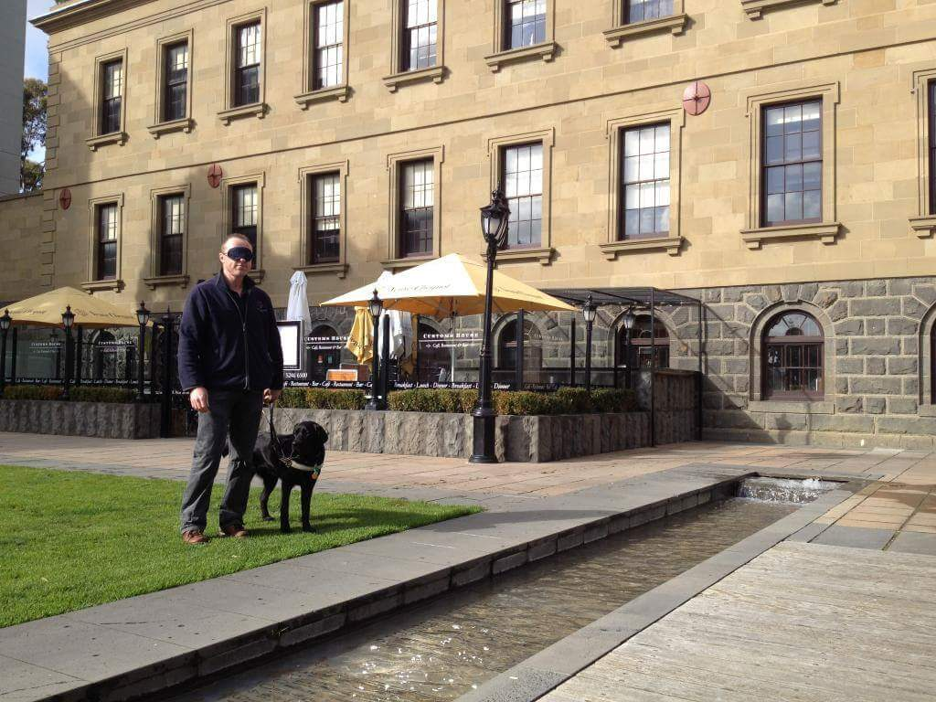
Photo: Pete Tomlins doing a blind-fold walk with a Guide Dog
Skip to contents

Contents
Tips for reading this newsletter 1
In this issue: 1
Upcoming Programs: 1
Introduction 2
Introducing Rory Douglas to Guide Dogs Victoria. 4
Dog Spot - Update from the GDV Vet Clinic 5
Latest on Skin Allergies 5
Latest on Ear Care 5
Call to Action: Clients required for important research pilot 7
Weigh in Day - Geelong 7
App Corner 8
Guide Dog Services Group Program Workshops 9
Cane to Canine 9
Traffic and Obstacle refresher training 10
Self- Orientation - Harness the power of Targeting 10
You and your older Guide Dog 10
Live Safe Travel Smart – Dr Janet Stumbo 11
Goalball Come and Try Day 13
Ballet for the Blind 14
Helping clients navigate the NDIS 15
Share your story! 16
Feedback 17

Introducing Rory Douglas to Guide Dogs Victoria.
Rory will running Job Readiness / Vocational planning programs with clients. Guide Dogs Victoria is very much aware that unemployment is high within the vision impairment population. There are many hurdles in place for a vision impaired person in gaining the initial opportunity to demonstrate their capabilities. Rory’s role will aim to assist GDV client’s in preparing for employment by providing job readiness and have the opportunity to participate in professional work experience.
Rory has extensive experience in Job Recruitment and will be available to support clients in resume writing, application letters, telephone skills, interview coaching and feedback.
If you are interested in learning more about the Job Readiness / Vocational Program then please call Client Service Referrals on 98544467.
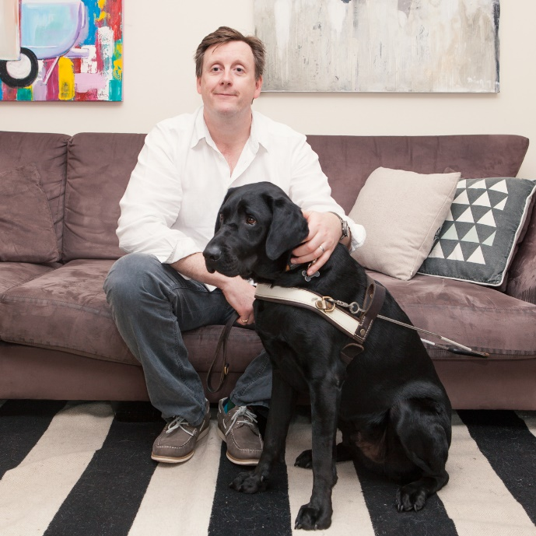
Photo: Rory sitting on the couch with Guide Dog Gideon sitting in front of him

Return to contents

Dog Spot - Update from the GDV Vet Clinic

Our philosophy at the veterinary department of Guide Dogs Victoria is prevention or investment in health. We take a holistic approach towards our dogs’ health. This includes good nutrition, good physical health, good mental health, early detection of illnesses and updated veterinary care.

Latest on Skin Allergies

In the world, the Labrador has surpassed the West Hyland White Terriers as a breed that suffers most from allergies. A small percentage of our Labradors suffer from allergic dermatitis caused by pollens, dust mites, grasses (This type of inhalation or skin penetrative allergy is called Atopy).

There is a new wonder drug that will make their lives a whole lot better. This new drug is called APOQUEL, recently released in Australia
It is a safe drug and does not have the side effects of cortisone. It works rapidly to relieve itching.

Important note - This drug will not work if your dog has secondary infections on the skin (Bacteria, yeast, mange)

Other ways to minimize this type of allergy:
- Walk dogs very early in am and very late to minimize the exposure to pollens. Pay attention to the pollen counts on the day
- Remove carpets in home
- With carpeted homes, steam clean very regularly to eliminate dust mites and insect skins

If your dog has non-seasonal allergy with feet licking or persistent ear infections, it could be a food allergy

Latest on Ear Care
Most ear infections are due to ‘Microclimate’ change such as wet ears, humidity and warm environment.

- A lot of dogs have undetected ear infections. Working dogs are often stoic and the ear infections go unnoticed. You will find that once the ear infection is treated, your dog will feel better and work better

- When you are visiting the vet, always ask them to examine your dogs’ ears. If untreated, dog will have a low grade pain and discomfort constantly. If left untreated for a long time the infection will get worse, will be painful and may affect hearing

- Minimize use of ear cleansers unless prescribed by the Vet. Wet ears are prone to ear infections.

- If your dog is a regular swimmer, ensure you dry the ears thoroughly using a cold hair dryer or a dry cloth. Apply a few drops of aqua ear lotion- a drying agent for ears. Note: aqua ear lotion will not work if the ears are already infected

- If your dog has a recurring or persistent ear infection and you have been to the Vet and medicated the ears correctly, then this ear infection may be due to allergies (atopy or food). Your Vet will be able to advise you about doing a food trial.

- When prescribed ear drops, it is best to ask for a few 1 ml syringes to administer the ear drops. For an adult lab 1 ml minimum must be used per treatment per ear. Take the top off the bottle, insert the syringe and draw up 1 ml and then squirt into dogs ears. Failure of treatment is often due to inadequate volume of drops being applied

- Most people will be able to detect ear infection in their dogs by the smell and appearance (redness, presence of discharge)

Dr Elaine Ong
Principal Veterinarian for Guide dogs Victoria
Principal of Box Hill Veterinary Hospital
AVASA accredited hospital of excellence
Return to contents

Call to Action: Clients required for important research pilot

The Centre for Eye Research Australia (CERA) is piloting an acceptance-based guided self-help programme to improve well-being in people who are blind or have low vision.
Any client within Melbourne over the age of 18 years is eligible to participate.
The study runs over the course of six months, and clients who agree to participate in this study will be involved in three interviews (45-60 mintutes) and randomly selected to go into a six week Acceptance Commitment Therapy (ACT) program – a modern evidence-based approach living well that has not yet been used in vision impairment. The program can be completed entirely from the clients own home and involves weekly modules while concurrently receiving weekly sessions with psychologist Dr Bonnie Sturrock. The sessions with Dr Sturrock will be provided both over the phone (three times) and face to face (three times). If clients would like to, they can come to the Centre for Eye Research in East Melbourne rather than receive a home visit for their three face to face sessions with Dr Sturrock. Participants will be reimbursed $20 for their travel expenses.

Dr Sturrock is a Psychologist who works in private practice and has over ten years of experience working and studying in the area of mental health with a focus on the provision of Cognitive Behavioural Therapy (CBT).

This is a world-first study, and clients can register to participate by contacting Marian Saeed at the on 03 9929 8161 or email Marian on: marian.saeed@unimelb.edu.au
Return to contents

Weigh in Day - Geelong

Guide Dogs Victoria’s Geelong office now has its own set of Veterinary Scales to help track the weight of dogs in training, and Guide Dogs in the Geelong region. These scales can be accessed by appointment when Guide Dog Mobility Instructor, Peter Tomlins, is available at the Geelong Office. These scales can be used as an alternative to a local veterinary clinic, and Peter will be able track your dog’s weight over time. Peter will also be available to discuss your dog’s diet to ensure weight is maintained effectively in an effort to promote a long and healthy career.
Return to contents

App Corner

‘Aipoly’ is a new app that is available to download from the App Store free of charge. It is an object and colour recogniser that helps the blind, visually impaired, and colour blind understand their surroundings. Simply point your phone at the object of interest and press the large toggle button at the bottom of the screen to turn on the artificial intelligence.

App features include:
- Recognise Objects: Aipoly can recognise a wide variety of objects at a rate of three times a second. Simply switch on the Aipoly button and it will start identifying what it sees through the camera. Recognising objects does not require an internet connection.
- Recognise Colours: Aipoly can tell up to 954 colours apart.
- Teach Aipoly: Aipoly will learn more objects if its users help it by writing descriptions of what it sees. This is a good way for sighted users to help the visually impaired.
- Voice Modes: You can switch between different voice modes in the settings page. Ranging from standard, which says one word at a time, to advanced for multiple words, to likelihood and fun, which express the likelihood of the item viewed and add additional captions respectively.
- Intelligent Torch: When Aipoly detects darkness through the camera, it will automatically turn on the torch so you don't have to worry about lighting. When the light is switched on, it will turn the torch off.

Photo: Aipoly logo

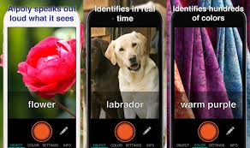
Photo: App screenshots
Return to contents

Guide Dog Services Group Program Workshops

Guide Dog Services would like to introduce you to our exciting list of 2016 group program workshops. These workshops cover a range of topics and will give you the opportunity to either refresh your knowledge on vital information and skills or provide you with the opportunity to learn about new information and take your teamwork to another level.

Programs are being held across the year so please contact the Client Service Administration team via (03) 9854 4467 or CSAdmin@guidedogsvictoria.com.au for dates and availability. Bookings are essential for all workshops.

Cane to Canine
In 2016 Guide Dogs Victoria is proud to introduce a new program for all ages to help answer the age old question; “Is a guide dog right for me?” This full day session will give you the opportunity to experience working a Guide Dog. We will also discuss GDV services including different mobility aids, technology and group programs.
Whether you’re thinking of exploring Guide Dog Mobility in a month, a year or in the distant future, this session is for you! The day will assist you in making an informed choice about your preferred mobility aid for now or the future.

The Cane to Canine program aims to:
- Help bust common myths about using a guide dog
- Provide information about the differences in travelling with a dog versus a long cane
- Outline support provided by an orientation and mobility specialist to prepare and transition to guide dog mobility
- Discuss Low Vision and using a guide dog
- Learn from new guide dog users about their experiences

Includes morning tea and lunch. Family member or carers welcome to attend.

Traffic and Obstacle refresher training
Do you have much opportunity to experience busy traffic situations or off kerb obstacles when working your guide dog? If not, the GD Services team are running a one day refresher workshop where you can practice:
- Near and far traffic situations,
- Entering and existing driveway situations and
- Off curb and partial footpath obstructions.

Includes morning tea and lunch. Cost $10

Self- Orientation - Harness the power of Targeting
Over the course of a day you will receive information on self-orientation techniques, positive reinforcement and motivation skills that will support your Guide Dog in its work. This program will give you an opportunity to discuss positive orientation strategies in a group setting and practice with one-on-one instruction.
Includes morning tea and lunch. Cost $10

You and your older Guide Dog
This seminar, conducted over one full day focuses on the needs of Guide Dog owners whose dogs are 8 years of age and older. The topics covered include:
- Older dogs require different considerations from a health perspective and our Veterinarian will present strategies and ideas to help maximize your dog’s working life.
- Changeover to a new dog may also be on the horizon, so join in the discussion about the challenges of changeover. Your experiences may also benefit someone facing this issue for the first time.
- Learn about new aids and “apps’’ from the GDV mobility team as they present other mobility support options available to you if you are taking a break between dogs or are considering other mobility options.
- Discuss behavioural changes that may be on the horizon for your aging dog and what you can do to prevent or manage these.
- Find out about the National Disability Insurance Scheme and how it might affect you.
Includes morning tea and lunch.
Return to contents

Live Safe Travel Smart – Dr Janet Stumbo

Recently my Orientation & Mobility (O&M) specialist, Rachel Abdulla, referred me to Guide Dogs Victoria’s “Live safe, travel smart” workshop to be held over 3 days in October 2015. I really had no idea what to expect. But it appears to me that just as every human brain is unique, every brain injury is unique, and so is each person’s vision impairment and how they deal with it. I was impressed by the individual attention and consideration each participant was given. Most of these three days were spent at Arnold Cook House (ACH) in Kew; where several rooms are available for people to sleep over and guide dogs are well accommodated.

At the moment I am using a long cane and public transport for all my travelling needs. So I applied and blocked out the three days. Very soon, and well in advance of the start date, an extensive information packet arrived in my post box. All of the paperwork required could be filled out on the computer & emailed back: Easy as. And a detailed agenda was provided for each day of the workshop. I elected not to stay at ACH and got myself organised to do all the travelling.

I am not blind. I have a bilateral inferior field defect making me half blind and I often forget all the other visual impairments that cause me so much grief in my daily living: fatigue, disorientation, memory. So I made the mistake of not booking to stay at ACH for the 2 late nights of the WKSP believing I would be preventing someone who really needed it a room to stay in. I actually expected to be able to manage my public transport needs after working all day and eating dinner relatively late at night [for me]. Fortunately our supervisors were much wiser, gave me a quiet bed to have a nap in every afternoon, and insisted on sending me home in a taxi. For some of the nights ended very late for me. I couldn’t have managed it all by myself. Next time I will know better.

Knowing ahead of time allowed me to work out my travelling arrangements at my own desk and computer with good lighting and magnification when I needed it. It is empowering to know what you will be expected to do and when. All the supervisors seemed to be aware of each of our unique potential difficulties and they were so helpful at all times. In fact that was a consistent aspect of the workshop and every one of the staff that I encountered: Empowering us participants to manage our own lives more effectively.

I was greatly heartened to discover that Guide Dogs Victoria now has a specialist ABI unit with several professionals trained to look after those of us who have lost our vision to brain trauma. When my brain was extensively injured back in 1984 - there seemed to be very little knowledge of ABI’s in the Royal Blind Society I was working with in Canberra. And apparently none in the neurosurgeon’s and the ophthalmologic surgeon’s experience. That is a really welcome improvement in this sector.

Each of the aspects of this training were relevant & we were never overwhelmed with masses of data that I was never going to be able to process in the time allotted. Each of the outside professionals was very attuned to this unique audience; each was obviously well prepared and delivered their segments in a fun and relaxed why all of us could learn from. We were given just the information we needed to know. All the information we were provided was aimed at two aspects of our lives: knowledge and control. If you know how things work and how you can work in with things to accomplish the goals you need to it engenders a profound sense of well-being: Empowerment in the truest sense of the word. This workshop was directed at that: knowledge and helpfulness. I feel so much more competent to use the public transport system, now, than I did before. Thank you to everyone involved. Thank you for making it so easy for me to participate.
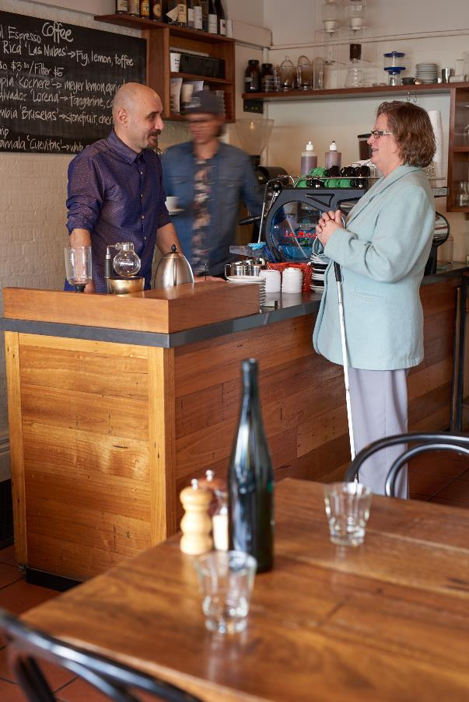
PHOTO: Janet at café
Return to contents

Goalball Come and Try Day
The Victorian Goalball Association would like to invite you to join in on all the fun and action of Goalball at our Local League on Saturday the 2nd of April 2016, between 9:30 am and 12pm. Never heard of or played Goalball before? No problem, no prior experience is needed.
What is Goalball? Goalball is a sport designed for the blind and vision impaired. It is one of the only blind sports played at a Paralympic level. It is a fast paced sport that relies on hearing. The objective of Goalball is simple: to score goals against the other team while defending your own goal area. This is achieved by throwing a ball slightly larger than a basketball into the other team’s half of the court, where they will then attempt to block the ball with their body and then throwing the ball back at the other team. For more information on what Goalball is all about, visit our website at http://www.goalball.org.au/. We encourage males and females of all ages, no matter whether you are fully sighted or totally blind to come and give this unique sport a go!
Our Local League competition is held at Scotch College Hawthorn Junior Gymnasium, found at 1 Morrison St, Hawthorn.
Entry is on the corner of Glenferrie Road and Calintina Road in Hawthorn, a minutes drive away from Vision Australia Kooyong. There are a number of parking spaces for those driving, and there is public transport close by.
What to wear? Comfortable clothing such as track pants, and runners.
What to bring? A water bottle
Please register your interest and attendance using the contact details below.
Andrew Martin
Email: andy.f.martin@gmail.com
Mobile: 0401330071
Please feel free to contact me with any questions you may have. We look forward to seeing you then!
Return to contents

Ballet for the Blind

I am the Principal and founder of Elancé Adult Ballet School, a school that offers ballet classes exclusively to adults. This year we started a unique program specifically for blind adult students.

The program was inspired by a student who came to us a couple of years ago. This student became blind in 2006, having done a little ballet in earlier life. Seeing the delight on her face at being able to stand and move independently, without the aid of a dog, a cane or a person at her elbow was a joy. It also made us rethink our teaching ideas, not being able to rely on her seeing what was being explained.

This led us to creating the “Ballet for the Blind” program. We understood that the most important starting point would be to create a strong, confident posture and basic technique before doing anything too adventurous in the way of moving. We have included exercises specifically for the head to aid in understanding of turning, inclining etc., and to help strengthen the neck muscles.

The program has three committed students and are hoping that this will expand in time. Their progress has been quite remarkable! Earlier in the year, one of our students shed tears because she ran, unaided, across the studio for what she said was the first time for 15 years.

The link below is a beautiful short film of our “Ballet for the Blind” class, created by one of our sighted students. It is simply the best way to understand this offering to the vision-impaired community.

https://vimeo.com/148765564

The password is : 123b

Our unique program has been featured on Channel 7 News and Channel 7’s “Sunrise” program. Both videos can be seen on our website: http://adultballet.com.au/

It is our hope to commence a second class for blind and vision impaired students in 2016. Ideally the class will be held on Tuesdays at 1:30 pm in our Flemington studio, commencing in late January/early February.
Please contact us if you would like to find out more!

P: 1300 739 483
E: dianne@adultballet.com.au
W: http://adultballet.com.au/
Return to contents

Helping clients navigate the NDIS
The National Disability Insurance Scheme funding is coming!
We at Guide Dogs Victoria believe that this funding model will be a good thing for many of our clients, who will be able to receive financial help towards a wider range of supports – from help with food and vet fees for Guide Dog users, to assistive technology or gym fees to help achieve life goals like going to Uni, rediscovering a hobby or getting fitter.
It is a great opportunity for many clients, but there is understandably a lot of confusion and concern about such a big funding change, and people are asking for more information.
Not everyone is eligible for NDIS funding, and even if you are eligible you will need to wait until the funding is rolled out into the area you live in. You can check your eligibility on the NDIS website (http://www.ndis.gov.au/ndis-access-checklist).
If you are eligible it is really important that you think about what you want to achieve and the supports you need – the NDIS is meant to be highly tailored to deliver what you need personally – giving you more choice and control than ever before. Because clients with vision impairments are often very active independent members of the community with highly specific orientation and mobility needs, we have developed a workbook that can help you think about the sort of things that my help you prepare your NDIS plan. You can get an electronic fillable version of this workbook here on our website (https://www.guidedogsvictoria.com.au/about-us/the-ndis-and-disability-care/) which also has more information about the scheme.
Guide Dogs Victoria will be contacting clients in each are before the NDIS rolls out, and offering workshops or one-on-one help with navigating your NDIS journey.
If you are in the North East Melbourne area drop in and visit us at the Yooralla Information Hub:
- 4th-16th April: 180 High Street Preston; with Guide Dogs Victoria info session on the 7th and 14th April
- 25th-7th May: Greensborough Plaza; with Guide Dogs Victoria info session 27th April and 5th May
For further information on any of the above, or to arrange a one-on-one discussion, email our Client Support Service team on CSAdmin@guidedogsvictoria.com.au or call 03 9854 4467.
Return to contents

Share your story!
If you have a story you’d like to share about your vision loss, your experiences with our services or being matched with your Guide Dog, we’d love to hear from you. The marketing team are always on the look-out to feature our client’s stories in the media to help spread the word about the wonderful work of Guide Dogs Victoria and to increase public awareness about people living with vision loss or blindness. If you are comfortable with sharing your story, please email the Marketing team at marketing@guidedogsvictoria.com.au to get in touch.
Return to contents

Feedback
If you have anything to contribute to this newsletter, please feel free to contact
us with your piece. We welcome all contributions.

Please either contact or email our client services administration team with your contributions as below:
csadmin@guidedogsvictoria.com.au or Phone: 9854 4467
Return to contents

