Contents
- Tips for reading this email
- Editor’s Update
- Guide Dogs Customer Community Hub
- 10 Questions with Anna
- Neighbourhood walks: what can your child learn?
- Introducing Tween Talk!
- Introducing Microsoft Soundscape
- PAWGUST - register today!
- Contact us
- Feedback

Editor's Note
Dear CMSers,
Welcome to the latest edition of Get About!
In this edition, we talk technology with a new update to Microsoft Soundscape, we introduce some of the new ways we’re staying connected and keeping up O&M training during COVID-19, and we meet Year 9 CMSer, Anna.
We know these are tough times for everyone, but we have been absolutely delighted with the feedback we’ve been receiving around our telepractice O&M sessions and our Zoom Young Adults Program sessions. At Guide Dogs, our number one priority is the health, safety and wellbeing of our Clients, staff, volunteers and donors, and that includes ensure we can continue to care for all of you no matter what challenges we may be facing.
If there is anything else we can do to support you during this period, please do not hesitate to contact your O&M specialist, or call our friendly Customer Service Team on 1800 804 805.
Happy reading! And remember, we are happy to send out multiple copies of Get About to your family members - one for mum, one for dad and one for the grandparents if they have an email address set up. Just give the customer service team a call, if you would like to request additional copies to be emailed out to your family members. If you ever miss an edition of Get About, you will find a copy on the Guide Dogs Victoria website.
Kids, it’s a great way to get in some reading practice using JAWS or by magnifying the text. Just give us a call on 1800 804 805 if you would like to request additional copies to be emailed out to your family members.
Stay safe, stay well and stay warm!
The CMS team
By the way, don’t forget to check out our website for all the latest news and updates from GDV: www.guidedogsvictoria.com.au
Return to contents

Guide Dogs Customer Community Hub
We are very excited to announce the upcoming launch of our online hub – “My Community, My Way.”
This online portal is being built by GDV in collaboration with Guide Dogs NSW/ACT, Guide Dogs SA/NT and Guide Dogs Queensland, and is designed to be a ‘one-stop shop’ for Clients, carers, donors, staff, volunteers, and health professionals wanting to find out all the latest news and information from Guide Dogs organisations across the country.
Right now, we have an exclusive group of Clients and other stakeholders testing the hub to make sure it’s the most comprehensive and valuable resource centre it can be before our official launch. Stay tuned for more closer to our launch date!
Return to contents

10 Questions with Anna
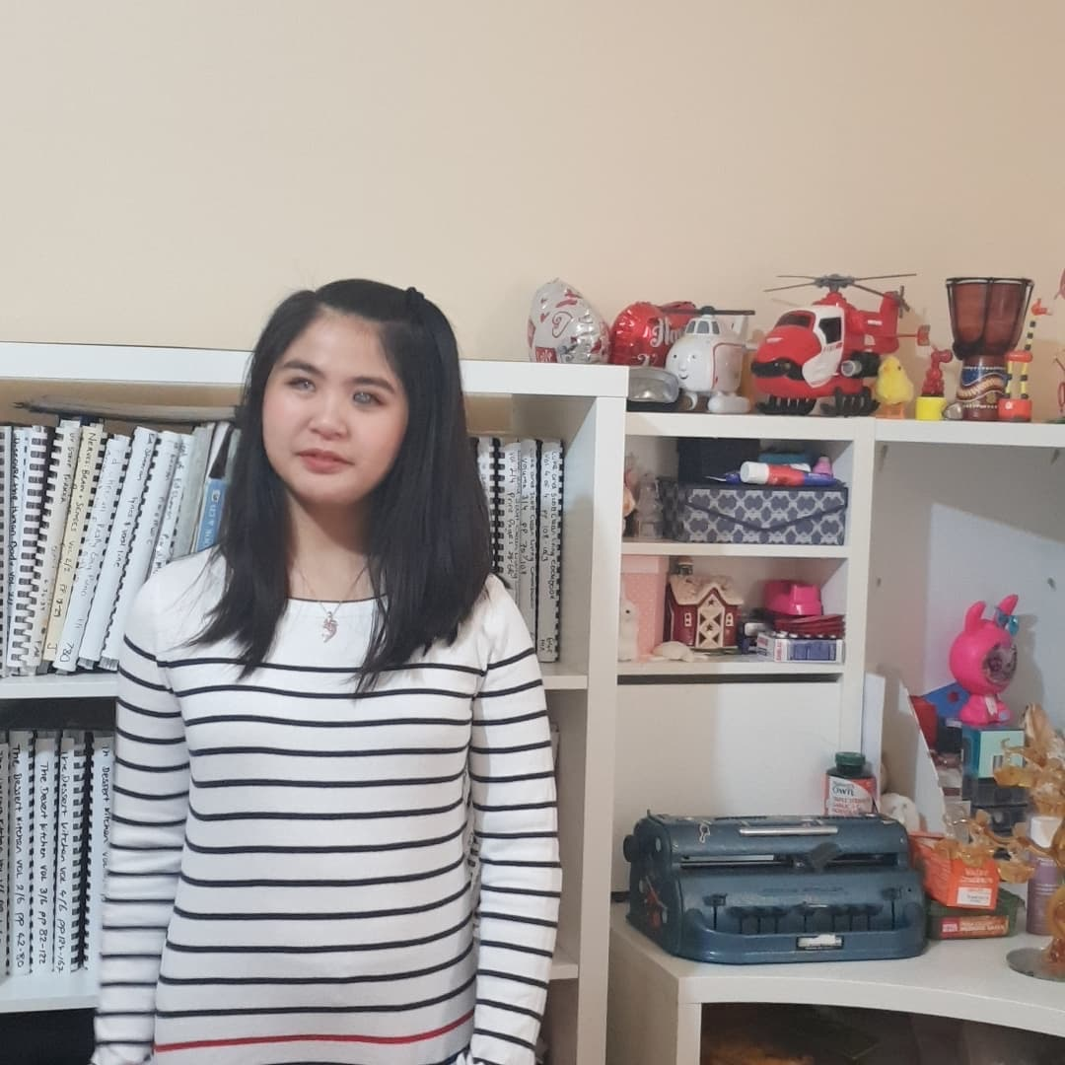

Name: Anna
Age: 14
1. What year are you currently doing at school?
I’m in Year 9 at Richmond High School.

2. Tell us what sort of fun things you can do when doing schoolwork at home?
Cooking projects.
3. Describe the most challenging thing about doing schoolwork from home?
Staying motivated!
4. What is your favourite book/movie/song?
Favourite song - Perfect by Ed Sheeran
Favourite book - The Road to Winter trilogy by Mark Smith
5. What makes you laugh?
Jokes.

6. Do you have any pets and if so what is their name, age and breed?
No.
7. What do you do to exercise while in isolation?
Stretching. My Physio is also a PE Teacher and shared a stretching program with me.
8. Tell us what sort of things you do apart from schoolwork when you are at home?
Music. Playing piano. I listen to a lot of audio books. Watching YouTube. Art - collages.
9. What is your greatest strength with your O&M?
Learning to navigate a newly built high school campus whilst completing my studies.

10. What advice can you give other vision impaired kids about their O&M?
It doesn’t happen all at once. Just be patient. Try not to get frustrated. Being blind you have to learn a lot of detail so it’s going to take longer than a sighted person. Patience is important.
Return to contents

Neighborhood walks: What can your child learn?
While we are currently confined to our homes, getting out for a daily walk with the kids for some fresh air and exercise can be a real highlight. A walk around the neighborhood can also provide some great learning opportunities for your child with blindness or low vision.
Here are a few activities you might choose to incorporate to develop your child’s skills:

Streetscape layout

Can your child identify the order of the features in a typical street layout? Do they recognise that not all streets are laid out the same?
Explore the order of the fence, footpath, nature strip, gutter and road, let them feel the different textures and describe the colours. Discover what is unique about your street. Does your street have a footpath?
Play a game where you call out a feature – for example “nature strip” - and the child has to rush to stand on the nature strip. This is best played on a quiet residential street for safety. You can practice calling out all different features, even “road”, advising your child they should stand on the gutter and point to the road, or touch the road with their cane.

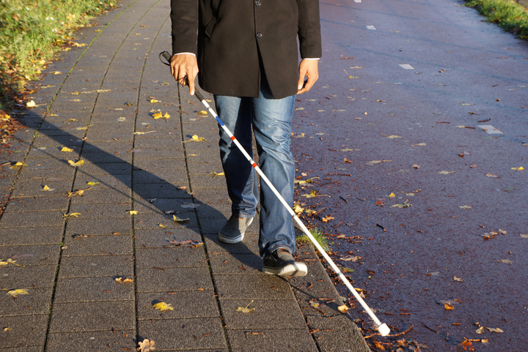

Fence materials
Fences come in all sorts of weird and wonderful materials and shapes these days. Can your child tell the difference between bricks and concrete? Wood and metal? Picket and chain link?
On your walk explore the different fences and talk about the characteristics. Is it smooth or rough? Cold or warm? High or low? What does it sound like when a metal ring is tapped on it? Is it solid or has holes to see through? How is it similar to your fence at home? How is it different?

House numbers

Does your child understand that each letterbox has a street number on it? That there is often an even and odd side of the street? That house numbers often go up or down in a pattern of two’s unless you live in a court?
During your walk, see if your child can trail along fence lines and locate a letter box with some verbal directions, for example a bit higher, a bit further to the left. Try to do this while holding your hands behind your back so you are not tempted to physically help.
If your child has some vision, do the same activity having them visually locate the letterbox and identify the street numbers. If your child cannot identify the number, let them know what it is before moving onto the next letter box or ask Siri on an iPhone “where am I” to get the address. Can your child start to predict what the number will be by the pattern? Is there anything that changes the pattern such as a park on one side of the street?
Happy walking!
Return to contents

Introducing Tween Talk!

Social skills are important for making friends, understanding social situations, getting assistance from others and even success as an adult in the workplace – and there’s no better time to learn and improve these social skills than during the “tween” years!
That’s why Guide Dogs Victoria has created Tween Talk – an online social skills program aimed specifically at “tween” aged participants (8-12 years old).
Tween Talk aims to improve:
- Socialisation
- Conversation skills.
- Confidence
- Body language
- Self-presentation skills
Tween Talk sessions will be held fortnightly during Term Three, after school hours . Sessions will last approximately one hour but please allow some time either side. Sessions will be held online, via the popular video platform, Zoom.
For further information including dates, fees and to register your interest, head to the Tween Talk event page on our website.
Return to contents

Introducing Microsoft Soundscape

Microsoft Soundscape is a free app (only available for iPhone) specifically designed to support people who are blind or have low vision to navigate their world with the assistance of 3D audio.

If you already have Soundscape, you’ll know that the app uses innovative audio-based technology to enable people with blindness or low vision to build a richer awareness of their surroundings, becoming more confident and empowered to get around. Its recent update includes a redesign of the sound of the beacon, making it easier to hear its direction when wearing your earphones or bone conduction headset, even in noisy environments such as the city.
Here is a simple activity that you can do to listen to the new beacon sound and learn how it works:
If you can, stand outside, and if you can’t stand near a window. Now we’re going to see how far away and in what direction particular places are from you. Let’s do it! On the main screen, select “Set Audio Beacon” and then in the search field type in your particular location. Your particular location could be a favourite place of yours, a famous landmark, or it could be a friends or family members house address. If it is going to be a friend or family member’s house, then you need to type in their address into the search field.
For Orientation and Mobility specialist Michael, he wanted to see how far and in what direction Luna Park is from his back door. To do this, he stood outside his back door, he set an audio beacon typing Luna Park into the search field, and as he typed, Soundscape started to display some suggestions. At the top of the list was Luna Park about 10 kilometres away. He selected it, and he could hear the Audio Beacon. Standing up, with the phone flat in his hand and with earphones on, he gently turned in a circle until the audio beacon sound changed, indicating that he was now facing Luna Park. Then he selected “My Location,” and it told him that he was facing “South West.” Luna Park is 10 kilometres southwest from his back door.
Happy exploring!
Want to learn more about Microsoft Soundscape and how it can support your orientation and mobility?
We are running sessions for primary and secondary school-aged students in July. For session times, fees and to register your interest, head to the Microsoft Soundscape event page on our website.
Return to contents

PAWGUST - register today!

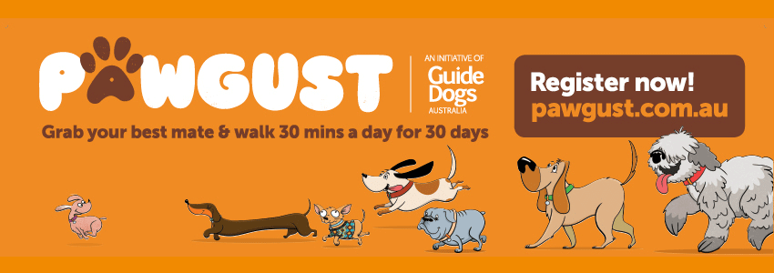

PAWGUST is a fun and challenging event that encourages people and their pooches to walk 30 minutes a day for 30 days during the month of August. That’s RUFFly 2km every day which is no small feat in the winter weather!
By sharing your journey, and asking family and friends for donations of supPAWt, you will be directly impacting the lives of Guide Dog puppies in training.
PAWGUST is the PAWfect excuse to get active and spend quality time with your dog all while supPAWting a great cause. Don’t have a dog? Don’t worry! You can still get involved in PAWGUST 2020 by doing your 30-minute walk on your own or with your human best mate! Find out more at the PAWGUST website.
Return to contents

Contact us
For all client client enquiries – CMS, O&M, OT or Guide Dog. call us on 1800 804 805. We will be able to make sure that your query gets through to the right person faster and is always followed up.
You can also contact us in writing:
Children’s Mobility Service
Private Bag 13, KEW, VIC, 3101
info@guidedogsvictoria.com.au
Or visit our website at:
www.guidedogsvictoria.com.au
Return to contents

Feedback
If you have anything to contribute to this newsletter, please feel free to contact us with your piece. We welcome all contributions. Please either contact or email our client services administration team with your contributions as below: info@guidedogsvictoria.com.au or Phone: 1800 804 805
Get About is now coming to you in a digital format. Going digital means our newsletter will be accessible, timely and environmentally friendly. The content of Get About has not changed: we will continue to let you know about our upcoming camps and group programs. Get About is also available on the Guide Dogs Victoria website.
Alternative formats are still available in audio CD, large print and braille. Please contact us at info@guidedogsvictoria.com.au or via phone 1800 804 805 to request these formats.
Return to contents

Tips for reading this newsletter

If you would like to increase the text size on your screen:

Using the keyboard
- Press ALT+W, and then press Q.
- Press the TAB key repeatedly until the Percent box is selected, and then type a percentage or press UP ARROW or DOWN ARROW to select a percentage.

Using the mouse
- On the View tab, in the Zoom group, click Zoom.
- Click the zoom setting that you want or type a percentage in the Percent box.
Return to contents

