‘Guide Dogs Victoria’s On the Move – April 2020 Bulletin

Tips for reading this newsletter

If you would like to increase the text size on your screen:
- Using the keyboard
    - Press ALT+W, and then press Q.
    - Press the TAB key repeatedly until the Percent box is selected, and then type a percentage or press UP ARROW or DOWN ARROW to select a percentage.
- Using the mouse
    - On the View tab, in the Zoom group, click Zoom.
    - Click the zoom setting that you want or type a percentage in the Percent box.

Contents
Tips for reading this newsletter 1
Editor’s update 2
Finding your ‘new normal’ 3
Blind Citizens Australia Happy Hour 6
Gear up your garden! 7
Join YAPPERS – our Young Adult Program – and connect with peers virtually 11
Have you tried a MiniGuide? 12
A word on weight from the Guide Dog Department 14
Lamps and light and why we need them 16
Share your story 19
Feedback 19

Editor’s update

Hi everyone, and welcome to the ‘new normal’ as we seem to be facing at least several months of living with the challenge of COVID-19.
Whilst there are many restrictions, this is an opportunity for us to try new experiences and hobbies at home, increase our tech literacy and maybe attend to the things we haven’t done so much of with the busy nature of day-to-day life.
In the GDV community we are seeing this time as an opportunity to stretch ourselves and prepare for the future. COVID-19 will pass. We are sure that in 6 -9 months we will all look back on this as a time of test, growth and challenge, and we will move on with our lives, having learnt new skills and with increased resilience.
This edition of On The Move is a little different to previous ones, not having events or programs listed. Instead, our practitioners have developed some articles and ideas we think might be of particular use at this time when we are all spending far more time at home. Do let us know if you have any ideas you would like to share.
We at GDV are here for you, we want to hear how you are going and what you need from us. Whilst we may not be running face to face programs we can still support you and are looking to learn with you about what works best. You can give us your input anytime through emailing info@guidedogsvictoria.com.au , or by joining our specially formed client reference group. This group will be invited to convene every couple of weeks by teleconference, to share their experiences and feedback on the current situation, throughout this period of COVID-19 restrictions. Please call 1800 804 805 if you would like to be part of this group.
Stay safe and well.
Leah McFazdean
General Manager Guide Dog and Vision Services
Return to contents

Finding your ‘new normal’

A key part in our everyday “normal” is the occupations and roles we have for ourselves, with our friends and family, and at work or in the community. For all of us, this ability to complete our regular activities has been turned on its head due to the COVID-19 pandemic. It is understandable to feel out-of-place, restless, lethargic and as if a normal day is a distant memory – however there are some ways to help you make a new “normal”.
- Make a conscious plan for your day – if you used to have a very scheduled day with work or other activities, it might be a long time since you have had to plan your day! It can be difficult and confronting, but being deliberate with your time can help stave off feelings of boredom and unease.
- Continue the routines that you can to preserve a sense of time and regularity.
  - Complete your morning routine - bathe, dress, complete chores or whatever your morning involves etc.
  - Get dressed and ready even if you are not going out.
  - Keep the parts of your day that you can and want to keep, like having your morning cup of tea or bedtime read.
- If you are feeling adventurous, you might take this as an opportunity to try a new way to use your day.
  - Have you always wanted to try being an early riser or a sleep in?
  - Give a new hobby a go.
  - Try a new recipe or a more involved one.
  - Give the garden the love it needs.
  - Do those chores you never get around to doing.
- Exercise - there are many online exercise groups or perhaps call a friend, crank up the volume and motivate each other through an exercise routine.
- Children will also need extra guidance during this time. School is a scheduled and directed bulk of the day, this structure disappearing in combination with routine changes and no play dates can result in some confused and worried little people. They will get the hang of it, but in this early stage, they may need extra routine and structure in their day to settle. You could try out the driveway rainbow challenge or a social-distance bear hunt.
- Stay connected – contact friends and family for a chat; play a game online together; start a book club; discuss things other than COVID-19; try something new.
It is a time of adjustment for us all; remember to reach out when you need help. If you are interested in adapting a task or improving your skills via telepractice, please request an Occupational Therapy referral on 1800 804 805.
Return to contents

Blind Citizens Australia Happy Hour

Blind Citizens Australia (BCA) have created ‘Happy Hours’ to keep Australians who are blind or vision impaired connected during this period of self-isolation. Happy Hours are daily catch ups, where you can join online or via phone, to share your thoughts around what’s going on, engage in informal conversations, participate in fun activities and share information to create positive social interactions. The sessions will evolve, particular with your feedback, to provide an opportunity to build further social groups and to keep everyone connected virtually. Please note that these session will not include professional advice, but rather an opportunity to share ideas.

Happy Hours will run from Monday – Friday (excluding public holidays) commencing from Monday 30th March on:
- Mondays, Wednesdays, Fridays between 11:00am – 12:00pm (AEDT)
- Tuesdays and Thursdays between 7:30pm – 8:30pm (AEDT)

There are three ways you can join the Happy Hour including:
- If you are on a computer, laptop or tablet you can click on this link: https://zoom.us/j/291084578
- If you are on a landline, you can dial 02 8015 6011 and enter the code: 291 084 578
- If you are on a smart phone, you can tap on this number: +61370182005,,291084578#

BCA encourages everyone to attend, as you do not need to be a BCA member to join Happy Hour.

Return to contents

Gear up your garden!
With the cancellation of the Melbourne International Flower and Garden show, Guide Dogs Victoria was unable to showcase the wonderful accessible garden creations designed and constructed with some of our Clients. Our wonderful Occupational Therapists and mobility Specialists were on hand to assist with the development of the projects.
Consideration was given to colour, smell, touch, placement of plants, the tools used, fun and of course the ease of ability to manage the garden beds over time. we also implemented QR codes, braille and beacons to assist with our gardens being accessible. this work has not been lost as the ideas will be utilised on campus as we develop our new permanent gardens.
If you are spending more time at home, why not challenge yourself to make your garden, whether on a balcony, courtyard or farm, more accessible? Here are some of our favourite ideas from the Occupational Therapists here at GDV.
- Labels - Create labels for your plants by laminating and sticking them on popsicle stick.
  - Individualise them based on your preference such as having white font on a black background; enlarged or bold text; Braille; or QR code.
- Texture and shape – Choose plants that have different shape or texture such as Lamb’s Ear or Red Fountain Grass.
- Contrast – Contrast various features of the garden with one another to make it easier to distinguish.
  - Consider how bright coloured flowers contrast with one another such as planting white flowers next to red flowers.
  - Use different coloured mulch or stones to the ground to contrast borders of the garden landscape. For example red tanbark against grey concrete flooring, or white stones against dark soil.
  - Use vibrant, contrasting colours to paint garden ornaments such as pot plants and bird houses. These can be used to identify important areas in the garden (e.g. vegetable patch) or as landmarks to maintain orientation. Ornaments may also be placed in areas as a reminder that there is a safety hazard nearby (drop offs or stairs).
  - If you have a garden bed you can paint the outside a colour you find the easiest to see, such as red, to highlight where it is.
- Smell – Try some plants with strong aromas such as a Curry plant or Lavender.
- Tactile markers – Put tactile marks on your garden tools to make it easier to identify without having to touch the dirty or sharp end. An example is using fabric paint on the handles to write the letter S for a spade or letter F for a fork. Use an elastic band on similar products like lawn seed and bird seed to differentiate the two.
- Sound - Introduce a wind chime to assist in identifying a particular location in your garden.

If you are interested in developing your gardening skills over the coming months, whether you are a novice or expert, our Occupational Therapists can help you. Get in touch through 1800 804 805!

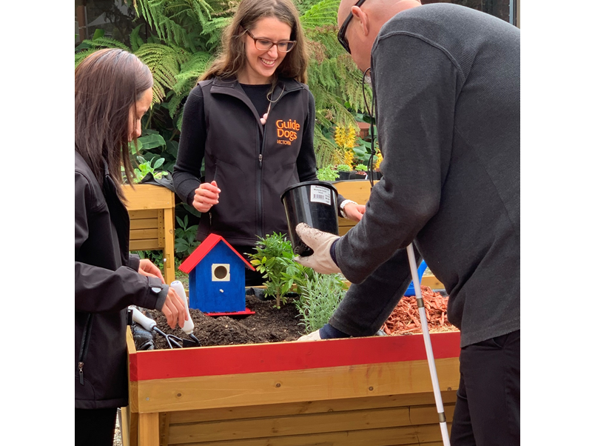
Image description – GDV Occupational Therapists Danette (left) and Alyce (middle) work with Support Coordinator Russell (right) who has low vision, to create a sensory herb garden. A brightly coloured birdhouse and red edge to the garden bed create contrast.

Return to contents

Join YAPPERS – our Young Adult Program – and connect with peers virtually

At Guide Dogs, we host a Young Adults Program called YAP, where we affectionately refer to participants as Yappers!
Meetings take place on the first Thursday of every second month. Our sessions will always include a topic, like Mental Wellbeing or Professionalism, or a fun activity like going to the theatre. YAP is a fun, safe space for people who are blind or have low vision, aged between 18 and 35, to connect, share ideas, learn from one another and build confidence.
During this period of social distancing, YAP is changing the way we meet. Our Coordinators, Amy and Luke, are busy thinking outside the box to plan ways for our Yappers to keep connected. We’re hoping to create some online catch-ups and will keep Yappers updated on our progress via email.
We’re ploughing ahead planning our next session, scheduled for the 4th of June, which is focused on Mental Health. We’re making plans to host this interactive session online and are currently chatting with a few different organisations to see how they can help us.
If you would like more information about YAP, or want to make sure you’re on our YAP mailing list, please email Customer Service on info@guidedogsvictoria.com.au or call 1800 804 805. We look forward to hearing from you!
Return to contents

Have you tried a MiniGuide?

Amongst all of the new technology used to support Orientation and Mobility (O&M), the Miniguide has stood the test of time and remains a useful secondary aid to assist individuals who are blind or have low vision.
The Miniguide is a hand held electronic device that vibrates to detect objects in the environment. It is an aid that can be used with a primary mobility aid, such as a Long Cane or Guide Dog. There are many comparable products on the market that all provide similar function however at GDV our O&M Specialists recommend the reliability and overall function of the Miniguide. The Miniguide emits an ultrasonic beam that bounces off an object reflecting back into the device causing it to vibrate in the user’s hand. If an object is located, the Miniguide vibrates and increases vibration intensity the closer the object is. If there is no object, the Miniguide does not emit a vibration. The Miniguide can be set to different meter ranges depending on the environment. This device can be used both indoors and outdoors.
It's an ideal tool to use to scan the environment around you to keep 1.5-2m away from other people, as in the current social distancing guidelines.
Other examples of using the Miniguide includes:
- A Long Cane user walking down a neighbourhood footpath where cars frequently park across the footpath. To avoid hitting the car with your cane detect the car prior with use of the Miniguide.
- Detection and avoidance of overhanging branches along your daily walking route.
- Determining when lift doors are about to open when you are waiting.
- Knowing when the queue in front of you at the supermarket is progressing.
- A Guide Dog user finds the Miniguide useful for being more aware of the location of obstacles the dog manoeuvers pass.
- A person working in a familiar office may choose to use the Miniguide for reaching the kitchen by locating doorways and gaps along an office corridor.
Our O&M Specialists are qualified to recommend and provide training to use the Miniguide to ensure safe and effective use. If you are interested in exploring whether a Miniguide is right for you then please call 1800 804 805.
Return to contents

A word on weight from the Guide Dog Department

During this period you and your Guide Dog may not be as active as usual, and extra attention does need to be paid to maintaining your Guide Dog’s weight.

A hefty subject we know, in more ways than one, and we understand that in these times of restricted travel it may be a challenge to maintain your dog’s ideal weight.

If you do notice that your dog is gaining weight, by sight or feel, or that the harness is becoming tighter when you put it on your dog, it is time to consider reducing the amount of food that you are giving your dog.

The first thing to reduce/remove would be any extra treats that your dog may be receiving. However small, these will contribute to your dog’s daily intake and add to the issue of weight gain.

Following this if you continue to find it difficult to maintain your dog’s ideal weight, then a reduction of ¼ cup food per day would be an ideal start. If this does not help then contact with your GDMI, as they will know your dog and how much of a recommended reduction would be appropriate.

As with all health matters, consultation with your vet is always a recommended option. Ring ahead first.

Everyone here at GDV continue to be positioned to support all our handlers and working Guide Dogs through remote means and hope that everyone remains safe and healthy!

Return to contents

Lamps and light and why we need them

Ever wondered why it is harder to see if you don’t have good lighting? Ever find that you can read better outside on a nice sunny day or next to a big, well-lit window?
Well it’s all because the back layer of our eyes called the retina contains tiny cells that can only fire off information to our brains about what we are looking at if what we are looking at is well lit. This is especially important if we are reading or need to look very closely at something to see anything small or detailed.
Try shining a light on a book or object and see what it looks like and then turn the light off and see the effect and whether you are able to see it as well.
It would be ideal to be able to access natural light by sitting side on to a large window or sitting on a balcony or in a garden, however that is not always possible – certainly as daylight savings draws to an end and as we are encouraged to self-isolate and stay indoors.
Task lighting can help with reading, craft and all sorts of activities. What is a task light? Well, it is basically a lamp with a good globe that has been well positioned so that what you are looking at is not only well lit but also isn’t glary. A lamp on a bendy arm is ideal so it can be correctly positioned so that:
- It is between your eyes and what you are reading or looking at. If it is too far away it may not be bright enough.
- It is directed straight at what you are looking at.
- It is angled so you don’t get the light from the globe shining directly into your eyes.

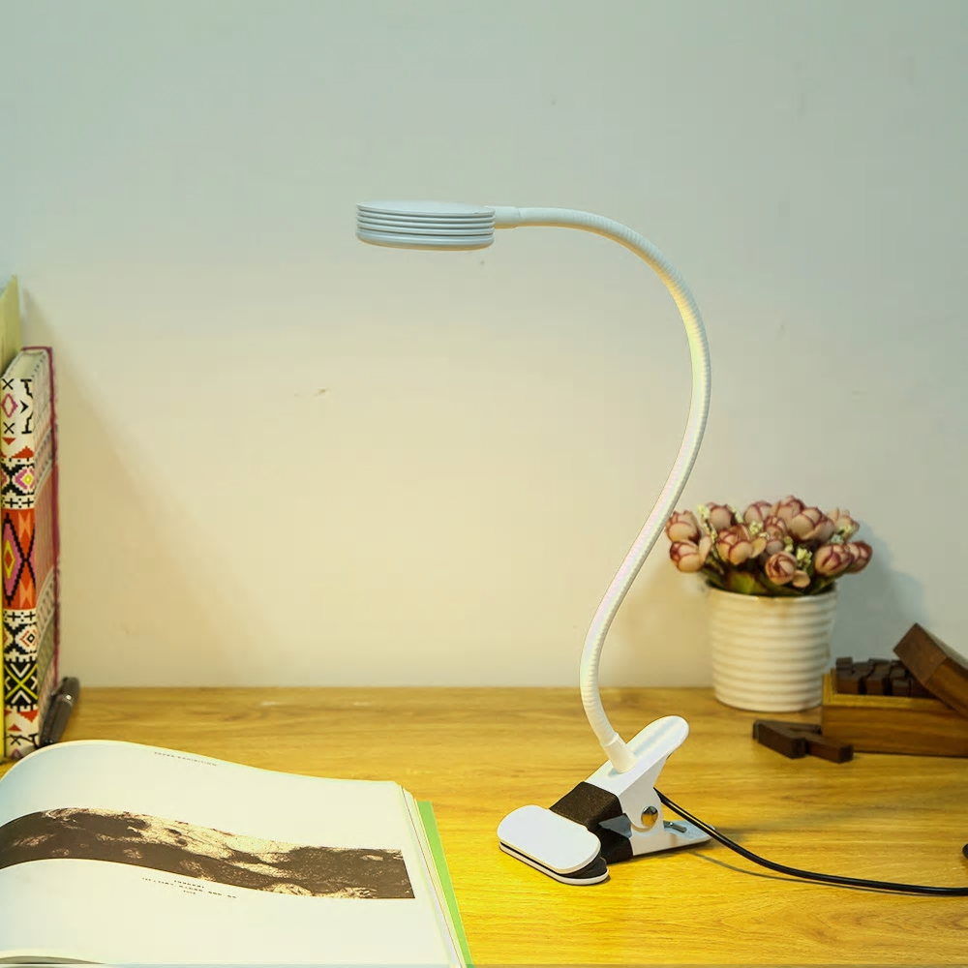
Image description: clip on LED light that can be angled in any direction, on a desk illuminating a book.

Are lamps and light globes all the same? No, they aren’t. Some people with low vision like a lot of light and some only a small amount. Some people like a very crisp white light whilst others prefer a warm yellowish light, it is down to personal preference and trial and error.
If you are unsure about task lighting feel free to call your GDV Orthoptists to chat through some suggestions what might be the right light for you.

Return to contents

Share your story

If you have a story you’d like to share about your low vision or blindness, your achievements, your experiences with our services or being matched with your Guide Dog, we’d love to hear from you. The marketing team are always on the lookout to feature our client’s stories in the media, to help spread the word about the wonderful work of Guide Dogs Victoria and to increase public awareness about people living with low vision or blindness. If you are comfortable with sharing your story, please email us at info@guidedogsvictoria.com.au to get in touch.

Return to contents

Feedback

If you have anything to contribute to this newsletter, please feel free to contact us with your piece. We welcome all contributions.

Please either contact or email our client services administration team with your contributions as below:
info@guidedogsvictoria.com.au or phone 1800 804 805.

Return to contents

