Guide Dogs Victoria’s GetAbout – Term 1 2020

Tips for reading this newsletter

If you would like to increase the text size on your screen:
- Using the keyboard
    - Press ALT+W, and then press Q.
    - Press the TAB key repeatedly until the Percent box is selected, and then type a percentage or press UP ARROW or DOWN ARROW to select a percentage.
- Using the mouse
    - On the View tab, in the Zoom group, click Zoom.
    - Click the zoom setting that you want or type a percentage in the Percent box.

Contents
Tips for reading this newsletter 1
Ed’s Note 2
CMS Group Programs 2020 Overview 3
Melbourne CBD – CMS Secondary Camp Program 30 March – 2 April 2020 5
Back to School Tips 7
Tips for Making Your Own Breakfast 11
Blind Sports and Recreation Program 13
Tech time with Michael 15
South Pacific Educators in Vision Impairment 2020 16
CMS Personnel Changes 2020 17
Contact us: Client Service Update Reminder – 1800 804 805 for all enquiries 19
Feedback 20

Return to contents

Ed’s Note

The CMS team welcomes all our readers to this first newsletter of 2020. We have had an exciting and busy start to the year, with many of our students having their first day at childcare, kindergarten, primary school, secondary school and university.

This edition is jam packed with interesting articles and helpful tips to assist you in your everyday life. You will find information on making the transition to school a smooth one, preparing breakfast and a tech update from Michael. You will also see our list of planned CMS camps and group programs for 2020 with NDIS cost estimates. We have had some staff changes we want to update you on too.

We would love to publish some articles from student and parent contributors, we can all learn so much from each other. It could be as simple as a handy tip you have found works really well or an experience you are happy to share, please email me at alicias@guidedogsvictoria.com.au
Get OUT and ABOUT and enjoy sunshine!

Alicia San Martin
Editor GetAbout
By the way, don’t forget to look at our website: www.guidedogsvictoria.com.au
Return to contents

CMS Group Programs 2020 Overview

The Children’s Mobility Service is excited to offer a range of camps and group programs during 2020. Our group programs aim to offer Orientation and Mobility and Occupational Therapy training in a dynamic setting. Students have the opportunity to develop independent skills considerate of their age and current personal goals. A group program also provides children with vision loss and their families’ social engagement with their peers. Please note that due to the redevelopment of our Kew campus, all group programs will be held offsite in suitable community based accommodation during 2020.

Places are limited on all camps. We prioritise attendance based on:

- Previous attendance on camp
- Skill development opportunity for the individual student
- Specific referral from the students Orientation and Mobility Specialist
- Alignment with individual goals
- Completion of all relevant application material
We encourage families to consider camp opportunities when building their NDIS plan. GDV is an approved provider of services under NDIS and NDIS recognizes the benefits the camps have on students achieving their goals. The camps are also made possible due to the support of the Shine On Foundation.

April Secondary Camp 4 Day Program – Based in the Melbourne CBD
30th March- 2nd April 2020. A four-day camp for secondary school students with low vision or blindness. Details of this camp appear below. Please contact the customer service team ASAP to request an application pack.
Estimated NDIS cost: $1709

July Primary Camp 3 day program- “Mobility Olympics” based in the Melbourne CBD
29th June-1st July - Three day camp for primary school students with low vision or blindness based at City CYC. Participants will travel to a range of Olympic themed activities with an emphasis on public transport, problem solving, self-advocacy and decision making.
Estimated NDIS cost: $1250

September Secondary Camp 4 Day Program – Based in the Mornington Peninsula
21st – 24th September 2020. A four-day camp for secondary school students with low vision or blindness with an emphasis on public transport, problem solving, self-advocacy and decision making. Participants will have the opportunity to plan and participate in a range of activities within the Mornington Peninsula.
Estimated NDIS cost: $1809
**Further day group programs may be announced during the year and details will be emailed to your inbox**
Our group program schedule will also be available on our website
https://www.guidedogsvictoria.com.au/events/?group_program=all
If you would like to discuss any aspects of our planned camp program or would like an NDIS camp quote specific to your child, please contact our customer service team on 1800 804 805. Detailed camp information for each of these programs will be emailed direct to your inbox closer to the date.

Return to contents

Melbourne CBD – CMS Secondary Camp Program 30 March – 2 April 2020

Building independence is a vital part of growing up. Learning and socialising with other students who have a vision impairment provides a range of positive benefits. On this secondary camp program based in the Melbourne CBD, students will have the opportunity to participate in a range of fun activities that will build their experience and skills to increase their ability to travel and complete activities of daily living more independently. To attend this program, students must be of secondary school age.

This program will look at the following mobility skills:
- Using technology to plan travel
- Public transport use
- Road crossings strategies when travelling in residential and central business districts
- Thinking and problem solving skills when travelling in new and challenging environments
- Managing personal safety in new and dynamic environments

This program would be most appropriate for students who have some experience in travelling on public transport and have the ability to use technology to access information to assist with planning travel. Students will be asked to research activities, travel and dining options throughout the program.

Staffing:
Orientation & Mobility Specialists from CMS will staff this program. An Occupational Therapist will also be available at certain times throughout the program.

Costs:
This program has been made possible due to the contributions of the Shine On Foundation.
- NDIS - For students with an NDIS plan the estimated cost is $1709. NDIS funding covers the service delivery of O&M and OT skills during the program and does not cover meals, accommodation or overnight costs.
- The program will be delivered at no direct cost to our client. Where possible we will access fee for service funding (NDIS) to support the program and Guide Dogs Victoria will cover all additional costs.
- Students will require a travel pass or Myki card with $40 credit for travel during the program.

Feedback:
A brief report will be provided to families regarding the program outcomes and student achievement. Families will also be invited to provide feedback via an anonymous survey.

Further Information:
This four day program will begin Monday 30th March at 9.30am and conclude on Thursday 2nd of April at 3.00 pm and is based in the Melbourne CBD. Accommodation will be apartment style, further information will be provided in the application pack. If we have more applications than places available on the closing date, a selection process of applicants will take place. This selection process will take into consideration the number of programs previously attended and the appropriateness of this program to the student’s age and O&M goals.

For an application package please contact Customer Service ASAP on 1800 804 805

*** To be considered for this mobility program, completed application packages (all paperwork, including medical forms) must be returned by Monday 2nd March 2020 ***

Return to contents

Back to School Tips
By Kristie Price
Starting at a new school, being in a new year level or having your classroom in a different area of the school are all significant, exciting changes that can be supported by the right training and preparation. Guide Dogs Victoria provides school orientation programs as well as classroom workshops to assist with this transition.
School orientation programs
The purpose of a school orientation program is to provide enough orientation and mobility sessions to enable your child to be able to safely and independently locate required areas of their school. This program may include:
- Large print or tactile maps with braille labels to identify travel routes and layouts.
- Orientation to classrooms and common areas.
- Exploring the layout of a classroom.
- Landmarks, clues and safety hazards identified.
- Discussions about how to explain your vision to other students and building up confidence of how to ask for assistance and how to turn down assistance.
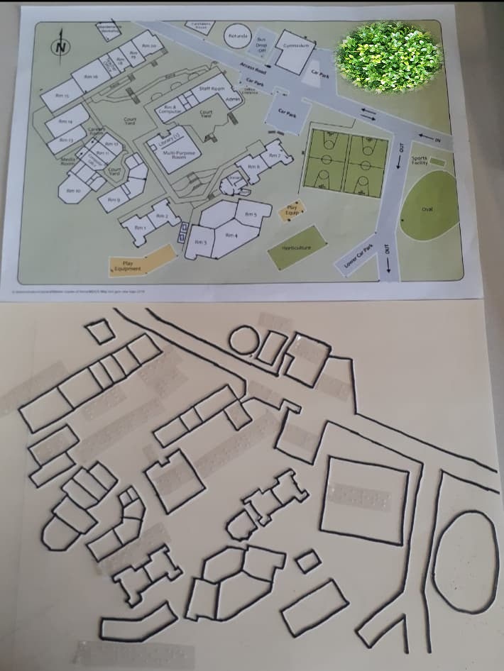
Image: An enlarged map and a tactile braille school map.
Workshops
Whether it’s a new school, new grade or even new teachers, there is much to learn from a workshop session! Guide Dogs Victoria provides classroom workshops for students and professional development sessions for teachers. The content is dependent on the audience age and involves:
- General information about vision loss and blindness causes and impacts.
- What is an orientation and mobility specialist?
- Tips on daily interaction and providing human guide.
- An experience under blindfold or using vision simulation glasses.
Useful tip: Some children enjoy making an ‘about me’ booklet about themselves and their vision impairment, explaining in their own words and experiences. This can be shared in one of these sessions.
Environmental assessment
Has your child’s new school had an environmental assessment? Guide Dogs Victoria provides environmental assessments to schools to make the environment accessible and safe for students with a vision impairment. This includes advice and recommendations on:
- Walkways
- Stairs
- Poles
- Pedestal and head height obstacles
- Uneven ground surfaces
- Doorways
- Signage
- Glare and lighting

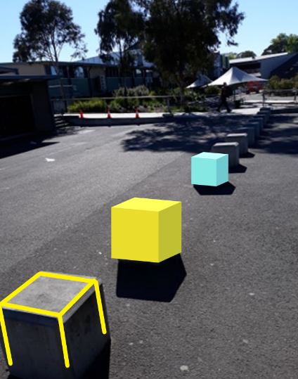
Image: Pedestal object in walkway.
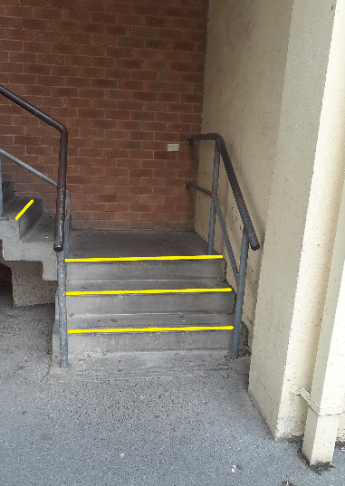
Image: Stairs.
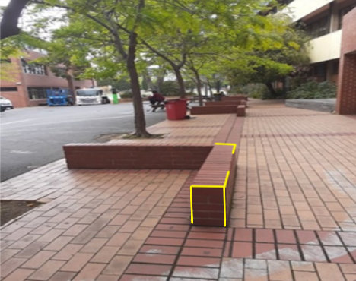
Image: Pedestal object in walkway.

Return to contents

Tips for Making Your Own Breakfast
By Alyce Woodruff, OT
If your children are not currently preparing their own breakfast, weekends are a great time to get them practicing this skill:
- Does your child know where the cereal/milk/bread etc is kept in the kitchen? Teach them where their food is located as well as crockery and cutlery. If they can locate these items themselves that is a great first step!
Does your child have trouble pouring cereal into their bowl? Putting your cereal into a container with a pouring lid (see image below), or giving your child a measuring cup to use (such as half cup) can help make this easier. Similarly keeping some milk in a smaller jug can be helpful if your child struggles to hold up a 2 or 3 L bottle of milk. Alternatively you can also buy single service bottles of long life milk (see image below). 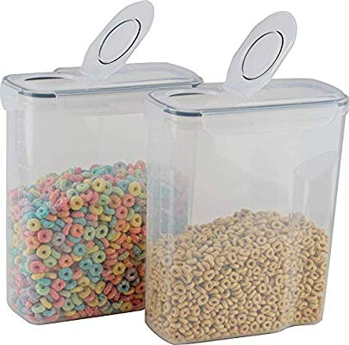
Image: Pouring cereal containers
Image: Devondale single serve long life milk

- Encourage your child to carry their toast, drink or cereal bowl to the table. You may need to give them hand over hand assistance to show them how to put their hand under the bowl or plate to carry it rather than holding the rim.
- A placemat on the table can help your child know how much space they have at the table. A singular bold colour is better than a patterned place mat as the contrast will be better.
- Lastly does your child know where dirty dishes go? Do they know where the dishwasher or sink is? Do they know how to stack their dishes in the dishwasher?
If you need help with any of these areas you can make an OT referral by calling our 1800 804 805 phone number.

Return to contents

Blind Sports and Recreation Program
Hi everyone,
Blind Sports and Recreation Victoria Active Teens program needs your help!
In January and February 2020 we will be running a NATIONAL online survey to better understand the needs of families and teenagers to engage with meaningful sport and recreation opportunities.
Please fill out the survey and go into the draw to win 1 of 10 gift vouchers worth $80!
We are looking for parents of teenagers 12 to 17 years of age who are blind or have low vision, to undertake the survey which should take 10 to 15 minutes of your time.
To register your interest, email:
activeteens@blindsports.org.au<mailto:activeteens@blindsports.org.au>
Teenagers do not need to have any previous experience participating in any blind or low vision sports for families to be engaged in the research, and families can live anywhere in Australia.
Please share this email and the attached flyer with any families who might be interested, and through your networks.
Regards,
Allie Douglas
Project Coordinator - Teens Program

Return to contents

Tech time with Michael
By Michael Evans
These articles aim to provide information on technology that can be used to support our clients with their Orientation and Mobility (O&M).
Introducing Bose Frames. Bose Frames are sunglasses with built-in speakers pointed towards your ear, keeping your ears free to hear environmental sounds. But they are much more than that; they are also an audio augmented reality headset.
What’s cool about this is that in terms of O&M, when connected with Microsoft Soundscape, sensors in the Bose Frames tell Soundscape the direction you are facing. This means that you don’t have to hold your phone for Soundscape to work effectively, allowing you to have a more hand’s free experience.
Bose Frames can do more. There are several compatible AR apps available that offer the user different types of AR experiences, including games and immersive stories.
If you would like to know more, please feel free to contact me.
Happy exploring.

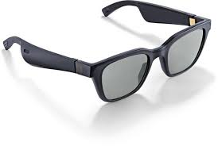
Image of Bose Frames Alto style

Return to contents

South Pacific Educators in Vision Impairment 2020

By Danielle
Claire, Michael and myself had the opportunity to attend the SPEVI (South Pacific Educators in Vision Impairment) conference in Adelaide in January. The conference theme was “creating a clear vision for the future” and was attended by representatives from around Australia, New Zealand, Fiji and the UK. Clare presented on her success with using haptics (touch) to communicate with students during O&M sessions, Michael presented on all the cool gadgets and apps that he is using with students and also supported Lil Deverell with her presentation on measuring outcomes of O&M, while I presented on the use of 3D maps to learn new environments.
It was great to see not only teachers, O&M’s and OT’s at the conference, but also parents of children who have a vision impairment, older students and even a representative of the NDIS. The take home message that I got from the conference was “Access to learn, learn to access”. In a nutshell, this means that our students need access to appropriate resources (braille, specialist teachers, training, technology etc.) to support their learning, but what is just as important is that our students are given the skills so that they can learn to access their world independently (accessing new environments, education, work or social activities).
If you are not aware of what the term “self advocacy” means, google it, and then expect to see it become an increasingly important part of your child’s future. Conferences like these provide not only invaluable professional development and learning opportunities but also the chance to network, socialise and be inspired.

Return to contents

CMS Personnel Changes 2020

2020 is finally here and brings a change of season with our team members in the Children’s Mobility Service.
As some of you may know, Simon McDonald-Kerr is moving into a new role as Regional Team Leader based in Geelong.
Simon has been Team Leader of CMS for the past two and a half years and a part of the team for ten years. Simon has been an invaluable asset to the team and wider organisation; he has led the team with dedication and passion and been a key driver of many positive changes and growth during his time. Although he is still with us in a different capacity, he will certainly be missed in the CMS leadership space.
Joining us late last year in CMS was Rachel Henningham, returning from parental leave. Rachel will be stepping into the position of Team Leader of the Children’s Mobility Service. Rachel joins us from the Adult/Acquired Brain Injury Mobility Service where she has worked as an O&M Specialist for the past seven years. She may already be familiar to many of you from her attendance at CMS camps and is very enthusiastic about becoming a permanent fixture of this team that she loves so much.
Marnie Roth will also be moving into a new role as Support Services Team Leader where she will lead our team of Occupational Therapists, Orthoptists and Assistive Technology Specialists, as well as steering the introduction of our Early Childhood Service. Both Marnie and Simon will still be involved in delivering O&M programs, though in a reduced capacity. We wish them all the very best in their exciting new roles.
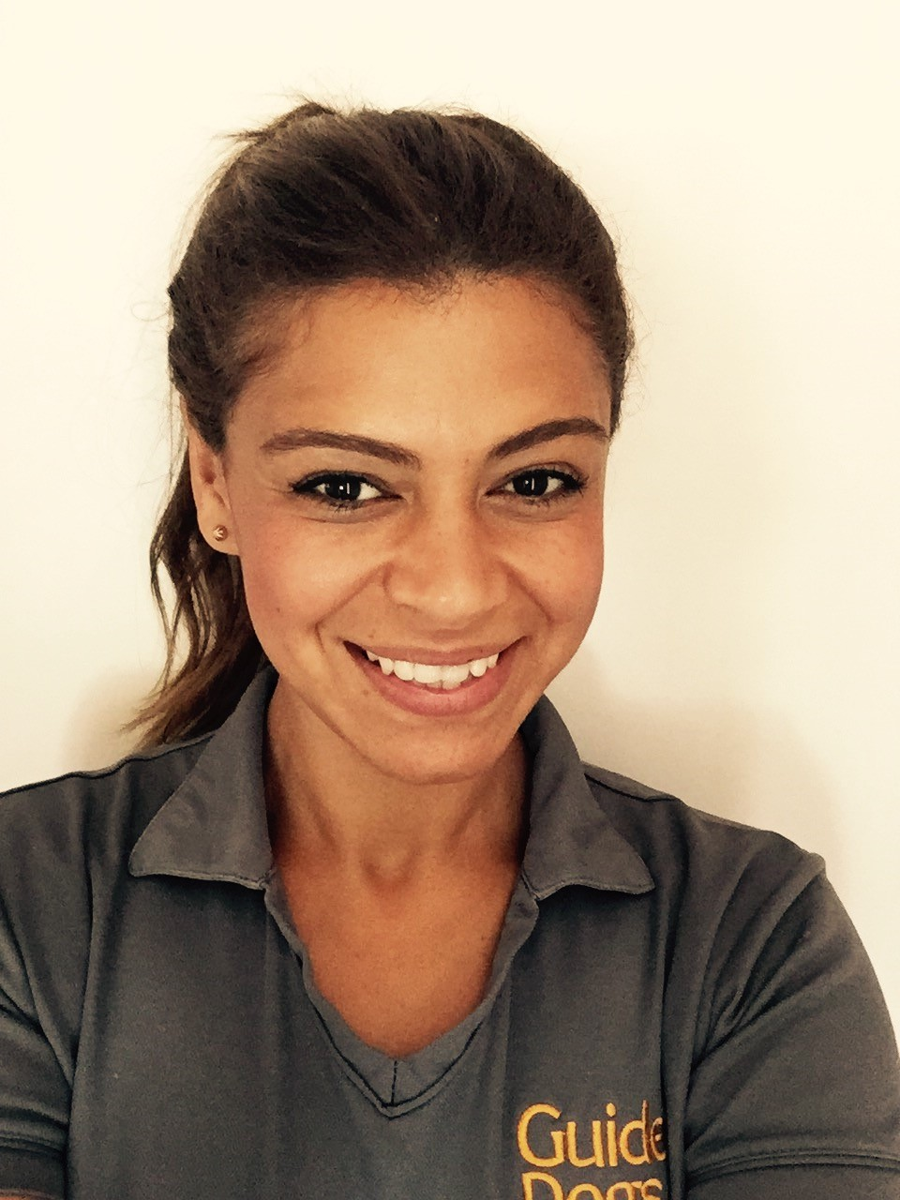
Image: Rachel Henningham

Return to contents

Contact us: Client Service Update Reminder – 1800 804 805 for all enquiries

From now on, this one number – 1800 804 805 – should be used for ALL client enquiries – CMS, O&M, OT or Guide Dog. We will be able to make sure that your query gets through to the right person faster and is always followed up.

You can also contact us in writing:
Children’s Mobility Service
Private Bag 13, KEW, VIC, 3101
info@guidedogsvictoria.com.au

Or visit our website at:
www.guidedogsvictoria.com.au

Return to contents

Feedback
If you have anything to contribute to this newsletter, please feel free to contact us with your piece. We welcome all contributions. Please either contact or email our client services administration team with your contributions as below: info@guidedogsvictoria.com.au or Phone: 1800 804 805
GetAbout is now coming to you in a digital format. Going digital means our newsletter will be accessible, timely and environmentally friendly. The content of GetAbout has not changed: we will continue to let you know about our upcoming camps and group programs. GetAbout is also available on our website www.guidedogsvictoria.com.au
Alternative formats are still available in audio CD, large print and braille. Please contact us at info@guidedogsvictoria.com.au or via phone 1800 804 805 to request these formats.
Return to contents

