Guide Dogs Victoria’s GetAbout – Term 2 2019

Tips for reading this newsletter

If you would like to increase the text size on your screen:
- Using the keyboard
    - Press ALT+W, and then press Q
    - Press the TAB key repeatedly until the Percent box is selected, and then type a percentage or press UP ARROW or DOWN ARROW to select a percentage
- Using the mouse
    - On the View tab, in the Zoom group, click Zoom
    - Click the zoom setting that you want or type a percentage in the Percent box

Contents
Tips for reading this newsletter 1
Note from the Editor 2
GDV Update 4
CMS Camps and Group Programs 2019 4
Ballarat Senior Camp 9
Tech Time with Michael 12
Family Corner: Upper limb strengthening activities for children with blindness and low vision 14
Interview with Andrew White (Assistive Technology Coordinator) 16
Contrast Sensitivity 19
New Staff Members 21
Australian Vision Impairment Registry 24
Contact us: 25
Feedback 25

Return to contents

Note from the Editor

Dear CMSers,
First Term has flown by with so many exciting events taking place. Of huge excitement for the CMS team is the securing of the final funds to get started on our GDV Kew Campus redevelopment.
While Arnold Cook House built in 1972 has been a wonderful venue for 19 years of CMS Camps, it is in need of replacement, and what a replacement it will be!
Guide Dogs Victoria will establish the world’s first ‘sensory campus’ – a specially-designed facility that will use lighting, scent, human-enabled technology, braille and a range of tactile features to create an inclusive and inspiring learning environment for people with low vision or blindness. For some artists impressions and more information visit: https://www.guidedogsvictoria.com.au/get-involved/campus-redevelopment-campaign/
In this edition of “GetAbout” learn about our Ballarat Senior Camp program held in the April school holidays and our upcoming group programs July Junior Camp program and also Family Camp being held in the September school holidays.
We also have lots of great articles about technology, building upper limb strength, the importance of good contrast and we introduce staff members Emma, Cherie and Jacinta.
We would love to publish some articles from student and parent contributors, so we can all learn from each other. It could be as simple as a handy tip you have found that works really well or an experience you are happy to share, please email me at alicias@guidedogsvictoria.com.au
It's been an unusually warm Autumn, but the winter winds are not far away so GetAbout and enjoy walking through and playing with all those crunchy autumn leaves.
Alicia San Martin
Get About Editor
Don’t forget to look at our website: www.guidedogsvictoria.com.au

Return to contents

GDV Update

Same great staff and services, new name! Our Client and Guide Dog Services department will now be known as ‘Guide Dog and Vision Services’.
Whilst we all LOVE our dogs, only 30% of our Clients use Guide Dogs. As you know, we provide a range of services and programs and the new department name has been selected to represent that.

Upcoming CMS Camps and Group Programs

‘Trains, Planes & Automobiles’
Primary Aged Camp Program
1 July – 3 July, 2019
The aim of this program is to develop knowledge of different forms of transportation including motor vehicles, public transport and even aeroplanes. Participants have the opportunity to explore different types of vehicles, learn about road rules, safe crossing procedures, and being a safe pedestrian.
This program will look at the following skills to increase independence:
• Technical skills and strategies – travel (O&M) and daily living tasks (Occupational Therapy)
• Public transport travel
• Conceptual understanding of different vehicles and forms of transport
• Road safety
• Assessing risk
• Decision making about personal safety
• Problem solving
• Safely negotiating complex situations and environments
Staffing
Orientation & Mobility Specialists from CMS will staff this program. Occupational Therapists will be present for some of the program.
Costs
This program has been made possible due to the contributions of the Shine On Foundation.
• NDIS - For students with an NDIS plan the estimated cost is $1,000. NDIS funding covers the service delivery of O&M and OT skills during the program and does not cover meals, accommodation or overnight costs.
• The program will be delivered at no direct cost to our client. Where possible we will access fee for service funding (NDIS) to support the program and Guide Dogs Victoria will cover all additional costs.
• Students will require a travel pass or Myki card with $15 credit for travel during the program.
Feedback:
A brief report will be provided to families regarding the program outcomes and student achievement. Families will also be invited to provide feedback via an anonymous survey.
Further Information:
This three-day program will begin Monday 1 July, 2019 at 10am and conclude on Wednesday 3 July at 2pm and is based on site at Guide Dogs Victoria in Kew. If we have more applications than places available on the closing date, 12 students will be selected. This selection process will take into consideration the number of programs previously attended and the appropriateness of this program to the student’s age and O&M goals.
For an application package please contact Customer Service ASAP on 1800 804 805
*** To be considered for this mobility program, completed application packages (all paperwork, including medical forms) must be received by Friday 7th June 2019 ***
Family Camp
Monday 30th September – Tuesday 2nd of October
Where: CYC City Venue (Melbourne CBD) https://city.cyc.org.au/accommodation/
Family Camp is:
- An opportunity for families who have a child with low vision or blindness to come together to form networks with other families
- To learn more about how to encourage age appropriate, independent mobility
- To explore a range of aids, apps and devices that can assist with independent mobility
- To hear from and meet other professionals who can support/provide training for your family
- To participate in fun activities as a family that develop or further enhances everyone’s mobility skills
Possible activities
- Ice breaker/bonding/get to know you games
- Mindfulness/listening/relaxation
- Botanical Gardens Children’s Garden Activity
- Melbourne Museum – organised activity
- Public Transport – explore a stationary train/tram/bus
- Technology challenge/Amazing race
- Kids audio described movie night – Parent supports discussion
- Orthoptist/Assistive Technology/OT/Service Coordinator display-workshop-presentation
Cost: This program has been made possible due to the contributions of the Shine On Foundation.
- NDIS - For students with an NDIS plan the estimated cost is still being determined. NDIS funding covers the service delivery of O&M and OT skills during the program and does not cover meals, accommodation or overnight costs.
- The program will be delivered at no direct cost to our client. Where possible we will access fee for service funding (NDIS) to support the program and Guide Dogs Victoria will cover all additional costs.

To register your interest for this program, please contact our customer service team on 1800 804 805 or csadmin@guidedogsvictoria.com.au

Return to contents

Ballarat Senior Camp

April 8 – 11

Ever wondered what it would be like to live in a share house or go traveling with a group of friends? Twelve teenagers had a chance to get a hint of that experience in the April school holidays when they attended the Ballarat Senior Camp. The first challenge for many was getting to the meeting place at Southern Cross on time – competing with buses replacing trains and protests in the city blocking roads, as well as many hours of travel from their homes. With everyone safely on board the Ballarat train there was plenty of time for everyone to get to know each other.

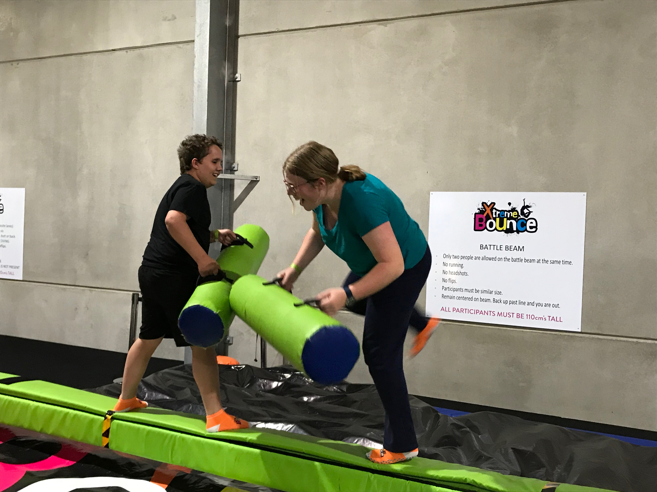

[IMAGE DESCRIPTION: Tyson and Jessica at the trampoline park in Ballarat]

Staying in serviced apartments means self-catering, and the first group challenge was to agree on what to buy to make breakfasts. Shopping for food completed, it was time to find out what activities Ballarat has to offer and for the students to come to an agreement on what they wanted to do each day.

Researching, negotiating, planning, booking and budgeting all had to be considered. Students were responsible for all aspects of their day – from setting alarms to wake up, making breakfast and cleaning up, packing what they needed for the day and ensuring they kept to the groups timetable. Traveling with a group offers many challenges and the students developed skills in managing their own safety while keeping together as a group.

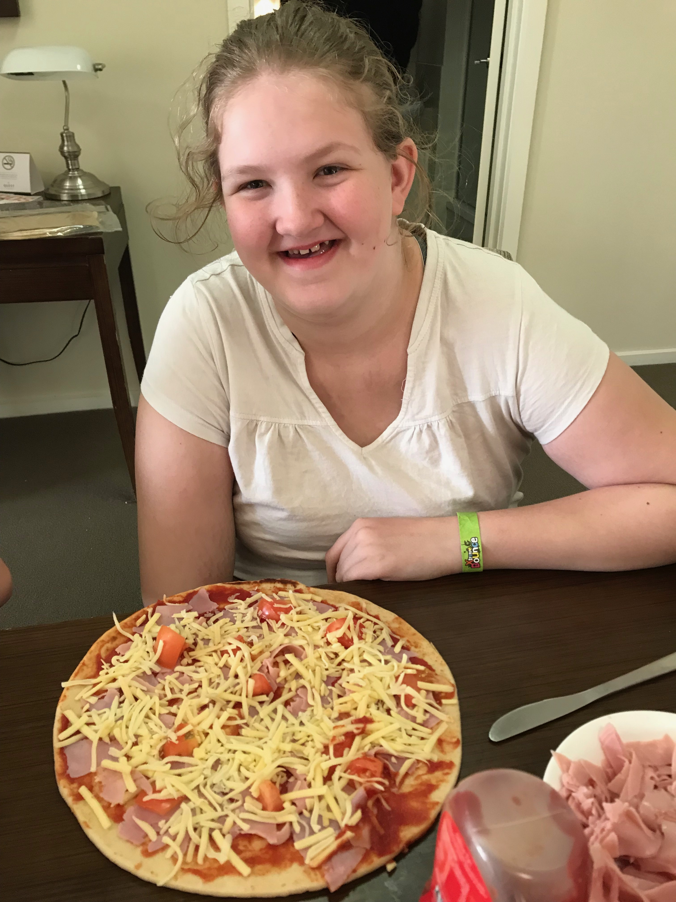
[IMAGE DESCRIPTION: Jasmine sitting at a table with a homemade pizza in front of her]

The students also demonstrated their cooking skills, managing to make pizza and pasta for dinner on one night, and a cooked breakfast of pancakes, bacon and eggs on one of the mornings.
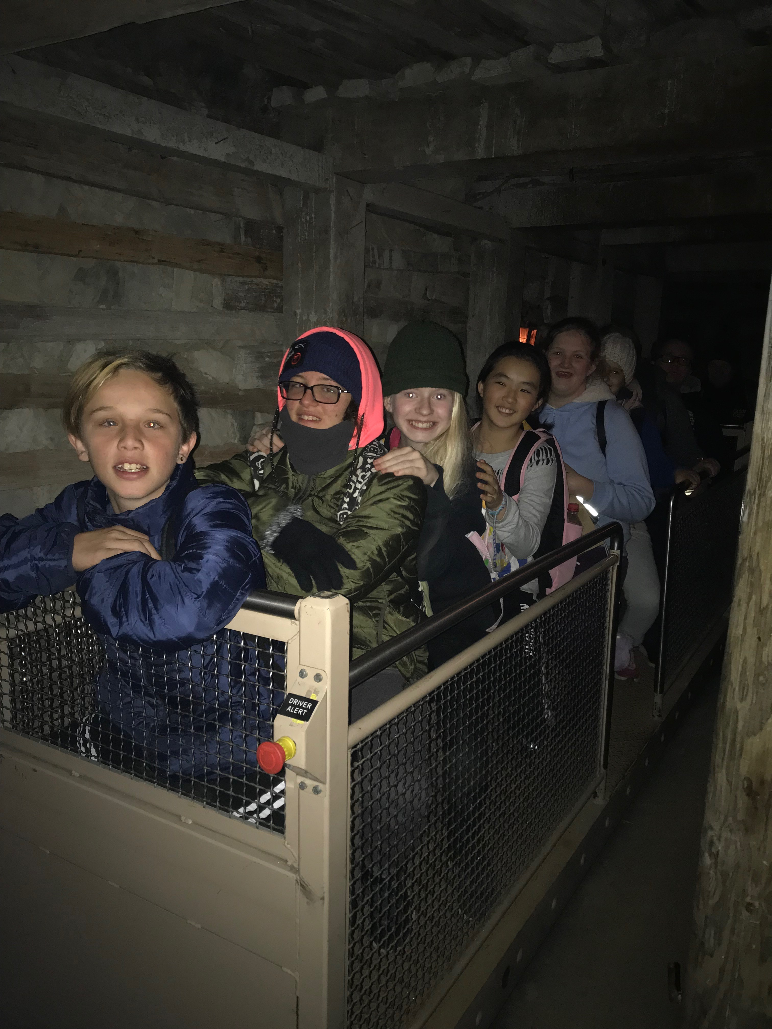
[IMAGE DESCRIPTION: Students in a mine cart during the mine tour at Sovereign Hill]

Return to content

Tech Time with Michael

By Michael Evans
These articles aim to provide information on technology which can be used to support our clients with their Orientation and Mobility (O&M).
I would like to introduce you to Bone Conduction Headphones. Bone Conduction technology delivers sound through your cheekbones, ensuring the user’s ears remain completely open to hear environmental sounds. Bone Conduction Headphones connect via Bluetooth to a device, such as a smartphone. Bone Conduction Headphones allow the user to simultaneously listen to information provided to them from a device via the headphones and environmental sounds.
From an Orientation & Mobility (O&M) perspective, users when travelling can listen to Global Positioning System (GPS) information from their device through the headset whilst still listening to important environmental sounds, such as:
- Traffic
- Accessible pedestrian audio signals
- Pedestrian traffic
- Announcements on public transport
- And other sounds that support navigation relevant to the individual
For example, whilst travelling on public transport the user could be listening to GPS information, music, audiobooks, emails, texts, or any type of information and at the same time be listening to the environmental sounds such as announcements or the other passengers.
The benefits of Bone Conduction Headphones can be transferred into many different environments, such as the workplace, school or home.
If you would like to know more, please speak with your Orientation and Mobility Specialist.
Happy exploring.
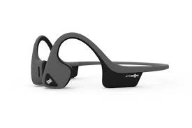
[IMAGE DESCRIPTION: A pair of black Bone Conduction Headphones]
Return to contents

Family Corner: Upper limb strengthening activities for children with blindness and low vision
By Alyce Woodruff, Paediatric Occupational Therapist
To improve fine motor skills needed for everyday activities such as dressing, using cutlery, learning to cut with scissors and to read and type braille it is important to strengthen the shoulder, arm, hand and fingers. It is important to have strong arm and shoulder muscles because these provide stability for the little muscles in the hands and fingers.

Shoulder and arm
- Digging in the sand or the garden
- Using cookie cutters and rolling pins with play dough
- Playground equipment – crawling through tunnels, climbing
- Twirling crepe streamers or ribbon sticks
- Painting or peeling stickers onto an easel (doing this on an easel works out the arm more than flat on a table)
- Simon Says

Hand
- Opening lids and jars to retrieve toys/objects
- Playing with shakers and shaking instruments
- Construction games
- Tearing and scrunching paper. Can then stick this down on paper using a squeezy glue bottle.
- Using craft hole punches of different shapes
- Use water bottles to spray plants in the garden
- Squeezing, rolling, using a garlic press or scissors with play dough
- Squeezing stress balls
- Joining in baking activities with family to stir & kneed

Fingers
- Pinching, molding and pressing play dough. Picking marbles or beads out of play dough
- Finger play with rhymes and songs e.g. Incy Wincy Spider
- Pegs – peg dolls clothes on a clothes horse or put pegs around the edge of a container
- Threading beads, buttons and stencils
- Pulling off and sticking on stickers
- Popping bubbles wrap
- Using kitchen tongs pick up noisy little objects such as bells and moving them from one container to another – race to make it a game!
Return to contents

Interview with Andrew White (Assistive Technology Coordinator)

With Clare O’Sullivan (CMS O&M)

Clare: So Hi, Andrew. What is it you do here at Guide Dogs Victoria?
Andrew: Well, I work with Kids and parents at home and at school to use technology to achieve their goals. I also work with adults.
Clare: What were you doing before you started here at Guide Dogs Victoria?
Andrew: I have been working as a trainer working with young adults (ages 14 and above) who are blind/low vision and teach them to make furniture. From there, the opportunity came up to work with children in schools teaching technology. I have worked all over Australia in this role from the Northern Territory – Tasmania.
Clare: How long have you been doing that?
Andrew: 17 years
Clare: Wow, Andrew you bring a wealth of experience! How are finding working at Guide Dogs Victoria so far?
Andrew: The team feels very supportive. I’m excited for this new challenge and I look forward to getting to know everyone
Clare: What kind of things to you do with Kids and Parents?
Andrew: I do all sorts. Anything from accessing social media, texting, WhatsApp to accessing books and information online. I can do a Tech assessment to work out what your needs are and help you find the best equipment or the best app to assist with your goals.
Clare: Is this at home or in school?
Andrew: I can work at school or in the home, depending what your needs might be?
Clare: What’s your favourite app at the moment?
Andrew: Well for fun, I am really enjoying playing “Blindfold Basketball”
Clare: What’s that?
Andrew: Blindfold Basketball is a fully accessible (works well with voiceover) audio game that’s just like playing basketball on an indoor court. Using head phones, you can work out which direction the ball is coming from. In the tutorial stage you learn how to move, pick up the ball and shoot.
Clare: I can think of some of the people I work with loving that game. Thank you for the hot tip. How would someone make an appointment with you?
Andrew: If you are working with O&M, OT or Orthoptist they can put through a referral for you or you can call the customer service team on 1800 804 805.
Clare: Lastly, what do you like doing for fun in your spare time?
Andrew: I love music so I love seeing live gigs and cooking spicy or Spanish food!

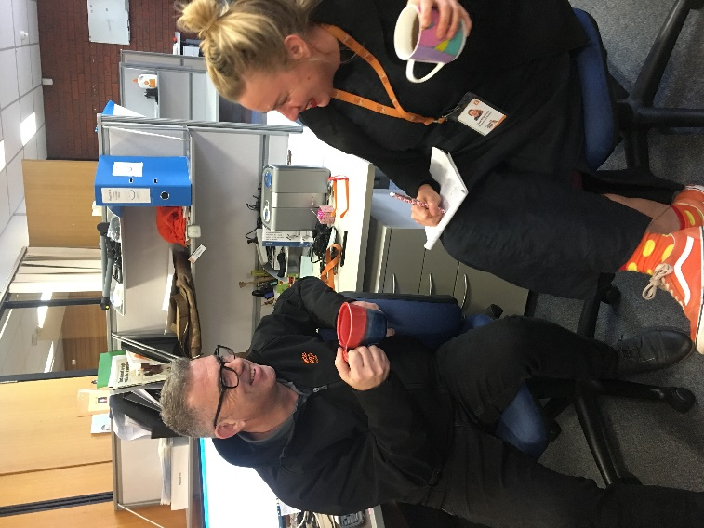
[IMAGE DESCRIPTION: Side on picture of Clare interviewing Andrew. Clare has a notebook and paper. Both are holding a mug and smiling]

Contrast Sensitivity
By Kate Clark and Khoa Nguyen – Orthoptists
Have you ever wondered why some print or writing is easier to read than others (even if they are the same size)? Or why some objects stand out better from their background than others?

This could be because of contrast. Contrast is how much something stands out from it’s background.

Examples of good contrast:

- Black writing on a white board
- A black remote control on a light table top or mat
- Making your breakfast of Weetbix and milk in a dark coloured bowl
In these examples, the colour of the writing or the object is every different from its background and therefore stands out and is easier to see.

Examples of poor contrast:

- Pale green writing on a white board
- A black remote control placed on dark tabletop
- Making your breakfast of Weetbix and milk in a light-coloured bowl
In these examples, the writing or objects are more similar in colour to their background and therefore blends in more with the background making it more difficult to see.

Sometimes you can improve contrast by:

- Choosing to write with dark coloured marker (black/dark blue) on white paper, rather than a light coloured marker

Return to contents

New Staff Members

Emma (Occupational Therapist)
My name is Emma and I have recently joined the Guide Dogs Victoria team, having started on the 18th March as an Occupational Therapist based in Geelong. Over the past 8 years I have worked as an OT in both Warrnambool and Geelong supporting people to achieve their goals at home and in the community.
I started life as an OT as a Paediatric therapist, supporting children from 0-7 years. In my previous role over the past four years I have enjoyed, working with children, teenagers and adults, who have presented with a range of different diagnoses, to achieve their goals.
I have enjoyed working with children and their families to support kids to achieve a range of different goals relating to their personal activities of daily living including dressing, toileting, bathing and use of cutlery to eat independently for meal times.
I have also enjoyed supporting other goals relating to their fine motor skills, emotional regulation, sensory processing, play and social skills. My work with teenagers and adults has included assisting them to have the equipment they needed to support independence, along with achieving their goals which often related to domestic and community activities of daily living.
I have been fortunate to be able to support children who have low vision at times in my previous roles and I was very excited to join the Guide Dogs team to be able to further specialise and assist those who have low or no vision.
I have always admired how Guide Dogs are able to support people to increase their independence and I look forward to contributing to the team and helping others through my role as an OT. I love working with people to help them to successfully participate in activities important to them.
Thank you to everyone who has already warmly welcomed me to the team, I am excited to have started working for Guide Dogs Victoria. One of the biggest challenges so far has been restraining myself from getting distracted by the beautiful Guide Dogs in the office as I am very much a dog person (I think my Hungarian Vizsla has been a bit jealous after detecting who I’m working with).
I look forward to meeting many of you involved with Guide Dog’s in the future!

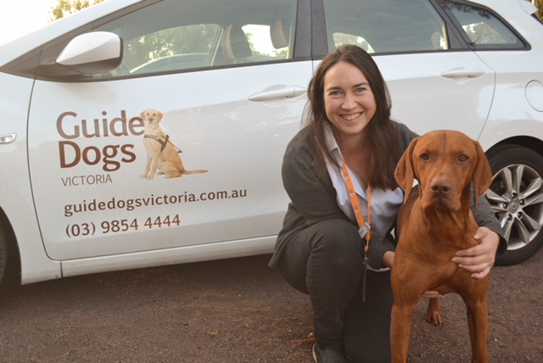
[IMAGE DESCRIPTION: Emma, a young woman with brown hair, crouched down with her arm around her own pet dog which is a Hungarian Vizsla, in front of her GDV car]
Cherie (Orientation and Mobility Instructor)
How lovely it is to be here working with Guide Dogs Victoria! I originally worked for Guide Dogs NSW (Sydney) and after several years off (living overseas, raising three daughters) I am very happy to be back.
The environment is so friendly and supportive and I’m loving being able to get out and meet new people every day. I have an interest in cultural diversity as well as helping our services be more accessible to people living in remote areas.
On a personal note, I have a golden cocker spaniel (Bailee – super cute), do F45 rather reluctantly with my eldest daughter and love going anywhere with my family on holidays.
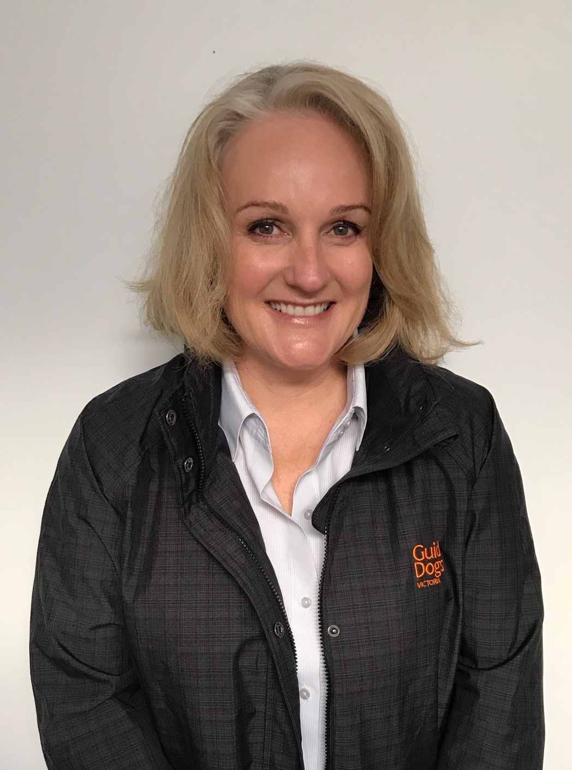
[IMAGE DESCRIPTION: Cherie smiling at the camera wearing a black and grey Guide Dogs Victoria jacket]
Jacinta (Customer Service Representative)
Meet Jacinta! Jacinta is part of the Customer Service Team but her primary role is the Residential Day Supervisor at Arnold Cook House.
Jacinta started in August 2018 and has quickly become an integral part of the experience for many clients training with their Guide Dogs and staying here at GDV. With a great combination of hard work, an ability to learn quickly and a sharp sense of humour (or sass), she has done a wonderful job of making this experience as memorable as possible for clients.
When class is not on, Jacinta can be found in our Customer Service Team helping out with the administration for GDV Group Programs such as kid’s camps as well as all the other day-to-day aspects of the reception roles. A wonderful team member and a jack of all trades!
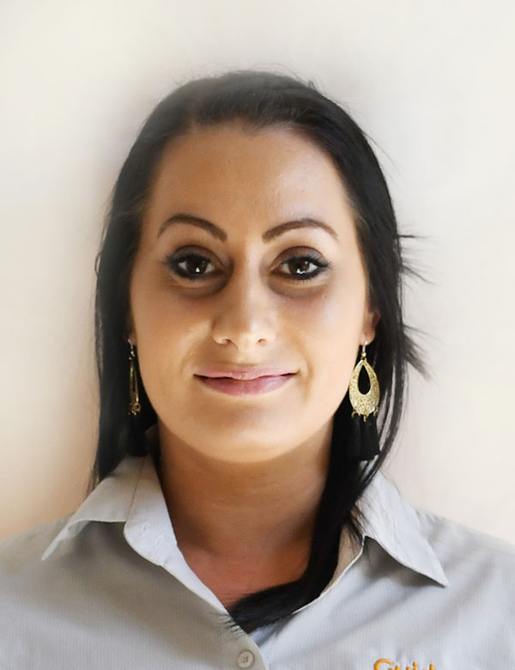
[IMAGE DESCRIPTION: Jacinta smiling at the camera wearing a Guide Dogs Victoria shirt]

Australian Vision Impairment Registry
Have you registered your child on the Australian Childhood Vision Impairment Register (ACVIR)?
The ACVIR collects data that helps build an accurate picture of the number of children with vision impairment in Australia.
Sponsored by Royal Institute for Deaf and Blind Children and founded in partnership with families, health professionals, educators and agencies, the register gives providers and researchers access to data to increase vital services, support funding requests and provide targeted support to the community.
For more information on the register visit the VI Family Network website at www.vifamilynetwork.org.au.
This site is home to the ACVIR and also provides links to Australian low vision resources, newsletters from partner organisations and events that families might like to find out about.
Return to contents

Contact us:
Children’s Mobility Service
Private Bag 13, KEW, VIC, 3101
General Enquiries: 1800 804 805
Facsimile: 03 9854 4466
www.guidedogsvictoria.com.au
Follow us on social media:
Facebook
Instagram
Twitter
LinkedIn
YouTube
Snapchat

Return to contents

Feedback
If you have anything to contribute to this newsletter, please feel free to contact us with your piece. We welcome all contributions. Please either contact or email our client services administration team with your contributions as below: csadmin@guidedogsvictoria.com.au or Phone: 1800 804 805
GetAbout is now coming to you in a digital format. Going digital means our newsletter will be accessible, timely and environmentally friendly. The content of GetAbout has not changed: we will continue to let you know about our upcoming camps and group programs. GetAbout is also available on our website www.guidedogsvictoria.com.au
Alternative formats are still available in audio CD, large print and braille. Please contact us at CSadmin@guidedogsvictoria.com.au or via phone 1800 804 805 to request these formats.
Return to contents

