‘Guide Dogs Victoria’s On the Move – February 2019 Bulletin

Tips for reading this newsletter

If you would like to increase the text size on your screen:
- Using the keyboard
    - Press ALT+W, and then press Q.
    - Press the TAB key repeatedly until the Percent box is selected, and then type a percentage or press UP ARROW or DOWN ARROW to select a percentage.
- Using the mouse
    - On the View tab, in the Zoom group, click Zoom.
    - Click the zoom setting that you want or type a percentage in the Percent box.

Contents
Tips for reading this newsletter 1
Editor’s update 2
Meet Andrew, our Assistive Technology Coordinator – Client Services 3
A word from the Guide Dog Department: Guide Dogs Have Access to All Areas 4
Orthoptist Awareness Week 3rd – 9th of March 6
Equipment that you can trial with our GDV Orthoptists 7
Giveaway! 10 double passes to the Melbourne International Flower and Garden Show 9
Works at Reservoir on the Mernda Line 11
Calling Participants for Study at the Centre for Eye Research Australia 12
Expressions of Interest – Coles Products 13
Feedback 13

Editor’s update

Hi everyone,

Welcome to the first edition of On The Move for 2019. I hope you had a fantastic break and have settled happily into the new year. This is a bumper issue, with lots of opportunities to get out and involved in the community.

I am very excited to introduce Andrew White, our new Assistive Technology Coordinator. Andrew will provide a tech update in future issues of On The Move. If you have any questions or would like him to write about something specific, please do get in touch via info@guidedogsvictoria.com.au.

I am also thrilled to announce that we are taking part in this year’s Melbourne International Flower and Garden Show. We have 10 x double passes to giveaway, get in quick as I am sure these will get snapped up quickly.

I hope you enjoy this issue,

Rosalind McClintock
Bulletin Editor
Return to contents

Meet Andrew, our Assistive Technology Coordinator – Client Services
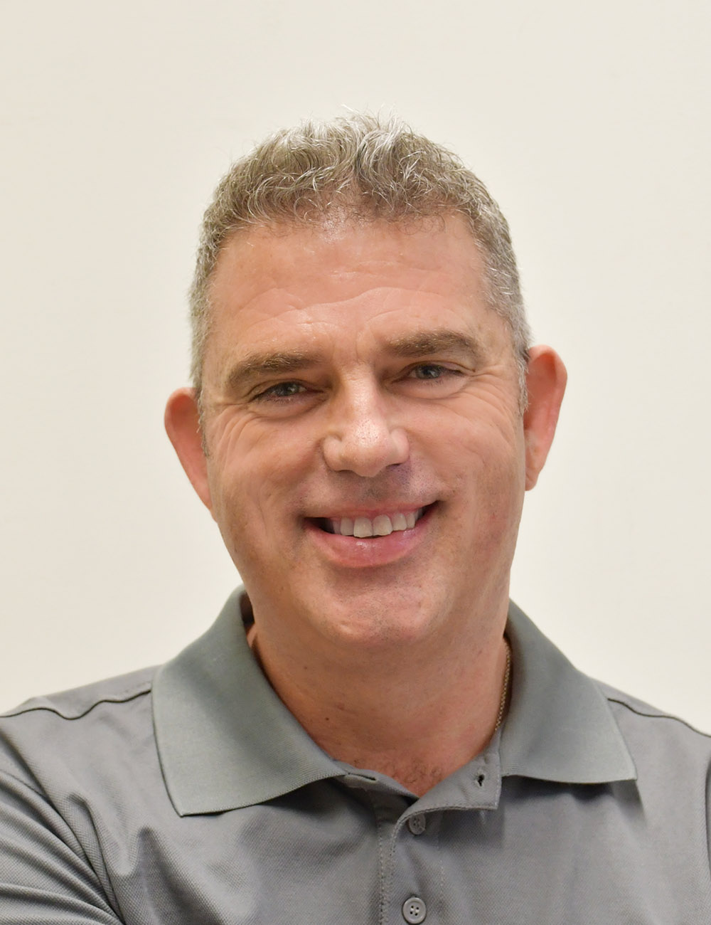
[Image description: A headshot of Andrew White against a cream background. He is wearing a grey polo shirt and is smiling at the camera.]
My name is Andrew, I joined Guide Dogs Victoria in December last year, just in time for the Christmas party! My role is the Assistive Technology Coordinator within the Client Services team.
I started my career in the blindness and low vision field at the Royal Victorian Institute for the Blind in 2002 teaching furniture making. After seven years I moved into the role of an Adaptive Technology Consultant working mainly in the children’s services area, covering Victoria, Tasmania and the Northern Territory. I feel very fortunate to be able to work in this field and extremely excited to now be working with GDV and the amazing people here.
I am going to be writing a tech column for each issue of On The Move, discussing some of the new technologies I am enthusiastic about.
This issue, I’m excited about the choice you have with mainstream technology options, especially with home automation companies like Apple, Amazon and Google investing heavily in the area. Having access to devices such as the Apple HomePod, Amazon Alexa and Google Home gives you more control over things like lighting, door locks, vacuuming and watering systems, etc.
Apple TV gives voiceover and magnification options and the development of audio description on TV shows is a great initiative.
If you are interested in learning more about the services Guide Dogs Victoria can provide then please contact 1800 804 805 and discuss the options with our Customer Service Team.
Return to contents

A word from the Guide Dog Department: Guide Dogs Have Access to All Areas

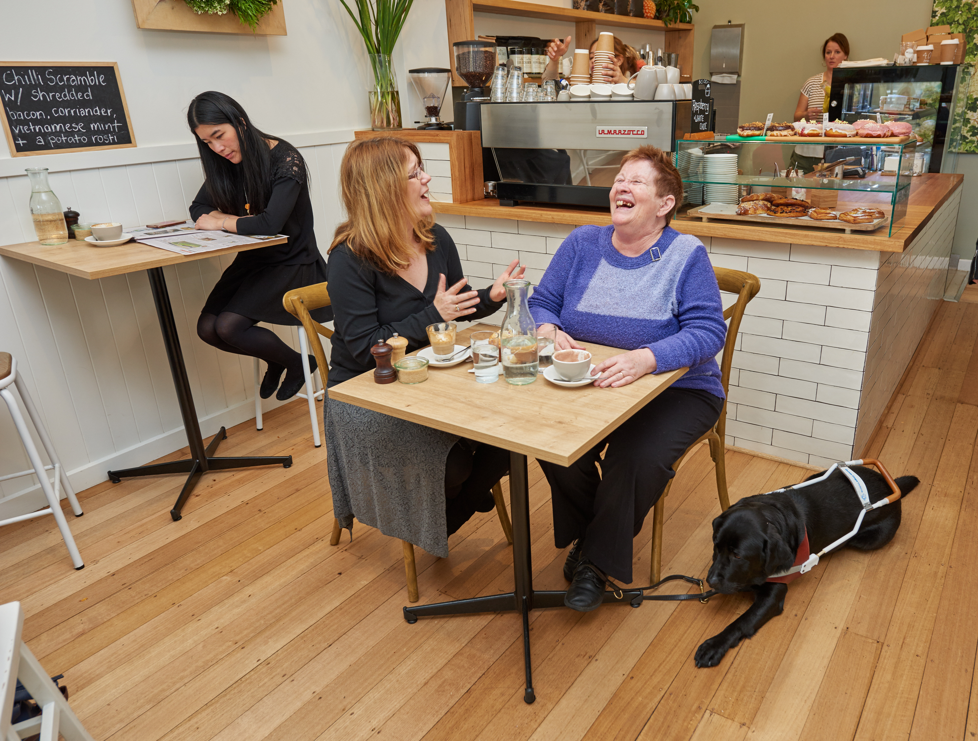
[Image Description: Two ladies are sitting at a square wooden table in a modern café. They are laughing. Each has a coffee. A black Guide Dog in harness is lying at the foot of one of the lady’s chair.]
This year International Guide Dog Day (IGDD) lands on Wednesday, 24th of April. It is a day to stop and celebrate the fabulous work of all Guide Dog teams, both locally and throughout the Guide Dog world.
As part of the day, we are launching a National Access All Areas campaign. We hope to raise enough awareness that no one with a Guide Dog is ever turned away from a café, hotel or mode of transport again.
To achieve this, we need your help. In the lead up to IGDD we will send out a survey, which we would love you to complete. This survey will form the basis of the research that we provide to media and we hope the results will generate some interest in the issue.
In addition, we want to remind you to make sure that you always carry your access card and that your Guide Dog is in harness. This will ensure that vendors have no recourse to turn you and your dog away. We realise this is an ongoing issue, but we hope that our campaign will see a marked improvement in the community.

Return to contents

Orthoptist Awareness Week 3rd – 9th of March

The role of a low vision Orthoptist is to assess your functional vision. A variety of different tests are used to establish a base line of vision. Once established an Orthoptist can explain your vision condition and what you can see, and will then work with you to identify the tasks that are important to you and determine your goals.
A low vision Orthoptist will trial and recommend low vision aids and/ or strategies to get you back to being independent with those tasks, which may be things like reading, writing, drawing, crafts, banking or woodwork. An Orthoptist can also provide information about your vision to family, carers, and other Practitioners (OT, Orientation and Mobility Specialist), so your support network is fully informed and able to assist you to achieve your goals.
GDV’s low vision Orthoptists often provide information about low vision to the greater community. You can sometimes find them at the Eye and Ear Hospital, or speaking at the GDV ABI Day information session - Understanding ABI and Low Vision. They work with a range of ages from early childhood all the way through to people beyond 100 years old! Support is provided in all settings, including home, school, care facilities, workplaces, etc.
To ask for an Orthoptist to come and see you, your child or your loved one, please contact 1800 804 805 and discuss the options with our Customer Service Team.
Return to contents

Equipment that you can trial with our GDV Orthoptists

Have you ever wondered what sort of equipment you can trial with our GDV Orthoptists?
We have a kit full of equipment that we take when we travel to a client’s home. The particular equipment we trial with someone depends on their level of vision, their pattern of vision loss and the sort of things that they want to be able to read or do.
Some equipment is very simple, such as a line guide. A line guide helps you stay on the line when you are reading. It can help identify the start or the end of a line if they are difficult to locate due to visual field loss.
We also have a selection of lamps to demonstrate the benefits of focal lighting and a variety of globes to trial as different people require, or prefer, a different strength of globe and a specific colour temperature (for example warm white or daylight).
We have a selection of hand magnifiers with LED lights in a variety of strengths. They are light and portable, and can be very helpful depending on the reading task at hand.
We have a good range of portable video magnifiers with different screen sizes and features. The settings can be adjusted to change the magnification and contrast and there is even a new one coming with a large screen that has OCR capabilities (can capture an image of the print and read the print out).
If a greater level of magnification is required with a larger screen, such as a desktop magnifier/ CCTV then we are happy to arrange a trial of these as well, either at the GDV campus or in your home.

We have a selection of monoculars/ binoculars to trial for distance viewing and also have a range of fitover sunglasses if you are struggling with glare control outdoors.
If you think you would like to trial any of the equipment we have or would like to know if an Orthoptic low vision assessment would be helpful for you then please contact 1800 804 805 and discuss the options with our Customer Service Team.
Return to contents

Giveaway! 10 double passes to the Melbourne International Flower and Garden Show

[Image Description: A yellow Labrador puppy is sitting in front of a rainbow of flowers looking at the camera. Their front two paws are resting on a piece of wood.]

Guide Dogs Victoria is proud to be participating in the 2019 Melbourne International Flower and Garden Show.

With the valued support of the Kangan Institute, we are designing a fully accessible and sensory garden. We would love as many of you to visit as possible. The show runs from 27 – 31 of March at the Royal Exhibition Building and Carlton Gardens.

We have 10 x double one day passes to give away to the first 10 people who email samantham@guidedogsvictoria.au with Flower and Garden giveaway in the subject line.

Be sure to be quick! These won’t last long.

Return to contents

Works at Reservoir on the Mernda Line
Construction is underway to remove the level crossing in Reservoir on the Mernda line.

To enable the installation of temporary station facilities and accommodate construction equipment, there will be changes to Reservoir Station facilities and around the station precinct.

Metro are there to help passengers with their travel during major construction projects and will endeavour to get you to and from your destination as quickly and easily as possible.
To get the latest travel information on changes around Reservoir, call PTV on 1800 800 007 or visit ptv.vic.gov.au. If you are deaf, or have a hearing or speech impairment, you can contact Metro directly or through the National Relay Service and request to call 1800 800 007.

For other languages visit ptv.vic.gov.au/languages or call 9321 5450.
MORE INFORMATION
If you have any questions about the Reservoir Level Crossing Removal Project or would like more information, phone 1800 105 105 or email contact@levelcrossings.vic.gov.au 24 hours a day.

Return to contents

Calling Participants for Study at the Centre for Eye Research Australia
The Centre for Eye Research Australia (CERA) are inviting people who have been diagnosed with Retinitis Pigmentosa (RP) to register their interest in a study that has been designed to understand the disease process.
This study will also determine which people may be able to be helped with a novel treatment such as a neuroprotective device or a drug to slow down the progression of RP.
They are looking for people with RP with early to moderate loss in vision.
To register your interest for this study please call (03) 9929 8117 or email c.abbott@unimelb.edu.au .
To keep updated with research at CERA, please visit www.cera.org.au. You are also able to register your details with CERA via the ‘Clinical Trials Web Sight’ link on our website.

Return to contents

Expressions of Interest – Coles Products
Coles are seeking expressions of interest from our clients to join their pool of customer research and user testing participants.
They are keen to learn more proactively from the community and use your feedback to shape the future of the products and services they offer.
If you are interested in learning more, please contact Samantha: Samantham@guidedogsvictoria.com.au

Return to contents

Feedback
If you have anything to contribute to this newsletter, please feel free to contact us with your piece. We welcome all contributions.

Please either contact or email Customer Service Team with your contributions as below:
info@guidedogsvictoria.com.au or phone 1800 804 805.
Return to contents

