Guide Dogs Victoria’s GetAbout – Term 1 2019

Tips for reading this newsletter

If you would like to increase the text size on your screen:
- Using the keyboard
    - Press ALT+W, and then press Q.
    - Press the TAB key repeatedly until the Percent box is selected, and then type a percentage or press UP ARROW or DOWN ARROW to select a percentage.
- Using the mouse
    - On the View tab, in the Zoom group, click Zoom.
    - Click the zoom setting that you want or type a percentage in the Percent box.

Contents
Tips for reading this newsletter 1
Note from the Editor 2
CMS Camps and Group Programs 2010 Overview 3
Teenage Guide Dog Mobility Camp Program 6
Space Camp 2018 10
Tech Time with Michael 11
Family Corner: Ways to help with identifying coins 14
Electronic signing made easy! 15
New O&M Masters students 16
Contact us: 18
Feedback 19

Return to contents

Note from the Editor

Dear CMSers,
Welcome to the first Get About of 2019. We have had an exciting and busy start to the year, with many of our students having their first day at childcare, kindergarten, primary school, secondary school and university. It’s great to be along for the ride and doing our best to support you and your families as you move onwards and upwards into new education settings.
This edition is jam packed with interesting articles and helpful tips to assist you in your everyday life. Our OT, Alyce, provides information about how to best identify different coins. Khoa and Kate, our Orthoptists, provide some tips on maximising contrast and Michael takes you into the world of virtual reality with the SuperVision magnifying app.
You will also see our list of planned CMS camps and group programs for 2019, which includes cost estimates for those on NDIS plans. We are providing this information to help families plan for the programs they may want to include in their current, or new, NDIS plans. Please contact our customer service team on 1800 804 805 for further information and to RSVP your interest.
We would love to publish some articles from student and parent contributors, so we can all learn from each other. It could be as simple as a handy tip you have found works really well or an experience you are happy to share, please email me at alicias@guidedogsvictoria.com.au
Get OUT and ABOUT and enjoy sunshine!
Alicia San Martin
Bulletin Editor
Don’t forget to look at our website: www.guidedogsvictoria.com.au

Return to contents

CMS Camps and Group Programs 2019 Overview

The Children’s Mobility Service is excited to offer a range of camps and group programs during 2019. Our group programs aim to offer Orientation and Mobility and Occupational Therapy training in a dynamic group setting. They also provides you and your family opportunities to socially engage with their peers.
To assist families who are on the NDIS, and for those who will soon be on the NDIS, pricing has been included based on February 2019 prices. Please note for those students who do not yet have an NDIS plan the cost will be covered by philanthropic funding. If you would like to discuss any aspects of our planned camp program please contact our customer service team on 1800 804 805.
Detailed camp information for each of these programs will be emailed direct to your inbox.
Our group program schedule will also be available on our website here.

All camp programs will provide you with the opportunity to develop a range of Orientation & Mobility and Occupational Therapy skills. You will have the chance to practice these skills in a variety of different environments tailored to your age and skill level.

April Senior Camp 4 Day Program – Based in the historic town of Ballarat.
8th – 11th April 2019
A four day camp for secondary school students with low vision or blindness. Please contact the customer service team ASAP to request an application pack.
Estimated NDIS cost: $1600

Supercharge Junior Camp 2 day camp program – Based at Guide Dogs Victoria’s campus in Kew.
20th and 21st May 2019
This program is designed to meet the unique learning needs of a child who is blind or has very low vision. Students will participate in intensive sessions aimed at developing their independence in Orientation and Mobility and activities of daily living. Suitable for primary school students.
Estimated NDIS cost: $1000

July Junior Camp 3 day program – Based at Guide Dogs Victoria’s campus in Kew.
1st – 3rd July 2019
Three day camp for primary school students with low vision or blindness based onsite at Guide Dogs Victoria in Kew.
Estimated NDIS cost: $1400

Supercharge Senior Camp 3 day program – Based at Guide Dogs Victoria’s campus in Kew.
12th – 14th August.
This program is designed to meet the unique learning needs of a child who is blind or has very low vision. Students will participate in intensive sessions aimed at developing their independence in Orientation and Mobility and activities of daily living. Suitable for secondary school students.
Estimated NDIS cost: $1400

Family Camp – Based in the Melbourne CBD, Family accommodation provided.
30th September to 2nd October
This will be an opportunity for families to come together and increase their understanding of the skills required to support development of independent travel in the community and completion of daily living activities. It will also provide informal networking opportunities for families.
Estimated NDIS cost: Cost is to be advised, please express your interest in this program ASAP by contacting our customer service team on 1800 804 805.

Return to contents

Teenage Guide Dog Mobility Camp Program

By Danielle Kruger

Early in December, the Children’s Mobility Service teamed up with our Guide Dog Client Services team to run a detailed information session for children, and their parents, who may be considering a Guide Dog in the future. Held over two days, the participants learnt:
- What O&M Skills are required before moving to Guide Dog Mobility
- What a Guide Dog can and can’t do
- The responsibilities of a Guide Dog handler
- What skills to work on in everyday life
The group then had an opportunity to focus on O&M skills that are relevant to Guide Dog Mobility, to experience a walk with a Guide Dog and participate in a session on how to care for a Guide Dogs (obedience, grooming, feeding and everyone’s favourite, toileting!).
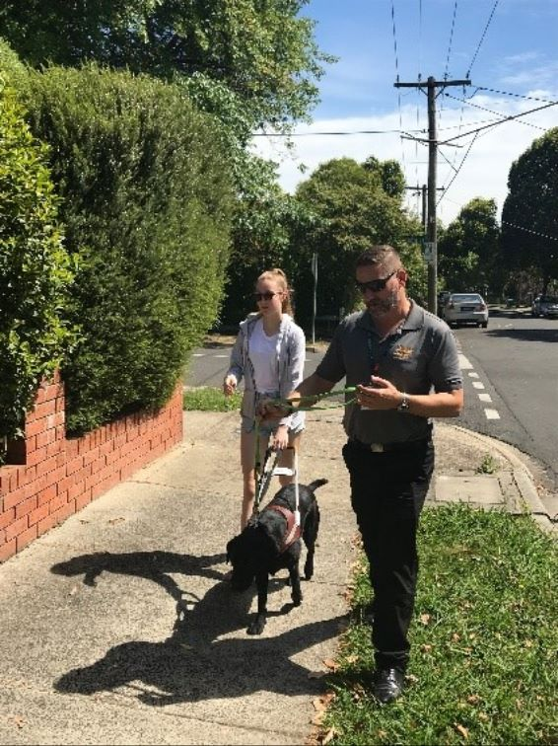
[IMAGE DESCRIPTION: Lucy and Guide Dog Mobility Instructor Aaron during their walk.]
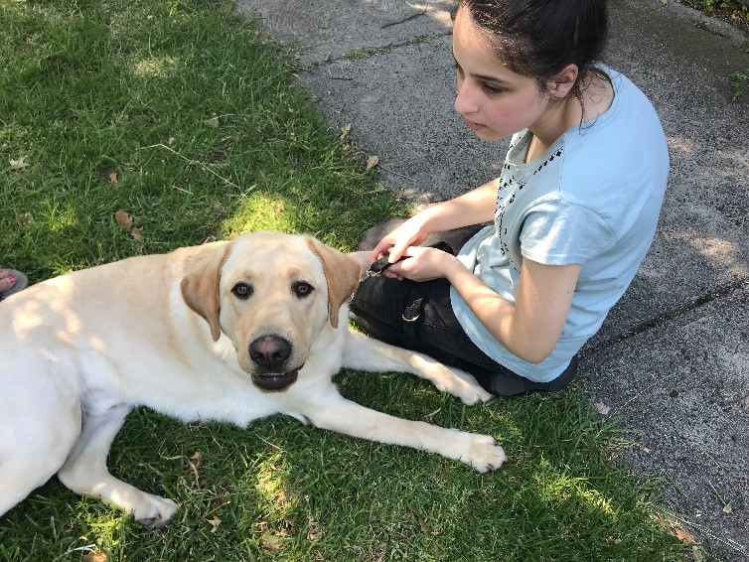
[IMAGE DESCRIPTION: Zeynep and Guide Dog sitting in the shade after their walk.]
Return to content

Space Camp 2018
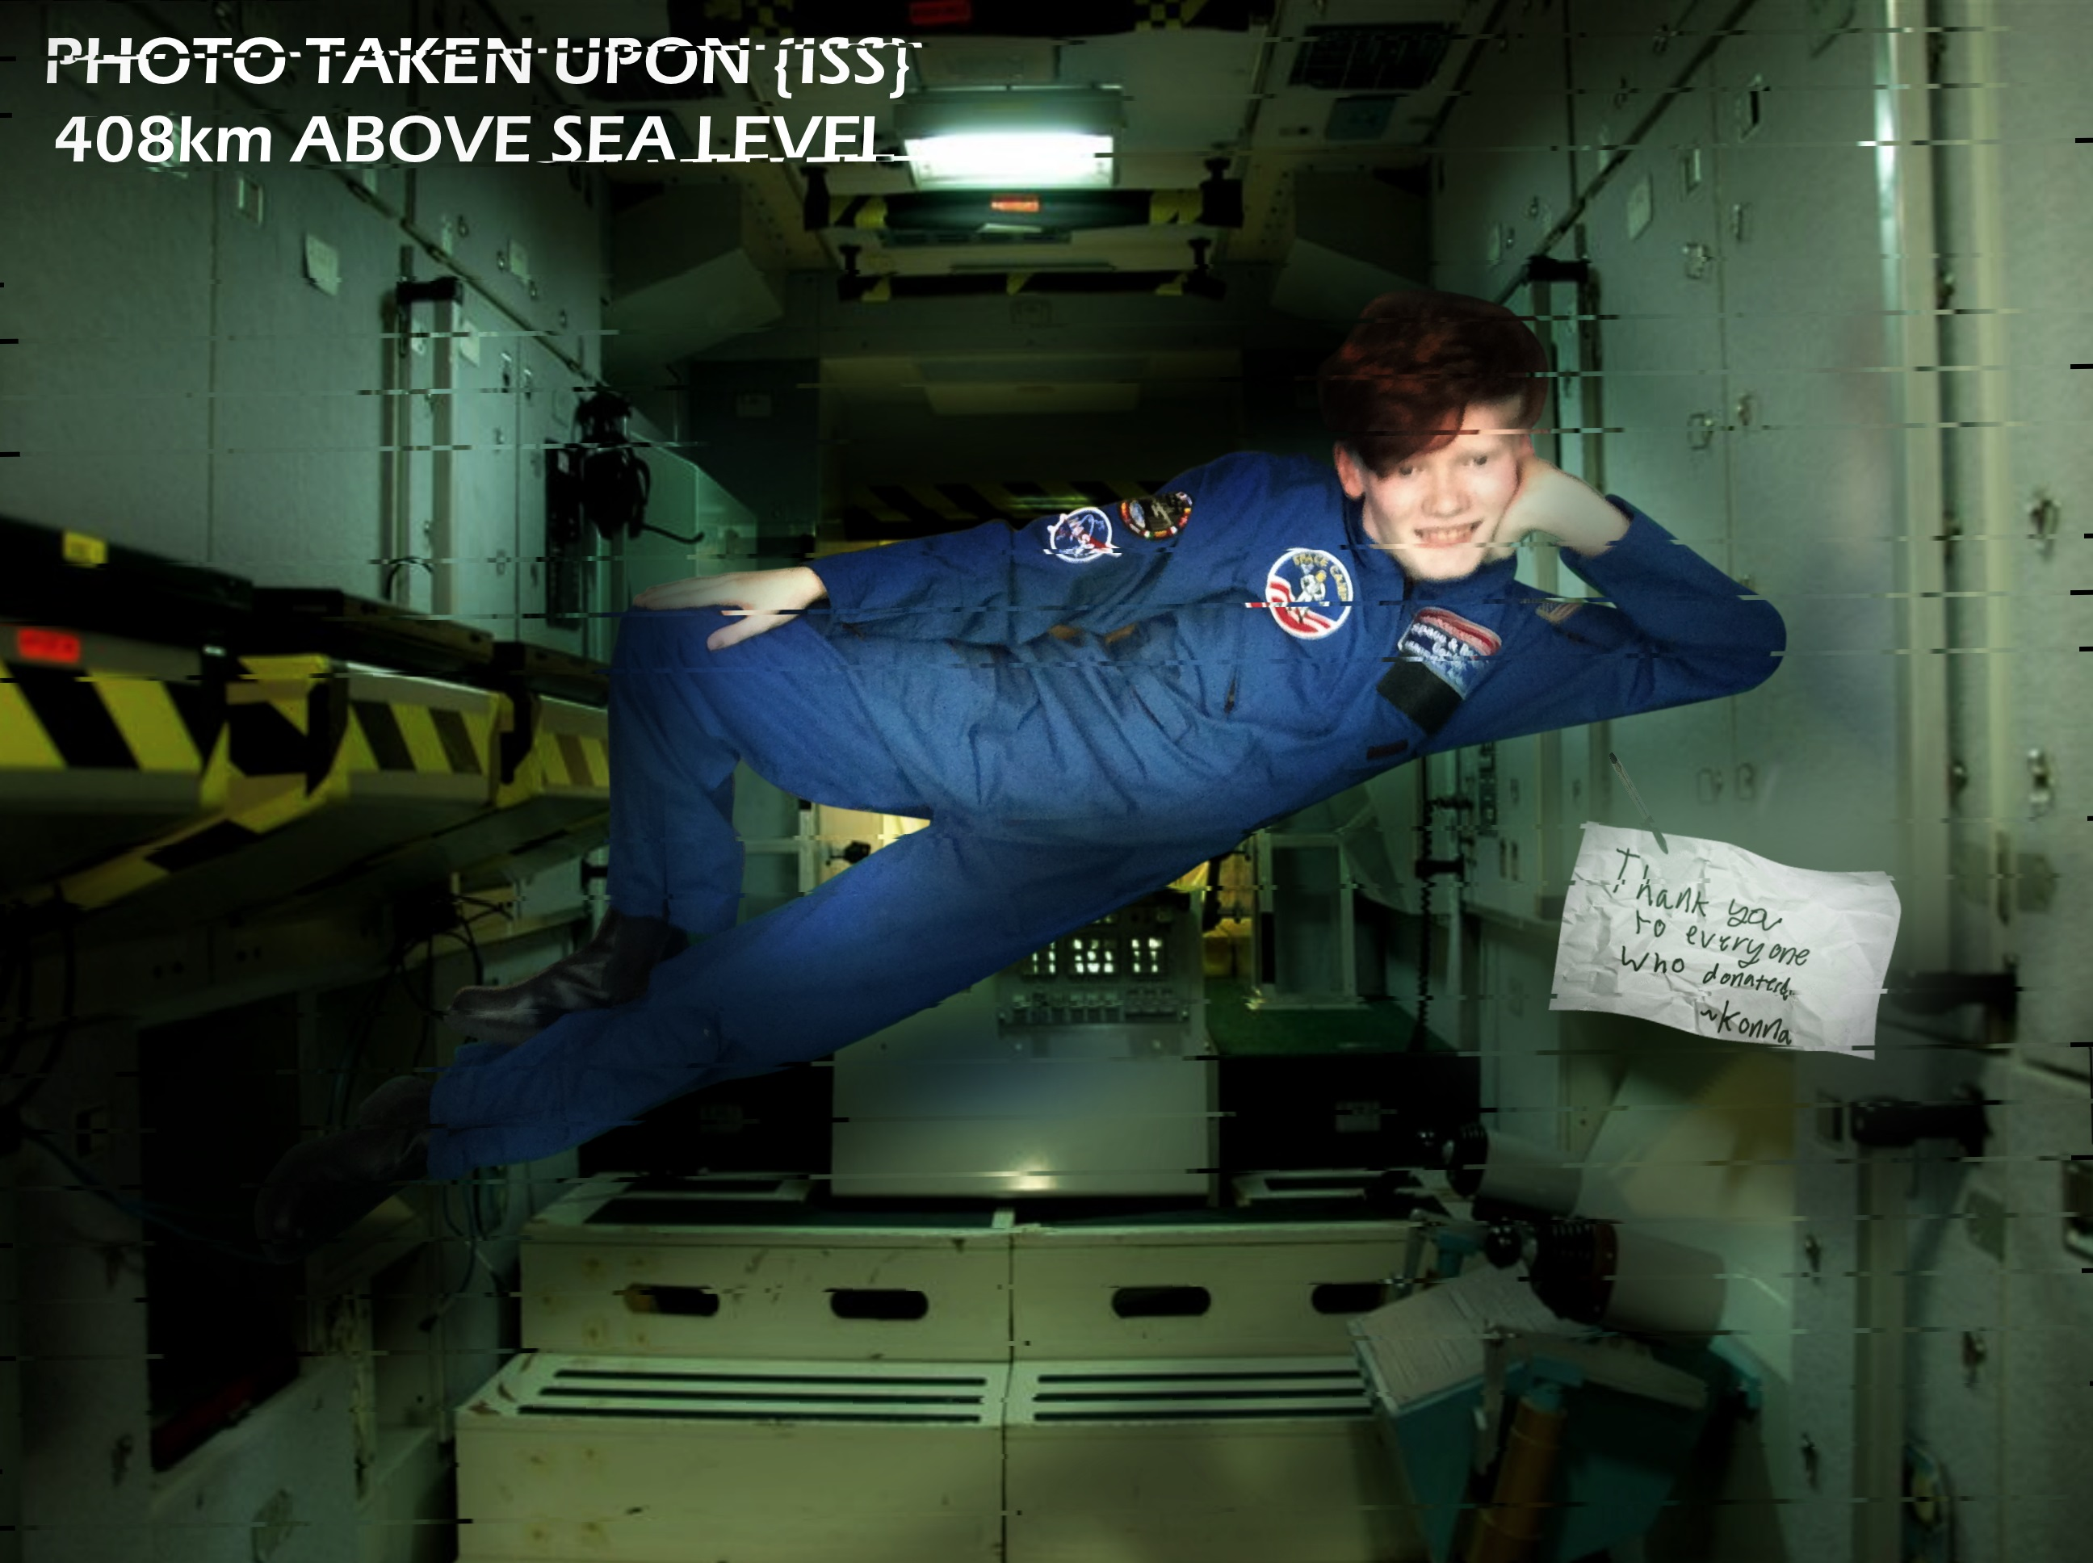
[Image Description: Kona floating casually in a Shuttle simulator with a note saying thank you]
Hi Everyone,
I was one of the students who participated in Space Camp 2018. I was asked to write a paragraph about the amazing journey that was Space Academy, let me tell you, it is out of this world.
Terrible jokes aside, space camp is an unbelievable opportunity for any student no matter how old.
We participated in many activities like a 1/1 Shuttle simulator, A moon landing and Moon Gravity Simulation. The camp was enjoyable and I am still in contact with most of my American friends so it is a great way to meet people.
All of the staff were very helpful and very kind to all of the students and I don’t recall a single time where they felt like teachers rather than friends.
The camp ground was very well prepared for accessibility and I felt comfortable walking around straight away.
Overall I recommend space camp to anyone that can go and it is truly a once in a lifetime opportunity, unless you go twice.
Once a year Space Camp is open for vision impaired students for one week.
If anyone would like to know more please email me
Thanks for reading,
~Konna
Ed’s Note: If you would like to get in touch with Konna about his space came experience, please email me at alicias@guidedogsvictoria.com.au

Tech Time with Michael
By Michael Evans
These articles aim to provide information on technology that can be used to support our Clients with their Orientation and Mobility (O&M). Using particular pieces of technology can make O&M sessions more interesting, engaging and fun.
I would like to introduce you to SuperVision.
SuperVision is an advanced magnifier app created to support people who have low vision. SuperVision turns your smartphone into a handheld magnifier. Even cooler than that, it can be integrated with a Virtual Reality (VR) headset and used for all sorts of things such as reading, watching TV or just looking out the window.
SuperVision allows you to easily control the zoom, contrast and colour mode of the image. SuperVision can be used in dark environments by activating the flash on your smartphone. It can be controlled by touching directly on the screen or with an external Bluetooth keyboard and/or controller.
The app is fully compatible with the accessibility system for Android (Talkback) and from my own experience VoiceOver too. Also available is a simplified version called “SuperVision Mini”.
Both apps are available for free from your preferred app store. VR headsets range in price, the VR headset that I am wearing in the picture attached is available at Officeworks for $14. Download the app and give it a try, I would love to know what you think of it.
If you have any questions please feel free to contact Guide Dogs Victoria. Happy exploring.
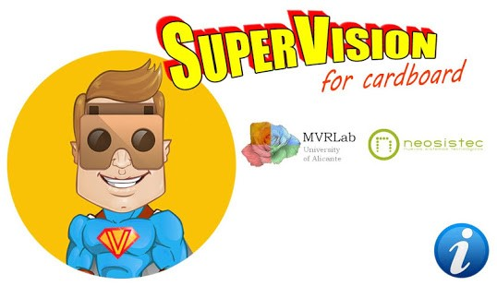
[IMAGE DESCRIPTION: SuperVision App logo. Developed by Mobile Research Lab and Neosistec.]
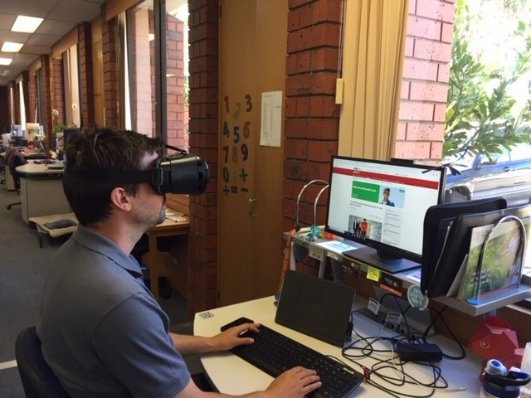
[IMAGE DESCRIPTION: Man sitting at a desk wearing a VR headset looking at computer screen.]

Return to contents

Family Corner: Ways to help with identifying coins
By Alyce Woodruff, Paediatric Occupational Therapist

It's really common for kids to find it tricky to identify the difference between $1 and $2 coins, and 20 cent and 10 cent pieces.

Here are some tips to help with this:
- Have a wallet with two zipped compartments. This will help with organising the coins. For example, $1 coins can be kept in the outside pocket and $2 coins on the inside zipped pocket. This means your child will know where to find each coin and won’t get flustered when they are paying for an item.
- Purchase a ‘coin buddy’ from Vision Australia. These are a small round metal containers with a hole for each type of coin, so your child knows they have one of everything on them.
https://shop.visionaustralia.org/shop/product/coin-buddy-coin-holder
- Your child can use the camera on their mobile or yours to take a photo of the coin and enlarge it.
- Discuss the features of different coins with your children. Think about the shape, weight, thickness and the little ridges around the edge of coins.
Lastly, it is good practice to give your children the chance to pay for things with coins themselves. This gives them the chance to practice money handling and to make sure they give and receive the correct change. It will also build their confidence in talking to sales people and asking for help if they need it.
Return to contents

Electronic signing made easy!
By Danielle Kruger
Everyone knows that the Children’s Mobility Service, and in fact most schools and community organisations, love a bit of paperwork! To make life as easy as possible, we have discovered a couple of tricks to make electronic signing a breeze using email on your smart phone.
For iPhone users:
Using the mail app on your iPhone, open the attached PDF document. Scroll to where your signature is required and then tap on the “pen” icon located at the top right of the screen. This will allow you to sign directly on your screen. You can even save your signature to use for other documents. When finished, tap done and then reply all, and it will attach the signed document ready for you to send straight back.

For Android users:
Search for a PDF signing app in Playstore. Download your preferred choice and then use the app to open any documents or forms that we send you. I used Adobe fill & sign, which allowed me to sign on screen, save a signature and then share the signed document by email or other means.

Return to contents

New O&M Masters students
GDV are pleased to be welcoming three new students into the O&M field and the team at GDV. They start with us on February 11th before heading up to Sydney for their intensive O&M training with Macquarie University/RIDBC for 5 weeks. When they return they will continue to complete the rest of Masters online and be out in the field with our O&M’s, OT’s and Orthoptists doing observations until July. They will each then have a 10 week practicum where they start to run sessions with supervision. You might meet them over the coming months so we wanted to take this opportunity to give you a quick introduction.

Kirstie
I have been a primary school teacher for the last 6 years, mostly teaching students who have English as a second language.
I became interested in O&M work after looking into where teaching could take me, teaching in a different environment.
I am a volunteer for Labrador Rescue where I take in foster Labradors until they find their forever homes.
I also enjoy bikram yoga and spending time with my two Labradors, Humphrey and Buddy.
I am looking forward to this new adventure and the rewarding work to come.

Lachlan
Before joining Guide Dogs Victoria I was as an Allied Health Assistant in a major public hospital, working with incredible clients and their families in the Melbourne CBD. After learning about Orientation & Mobility through my clients and colleagues I discovered the Graduate Program at Guide Dogs Victoria and found it was a great fit. Here, I can do the work I enjoy while still learning and getting to know more wonderful people in the community. I’m really looking forward to working with a great new team and helping others to achieve their Orientation and Mobility goals. I like to spend my spare time outdoors, either camping, hiking or playing sports, especially when my (very spoiled) dog Koby comes with me!

Emma
I have a background in nutrition (experience within an acute hospital setting) and I am keen to explore a new field and create a positive difference in the lives of others. One of my friends currently works as an O&M - hearing about her role fascinated me and I was really excited to find it was role that I would be able to do! My personal interests include fitness (instructing les Mills classes), exploring the food culture of Melbourne (especially brunch) and travelling (my favourite country is Turkey). Both a people person and animal lover (waiting for Guide Dogs Victoria to change me from a cat person to a dog person!), I am excited to start with Guide Dogs Victoria to expand my knowledge, take on new challenges and get out of my comfort zone.
Return to contents

Contact us:
Children’s Mobility Service
Private Bag 13, KEW, VIC, 3101
General Enquiries: 1800 804 805
Facsimile: 03 9854 4466
www.guidedogsvictoria.com.au
Follow us on social media:
Facebook
Instagram
Twitter
LinkedIn
YouTube
Snapchat

Return to contents

Feedback
If you have anything to contribute to this newsletter, please feel free to contact us with your piece. We welcome all contributions. Please either contact or email our client services administration team with your contributions as below: csadmin@guidedogsvictoria.com.au or Phone: 1800 804 805
GetAbout is now coming to you in a digital format. Going digital means our newsletter will be accessible, timely and environmentally friendly. The content of GetAbout has not changed: we will continue to let you know about our upcoming camps and group programs. GetAbout is also available on our website www.guidedogsvictoria.com.au
Alternative formats are still available in audio CD, large print and braille. Please contact us at CSadmin@guidedogsvictoria.com.au or via phone 1800 804 805 to request these formats.
Return to contents

