‘Guide Dogs Victoria’s On the Move – November 2018 Bulletin

Tips for reading this newsletter

If you would like to increase the text size on your screen:
- Using the keyboard
    - Press ALT+W, and then press Q.
    - Press the TAB key repeatedly until the Percent box is selected, and then type a percentage or press UP ARROW or DOWN ARROW to select a percentage.
- Using the mouse
    - On the View tab, in the Zoom group, click Zoom.
    - Click the zoom setting that you want or type a percentage in the Percent box.

Contents
Tips for reading this newsletter 1
Editor’s update 2
Meet Aaron, our Team Leader – Guide Dog Client Services 3
Advice from the Guide Dog Department 5
The Next Generation of Banknotes Have a Tactile Element. 7
Free Bowling for International Day of People with a Disability 8
Feedback 9

Editor’s update

Hi everyone,

With just under a month left until the end of the year, it is a good time to stop, and look back on what you have achieved this year. 2018 has certainly been a big year! We have loved working with you all and seeing many of you at our programs, in training or just chatting on the phone.

This year Financial Year, Guide Dogs Victoria delivered over 2,500 exciting programs for our Clients and ran over 7,500 Guide Dog training sessions.

I am sure it has been an amazing year for you too! I hope that you enjoy the last On The Move for the year.

Just a quick note to let you know that we will close down over the Christmas and New Year period. Our final day is Friday, 21st of December and we return on Monday 7th January. We will have a small number of Customer Service Staff working on all the days (excluding public holidays), so please do call if you require any assistance and we will do our best to assist.

Rosalind McClintock
Bulletin Editor
Return to contents

Meet Aaron, our Team Leader – Guide Dog Client Services
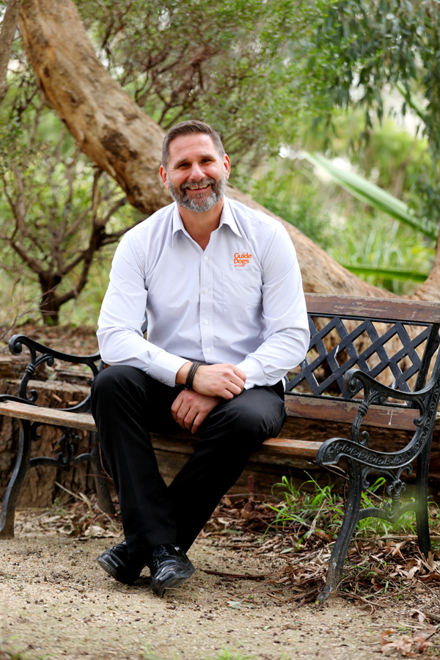
[Image description: Aaron is sitting on a park bench under a tree, smiling at the camera. He has short brown hair and a beard. He is wearing a long sleeved business shirt with a Guide Dogs Victoria logo on it. His hands are crossed at the wrists and his legs are crossed at the ankles]
My name is Aaron Horsington and I have worked at Guide Dogs Victoria for over 11 years. I started my career in the world of Guide Dogs in 1996 with Guide Dogs UK, initially in Exeter and then in Cardiff.
I moved to Victoria in 2007 as a Guide Dog Mobility Instructor preparing Guide Dogs and providing mobility services to GDV’s Client base.
I have worked with a developing school in Singapore to increase their Guide Dog population and raise awareness of the needs of people with low vision or blindness in a country which has historically been reluctant to provide the access rights that Guide Dog handlers enjoy in Australia. I am pleased to report that Singapore has become much more accepting of the Guide Dogs in the community, and their handlers now enjoy a much warmer welcome when they try to access public spaces, retail outlets and public transport.
I have recently taken up the position of Team Leader, Guide Dog Client Services. This role involves working together with the GDV teams and Clients to provide the appropriate services and support to achieve successful Guide Dog mobility outcomes.
Recently, we have experienced the rollout of NDIS in Victoria, which is continuing over the next few months. We can provide information and support to individuals who can access the NDIS through our Support Co-Ordination team. Guide Dogs Victoria will continue to provide services to those individuals who are not eligible to access the NDIS, supported by our philanthropic funding.
If you are interested in learning more about the services Guide Dogs Victoria can provide then please contact 1800 804 805 and discuss the options with our Customer Services Team.
Return to contents
Advice from the Guide Dog Department:
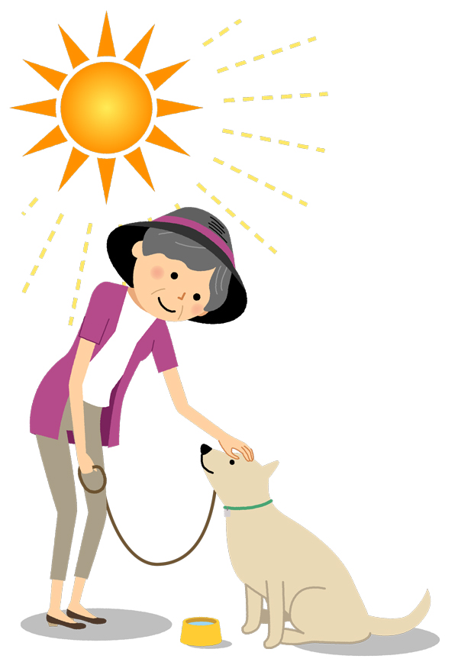
[Image Description: Illustration of a lady in a broad-brimmed hat patting a yellow Labrador under a hot sun. There is a bowl of water at the dog’s feet]
The summer sun isn’t always fun for our pets.
A lot of animals become stressed in the heat. This is not only uncomfortable for the animal, but it can be dangerous and even deadly.
Dogs suffering from heat stress may pant excessively, drool, develop a rapid heartbeat and be restless. Over time, they could become weak and the colour of their gums may change. They may also start to stagger and experience vomiting, diarrhoea or seizures.
Heat stroke is an emergency. Given the seriousness of this condition, it is better to be safe than sorry and have your pet checked out by a vet.
It’s important to plan ahead and take precautions in warmer weather, not just summer.
Before taking your dog out for a walk, check the temperature of the footpaths. If the ground is too hot for you to walk on, it’s too hot for you dog! Stay in shaded areas as much as possible on hot days and try and make regular stops to rest. You can buy portable water bowls in many pet shops that you can fold up and take with you for regular doggy drink stops.
Never, ever leave your Guide Dog, or any animal, in a car unattended in warm weather. Pets can overheat even when the windows are down, or the car is in the shade. It can take just a matter of seconds for an animal to become distressed and even die.
When you are at home, change your dog’s water frequently and ensure plenty of shade is available. Putting ice blocks in your dog’s water bowl, giving them a wet towel to lay on and allowing them to paddle in a plastic clam shell children’s wading pool (available from hardware shops), will also help to keep your dog cool.
With some planning and consideration, we can safely enjoy the warmer weather together.
Return to contents

The Next Generation of Banknotes Have a Tactile Element.

The new $50 banknote has entered the market, marking a milestone in the upgrade of Australia's banknotes.

The $50 is the most widely circulated banknote, accounting for nearly half of the total value of banknotes in use, and it is the denomination primarily used in ATMs.

The new $50 is the third denomination in the new series of banknotes and follows the release of the $5 and $10 over the past two years. The new $20 is expected to be issued in 2019 and the new $100 in 2020.

Importantly, the new note has a ‘tactile’ feature to help people with low vision or blindness to distinguish between different denominations of banknotes. On the $50 banknote, this is four raised bumps on each of the long edges of the banknote.

The new $50 retains the basic design elements from the previous series. It features portraits of Aboriginal writer and inventor, David Unaipon, and Australia's first female Member of Parliament, Edith Cowan. They were both campaigners for social change and their work is recognised in several design elements on the banknote. The microprint includes excerpts of Unaipon's book, Legendary Tales of the Australian Aborigines, and Cowan's first speech to the Western Australian Parliament.
The new banknote also has the same security features as the $5 and $10 to deter counterfeiting. It has a top-to-bottom clear window that contains a number of dynamic features including a reversing number and flying bird, as well as microprint and a patch with a rolling colour effect.
As with any new banknote release, it will take time for the new banknotes to be widely available. While the existing series of banknotes will be progressively withdrawn from circulation, they will retain their legal tender status and can continue to be used.

Return to contents

Free Bowling for International Day of People with a Disability

Zone Bowling are offering FREE bowling for disabled persons and their carers from 10am – 3pm on Monday 3 December, International Day of People with a Disability. Make sure to book to secure your lane - simply just fill out the form via this link https://www.zonebowling.com/bowling-activities/people-with-a-disability and someone will get back to you with a confirmation!
Return to contents

Feedback
If you have anything to contribute to this newsletter, please feel free to contact us with your piece. We welcome all contributions.

Please either contact or email our client services administration team with your contributions as below:
info@guidedogsvictoria.com.au or phone 1800 804 805.
Return to contents

