Guide Dogs Victoria’s On the Move – February 2017 Bulletin

# 

# Tips for reading this newsletter

If you would like to increase the text size on your screen:

* Using the keyboard
  + 1. Press ALT+W, and then press Q.
    2. Press the TAB key repeatedly until the **Percent** box is selected, and then type a percentage or press UP ARROW or DOWN ARROW to select a percentage.
* Using the mouse
  + 1. On the View tab, in the Zoom group, click Zoom.
    2. Click the zoom setting that you want or type a percentage in the Percent box.

Contents

Tips for reading this newsletter 1

Editor’s update 2

Upcoming programs and events for your diary 3

Guide Dogs Victoria are revving up in March to ‘Supercharge the senses’ and you can win one of 4 amazing experiences! 7

Any one for tennis? 11

Better assistance for commuters with low vision or blindness in and around Frankston Station 13

Guide Dog Healthcare Update: Working with your Guide dog in hot weather! 16

New for our Guide Dogs – NexGard replaces Frontline as our preferred flea and tick treatment 18

Share your story 19

Feedback 20

Return to contents

# Editor’s update

Welcome to ‘On the Move’ – 2017! I can’t believe that we are over halfway through summer already, Christmas seems a long time ago! I hope that you all had a wonderful holiday season.

We have an exciting year ahead. The big news for all revheads is that GDV has been selected as the charity for the 2017 Formula 1® Rolex Australian Grand Prix. It’s a great opportunity for us to join forces with another iconic Australian brand in raising awareness about living with low vision or blindness and how the public can help. The Grand Prix is so much more than just a visual event. It supercharges all your senses, from the screeching of the tyres to the adrenaline that can be felt trackside. For people with low vision or blindness, other senses (such as sound and smell) are a major component of their lives, and we plan to use the event to demonstrate how our clients adapt and make the most of all their senses to experience life.

We have a wonderful opportunity for 4 clients to win an awesome race experience at the Event – see later in this newsletter for details of how to enter. I hope you will all have a go!

Enjoy On the Move, and do get in touch with your stories – we love to hear them!

Sophie Wild

Bulletin Editor

# Upcoming programs and events for your diary

* **Our Choice Expo for Bendigo & surrounds:** 16th March 2017 10am-5pm, Bendigo Exhibition Centre, Prince of Wales Showgrounds. Run by VALID to empower people with disabilities to know what support is available in their community. Come and visit the Guide Dogs Victoria stand and talk with our experts about the upcoming NDIS and how we can help. Make connections with a huge range of organisations that can support with equipment & assistive technology, therapeutic supports, accommodation & housing options, rights & complaints info, personal care & community access. Entry is free and you can find out more at   
  <http://www.valid.org.au/expo/ourchoice_bendigo_flyer.pdf>
* **Personal Safety Concepts**: 28th March 2017, 9.30am-3.30pm. Aiki-Centre, 44 Lynch Street, Hawthorn. “A practical event facilitated by Catherine Schnell of Aiki-Centre, Hawthorn. An opportunity to understand, develop and practice personal safety skills to support safe independent mobility”.

Please reserve your place by emailing [CSAdmin@guidedogsvictoria.com.au](mailto:CSAdmin@guidedogsvictoria.com.au) or call 1800 804 805.

* **Meet Melbourne**: 27 – 28th June. Lock this one in! Two days, one night, and a whole lot of Melbourne Mobility Mischief! Contact [CSAdmin@guidedogsvictoria.com.au](mailto:CSAdmin@guidedogsvictoria.com.au) or call 1800 804 805.
* **Come Fly with Me** – sometime in August 2017 – a blue sky idea that we’re hoping to get off the ground!! Watch this air space…
* **Understanding Vision Impairment and Acquired Brain Injury** – 22nd February, 24th May, 23rd August and 8th November. A one-day information program for people with vision changes secondary to an acquired brain injury (ABI).  The day will aim to help you and your family gain an understanding of how vision can change following an ABI, such as stroke, accident, surgery, tumour or other brain injury.  It will investigate how changes to the brain’s function can impact on mobility in unexpected ways.  The day will also provide an opportunity to share experiences with people of all ages, and their families, who have low vision or blindness from an ABI. Places are limited to so please book your place by emailing [CSAdmin@guidedogsvictoria.com.au](mailto:CSAdmin@guidedogsvictoria.com.au) or call 1800 804 805.
* **Young Adults Program (YAP):** Connecting young people (approximate age 18-30) with low vision or blindness for discussions and fun activities. YAP sessions run bi-monthly throughout the year. Contact [rachelh@guidedogsvictoria.com.au](mailto:rachelh@guidedogsvictoria.com.au) for more information.

**You’re invited! Social events**

* **Coffee mornings every Friday in the Frankston area.** If you enjoy having a cuppa and meeting new friends, please join our casual client run coffee mornings. New members always welcome. For details please contact Robert on 0409 685 606 or email [rgsblind@yahoo.com.au](mailto:rgsblind@yahoo.com.au)

Following on from the success of our Frankston Coffee Club, we are currently canvassing interest **in similar programs being run in Mornington and Pakenham.** These catch-ups are a great opportunity to meet up and discuss topics such as transport, technology, the NDIS roll-out as well as a great excuse to have a chat and great coffee! If you or someone you know might be interested or has any further questions, please contact Tim Carter on (03) 9854 4448 or by email at [timc@guidedogsvictoria.com.au](mailto:timc@guidedogsvictoria.com.au)

**National Insurance Disability Scheme Update:**

TheNDIS is tending to phase rollouts slower than expected. It is looking to produce smaller ‘My First Plans’ as an initial step with the aim of making applying quicker and easier. We can help you through your application. The following areas have or are close to rolling out. If you believe you are NDIS eligible and live in one of these areas contact our Customer Service staff on [csadmin@guidedogsvictoria.com.au](mailto:csadmin@guidedogsvictoria.com.au) or call 1800 804 805.

* Zones already launched: Barwon (Greater Geelong, Colac Otway, Surfcoast, Queenscliff), North East Melbourne (Banyule, Darebin, Nillumbik, Whittlesea, Yarra) and Central Highlands (Ararat, Ballarat, Golden Plains, Hepburn, Moorabook, Pyrenees)
* Launching 1st May 2017: Lodden (Campaspe, Central Goldfields, Greater Bendigo, Lodden, Macedon Ranges, Mount Alexander).

**Are you suffering from diabetes or diabetes-related vision loss?** Come the Diabetes Expo 2017 on Saturday 25th February at the Melbourne Exhibition and Convention Centre. There will be speakers, expert exhibitors including Guide Dogs Victoria Occupational Therapists, and cooking demonstrations. Diabetes Victoria members/kids under 17 attend free, otherwise $25 entry. Find out more at <http://campaign.diabetesvic.org.au/Expo>

Return to contents

# Guide Dogs Victoria are revving up in March to ‘Supercharge the senses’ and you can win one of four amazing experiences!

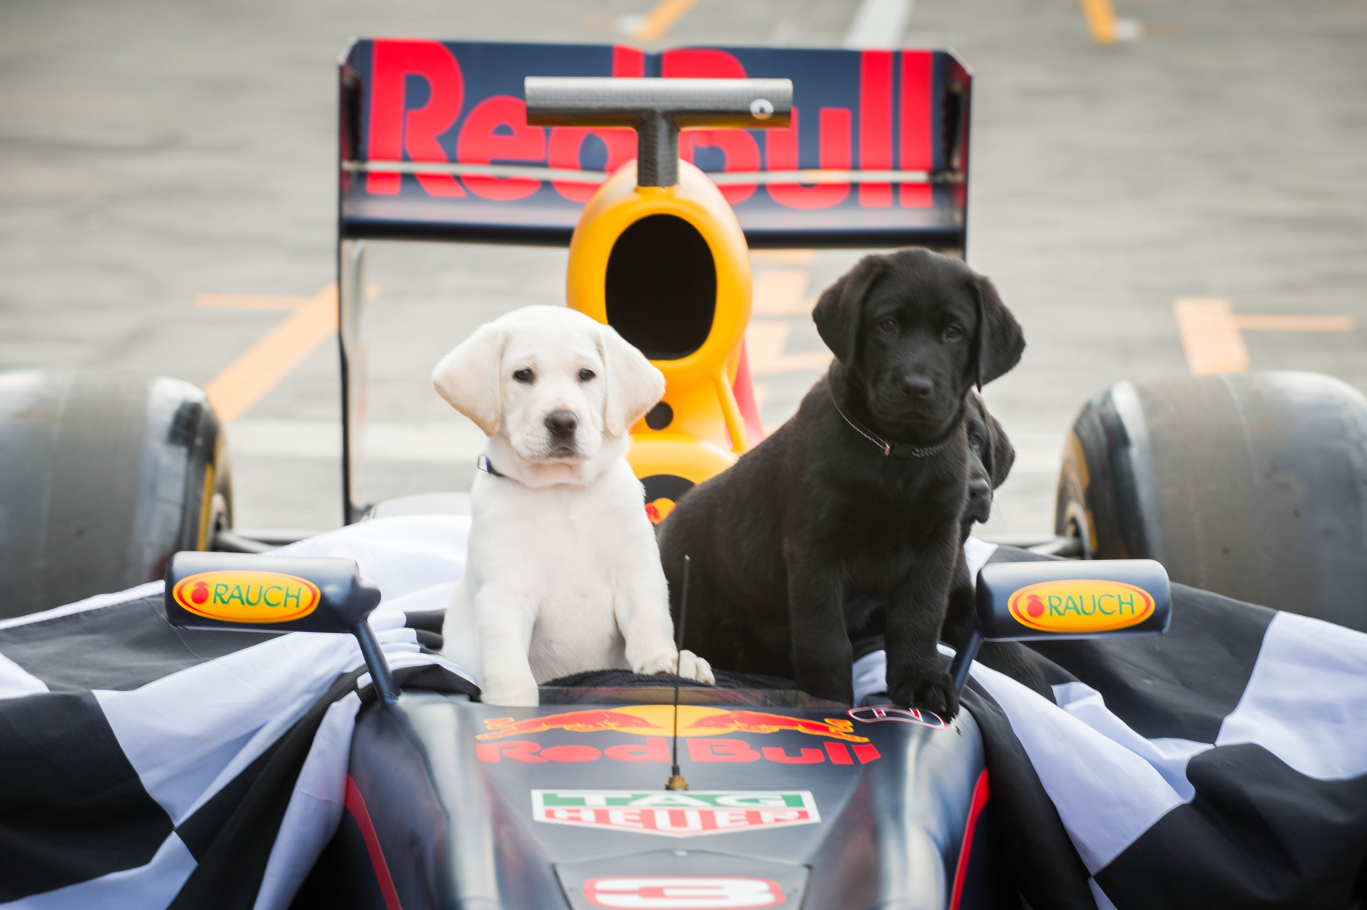

(photo description: blonde pup Kovu and black pup Kosta sitting in a Formula 1 car)

Guide Dogs Victoria are thrilled to be the charity of the 2017 Formula 1® Rolex Australian Grand Prix. As a national event this will be done under the banner of Guide Dogs Australia but Guide Dogs Victoria will organise all the activity.  All funds raised will go directly towards the training of more Orientation & Mobility Specialists so we can help more people.

Join in the fun by winning one of 4 amazing experiences!

1. **A chance for 2 lucky GDV clients to win the experience of a lifetime!**

The Australian Grand Prix Corporation has donated 2 amazing experience prizes for our clients. These are two ‘behind the scenes’ experiences. Clients of any age can enter this competition. Prize includes a General Admission ticket for 1 full day’s entry to the 2017 Formula 1® Rolex Australian Grand Prix for each prize winner and up to 2 accompanying adults.

1. **A chance for 2 lucky GDV clients to win a ride in the Ferrari Parade**

The Ferrari Club of Victoria has donated 2 passenger places in two separate Ferraris in the 2017 Formula 1® Rolex Australian Grand Prix Ferrari Parade, 11.30am to 11.50am on Saturday, 25 March. You must be over 18 years old and willing to participate in this experience as a passenger and unaccompanied. You will be required to have a BAC (blood alcohol concentration) reading of 0.0% to participate in this cavalcade. Prize includes a General Admission ticket for 1 full day’s entry to the 2017 Formula 1® Rolex Australian Grand Prix for each prize winner and 1 accompanying adult.

**All entries will go into a draw to win 1 of 38 General Entry tickets:** drawn in reverse for Sunday 26th entry (10 tickets), Saturday 25th entry (8 tickets), Friday 24th entry (10 tickets), Thursday 23rd entry (10 tickets).

**How to enter**

All you have to do to enter is to:

1. Tell us which prize you want to win (Behind the scenes or Ferrari ride).
2. In 150 words or less, tell us why you should win that prize! The more passion and enthusiasm you can communicate for the 2017 Formula 1® Rolex Australian Grand Prix /cars in general/or the reasons why you want to go the better!
3. Please add your name, address, email, phone number. Check the competition terms and conditions below and state that you agree to them.

Entries can be submitted by writing a short letter or email, or making a short video or audio recording.

Send entries to:

[CSAdmin@guidedogsvictoria.com.au](mailto:CSAdmin@guidedogsvictoria.com.au)

or by posting to:

Evan Gordon

Guide Dogs Victoria

2-6 Chandler Highway

Kew, Victoria 3101.

Guide Dogs Victoria must receive all entries by 5pm on Friday, 3rd March 2017. No late entries will be considered.

Guide Dog Handlers please note: Due to the trackside environment & noise Guide Dogs should not be brought to the Event – Guide Dog users will need to use alternative travel aids such as long canes or assistance from family or friends.

The Australian Grand Prix Corporation (AGPC) & Guide Dogs Victoria (GDV) Experience of a Lifetime Competition/Ferrari Club of Victoria & GDV win a Ferrari Ride Terms & Conditions:

‘Behind the scenes Experience’ winners can choose a day to attend out of 23rd March, 24th March or 25th March.

Ferrari Ride winners must attend on the morning of Saturday 25th March.

Only people who are or who have been Guide Dogs Victoria clients may enter this competition.

One entry is allowed per person.

The entries will be judged by a panel of staff from Guide Dogs Victoria, and the Australian Grand Prix Corporation (Behind the Scenes) or Ferrari Club of Victoria (Ferrari Ride). General Entry tickets will be drawn blindfolded by Evan Gordon of GDV at the GDV premises on Friday 10th March.

The judges’ decision will be final and no correspondence will be entered into.

The prizes have no monetary exchange value and will not be exchanged for money, and cannot be transferred to other people (unless authorized by GDV).

Paid employees of Guide Dogs Victoria and their families are not allowed to enter.

Competition closes 5pm on Friday 3rd March 2017. No entries will be considered after this time. Competition winners will be notified by Monday, 13th March 2017.The winners’ names will be published on the GDV website on the 15th March 2017.

Competition winners agree to GDV and/or AGPC and/or Ferrari Club of Victoria publishing their entry and images, and agree to being interviewed about their experience.

Competition entrants’ details will not be used for any other purpose.

Competition winners agree to abide by the conditions of entry into the Event available at [www.grandprix.com.au](http://www.grandprix.com.au).

# Any one for tennis?

# 

Guide Dogs Victoria is delighted to share the news that client Adam Fayad has been selected to represent Australia in the first ever International Blind Tennis tournament taking place in Great Britain during April 2017.

Adam has been a lifelong fan of tennis, and originally gave it a go at his school tennis club.

After a spell at GDV in Arnold Cook House training with his Guide Dog Ivory, Adam realised that he could try Blind Tennis. This was only 4 years ago, and since then Adam has gone from strength to strength. Playing opponents with a similar vision level makes the game far more exciting and competitive, and Adam would urge anyone with low vision or blindness thinking about taking up a sport to try Blind Sports.

To find out more please email [info@blindsports.org.au](mailto:info@blindsports.org.au).

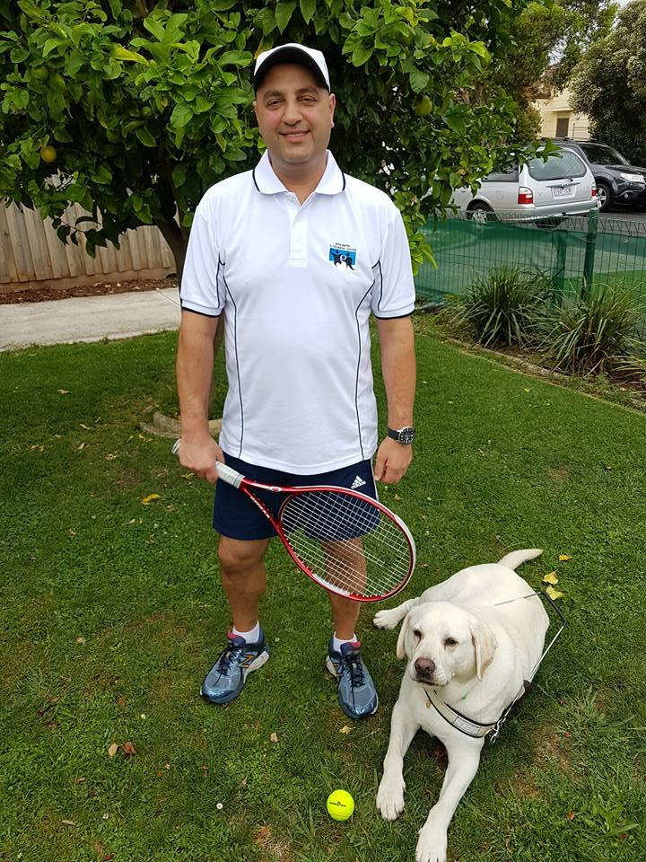

(photo description: Adam dressed for tennis with racquet and ball, and Guide Dog Ivory)

About blind tennis:

* **How is blind tennis possible?** Scientists have found that the visual cortex—the part of the brain that processes what your eyes see—can also process auditory and tactile information. Put another way, it is possible to retrain the brain to ‘see’ objects in space using other senses.
* **Sport modifications**. A foam tennis ball with ‘rattling’ bearings in it; a smaller court with tactile raised lines, a lower net and shorter racquets; players are allowed up to three bounces, depending on the severity of the visual impairment.
* **Blind tennis history.** The sport was founded in 1984, when a blind Japanese teenager named Miyoshi Takei designed the first sound-adapted tennis ball. His dream was to spread blind tennis all over the world.

(information taken from <http://www.tennis.com/your-game/2014/12/blind-ambition/53376/>)

Return to contents

# Better assistance for commuters with low vision or blindness in and around Frankston Station

Guide Dogs Victoria has teamed up with VicRoads and the Department of Economic Development, Jobs, Transport and Resources as part of the Young Street Improvement Project to better assist commuters with low vision and blindness in Frankston.

With works underway on the project to create a high quality pedestrian streetscape linking to the Frankston Station, Guide Dogs Victoria are training customer service staff to assist commuters who may need assistance with mobility to support them to interchange between trains, buses and taxis throughout the Young Street Improvement Project.

Guide Dogs Victoria CEO Karen Hayes said the construction site could present some complexities for pedestrians, particularly those with low vision, blindness and the elderly.

“VicRoads is working with Guide Dogs Victoria and Vision Australia to identify how we can safely move pedestrians through the work site, which is the transport hub for Frankston,” Karen Hayes, CEO Guide Dogs Victoria said.

“One of the key recommendations was the need to have customer service staff on the ground, and we have recently trained staff members to provide this guidance to pedestrians.

“Next month, we will also provide training to staff on the Young Street project, who will be able to implement these skills at future pedestrian improvement projects,” Karen Hayes CEO Guide Dogs Victoria said.

VicRoads Project Director Brendan Pauwels said the engagement of customer service staff has left positive impressions with commuters.

“By having customer service officers available, we can better assist people interchanging between bus, train and taxi services, and this is important in ensuring all commuters have access to public transport.”

**The Customer Service Officer (Mobility Assistance) will be available Monday to Friday 8am to 6pm and weekends and public holidays 9am to 6pm. The Customer Service Officer will be contactable through calling 0402 351 491.**

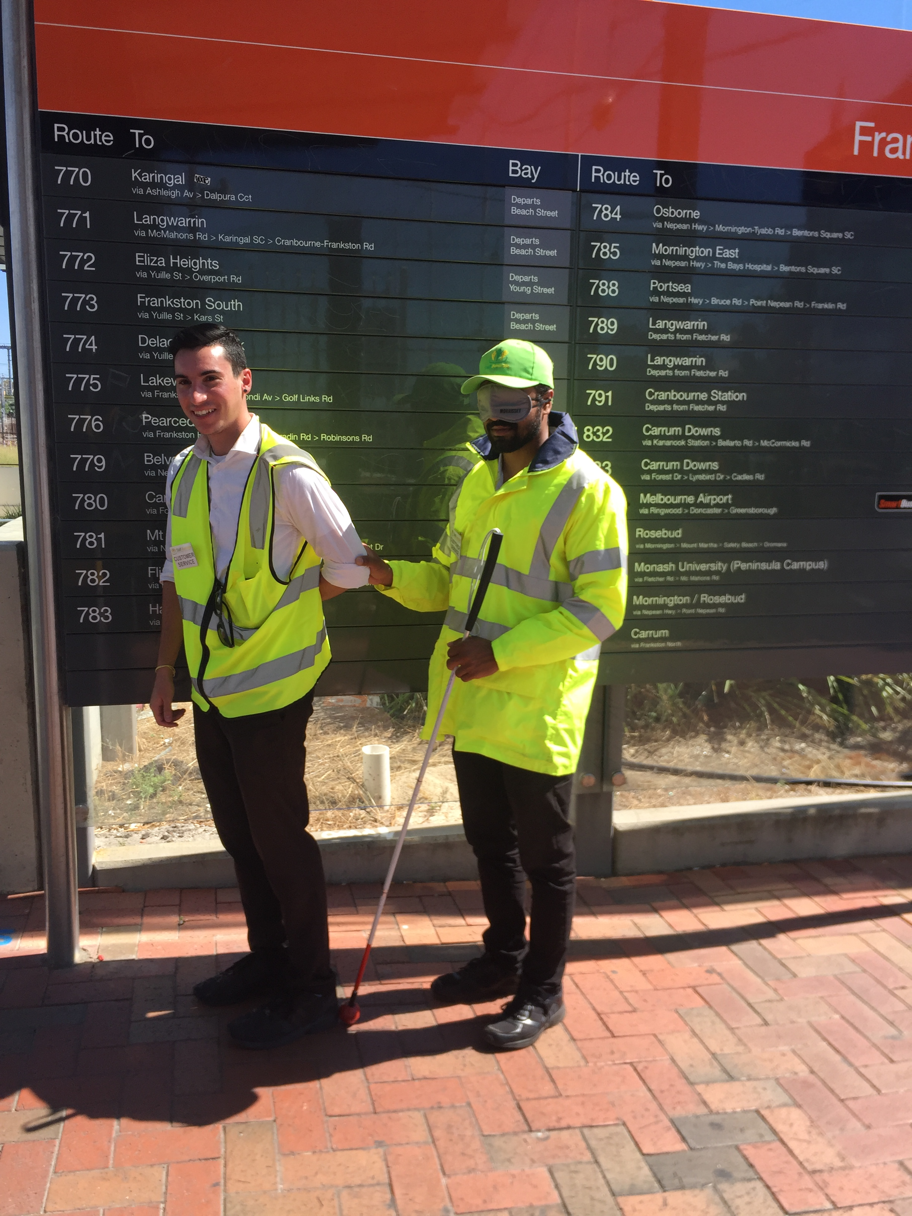

Photo description: Customer Service Officer training to be a sighted guide for a long cane user in front of Bus Bay Notice Board

Return to contents

# Guide Dog Healthcare Update: Working with your Guide dog in hot weather!

With the hottest month of summer on us, we thought it might be timely to remind all Guide Dog users of the dangers of working with your Guide dog in hot weather, along with some guidance on how you can best reduce any risk. These guidelines have recently been reviewed and a fuller article can be downloaded from the GDV website at: <https://www.guidedogsvictoria.com.au/about-gdv/fact-sheet/>

**KEY POINTS TO REMEMBER:**

* In hot weather, dogs are at risk of dehydration, heatstroke and hyperthermia (elevated body temperature).
* Do not work your dog when it is over 32 degrees centigrade. You will need alternatives like your long cane.
* A simple test to determine if it is too hot to work your dog is to place your flat hand palm down on the pavement. If you cannot hold your hand there for longer than five seconds, it is too hot to work the dog.

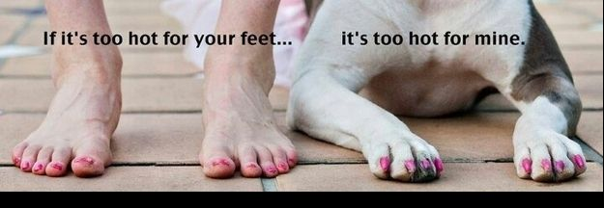

(photo description – picture of person’s bare feet next to dog’s paws with caption “If it’s too hot for your feet it’s too hot for mine”

**STEPS TO PREVENT HEAT STROKE INCLUDE:**

* + - Modify your routes in hot weather to incorporate public transport and shaded areas.
    - Take a taxi to your destination if possible.
    - Always carry water with you in warmer weather and stop in shade to give the dog rest and an opportunity to drink.
    - Travel earlier in the morning or later in the evening on hot days.
    - If you must go out in the middle of the day and it is very hot, leave your dog at home with access to water and shade if possible or with a carer.
    - Restrict exercise activity in warmer weather.
    - Never leave your dog alone in a car.

**IF THE DOG DOES SHOW SIGNS OF HEAT STRESS:**

* + - Immediately remove the dog from the heat into air-conditioning or shade.
    - Wet the dog with cool but not chilled water and wet the area around the dog.
    - If the dog is showing severe signs of heat stress see the vet immediately.
    - Even if the dog shows signs of recovery after being cooled down, you should still see check with a vet as soon as possible.

Return to contents

# New for our Guide Dogs – NexGard replaces Frontline as our preferred flea and tick treatment

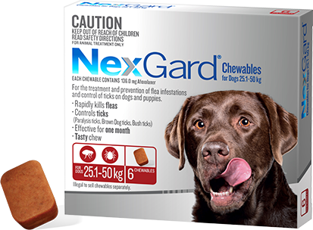

(photo showing a packet of NexGard chewables, with an enlarged chewy tablet.)

Our flea treatment sponsor Merial has released a new premium flea treatment called NexGard, which GDA now has access to free of charge.

All clients with Guide Dogs will now be sent NexGard instead of Frontline (with exceptions for dogs allergic to chews).

NexGard is an oral flea and tick treatment and preventer. You just give your dog one of the tasty chews each month – we recommend the 1st of each month for ease of remembering, along with their monthly heartworm chew. Giving a chew is easier than spotting on the Frontline drops, and if your dog gets wet or needs a bath it won’t decrease the effectiveness.

NexGard protects against fleas, paralysis ticks, brown dog ticks and bush ticks.  In Victoria, the distribution of the paralysis tick is primarily in the east Gippsland region, which extends from the east coast as far inland as Bairnsdale and Omeo, but there have been cases of ticks in Melbourne suburbs. If you are in a paralysis tick area, you should ideally try to check your dog for ticks daily. A ‘feel’ test is much more thorough than a visual check and your dog will love the pat! Run your fingertips firmly across its skin, checking for any small lumps on the surface. Pay particular attention to the head and neck. Make sure you check those easy-to-miss spots such as between the toes, the ears, under the collar and on the inside leg.

Return to contents

# Share your story

If you have a story you’d like to share about your low vision or blindness, your achievements, your experiences with our services or being matched with your Guide Dog, we’d love to hear from you. The marketing team are always on the lookout to feature our client’s stories in the media, to help spread the word about the wonderful work of Guide Dogs Victoria and to increase public awareness about people living with low vision or blindness. If you are comfortable with sharing your story, please email the marketing team at [marketing@guidedogsvictoria.com.au](mailto:marketing@guidedogsvictoria.com.au)to get in touch.

# Feedback

If you have anything to contribute to this newsletter, please feel free to contact us with your piece. We welcome all contributions.

Please either contact or email our client services administration team with your contributions as below:

[csadmin@guidedogsvictoria.com.au](mailto:csadmin@guidedogsvictoria.com.au) or phone 1800 804 805.

Return to contents