Guide Dogs Victoria’s On the Move – November 2016 Bulletin

Tips for reading this newsletter

If you would like to increase the text size on your screen:
- Using the keyboard
    - Press ALT+W, and then press Q.
    - Press the TAB key repeatedly until the Percent box is selected, and then type a percentage or press UP ARROW or DOWN ARROW to select a percentage.
- Using the mouse
    - On the View tab, in the Zoom group, click Zoom.
    - Click the zoom setting that you want or type a percentage in the Percent box.

Skip to contents

Contents
Tips for reading this newsletter 1
Editor’s update 2
Upcoming programs and events for your diary 3
Guide Dog Healthcare Update: Good Dental Care 8
International White Cane Day 2016 and reflections from Pari 10
#Open Doors – the new accessibility campaign from the Taxi Services Commission 13
The new $5 banknote hits the accessibility mark 15
Share your story 16
Feedback 16

Return to contents

Editor’s update

Christmas is nearly here and our client Christmas Party is planned for the afternoon of 26th November (note change of time to afternoon from October’s On The Move invite). We would love to have as many of you join us as possible, so put it in your diaries!

Thank you so much to the clients who helped with our ‘Why Wait’ survey and client stories last month. This survey revealed that around one third of people wait before seeking any help at all once they start suffering vision loss, and a staggering 16% of people took 10 years to get to Guide Dogs Victoria. We know from your feedback that the longer people wait to get help the more confidence and independence they lose. Many of our survey participants wished they had got help sooner. We had a lot of media coverage and hopefully prompted many people who may be delaying seeking help with low vision to think again and start to reclaim their independence and confidence. Our clients are our most powerful voices, so if someone you know is experiencing vision loss please tell them to get in touch with us, we can help!

Finally, a reminder to give us your email address if you have one, and to regularly check into our website – www.guidedogsvictoria.com.au - to see the latest news and events. All bulletins including On the Move are available on our website.

Happy reading!

Sophie Wild
Bulletin Editor

Upcoming programs and events for your diary

All clients:
- Live Safe Travel Smart – Travel Series:– Final session of the year Thursday 10th November. Contact CSAdmin@guidedogsvictoria.com.au

- Try Before You Ride – build up your public transport confidence & skills:- Practice how to board and alight a V/Linetrain, coach and low floor bus. Thursday 24 November, 11:00am to 2:00pm at Seymour Railway Station. RSVP: Friday 18 November 2016 by phoning Tessa on 03 9619 5900 or emailing community.relations@vline.com.au

- Understanding Vision Loss and Acquired Brain Injury – Wednesday 9th November. Contact CSAdmin@guidedogsvictoria.com.au

Dog Handlers:
- Guide Dog Handler’s Traffic Refresher workshops – Friday 25th November, 9.30am-3pm. Cost $10. Numbers are limited so enquire direct with Jenny Black – 9854 4473 or jennyb@guidedogsvictoria.com.au

Children’s and Youth Services:
- Young Adults Program (YAP) Save the Date – Thursday 8th December 5.30pm, CBD venue to be confirmed: Connecting young people (approximate age 18-25) with low vision or blindness for discussions and fun activities. Contact rachelh@guidedogsvictoria.com.au for more information.

You’re invited! Social events

- Client Christmas Party – note change of time to afternoon: 26th November 1-3pm. We would love all clients and their families to join us for a festive celebration of another year of wonderful programs and progress. Catch up with old friends, meet some new ones and share some Christmas cheer. A lavish GDV afternoon tea complete with mince pies will be provided, and rumour has it even Santa will be popping along! RSVP to CSAdmin@guidedogsvictoria.com.au by 20th November. (photo: Christmas pup images)
- Friday Coffee Club is going strong! Coffee mornings every Friday in the Frankston area. This is a casual client run event, driven by the client group. If you enjoy having a cuppa and meeting new friends, please join us. New members always welcome. For details please contact Robert on 0409 685 606 or email rgsblind@yahoo.com.au

Sport activities Notice Board (please note the following activities are not organised or run by GDV and GDV staff will not be present):
- Blind Football (Soccer) special events - Children and adults of all abilities and level of experience are invited to participate in Blind Football (soccer) in November and December this year, as part of a program run by Blind Sports Victoria, Football Federation Victoria and Social Goal. Blind Football is open to everybody with vision impairments of any kind. It is played with an audible ball which makes a rattling noise, allowing players to locate it by sound. Our two special events are:
  - November to December, a 5-week training program in B1 Blind Football, the Paralympic version of soccer for all people aged 16 or above. When: every Sunday - 6th November to 4th December, 2-4pm at Docklands Multi-purpose Sports Field, Harbour Esplanade between Collins St and Bourke St. Cost: $30 for new participants
  - Blind Football Gala Day - Adults and Children of all abilities welcome – Saturday 10th December 3-5pm, CB Smith Reserve, Fawkner. To celebrate International Day for People with a Disability, come along and give Blind Football a go and watch some players in action. Including free Mini Roos Clinic for children aged 4-12 of all abilities at 3pm Click here to register your child; free Adults 'Come and Try' session for Blind Football and Melbourne blind football team exhibition match and demonstration (no registration required)
Enquiries: Megan Smith, Football Federation Victoria. Phone: 03 9474 1805, Email: msmith@ffv.org.au Website: http://www.footballfedvic.com.au/access-all-abilities/blind-football/

- SWISH – table tennis for people with low vision or blindness. Entrants sought for the inaugural Ray Hannah Swish Victoria cup – Saturday 26th November from 9am. This tournament is a doubles only competition and entry is $10.00 which includes entry into the tournament, lunch and a drink. Entries close COB 12th November. For more information phone 0412 128 429 or email secretary@swishvictoria.org
- Vision impaired kayaking expedition in Tasmania - 18 March 2017 – 25 March 2017; cost approx. $3250 per person. Expedition is open to anyone over the age of 16 irrespective of vision levels. Friends, family and partners welcome. No experience, but moderate fitness required. See more at http://www.roaring40skayaking.com.au/7-day-sea-kayak-expedition Or contact (Eion Jennings) either by email at couchtokayak@outlook.com

- Achilles Running Club: If you would like to give running a go, and have any level of vision loss, come along. We pair runners with vision loss with sighted guides. We have plenty of helpers but would love more runners. Meets every Sunday morning at 8:30am at the Tan running track in Melbourne CBD. Contact Amanda Kwong at achillesmelbourne@gmail.com; 0468 373 373; http://www.achilles-sydney.org.au/melbourne.html, or on Facebook (Achilles Melbourne) for further information about running/walking with us or volunteering with us.

Return to contents

Guide Dog Healthcare Update: Good Dental Care

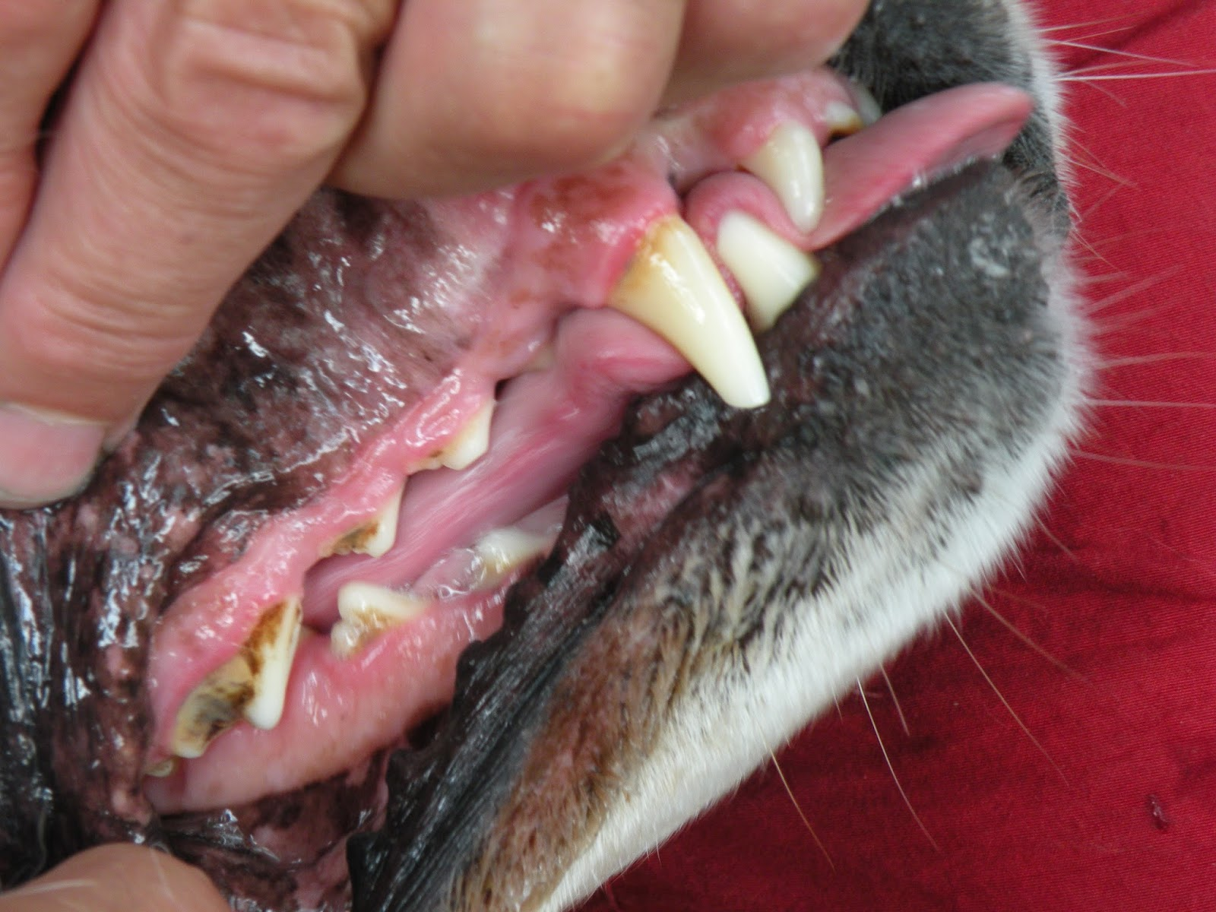
(Photo – Labrador with plaque and tartar showing on teeth)

Four out of every five dogs (and cats) over the age of three years have some sort of dental disease, broken teeth or sore gums, which becomes more severe with age. This can be a real issue because it can lead to more serious problems such as infection, and illnesses related to the heart, liver and kidney. It’s important to try and check your Guide Dog’s teeth regularly as they often won’t show pain. Even Guide Dogs with sore gums, an infected mouth or broken teeth will continue to eat so you may not notice they have problems.

How to identify dental problems:

Signs of toothache or an infection in the mouth to look out for in your Guide Dog include red and inflamed gums and stained teeth. If your vision loss means you can’t check these maybe get a friend to check. You certainly might notice the other major symptom of dental problems – consistent bad breath in your Guide Dog is often a give-away! Your Guide Dog may also start dropping food when he or she is eating.

Your Guide Dog will also get a teeth exam at his or her annual vet health check. Annual dental checks are an ideal opportunity to find out if your dog has an existing problem which has gone unnoticed. Dental checks also help ensure bacteria and poisons from dental infections do not spread to the heart, liver and kidneys through the bloodstream.

You can also have a go at regular tooth brushing. Tooth brushing is safer and more effective than chewing and many Guide Dogs enjoy having their teeth brushed, especially if started when they’re young. You can use a regular toothbrush – just make sure it has soft bristles – or you can buy special pet toothbrushes from most pet shops – these go over your finger so make it very easy to use. DO NOT USE HUMAN TOOTHPASTE as this has fluoride in which is bad for dogs. You can buy dog toothpaste or just water is fine.

If you do have problems cleaning your Guide Dog’s teeth don’t despair, there are special rawhide treats or dog chews which can also help. We encourage you to feed your Guide Dog a good quality dry kibble, and no sugary treats. As always, if you have any specific concerns you should contact your regular vet.

(Photo – special pet toothbrush)

Return to contents

International White Cane Day 2016 and reflections from Pari

We know the importance of regular eye checks for preventing many forms of vision loss, but for the significant number of Australians for whom vision loss is permanent, early intervention is also critical. With appropriate support the outlook is very positive and people can maintain their independence and live the life they want. We celebrate those achievements and the courage and independence of our clients on International White Cane Day. Our aim at GDV is to help our clients get out and about when they want, where they want, how they want, so they can live the life they want to lead.

International White Cane Day 2016 saw a group of clients and GDV staff gather in Melbourne’s CBD to spread the word -– Don’t delay, seek help today.

Pari is one of the clients who joined us, and these are her reflections on International White Cane Day 2016.

“International White Cane Day hit a high note. The day took place on Friday the 14th of October 2016 at the Melbourne Central Business District. (Cbd.)
I've purchased a Trekker Breeze Plus which is a standalone Global Positioning System (GPS) device for people who are blind, from Humanware. I can create and record landmarks and routes at the same time while travelling. I'm using it to travel independently.
But I don't travel alone today, I travel with family members so we can all enjoy a day in the city.
Unfortunately, the trains, the buses and the trams have been delayed so we caught a taxi to Federation Square where we met the group from GDV. We enjoyed the walk and tram ride though the city with the group, and then morning tea.
Then we went to China Town for another walk. We had lunch together at Hungry Jacks followed by our final stop to Melbourne Central shopping centre. We also ordered teriyaki for dinner.
I loved it, it was so much fun.
At the Melbourne Central shopping centre we went up and down the escalators and the lifts which was definitely my favourite part and many other things.
The day was busy but it was very enjoyable. We did so much. After our journey to the city we caught a taxi back home to have a rest.
I'd like to thank my Mum for attending the program for the day. And thanks to Naomi and the team at GDV for organising a special trip to the city to celebrate International White Cane Day.
I’m looking forward to doing more travel like this, and going along to the GDV Christmas party!”
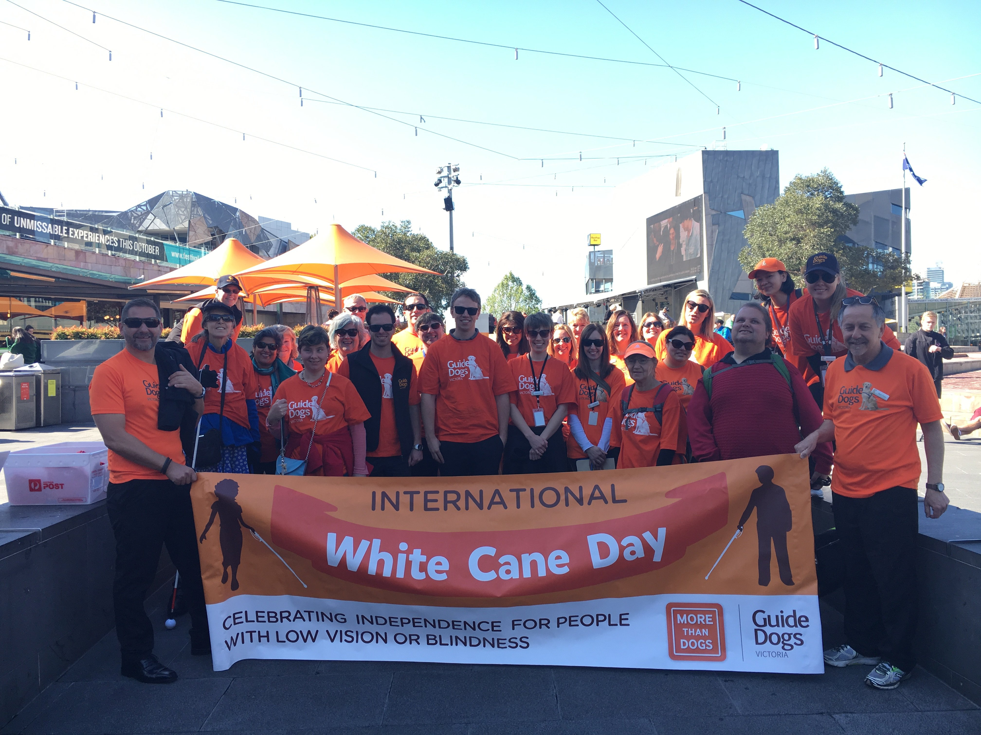
(photo - GDV clients and staff gathered at Fed Square to start the walk, behind a orange and white International White Cane Day banner)

Return to contents

#Open Doors – the new accessibility campaign from the Taxi Services Commission

The Taxi Services Commission has developed an accessibility campaign called Open Doors. This aims to educate taxi drivers about their legal responsibilities to take all passengers with disabilities, including people who need support from an assistance animal, and provide information to passengers about what rights they have or what service levels they should expect when travelling in taxis.

Below are some common questions asked regarding how assistance animals must travel in taxis and the rights and obligations of passengers and drivers:
Q: Are assistance animals required to carry identification?
A: If an assistance animal is not wearing a jacket or badge for identification, a driver can lawfully ask for evidence that it is in fact an assistance animal, as drivers who transport animals that are not assistance animals can be fined. Please help taxi drivers by providing this information when asked.
Q: Do assistance animals need to sit in the back of the taxi?
A: No, although if a taxi driver is uncomfortable around dogs, it is helpful to offer to sit in the back of the taxi if possible and ensure your assistance animal is facing away from the driver.
Q: Can drivers refuse to take an assistance animal for any reasons (cultural, religious, allergy)?
A: It is illegal to refuse service to passengers with assistance animals. If you experience this, please complain to the taxi operator in the first instance quoting the driver or taxi registration number.
Q: What responsibilities do I have to a taxi driver?
A: You are responsible for making sure that your assistance animal is clean, groomed and well-behaved at all times.
Q: What if I have more questions, or need to make a complaint?
A: If you experience poor taxi or hire vehicle services, contact the Taxi Services Commission on 1800 638 802 or visit www.taxi.vic.gov.au to lodge a formal complaint. Your complaint can be taken via phone or in person if you have difficulty completing a form.
If you have been denied access to a public area or transport service and were unable to self-resolve the issue with the proprietor, please contact the GDV Business Development and Advocacy Manager on 03 9854 4419.

More information about Guide Dog Access can be found on the GDV website at https://www.guidedogsvictoria.com.au/resources/about-our-dogs/access-guide-dogs/

Return to contents

The new $5 banknote hits the accessibility mark

GDV Occupational Therapist, Krystle Prenter, organised a group of clients to visit the Reserve Bank of Australia (RBA) to take a look at the new $5 bank note in September. GDV client Maribel Steel wrote an article about this visit, reviewing the $5 note for the American Foundation for the Blind’s international VisionAware bulletin. Read her article at http://www.visionaware.org/blog/visually-impaired-now-what/the-reserve-bank-of-australia-hits-the-jackpot-with-an-accessible-banknote/12#like_button

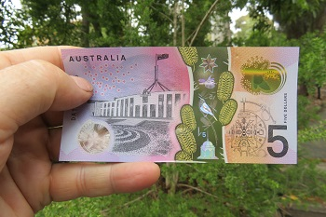 (Photo – the new $5 bank note)
Return to contents

Share your story

If you have a story you’d like to share about your vision loss, your experiences with our services or being matched with your Guide Dog, we’d love to hear from you. The marketing team are always on the lookout to feature our client’s stories in the media, to help spread the word about the wonderful work of Guide Dogs Victoria and to increase public awareness about people living with low vision or or blindness. If you are comfortable with sharing your story, please email the marketing team at marketing@guidedogsvictoria.com.au to get in touch.

Return to contents

Feedback

If you have anything to contribute to this newsletter, please feel free to contact us with your piece. We welcome all contributions.

Please either contact or email our client services administration team with your contributions as below:
csadmin@guidedogsvictoria.com.au or phone 9854 4467

Return to contents

