GetAbout
- Ed's Note
- CMS Group Programs 2018 overview
- Bendigo Senior Mobility Camp
- Tech time with Michael
- Great YouTube Channels
- Would a monocular or binocular help me?
- Pupdate by Zoz
- Family corner: Ten ways to encourage and develop cane skills
- Contact Us: Client Service Update Reminder
- Feedback

Ed's Note

Spring has certainly sprung and Melbourne is enjoying a beautiful sunny start to the season.

In this edition of GetAbout you can read all about our September Senior Mobility Camp Program which was held in the regional city of Bendigo. Michael has some great tips for using the Blindsquare app and OT, Alyce, gives details of some great YouTube vloggers with tips for vision impaired skills such as applying makeup, fashion and technology. Our Orthoptists, Khoa and Kate, have some information about monoculars and binoculars and how they can help those with low vision to look further into the distance.

We have attached our upcoming group program flyers for Snack Attack and the Teenagers Guide Dog Program as separate documents to this edition. We hope that this makes it easier to save them to your PC or print out a copy to stick on the fridge, let us know if this works for you.

Enjoy the warm sun on your skin and the smell of spring as you GetAbout and enjoy this beautiful season!

Alicia San Martin
GetAbout Editor

Upcoming programs and event for your diary
Teenager’s Guide Dog Mobility Program: Wednesday 11th and 12th December 2018. If you have an interest in using a Guide Dog as your mobility aid at some point in future, then this program is for you. Click here for more information.

Snack Attack! 10am–3pm, Tuesday, 22 January 2019
Develop independence and valuable life skills during this tasty and snack-filled holiday program with our Paediatric Occupational Therapist and staff from the children’s team. Click here for more information.

Our group program schedule is be available on our website
https://www.guidedogsvictoria.com.au/news-events/cms-group-programs-2018/

September Senior Mobility Camp Program
By Marnie Roth
On Monday, September 24th, nine excited students, along with our CMS staff, set off on a VLine train from Southern Cross Station to Bendigo for a four day camp.

Once we all settled into our apartments and had a bite to eat, the students set off to the local supermarket to get ingredients for that night’s dinner and breakfast each day. Tacos were on the menu for the first night. With the support of Occupational Therapist, Alyce, students prepped and cooked dinner, before sitting down to enjoy the delicious meal.

Over the course of the camp, the students became experts at making their own ‘Smores’ for dessert and snacks - much of the camp was spent on a sugar high!

Tuesday was a busy day with an initial overview on the BlindSquare app followed by a trial run using it on a walk to Lake Weerona. Students then set off to the Bendigo Information Centre where they booked a tour of the Deborah Mine and a trip from Castlemaine to Maldon for the following day. We were fitted up with helmets and light packs before heading down into the mine. The tour was an interesting look into the life of miners and the challenges involved in trying to strike it rich. It was also a great opportunity to practise mobility skills in unfamiliar and somewhat challenging environments.

Our return trip from the mine back to the apartments was on the famous Bendigo Talking Tram where we learnt lots about the history of Bendigo and got to explore the Tram Depot/Museum.

After dinner, with some local ex-CMS Clients, we set off on an Amazing Race. Students solved cryptic clues to find their way to local landmarks where they took a photo of themselves. The final landmark was the local Cold Rock where everyone enjoyed an ice cream before heading home. The Amazing Race was through some challenging environments with poorly lit paths that added an extra degree of complexity. Sammy, Jess and Gabriel won the race, in controversial circumstances!

On Wednesday, after some enthusiastic participants and staff went on a morning run around the lake, we were back on the VLine to travel to Castlemaine to meet our connecting steam train to Maldon. After a fun trip on the steam train and a yummy lunch in Maldon, we completed the return journey back to Bendigo. We had dinner delivered to the apartments before those with some extra energy headed out on a night walk to practice travel skills in low lighting conditions with the O&M’s there to provide support as needed.

Thursday involved packing our rooms and a quick trip to the Golden Dragon Museum and Gardens where students were fortunate to be able to have a tactile experience of some aspects of the museum. After a quick lunch and we collected our bags and boarded the train to head back to Melbourne.

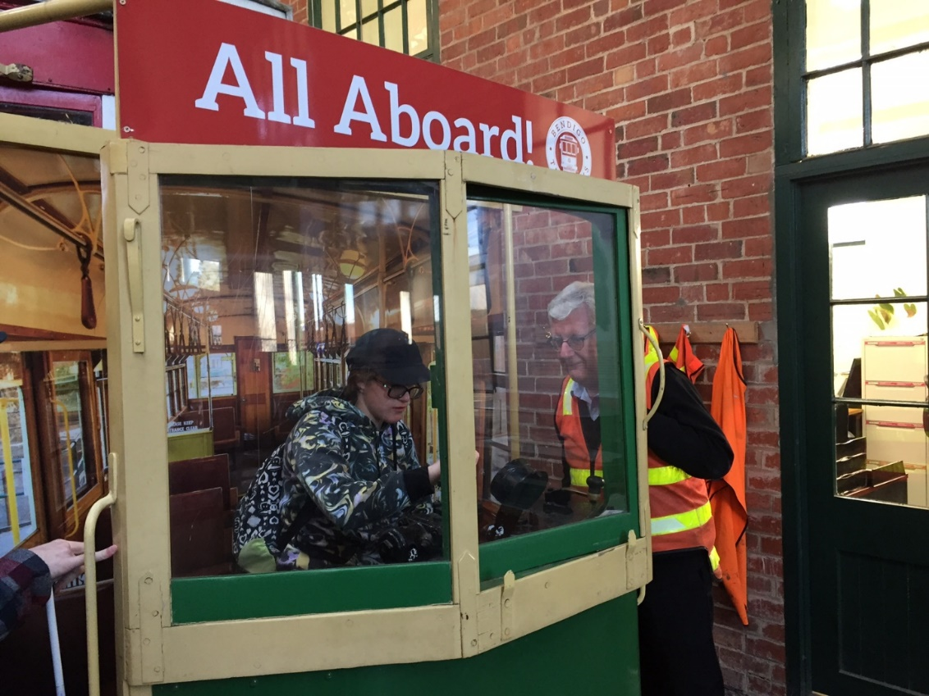

[IMAGE DESCRIPTION: Student in a replica tram being shown how to operate it by a volunteer.]

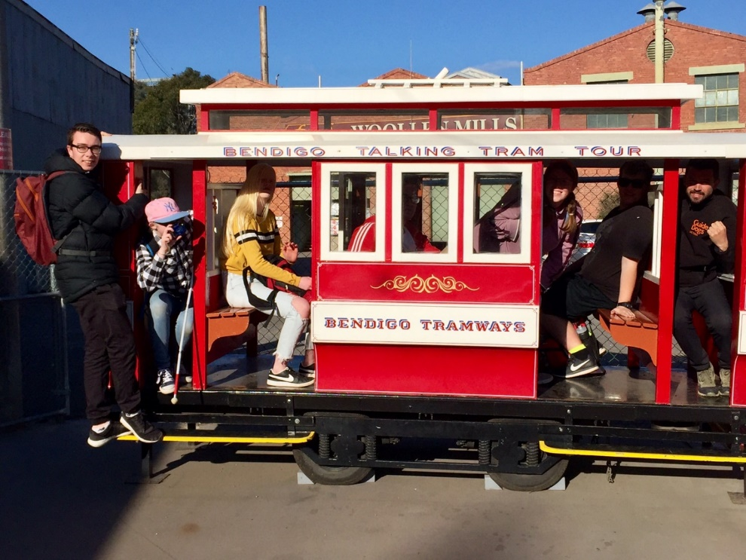

[IMAGE DESCRIPTION: Students sitting in a small replica of the Bendigo Talking Tram]

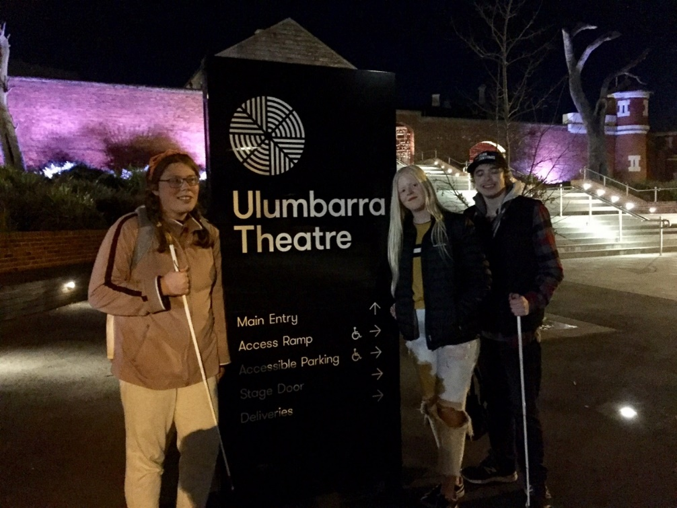

[IMAGE DESCRIPTION: Three students standing at the front of the Ulumbarra Theatre.]

Tech time with Michael
By Michael Evans

These articles aim to provide information on technology that can be used to support our Clients with their Orientation and Mobility (O&M).
In this edition, I will continue to introduce you to some of the features offered by BlindSquare, the accessible GPS app developed for people who are blind or have low vision.

The Search Tool:
The search tool can be found in the top left-hand corner on the main screen. This tool is used if you know the address of a destination or the name of the place.

When you select ‘search’, it takes you to the search menu and puts the cursor in a text box. Here, you can either type or you can dictate what you want to search.

When you search for a location or ‘Points of Interest’, BlindSquare will give you a number of results and sort them in relation to distance with the closest being first. You can swipe through the search results to find the one you are looking for.

Once you have selected the most appropriate search result, BlindSquare takes you to the Place Summary Screen. The Place Summary Screen allows the user to do a number of things, such as:

- Save the location as a favourite (My Places).
- Edit the place, such as editing the name of the place or its coordinates, it even allows you to set an alert distance when approaching the location (meaning an alarm will sound letting you know that you are approaching that location from the distance you have set).
- Start tracking and plan a route; the two options for getting guidance to a location.

In the next edition of GetAbout I will attempt to explain more about the features of the Place Summary Screen. In the meantime, one of the best ways to learn how to use BlindSquare is to just spend time with it.

Download the free event edition, here, and explore it, try all the features and just play around with it. Happy exploring!

Great YouTube Channels

By Alyce Woodruff, Occupational Therapist

There are a few really good YouTube channels that have been created by young adults who are either blind or have low vision. These channels are great for picking up tips on how to do everyday tasks such as meal preparation, hair styling and make up. Below is a list of some of my recommendations:

Molly Burke: https://www.youtube.com/user/MollyBurkeOfficial
Molly is a young American adult with a diagnosis of Retinitis Pigmentosa. She has a range of videos on:
- Describing colours to a person who is blind
- Make up application
- Blindisms
- How she uses technology
- Her Guide Dog

Christine Ha: https://www.youtube.com/user/ChristineHaTube
Christine is an American woman aged in her 30s. She was the first blind contestant on USA Masterchef. She has a range of videos on:
- Cooking
- Make-up
- How to use technology with low vision
- How people with low vision know what to wear

Fashioneyesta: https://www.youtube.com/user/fashioneyesta
Emily is a young adult from England, who has Septo-optic Dysplasia. She works and studies. She has a range of videos on:
- Doing make –up
- Misconceptions of vision impairment
- Hair styles and using heated styling tools
- Her Guide Dog

Would a monocular or binocular help me?
By Orthoptist Kate Clark and Khoa Nguyen

What are they?
Monoculars and binoculars are low vision aids, similar to a small telescope that make objects in the distance appear closer and possibly easier to see.

They can be helpful for you to see in the distance. For example at school assemblies and excursions, the footy or the zoo. They may also be helpful for seeing street and shop signs when you’re out and about with your Orientation and Mobility Specialist or family and friends.

What’s the difference?
A monocular is used with one eye and a binocular is used with both eyes. An Orthoptist can help by showing you monoculars and binoculars of different strengths. Together you can decide which is best for you and what you want to see.

Will it help me?
You won’t know until you give them a try, so give us a call on 1800 804 805!

Pupdate
Written by Zoron (AKA Zoz)

This is a story I wrote in 2016, but as it’s about the beach I thought it would be relevant as we are heading towards beach weather. I love the beach!

I love running, swimming, chasing waves, digging and smelling all the weird smells that the beach has to offer. For a lot of dogs, the beach is the best place in the world. Guide Dogs love to play at the beach too! When we go to the beach and our harness is taken off, we are just regular pet dogs and we get to run, chase, dig and play like any family dog.

Here’s a question for you:

Can Guide Dogs go to a dog restricted beach without wearing their harness, even though they are a Guide Dog?

The answer is no. A Guide Dog not wearing their harness is not doing the work of a Guide Dog and is therefore not officially a Guide Dog at that time. A Guide Dog not wearing a harness doesn’t have the rights of a Guide Dog in a harness. So, if pet dogs can’t go to a dog restricted beach then Guide Dogs not wearing their harness are not permitted access to a restricted beach either.

Did you know this fact?

If the Guide Dog was guiding their handler along the beach and the dog was in harness, then the Guide Dog is certainly allowed on the dog restricted beach. The Guide Dog would not be running, swimming and playing while in harness, so the restriction doesn’t count if the dog is working.

Write to Zoron’s Pupdate, paula.f@guidedogsvictoria.com.au
Zoron

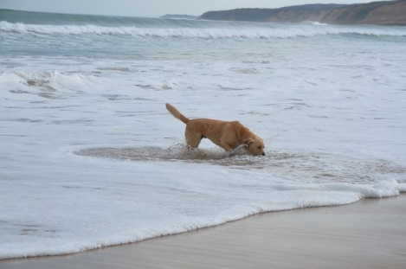
[IMAGE DESCRIPTION: Zoz, a yellow Labrador splashing and tasting the salty sea water]
Family corner: Ten ways to encourage and develop cane skills

By Danielle Kruger

Here are some great tips from the CMS team to encourage your child to develop cane skills.

- Ask your Mobility Instructor to teach you how to use the cane. Go for a walk under blindfold using the cane.

- Have your child teach you the different cane skills (e.g. skill names, cane terminology, how and when the cane is used).

- Place a hook at your front door to ensure your child’s cane has a place to live when at home and that it’s always handy when you are leaving the house.

- Talk about and ask your child to describe the different surfaces that the cane touches when you are walking together.

- When appropriate, encourage your child to tap the cane and make echoes – compare the sound of the cane in different areas.

- Help your child to practice folding the cane and putting it away in the appropriate manner (e.g. cane etiquette at a restaurant, movies, on public transport etc).

- Ensure that your child uses their cane whilst using sighted guide.

- Even when walking in sighted guide encourage your child to practice cane skills such as shorelining (e.g. to locate doorways in a shopping centre).

- When your child contacts an obstacle allow them time to explore the object rather than just walking around it.

- At road crossing, stand beside your child so they can practice using their cane (have them hold it across their body in diagonal position while waiting to indicate that they are about to cross the road).

Contact Us:

1800 804 805 – for ALL client enquiries – CMS, O&M, OT or Guide Dog. We will be able to make sure that your query gets through to the right person faster and is always followed up.
You can also contact us in writing:
Children’s Mobility Service
Private Bag 13, KEW, VIC, 3101
info@guidedogsvictoria.com.au
Or visit our website at:
www.guidedogsvictoria.com.au
Return to contents

Feedback
If you have anything to contribute to this newsletter, please feel free to contact us with your piece. We welcome all contributions. Please either contact or email our client services administration team with your contributions as below: info@guidedogsvictoria.com.au or Phone: 1800 804 805
GetAbout is now coming to you in a digital format. Going digital means our newsletter will be accessible, timely and environmentally friendly. The content of GetAbout has not changed: we will continue to let you know about our upcoming camps and group programs. GetAbout is also available on our website www.guidedogsvictoria.com.au
Alternative formats are still available in audio CD and large print. Please contact us at CSadmin@guidedogsvictoria.com.au or via phone 1800 804 805 to request these formats.
Return to contents

