Guide Dogs Victoria’s GetAbout – Term 4 2017

Tips for reading this newsletter

If you would like to increase the text size on your screen:
- Using the keyboard
    - Press ALT+W, and then press Q.
    - Press the TAB key repeatedly until the Percent box is selected, and then type a percentage or press UP ARROW or DOWN ARROW to select a percentage.
- Using the mouse
    - On the View tab, in the Zoom group, click Zoom.
    - Click the zoom setting that you want or type a percentage in the Percent box.

Contents
Tips for reading this newsletter 1
Editor’s update 2
News & events 4
School Workshops 4
Planning new programs – we want to hear from you! 5
GDV welcomes Orthoptics – our Low Vision Services are back! 6
Around the Bay – 25th-28th September 7
Marty and Me 12
Meet Joffa! 15
Contact us: Client Service Update Reminder – 1800 804 805 for all enquiries 17
Feedback 18

Return to contents

Editor’s update
Dear CMSers,
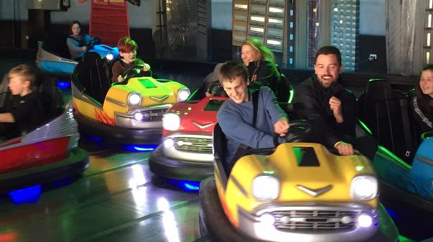 (Cover picture: The competition is on! Practitioners vs Students on our secondary school program Around the Bay)
Welcome to our Term 4 edition of GetAbout.
In this edition we reflect on our Around the Bay camp – a highly adventurous 4 day expedition for some of our secondary school students. We all faced new challenges and learnt some new skills – but most of all had so much fun. We run heaps of programs like this for children of all ages throughout the year, so if you have never been on one before maybe think about giving one a try in 2018 as your New Year’s resolution! We are always looking for exiting new program ideas and are in the process of planning for next year, so if you have any suggestions we would like to hear from you. See below for some ideas to get you thinking, and get in touch!
We are also delighted to announce the return of an orthoptics low vision service to GDV. Our new orthoptists Kate and Khoa can come to you and assess your vision changes, and offer new strategies to help you use your vision better.

We also welcome two new staff members. Clare O'Sullivan is joining our CMS team as a new O&M. Clare has spent the last 12 years working with people who are d/Deaf and Deafblind and has a Diploma of Auslan (Australian Sign Language.) Clare says: "I have worked in this capacity guiding people through the hubbub of the streets of London – to leisurely strolls along the white sandy beaches of Perth. Over time though, I became more interested in working in a role that was about developing client’s goals and independence and studying Orientation and Mobility seemed like the perfect fit. I am very excited to be a part of The Children’s Mobility Service and the team at Guide Dogs Victoria and I look forward to meeting and working with you.”
Alyce Woodruff is our new Occupational Therapist. She has experience working in early childhood intervention services (peadiatrics) with the Department of Education and Training in rural and metro areas, and with Yooralla. Alyce loves the footy (Go demons!), cooking and travelling.

We hope you are enjoying receiving our newsletters in the accessible digital format. We are happy to send out multiple copies to your family members - One for mum, one for dad and one for every child if they have an email address set up. Kids, it’s a great way to get in some reading practice using JAWS or by magnifying the text. Just give us a call on 1800 804 805 if you would like to request additional copies to be emailed out to your family members.
Have a fantastic summer holiday – whatever you get up to or wherever you go.
Simon, Bulletin Editor
By the way, don’t forget to look at our website: www.guidedogsvictoria.com.au
Return to contents

News & events

School Workshops

Starting at a new school, or moving to a new class, can bring up challenges. Everyone knows that an O&M can help by providing orientation to any new surroundings, but did you know that O&M’s can provide workshops to school staff and students?

Our aim is to provide the teachers and student with a better understanding of what it is like to have vision loss, to experience using different types of mobility aids, and learn more about the best way to support someone with low vision or who is blind. These talks can be generic in nature, or tailored to meet the needs of a particular student.

If you think your child would benefit from having a workshop held at their school, talk to your O&M about organising a visit.

By Danielle Kruger

Return to contents

Planning new programs – we want to hear from you!

We are busy gathering ideas for next year’s camps and programs, and we want to hear your ideas. If there is something you have always wanted to have a go at, a new skill you want to learn, or something you have always felt GDV should offer, then let us know.

Maybe there is something you’ve tried elsewhere or heard about another organisation offering, but want to do it with your GDV community and friends.

It may be physical fitness or sport, craft, cooking or art. It could be technology related, from trying technology, making technology, enjoying technology like gaming/design, or issues around technology like staying safe online. Or maybe you are interested in learning about social skills and interactions or career counselling.

We can’t guarantee that we can run programs on every idea, but we promise to investigate the possibilities.

So please do let us know – email sophiew@guidedogsvictoria.com.au

Return to contents

GDV welcomes Orthoptics – our Low Vision Services are back!

Hello from Kate and Khoa. We are the new Orthoptists here at Guide Dogs Victoria. Orthoptist are vision specialists whom you can come in to see in our office or we can visit you at home or school. We can check how you are using your vision with different activities and games. We will not put any drops in your eyes! We may have some suggestions and gadgets to help you to use your vision better, to do things such as; reading, school work, computer, television, crafts.

We would love to meet you so please call us!

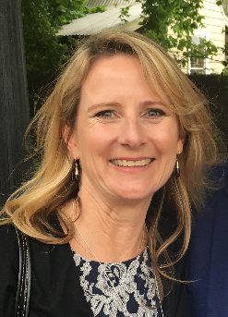
Photo's : Khoa Nguyen Kate Clark

Return to contents

Around the Bay – 25th-28th September

By Darren Moyle

This camp was an exciting opportunity for 12 secondary school students to attend one of the most challenging programs in the 17 years of CMS history!
Those who attended had proven independent travel skills and leadership qualities that the instructors had observed on previous camps or individual programs. However, everyone’s O&M skills were put to the test by travelling up to 4 hours per day to stay overnight at three different locations around Port Phillip Bay. The goal of this program was to provide students with an opportunity to test their travel skills in unfamiliar environments in preparation for future travel in their local community or on holidays.

After meeting at Southern Cross station, the group travelled to Quest St. Kilda Bayside to plan for the big week ahead. We kept up with the CMS tradition and travelled to Grill’d for lunch after some strong persuasion by certain instructors (who will remain unnamed!). A group of teenagers can’t visit St. Kilda without having a few rides at Luna Park, so that was the plan decided on by the group.
If you don’t like queues, the group found that going to Luna Park during the same week as the Melbourne Show means you can have unlimited dodgem car rides; but make sure you watch out for Sam and Michael as there was no dodging any cars for those guys!
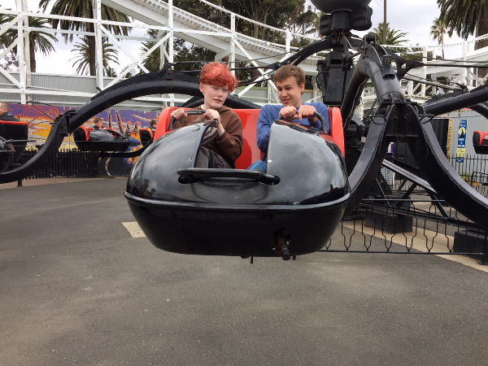
(Photo: Konna and Sam enjoying a ride)
Each group set out for dinner with the route planned with GPS. We found that different apps sometimes take you different ways. But everyone made it on time for a nice Italian dinner in Fitzroy Street.
Up and ready for breakfast at 8am, the students were ready to embark on the longest journey of the program from St. Kilda to Hotel Sorrento. This involved a tram, a train and a long bus ride. If you were with Paula and Ange, let’s add in an Uber trip to make up the time!
Luckily it was nice weather so the group did what anyone does when they arrive at the seaside… got some fish ‘n’ chips and took the ball for a kick on the beach. There were some talented soccer skills on display as well as some competitive play from Alicia (just ask Nathan about that one…).
After dinner, the guys kept the CMS traditions going strong by heading off in search of an ice cream. Along the walk the group paid close attention to important landmarks such as all the closed ice cream stores. Rest assured we found some - ordering 23 choc tops from the movies along with zero movie tickets.
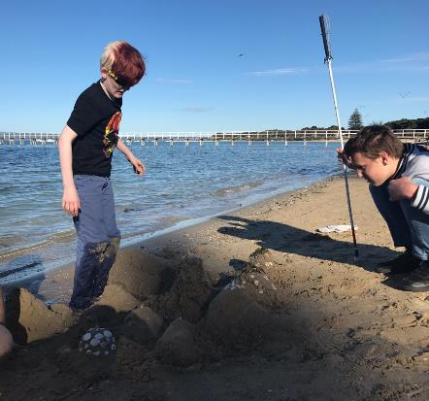
(Photo: Konna and Sam working on their sand sculpture at Sorrento Beach).

Bags packed up again and eating breakfast at Hotel Sorrento at 8am with the day’s trip involving a ferry and a bus to Quest Geelong. After getting off the ferry at Queenscliff the group planned to get a bus but only had 10 minutes to catch it. Unfortunately, we missed that bus and worse news, it was a 2-hour wait until the next one. Being very resourceful, the students decided to find some lunch venues in Queenscliff to be ready to start an activity once they reached Geelong. As soon as we arrived in Geelong Rose assisted with local knowledge to catch the bus to Supertramp for some trampoline fun. There were continuous dodgeball games where Johnny won best in-group despite Darren and Simon doing their best to take him out. After the last few busy days we decided to stay in for the night in the apartment and a few of us went out to pick up pizza, Indian and of course ice creams!

Up and ready to go for the last day and journey back to Melbourne, but not before breakfast - pancakes or bacon and eggs! Rose, with some help from Simon, had planned an Amazing Race around Geelong where the students had to complete a series of challenges by finding different landmarks around Geelong’s CBD. We then jumped back on the train to Southern Cross for a well-deserved rest and grand final long weekend.
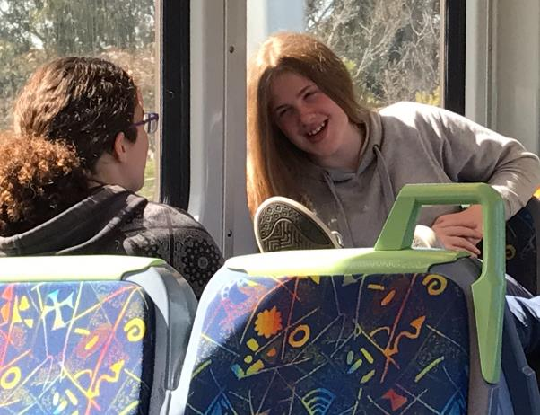 (Photo: Ingrid and Rose chilling on one of many train rides)
Congratulations to all those students who participated in this 4-day challenging camp. It involved very good independent travel skills along with skilled technology use, planning and problem solving. You worked together well to help each other out and hopefully this program will hold you in good stead for any future travel adventures you may have.

Return to contents

Marty and Me

Written By Zoz (aka Zoron)
Things are pretty quiet around here now that Marty has gone…..
Let me tell you about my friend Marty.
Marty is a 2-year-old Labrador Retriever who came to stay with me and Paula for about 6 weeks recently as he had completed his Guide Dog training at the Training Centre in Kew and was waiting to be placed as a Guide Dog with a young student.
When Marty first arrived with Paula, he was very excited to be coming to his temporary home. He had spent approximately 6 months learning how to be a Guide Dog and had been living in kennels with his other Guide Dog trainee friends. Marty had passed all his tests and was going to be a fantastic Guide Dog. He just had to wait a few weeks until his handler was ready to train with him.
When Marty arrived, he came through the door of our house with boundless enthusiasm only to be greeted by our family Burmese cat Taotsar. Taotsar took an instant dislike to Marty and showed his disapproval of him being in our house, by hissing, whining like a fire engine and puffing up like a 6kg powder puff. Taotsar’s mean spirited greeting did not faze Marty and for the entire 6 weeks, he tried to make friends with Taotsar, but to no avail.
Marty thought everything was a big joke. Being fed in the morning and evening was his favourite time of the day. He would get his toy monkey, bring it to Paula, and wiggle as if to say, ‘I am so hungry, I could even eat this furry monkey’.
Every time someone walked into the house, Marty got a toy and wanted to play with them. He wiggled his body so much that everyone had to hold on to their coffee cups and glasses if they were sitting down. Marty’s tail would sweep back and forth knocking everything flying as he walked around oblivious to its powers of destruction.
Marty was a lot of fun while he stayed with us. He was the first up in the morning and the last to go to bed at night. He greeted anyone and everyone who came near him like a long lost friend, offering up his slobbery toy monkey or half-chewed Nyla Bone as a heartfelt gift. Marty worked for love and cuddles and he buried himself into everyone’s heart; except for one particular pompous Burmese cat.
Marty has started working with his new handler and Paula says that he is doing a fantastic job. He has taken his monkey and Nyla Bone with him and he has made a whole bunch of new friends at his new forever home.

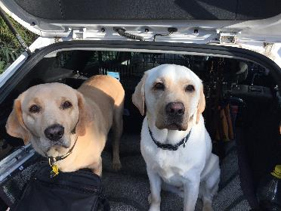
Marty and Zoz in the back of the car
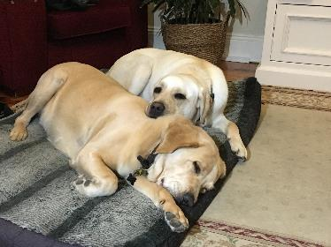
Zoz and Marty cuddled up together ready for sleep.
Have a wonderful summer holiday, and I’ll be back with more adventures next year!

Zoz

PS: Just a reminder to all my human friends out there, with Christmas coming up there can be tempting chocolate treats left under the tree or around the house. We often find it impossible to resist but these can be very poisonous to us dogs, so please help us out and keep them out of reach.

Return to contents

Meet Joffa!
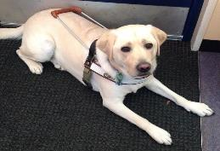
Hi, my name is Joffa and I’m Jamie’s guide dog. I help Jamie to move around because she has low vision. (Image: blonde dog Joffa in harness looking up at the camera)
When I have my harness on that means I’m working and you shouldn’t distract me because that could put Jamie’s safety at risk. When I have my harness off, I’m off duty, so please ask Jamie if you can pat or talk to me. I am trained to be clean, quiet and well behaved. I am toilet trained on command and when I need to go to the toilet Jamie puts a special toilet harness on my bottom. It costs $50,000 to breed, raise, maintain and train me. I have learnt to walk in a straight line; ignore distractions like cats, food and other dogs; indicate a curb by stopping, and the meaning of many commands such as "stop", "forward" and "straight to the curb".
People do not have to be totally blind to have a Guide Dog, and to benefit from the increased mobility and companionship they can bring. Most Guide Dog handlers have a small amount of vision.
I can enter ALL public places by Law.
I have had experience in guiding Jamie all around her home locality and I have been checked for traffic safety. I can follow around thirty commands by word, hand or foot and sometimes I have to refuse to obey for safety reasons, like if I can see cars coming when Jaimie asks me to cross the road. I will be Jamie’s companion and best friend for the next eight to ten years.
Thing you can do to help keep Jamie and me safe:
- Stand aside: clear space for us, look around to check our path is not blocked and make sure chairs are pushed in.
- Approach: if you think we may need a hand, walk up, greet us and identify yourself.
- Ask: ask us if we’d like some help, but don’t be offended if we don’t need your assistance. You might have just made our day by offering to lend a hand.
Thank you for not feeding, patting or talking to me in harness.
If you think you would like to get a Guide Dog in the future, then you can have a try-out. To learn more call 1800 804 805 or speak to your instructor.

Return to contents

Contact us: Client Service Update Reminder – 1800 804 805 for all enquiries

From now on, this one number – 1800 804 805 – should be used for ALL client enquiries – CMS, O&M, OT or Guide Dog. We will be able to make sure that your query gets through to the right person faster and is always followed up.

You can also contact us in writing:
Children’s Mobility Service
Private Bag 13, KEW, VIC, 3101
csadmin@guidedogsvictoria.com.au

Or visit our website at:
www.guidedogsvictoria.com.au

Return to contents

Feedback
If you have anything to contribute to this newsletter, please feel free to contact us with your piece. We welcome all contributions. Please either contact or email our client services administration team with your contributions as below: csadmin@guidedogsvictoria.com.au or Phone: 1800 804 805
GetAbout is now coming to you in a digital format. Going digital means our newsletter will be accessible, timely and environmentally friendly. The content of GetAbout has not changed: we will continue to let you know about our upcoming camps and group programs. GetAbout is also available on our website www.guidedogsvictoria.com.au
Alternative formats are still available in audio CD, large print and braille. Please contact us at CSadmin@guidedogsvictoria.com.au or via phone 1800 804 805 to request these formats.
Return to contents

