‘Guide Dogs Victoria’s On the Move – June 2018 Bulletin

# 

# Tips for reading this newsletter

If you would like to increase the text size on your screen:

* Using the keyboard
  + 1. Press ALT+W, and then press Q.
    2. Press the TAB key repeatedly until the **Percent** box is selected, and then type a percentage or press UP ARROW or DOWN ARROW to select a percentage.
* Using the mouse
  + 1. On the View tab, in the Zoom group, click Zoom.
    2. Click the zoom setting that you want or type a percentage in the Percent box.

Contents

Tips for reading this newsletter 1

Editor’s update 2

News & events for 2018 3

Group programs: 4

Public transport for families – All Aboard!! 6

Southland Station - Stop and Shop Program 7

It’s nearly PAWGUST! 9

Meet Amy, our new Orientation & Mobility Specialist 10

Metro trains text messaging assistance service – 0428 789 329 12

Advice from the Guide Dog dept: Looking after your Guide Dog during winter 13

Tech review – have you tried the new smartphone app Eye-D? 15

Swinburne University Survey on O&M Technology 17

Social and Sport groups 17

Share your story 19

Feedback 20

# Editor’s update

Brrrrr, it’s certainly getting chilly all of a sudden! Winter is well and truly here so it’s a good time to grab a cuppa and sit down for a read through On The Move.

This month we introduce 2 exciting new Group Programs –

* Public Transport for Families – All Aboard! for parents & grandparents who want to build their skills and confidence getting around on public transport with the little ones, and:
* Stop & Shop Southland – get to explore the new Southland Station & even get some Christmas Shopping in…yikes, it’ll be here before you know it!

We are always looking to try different and interesting programs focused on things you want to try, so if you have any suggestions please get in touch. Remember, we are your Guide Dogs Victoria!

Also below, meet Amy our new Graduate O&M. In our Tech section find out about the App 'Eye-D'; and for our Guide Dog Handlers there are tips on keeping your Guide Dog snug this winter. Enjoy the read, and stay warm!

Sophie Wild

Bulletin Editor

Return to contents

# News & events for 2018

**Mornington and surrounds GDV information session: Friday 27th July 1.30-3.30pm** Brooklands of Mornington, 99 Tanti Avenue, Mornington.

Come along to this free information session (with afternoon tea), at the beautiful Brooklands of Mornington Hotel, covering the locally available services provided by GDV. Whatever your age, stage or cause of vision loss we can provide Mobility services, Occupational Therapy, Technology advice, support with understanding funding options, and low vision Orthoptic support – all at a time and place that’s right for you. Come and meet some of your local practitioners, have a look at some technology, and see if we can offer you something new to help you meet your goals in life. No bookings necessary. For further info call 1800 804 805.

**Southern Melbourne Area NDIS information Sessions – held by the National Disability Insurance Agency, Wednesday 4th July, Narre Warren**, go to: <https://www.eventbrite.com.au/e/ndis-community-information-session-narre-warren-4th-july-2018-tickets-47097931180>

## Group programs:

**Live Safe Travel Smart**. October 2018:  an opportunity to develop and practice your public transport and personal safety skills in a supportive team environment, over 3 days of training in a group, on and off our Kew campus. Supported by Boroondara City Council. Expressions of interest to   
[info@guidedogsvictoria.com.au](mailto:info@guidedogsvictoria.com.au)

**Understanding Acquired Brain Injury (ABI) and Low Vision:** choose from 8th August or 28th November. The highly recommended one-day information program for people with vision changes secondary to an ABI.  Gain essential understanding of:

* how vision can change following an ABI, such as stroke, accident, surgery, tumour or other brain injury.
* how changes to the brain’s function can impact on mobility in unexpected ways.
* share experiences with people of all ages, and their families, who have low vision or blindness from an ABI.

Places are limited so please book your place by emailing [info@guidedogsvictoria.com.au](mailto:info@guidedogsvictoria.com.au) or call 1800 804 805.

**Young Adults Program (YAP):** connecting young people (between 18-30 years of age) with low vision or blindness for discussions and fun independent skill building activities. YAP sessions run bi-monthly throughout the year. The wonderful Rachel Henningham is off on maternity leave very soon, but we have other Practitioners raring to work with the group. Please contact [info@guidedogsvictoria.com.au](mailto:info@guidedogsvictoria.com.au) for more information.

**Public Transport for families – All Aboard!** A fun and social program for parents or grandparents with vision loss, and their children/grandchildren, to gain confidence travelling on public transport as a family group. Six sessions run fortnightly 25th July, 8th & 22nd August, 5th & 19th September and 3rd October, Seaford. For more information see article below, or call 1800 804 805.

**Southland Station - Stop and Shop Program.** Come and join in on the benefits of the new Southland train station, located at the doorstep of Southland shopping centre. Thursday 20th September, 10am-1.30pm. For more information see article below, or call 1800 804 805.

# Public transport for families – All Aboard!!

A fun and social program for parents or grandparents who have low vision or blindness and their children/grandchildren.

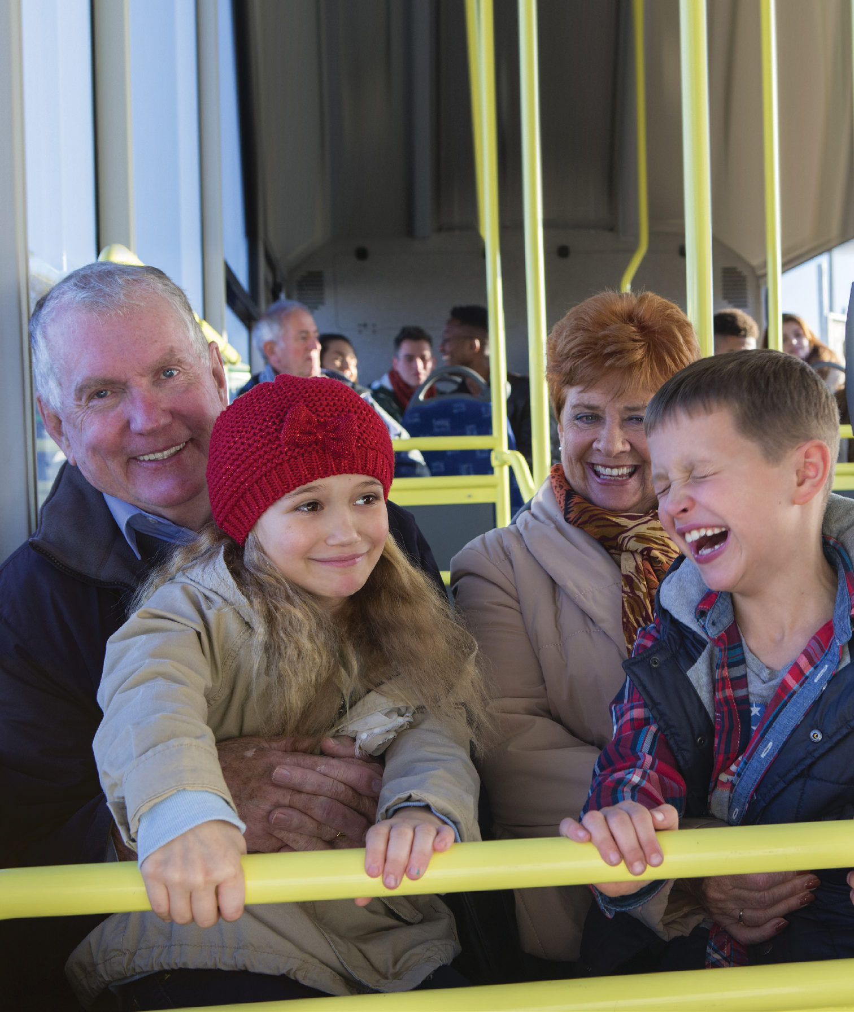

(Photo: Grandad and Grandma sit on a bus seat next to each other, with smiling grandchildren sitting on their laps).

* Increase confidence and independence in safely travelling via public transport with children
* Build confidence to advocate on behalf of yourself & your children whilst travelling via taxi, bus and train
* Build friendships

DETAILS

* Six sessions run fortnightly, 10am–2pm on each of 25th July, 8th & 22nd August, 5th & 19th September and 3rd October
* Seaford Surf Life Saving Club
* This program will be run by Occupational Therapy & Orientation & Mobility practitioners and guest speakers.
* Light catered lunch for adults will be provided – BYO children’s food. Transport needs for participants can be accommodated when you RSVP.
* The program will be delivered at no direct cost to our clients due to the contributions of The Flora and Frank Leith Charitable Trust.

BOOKING: Call 1800 804 805 and advise numbers of adults and children attending, and any transport needs.

Return to contents

# Southland Station - Stop and Shop Program

Come and join in on the benefits of the new Southland train station, located at the doorstep of Southland shopping centre.

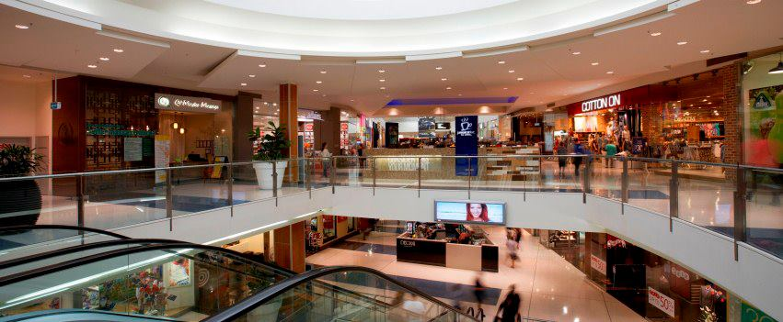

(Image: inside of Southland Shopping Centre showing escalator in foreground and shops and cafes such as Cotton On and Jamaica Blue, over 2 levels)

This program is a great opportunity to get prepared for your Christmas shopping and learn about the accessibility services that the station and shopping centre have to offer.

* General orientation to the station and the ground floor of the shopping centre will be provided, and tactile maps available.
* Participants will also have the chance to speak with a Metro officer from the station, as well as Southland Shopping centre concierge, to discuss what services are available to them.
* Morning tea will be provided.

DETAILS

**Date:** Thursday 20th September, 10am-1.30pm

**Location:** Meet at Southland Station (Situated on the Frankston line, between Highett and Cheltenham stations).

Mobility instructors will be available to support clients to travel from Frankston station and Highett station.

**RSVP required:** Limited spots are available. To reserve your place call 1800 804 805, and advise of any support required to travel from Frankston or Highett Stations.

**Please note**: A shopping experience is not provided as part of the program; however, participants may choose to remain at the centre and complete their own shopping and the end of the program.

This program is provided by the Adult Mobility Service at Guide Dogs Victoria.

Return to contents

# It’s nearly PAWGUST!

This August, Guide Dogs Victoria will be a part of a new national fundraising campaign called PAWGUST.

PAWGUST is a fun fitness initiative for dog lovers. The campaign challenges people to walk their dog for 30 minutes a day for 30 days during the month of August to improve their health and raise money for Guide Dogs.

Could you get involved – walking your Guide Dog, a pet dog, or even a friend/neighbour’s dog? Please visit [www.pawgust.com.au](https://guidedogs.us1.list-manage.com/track/click?u=c6d2fb100df92f77d1cf768d3&id=7c571f8da9&e=4ea5f56c16) to register your interest.

Return to contents

# Meet Amy, our new Orientation & Mobility Specialist

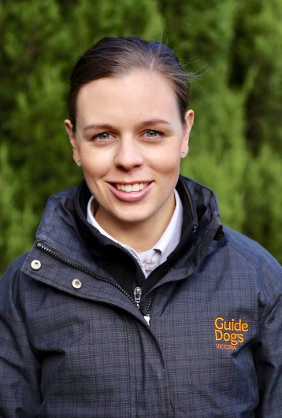

(Photo: Amy smiling at the camera. She is in her late twenties, has dark brown hair tied back and is wearing a dark Guide Dogs Victoria raincoat with the yellow logo)

My name is Amy O’Reilly and I joined Guide Dogs Victoria at the start of this year as a Graduate Orientation and Mobility (O&M) Specialist within the Adult Mobility Services Team. I started my career within Nutrition and Dietetics, working within a rehabilitation setting for seven years. From then, I completed a Masters of Occupational Therapy and have been working within the Aged Care sector as an Occupational Therapist. I have a keen interest in working with clients within the community to help them achieve their goals within a positive and supportive environment. I have always had an interest in vision loss and am excited to be taking the next step towards working within this area. I was fortunate to receive an opportunity to complete a Masters of Disability Studies (Vision) to begin my career as an O&M Specialist through Guide Dogs Victoria. The course is facilitated through the Royal Institute for Deaf and Blind Children (RIDBC), in conjunction with Macquarie University in Sydney. I will be completing the course over the next two years while building up a caseload until I become a fully qualified O&M Specialist. As Guide Dogs Victoria is an extremely well-recognised organisation that positively impacts a cross section of our community, I feel proud to be a part of this organisation, where positive client outcomes are at the forefront of our practice

Within the short time that I have been with Guide Dogs Victoria, I have already experienced many highlights. Firstly, the highlight of meeting and interacting with other Graduate O&M Specialists in Sydney while completing an intensive 5-week start of the Masters of Disability Studies (Vision). This allowed me to network with likeminded individuals and share experiences with other graduates from varying academic backgrounds. I have also had the opportunity to participate within the 2-day Food Safari Young Adults Program (YAP) camp around Melbourne city. This camp opened my mind to working with an age group that I have previously not had experience with. The highlight of the camp was completing a progressive dinner, where each course of the dinner was prepared by different group. The aim of this activity was to increase the confidence and skills in planning, shopping and cooking a meal for the group to share. Finally, I was given the opportunity to attend the Orientation and Mobility Association of Australasia conference in April this year. Being new to this profession, I was inspired and was able to see the avenues for new research and development within O&M.

I look forward to continually learning and applying the skills into the professional practice as a Graduate O&M Specialist. I also look forward to meeting you and perhaps working with you in the future.

Return to contents

Metro trains text messaging assistance service – 0428 789 329You can now text your train queries to Metro!

As part of its commitment to continuous improvement in accessibility, passengers with accessibility needs such as communication difficulty, vision loss and mobility impairment now have a greater choice in the way they seek information and enquire about Metro’s services through a text messaging assistance service.   
  
The service provides a backup option for Metro Trains passengers who rely on platform announcements, have difficulty vocalising their needs, or find it difficult to access the red button on station platforms.   
  
The text messaging assistance service is available daily between the hours of 7am – 7pm weekdays and 9am-5pm weekends and public holidays. It is intended for general enquiries related only to Metro Trains, including information on service changes. The service can be accessed by text only on 0428 789 329 and responses are typically provided within 15 minutes.

Return to contents

# Advice from the Guide Dog dept: Looking after your Guide Dog during winter

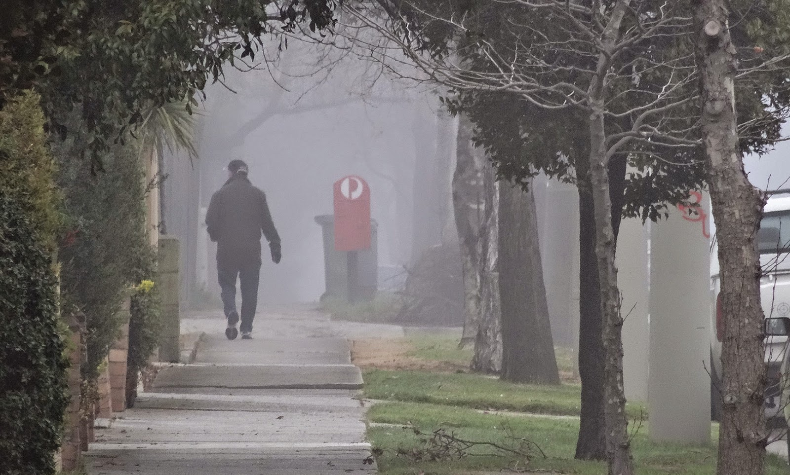

(Photo: A man walks down a pavement, away from the camera. There is some fog, the trees are bare, and he wears gloves and a hat.)

Victoria’s certainly shivering through the end of June, so there’s a few things to consider when thinking about keeping your Guide Dog snug and healthy over winter.

**Winter wellness:** Has your Guide Dog had his/her annual health check-up? Cold weather may worsen some medical conditions such as arthritis. Your Guide Dog should be examined by a vet at least once a year, and it's as good a time as any to get him/her checked out to make sure (s)he is ready and as healthy as possible for cold weather.

**Know the limits:** If it’s very cold and damp, you may need to shorten your walks to protect you both from weather-associated health risks. Check your Guide Dog's paws more frequently for signs of cold-weather injury or damage, such as cracked paw pads or bleeding, as they can dry out and get more fragile, a bit like how humans get chapped lips.

**Provide a snug sleeping spot, indoors:** Your Guide Dog will prefer a comfortable sleeping place, raised or insulated from the floor and out of a draft. They may change their location based on their need for more or less warmth. Give them some safe options to allow them to vary their sleeping place to adjust to their needs. Make sure your Guide Dog’s bed isn’t right next to a heater because of the risk of burns or fire. Heated pet mats should also be used with caution because they are still capable of causing burns.

**Snow fun:** If you are in a part of Victoria that gets snow, then your dog's feet, legs and belly may pick up slush and also de-icers, antifreeze, or other chemicals. When you get back inside, wipe down (or wash) your Guide Dog’s feet, legs and belly to make him or her more comfortable and dry, and prevent them ingesting anything they shouldn’t when they lick themselves. You may also find that dog bootees are a useful thing to make your dogs feet more grippy and keep them dry.

**Don’t leave your Guide Dog in a car or outside:** Hot cars are a known threat to pets, but cold cars also pose significant risk to your Guide Dog's health. A car can rapidly cool down in cold weather; it becomes like a refrigerator, and can rapidly chill an animal.

Remember, if you have any concerns about your Guide Dog’s health you can call your instructor, or see your local vet.

Return to contents

# Tech review – have you tried the new smartphone app Eye-D?

Eye-D is designed to assist people with vision loss evaluate the world around them with help of their smartphone.   
It will work as your companion when you travel, help you explore places and tell you about the objects in front of you and read text whenever you need.  
  
**Where Am I:** Tap on “Where Am I” and you get to know your location with a list of landmarks nearby. Tap the preferred landmark and Eye-D guides you to it with directions (currently by opening Apple/ Google maps for navigation).  
**Around Me:** If you are somewhere unfamiliar select “Around Me” and find ATM’s, Banks, Bus stops, Cinemas, Restaurants,  
Hospitals, Stores etc. within a radius you can specify and adjust.  
**See Object:** Click on this mode, take a picture and Eye-D app will tell you what’s in front of you.

**Read Text:** Open read text mode, click a picture and Eye-D app will read the text in front you.

Reviewers comments: Advantages: Completely free. Object recognition gives quite a lot of detail. You can adjust radius of search for things around you.

Disadvantages:   
Text recognition doesn't read multiple columns very well e.g.: menus.

If you have any apps or gadgets you would like to review for us, send reviews to info@guidedogsvictoria.com.au

Return to contents

# Swinburne University Survey on O&M Technology

The Swinburne University O&M research team is conducting a survey of people with low vision or blindness to find out more about the technology you have, use, and want to support your travel. The survey responses will inform the development of assistive technologies. Results will be shared with technology developers and distributed via O&M service providers. The survey will be open until 31 July 2018.  
You can click on this link to take the survey.  
<https://swinuw.au1.qualtrics.com/jfe/form/SV_d7uinu65ZjWIV8h>

Return to contents

# Social and Sport groups

* **Coffee mornings every Friday in the Frankston area.** If you enjoy having a cuppa and meeting new friends, please join our casual client run coffee mornings. New members always welcome. For details please contact Robert on 0409 685 606 or email   
  [rgsblind@yahoo.com.au](mailto:rgsblind@yahoo.com.au)
* **Rosebud Coffee Club.** We are proposing a Rosebud area coffee club. Mobility support from public transport to the café will be supported by GDV O&M Specialists for the first 4 sessions, with meeting facilitation support also provided. Please call 1800 804 805 to register your interest. We hope to see you there!
* **Cranbourne Coffee Club.** If you are interested in us setting up a Cranbourne Coffee Club let us know – email [info@guidedogsvictoria.com.au](mailto:info@guidedogsvictoria.com.au).
* **Ballarat Book Club** – 3rd Thursday of the month. Lunch followed by discussion on our audio book of the month. If you are looking for interesting conversation, a diverse group, and good humour, join us! Our members have Guide Dogs and/or canes all of which are accommodated in a very friendly café atmosphere. Contact Janice on [jannorth1@gmail.com](mailto:jannorth1@gmail.com)

**Goalball – get involved!**

See our article on goalball later in this issue. If you are interested in having a go then goalball is played every Saturday at Scotch College Junior Health Centre, accessible by public transport. Anyone can come and play or volunteer irrespective of sight level or age. There are four divisions for children, teens, men and women. To find out more about goalball, email [info@goalball.org.au](mailto:info@goalball.org.au).

**Croydon Vision Impaired Table Tennis Club** - Every Tuesday 6:00 pm to 8:30 pm. Table Tennis Stadium, Kilsyth Sports Centre, Liverpool Road Kilsyth Victoria 3137. This is an all-inclusive game of table tennis that has been specially adapted for people with low vision or blindness to play and is a fun game with plenty of laughter and good cheer so come along and join us. Contact Wayne Hyland by phone: 0497 905 638 or email: [flinghyland@iinet.net.au](mailto:flinghyland@iinet.net.au)

**Blind Sports and Recreation Victoria Event Calendar 2018:**

Download at <https://www.guidedogsvictoria.com.au/news-events/?category=general-news> or email [info@blindsports.org.au](mailto:info@blindsports.org.au)

Return to contents

# Share your story

If you have a story you’d like to share about your low vision or blindness, your achievements, your experiences with our services or being matched with your Guide Dog, we’d love to hear from you. The marketing team are always on the lookout to feature our client’s stories in the media, to help spread the word about the wonderful work of Guide Dogs Victoria and to increase public awareness about people living with low vision or blindness. If you are comfortable with sharing your story, please email us at [info@guidedogsvictoria.com.au](mailto:info@guidedogsvictoria.com.au) to get in touch.

Return to contents

# Feedback

If you have anything to contribute to this newsletter, please feel free to contact us with your piece. We welcome all contributions.

Please either contact or email our client services administration team with your contributions as below:

[info@guidedogsvictoria.com.au](mailto:info@guidedogsvictoria.com.au) or phone 1800 804 805.

Return to contents