Guide Dogs Victoria’s GetAbout – Term 2 2018

Tips for reading this newsletter

If you would like to increase the text size on your screen:
- Using the keyboard
    - Press ALT+W, and then press Q.
    - Press the TAB key repeatedly until the Percent box is selected, and then type a percentage or press UP ARROW or DOWN ARROW to select a percentage.
- Using the mouse
    - On the View tab, in the Zoom group, click Zoom.
    - Click the zoom setting that you want or type a percentage in the Percent box.

Contents
Tips for reading this newsletter 1
Ed’s Note 2
CMS Group Programs 2018 4
Junior Camps: 5
Senior Camp September 24th – 27th: 5
Supercharge Primary Camp & Supercharge Secondary Camp: 5
Early childhood O&M mornings: 6
Early Childhood Mornings – May 4th & May 29th 2018 7
Junior Mobility Camp – 2nd-4th July 2018 8
Supercharge Mobility Primary Student Program – 4th-5th June 2018 10
Guide Dog Mobility Information Program – Wednesday 6th June 2018 12
Fun Times on Junior Mobility Camp 13
Goalball – come on down! 17
Great ideas! 20
Tech time with Michael 21
Using a knife to spread 23
Pupdate 25
Family corner: Ten ways to encourage and develop public transport skills 27
Contact us: Client Service Update Reminder – 1800 804 805 for all enquiries 29
Feedback 29

Return to contents

Ed’s Note

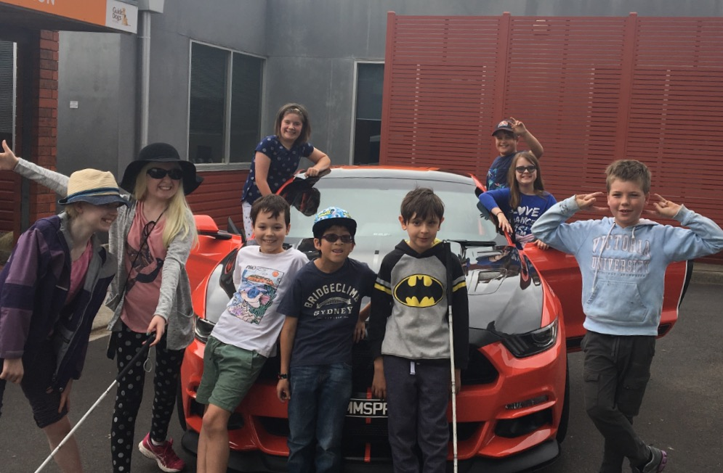
Cover picture: Some of our April CMS Camp students pose with an amazing Mustang car!
Ed's note
What a busy first term for the CMS Team, it's been great to see so many children thriving in their new daycare centre, kindergarten, school or university. The team have all marveled at the innovative ideas implemented by educators in different settings to support children with low vision or blindness. We will feature some of these ideas in a new "Great Ideas" section in GetAbout, so if your educator has done something clever, nifty or innovative please share it with us.
In this edition, you can read all about the April junior camp which was full of road safety and mobility fun, get some pointers on toast spreading from our OT Alyce, get updated on the latest O&M technology from Michael and much more. We also have a bumper term of group programs coming up, so please let us know which ones you are keen to attend by contacting the customer service team ASAP.
Autumn is always a fantastic time for an adventure as the weather cools, the leaves become crunchy underfoot and the wind picks up. So skip out, jump out or cartwheel out…just make sure you GetAbout!
Alicia San Martin
Editor GetAbout
By the way, don’t forget to look at our website: www.guidedogsvictoria.com.au
Return to contents

CMS Group Programs 2018

The Children’s Mobility Service is excited to offer a range of camps and group programs during 2018. Our group programs aim to offer Orientation and Mobility training in a dynamic group setting which also provides children with vision loss and their families’ opportunities to socially engage with their peers.

To assist families who are on NDIS and for those who will soon be on NDIS, pricing has been included based on April 2018 prices. Please note that there is no cost to attend for those students who do yet have an NDIS plan. If you would like to discuss any aspects of our planned camp program please contact our customer service team on 1800 804 805.

Our group program schedule will also be available on our website https://www.guidedogsvictoria.com.au/news-events/cms-group-programs-2018/

All camp programs will provide students with the opportunity to develop a range of Orientation and Mobility skills and practice these skills in a variety of different environments considerate of their age and skill ability.

Junior Camps: three day Orientation and Mobility camps for primary school students with low vision or blindness based onsite at Guide Dogs Victoria in Kew.
- July 2nd- 4th: More details of this camp can be found in the next section of this newsletter. NDIS Cost estimate: $850.

Senior Camp September 24th – 27th: A four-day Orientation and Mobility camp for secondary school students with low vision or blindness. Details of this camp will be in our newsletters closer to the dates. NDIS Cost estimate: $1210.

Supercharge Primary Camp & Supercharge Secondary Camp: Both of these two-day programs will help students with further developing their understanding of
- their body in space,
- road and traffic concepts,
- self-orientation strategies
- use of sensory information to draw meaningful conclusions about their environment.

This program is a great opportunity for students who are blind or who have very low vision to learn in an environment that facilitates exploration of ideas and skills unique to a traveler who is blind. Students can also work with our Occupational Therapists during the program, to continue to develop daily living skills including individual pre-determined goals. Students may choose to work on self-care, meal preparation, money identification or organisational skills depending on their goals and interests. Please contact our customer service team on 1800 804 805 to register your interest to attend these programs and discuss if you child is suitable to attend. NDIS cost estimate: $545.

Early childhood O&M mornings: Suitable for parents with children aged 0-5 years. Come and learn more about what Orientation and Mobility is by joining in with fun O&M based activities. Find out how you can support your child’s skill development during every day activities alongside more formal O&M training. Programs will occur once a term and will provide you with the opportunity to meet other parents and their children who have a vision impairment. Please contact our customer service team on 1800 804 805 to register your interest to attend these programs and you will be contacted with dates and details. NDIS Cost estimate: $45 per session or $180 for all four sessions.

Return to contents

Early Childhood Mornings – May 4th & May 29th 2018

Come along to Arnold Cook House at Guide Dogs Victoria and learn more about Orientation and Mobility (O&M) and Occupational Therapy (OT) for littlies! Explore how you can support your child with practical strategies you can use in everyday routines.
Meet other children with vision loss and their families as you have a fun morning learning together.

Term 2 sessions:
Friday May 4th – Body concepts. Building an understanding of body parts and how this can support independence now and into the future.
Tuesday May 29th – Directional language. How to use everyday language to build your child’s understanding of space and how to move through it safely and confidently.

This program is suitable for children with low vision or blindness aged 0-5 and their families.

Session information
Sessions run from 10am-12:30pm. Please bring your own lunch to eat at the conclusion of the program. During this time staff will be available to provide relevant hand outs and answer any questions. Please let us know if your child requires a high chair in advance.

Staffing
Orientation & Mobility Specialists and an Occupational Therapist from the Children’s Mobility Service (CMS) will staff this program.

Costs
This program has been made possible due to the contributions of the Shine On Foundation.
- The program will be delivered at no direct cost to our client. Where possible we will access fee for service funding (NDIS) to support the program and Guide Dogs Victoria will cover all additional costs.
- NDIS - For children with an NDIS plan the estimated cost is $45 per session. NDIS funding covers the service delivery of O&M and OT skills during the program.

Feedback
Families will be contacted by a GDV volunteer after the program to get feedback regarding the program. Families will also be invited to provide feedback via an anonymous survey.

Further Information:

To register to attend or to find out further information please contact Customer Service by 27th April on 1800 804 805
Return to contents

Junior Mobility Camp – 2nd-4th July 2018

Building independence is a vital part of growing up. On this junior camp, students will have the opportunity to participate in a range of fun activities that will build their experience and skills to increase their ability to travel and complete activities of daily living more independently.

This program will look at the following skills to increase independence:
- Technical skills and strategies – travel (O&M) and daily living tasks (Occupational Therapy)
- Assessing risk
- Decision making about personal safety
- Problem solving
- Safely negotiating complex situations and environments
- Self-advocacy – asking appropriate people for assistance/information
- Public transport use to activities (where possible)

Staffing
Orientation & Mobility Specialists and an Occupational Therapist from CMS will staff this program.

Costs
This program has been made possible due to the contributions of the Shine On Foundation.
- The program will be delivered at no direct cost to our client. Where possible we will access fee for service funding (NDIS) to support the program and Guide Dogs Victoria will cover all additional costs.
- NDIS - For students with an NDIS plan the estimated cost is $845. NDIS funding covers the service delivery of O&M and OT skills during the program and does not cover meals, accommodation or overnight costs.
- Students will require a travel pass or Myki card with $15 credit for travel during the program.

Feedback
A brief report will be provided to families regarding the program outcomes and student achievement. Families will also be invited to provide feedback via an anonymous survey.

Further Information
This three day program will begin Monday 2 July 2018 at 10am and conclude on Wednesday 4 July at 2pm and is based on site at Guide Dogs Victoria in Kew. If we have more applications than places available on the closing date, 12 students will be selected. This selection process will take into consideration the number of programs previously attended and the appropriateness of this program to the student’s age and O&M goals.

For an application package please contact Customer Service ASAP on 1800 804 805.

*** To be considered for this mobility program, completed application packages (all paperwork, including medical forms) must be received by Friday 1 June 2018 ***
Return to contents

Supercharge Mobility Primary Student Program – 4th-5th June 2018

This program is designed for primary school students who want to work on a range of core Orientation & Mobility skills and concepts. Over the two-day program students will focus on further developing their understanding of their body in space, road and traffic concepts, self orientation strategies and use of sensory information to draw meaningful conclusions about their environment. This program is a great opportunity for students who are blind or have very low vision to learn in an environment that facilitates exploration of ideas and skills unique to a traveller who is blind.

Program goals
- Body awareness in space
- Use of directional language
- Road and traffic concepts
- Use of sensory input such as using external sound and echolocation to assist mobility
- Self orientation to an environment
- Use of technology to facilitate increased independent mobility
- Meal preparation

Staffing
The Children’s Mobility Service Orientation and Mobility Specialist's will be coordinating this program. Occupational therapists will also be running sessions for the students who have identified a need in this area on their application. Occupational Therapists will also be present during meal times to assist with meal preparation.

Costs
This program has been made possible due to the contributions of the Shine On Foundation.
- The program will be delivered at no direct cost to our client. Where possible we will access fee for service funding (NDIS) to support the program and Guide Dogs Victoria will cover all additional costs.
- NDIS - For students with an NDIS plan the estimated cost is $545. NDIS funding covers the service delivery of O&M and OT skills during the program.

Accommodation
This program will be based at Arnold Cook House at Guide Dogs Victoria. All activities will be held on site or in the local community close to the campus.

To register your interest or to find out more please contact
Customer Service on 1800 804 805

***We have up to 8 places available for this program, if we receive more interest than this number, the selection process will take into consideration the number of programs previously attended and the appropriateness of this program to the student’s O&M goals***
Return to contents

Guide Dog Mobility Information Program – Wednesday 6th June 2018

This program is designed for students of any age, and their families, who have any interest in using a Guide Dog as their mobility aid in the future.

We will introduce you to the concepts and benefits of Guide Dog Mobility (GDM) and discuss the practical requirements for successful GDM outcomes including;
- Orientation and mobility skills required
- Knowledge and understanding of a dog as both an animal and as a mobility aid
- External factors that may influence outcomes e.g. changes in living and work/study conditions, structured/unstructured lifestyle, social implications, regular travel routes, communication and leadership skills, “maturity”, cost, etc.
- Structure of a GDM program
- Process of O&M progression to GDM
- Cost considerations for GDM
- “Feel” of GDM through a possible trial walk (depending on numbers of participants and dogs available)

Staffing
Guide Dog Mobility Instructors and Children’s Mobility Service Orientation and Mobility Specialists will be coordinating this program.

Costs
This program has been made possible due to the contributions of the Shine On Foundation and is provided at no cost to clients and their families.

Location
This program will be based at Arnold Cook House at Guide Dogs Victoria. All activities will be held on site or in the local community close to the campus.

Feedback
Families will be contacted by a GDV volunteer after the program to get feedback regarding the program. Families will also be invited to provide feedback via an anonymous survey.

To register your interest or to find out more please contact
Customer Service on 1800 804 805

Return to contents

Fun Times on Junior Mobility Camp

By Clare O’Sullivan

Camp was a wonderful time and we had the most perfect weather for outdoor travel and play.
First, we learnt about intersections with Michael at GDV and then put this into practice at Kew Traffic School.
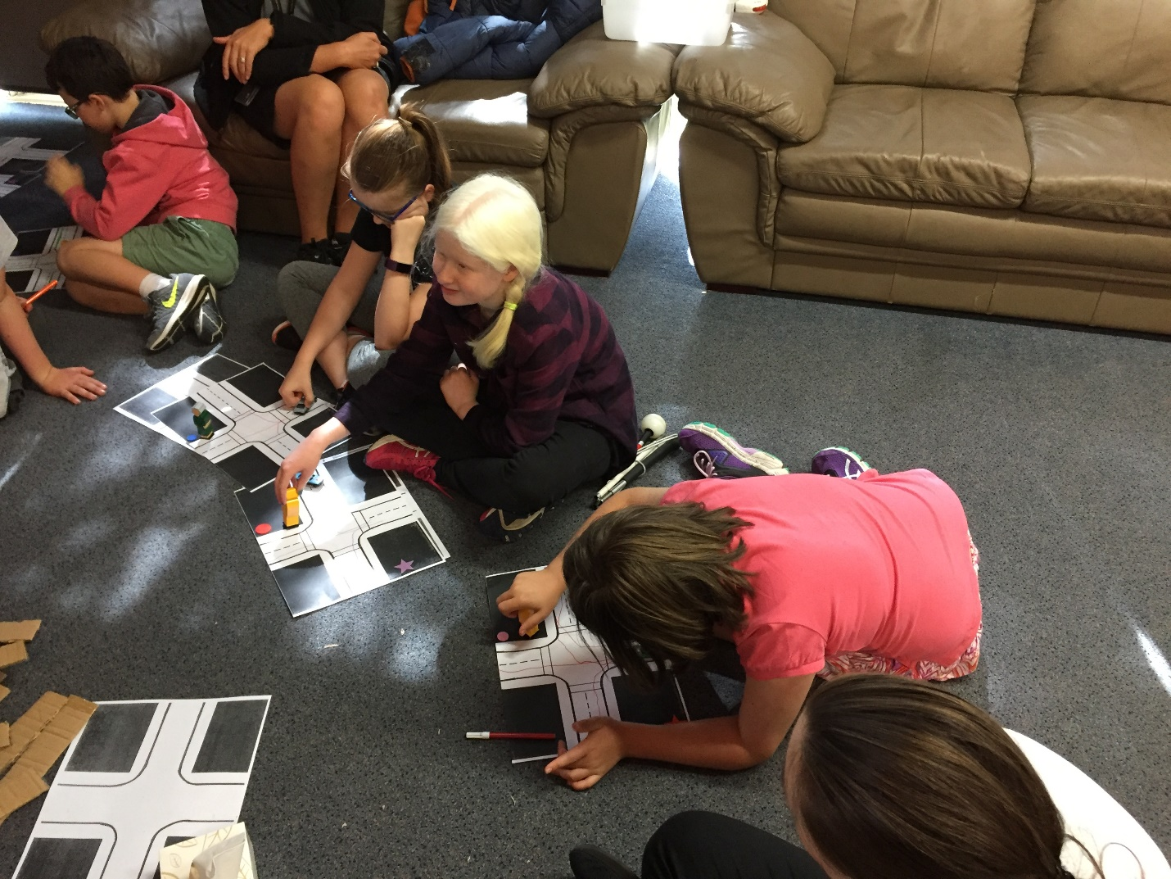
Photo: Learning all about intersections and how traffic flows through them

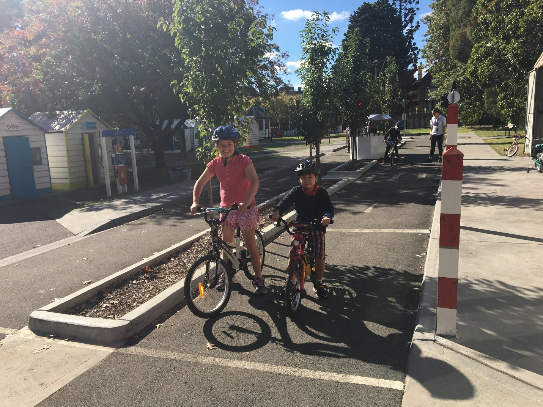
Photo: Students getting a drivers perspective by riding bikes through junctions at Kew Traffic School
We put our independent travel tips to the test by having a mystery drop off and finding our way to Doncaster shopping centre.
At Doncaster shopping centre we used our self-advocacy skills to find various locations.
Back at GDV there were a host of different cars for us to explore in the car park. We were official car inspectors, getting in and out of the vehicles to look and feel them all over, ranging from tractors to racing cars and everything in-between.
At the end of the camp I put the students in the hot seat and interviewed them about their experience.

  - What were you’re favourite things about being on camp?
“I learnt how to ride a bike “-Tegan
“Meeting other kids like me instead of other people that don’t understand “- Alkira
“ My favourite thing was doing the mystery drop off and having free time and being out at a shop, the mystery drop off was good because we got to work out the times that the buses were coming, what numbers the buses are and where the buses go to“ -Phoebe
  - Things you learnt while on camp?
“If you want to travel on public transport you need to take a Mykii with you” – Jarrah
“You can always ask the bus driver to tell you when a stop is “ – Alkira
“If you are blind or visually impaired and you have a long cane, stand at the front of the bus stop then the driver will know that you are there and they won’t drive past you “- Phoebe
“How to use Public Transport. Me and Simon videoed to help us know when to get off the bus “ – Malachy

  - What would you tell a person who has never been on camp before?
“There is yummy food here “– Tegan
“Camp makes you feel confident with walking outside “ – Alkira
“The Instructors are really nice “- Jess
“No matter always try to help each other , no matter what, go up to someone and say “Hi my name is______ would you like any help or I’m new can I have some help, can you show me around” or just talk to someone, introduce yourself. No matter what, have fun“ – Phoebe
“Take a shower once a day and bring a Mykii “ – Malachy

Thanks everyone for having a super fun time and being such excellent travellers.
See you next time
- Clare

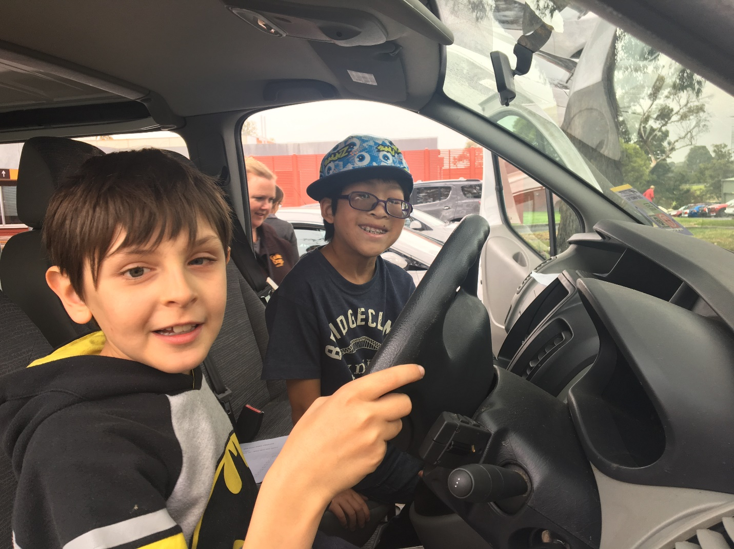
Photo: Students inspecting the Guide Dog bus.

Return to contents

Goalball – come on down!

Do you want to get fit and active in a friendly and social environment? Do you want to play a sport where you can bring along your family and friends and be on a level playing field?

Then Goalball could be the sport for you!

What Is Goalball?
Goalball is a Paralympic sport designed specifically for people with low vision or who are blind. Goalball is a team sport where two teams of three blindfolded players are placed in front of nine metre wide goals at each end of the court. Teams alternate throwing the ball with bells inside to attempt to score a goal while the defending team uses their ears, teamwork and tactile floor marking to attempt to stop their opponents scoring.

Why Goalball?
Goalball is different in that it is not an adapted sport, it was created specifically for people with vision loss. It is also unique in that as all participants are blindfolded you can bring along your family and friends whether they are fully sighted, have low vision or are totally blind.

Getting Involved
We play every Saturday at Scotch College Junior Health Centre, accessible by public transport and we would like to invite you down to try out Goalball. Anyone can come and play or volunteer irrespective of sight levels or age as there are four divisions for children, teens, men and women. Goalball is a great sport to not only keep fit but is also a great opportunity to make friends and share experiences.

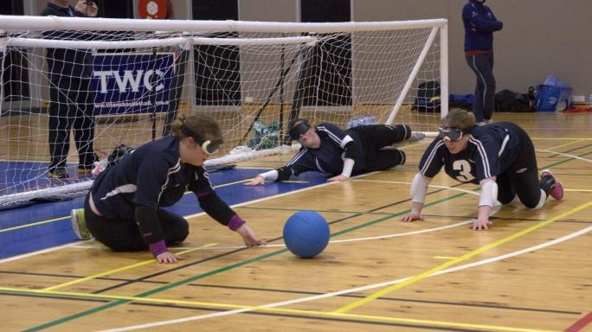
Photo: Three people playing goal ball next to the net

Who can attend: Open to all ages, abilities and all levels of sight.
Where: Scotch College Junior School Gym. Entry 7, Corner of Callantina Road and Glenferrie Road, Hawthorn
Getting There: 10 minute walk from Kooyong train station (Glen Waverley line) or alternatively, Tram #16 Stop 68 (Callantina Road / Glenferrie Road)
Cost: Free
What to Wear: Runners, tracksuit pants, and a comfortable top. Please note, there are changing facilities available at the venue.
What to Bring: Water bottle.
To find out more about goalball, contact info@goalball.org.au, follow us on Facebook or register via our website www.goalball.org.au.

Return to contents

Great Ideas!

Livingstone Primary School integration aide Casey found that it was tricky for the prep class to walk from the mat up to the board through the group of students sitting on the mat. Her great idea was to create a clear space walkway with tape, which all preps know to keep clear. It is also very useful as a clear pathway and landmark for the student with a vision impairment in her classroom when moving across the room without her cane. A great tip to benefit students who are sighted and also those with vision loss, great work Casey!
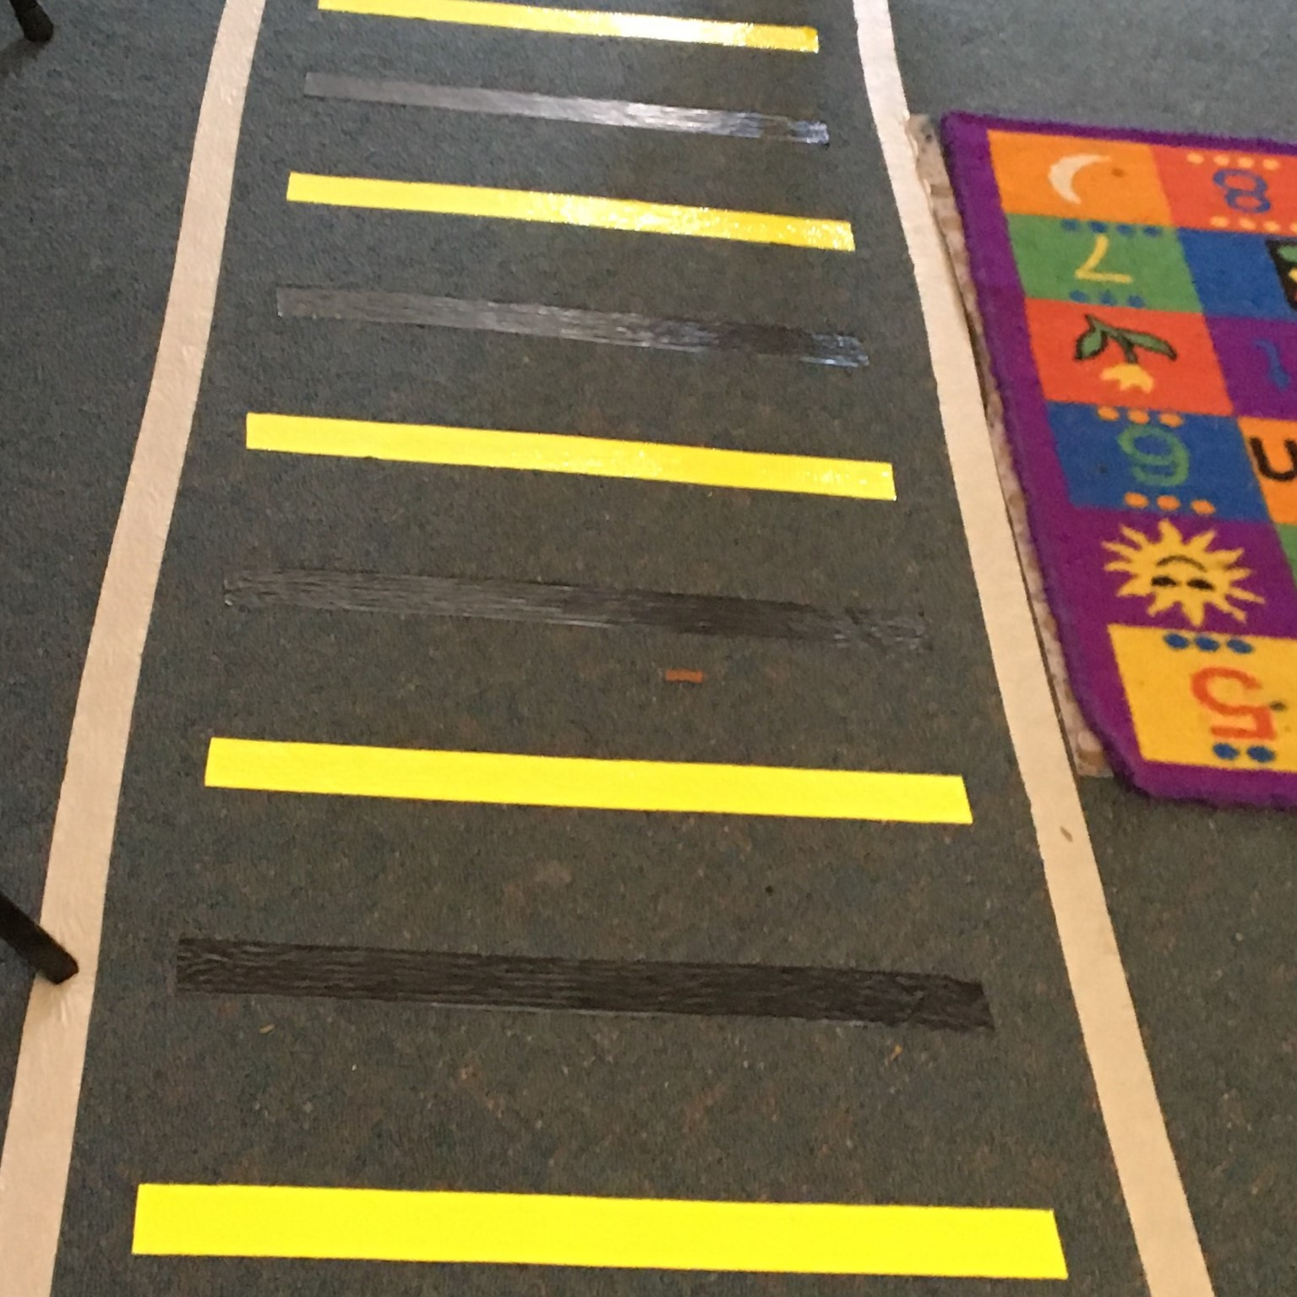
Photo: The tactile path integration aide Casey created.
Return to contents

Tech time with Michael

By Michael Evans

These articles aim to provide information on technology, which can be used to support you with Orientation and Mobility (O&M). Using particular pieces of technology can make O&M sessions more interesting, engaging and fun.
I would like to introduce you to a Bluetooth tracker. There are many different types of Bluetooth trackers available.
A Bluetooth tracker lets you use a smartphone app to monitor the location of whatever they’re attached to. If your Bluetooth tracker is within a certain Bluetooth range, it will play a loud tune until you find it. I have a couple of Bluetooth trackers that have a range of around 60 metres. Also, if you can’t find your phone, you can double press your Bluetooth tracker to make it ring even if it’s on silent.
I use Bluetooth trackers to support clients with:
- Locating items, such as their Long Cane.
- Locating important locations, such as lockers.
- Route travel, such as prompting clients to stop or to redirect clients when they may be travelling off track. It also allows the client to contact me from a far to alert me to difficulties they may be having.
- Self-exploration. Clients can attach the device to a landmark and explore the surrounding area. This allows the client to locate their landmark upon completion.
- Sound localisation, which is the ability to determine the exact source or line of direction of a sound.
Maybe you could think of a different way to use Bluetooth trackers to support you or others with their Orientation and Mobility. If you’ve got an idea let us know, we would love to hear from you.
(Picture: Tile Mate Bluetooth tracker)

Return to contents

Using a knife to spread
By Alyce Woodruff, Occupational Therapist

Many children and teenagers I see find it tricky to put spreads and toppings onto bread and toast. Here are some tips that might help when practicing at home:
- It is easier to start with toast as it doesn’t tear as easily as bread does.
- Jars/containers with larger openings are easier to place a knife into rather than a small jar - the action will be more of a sweeping one rather than having to dig into the jar with a knife. Also try to avoid practicing with a nearly empty jar as this will make it harder for to get the spread onto the knife.
- A knife with a wider blade may make it easier.
- Mums, dads or carers: Hand over hand assistance from you and verbal prompts may help. As your child becomes more confident gradually take this assistance away.

Tips to help with making sure the entire piece of toast is covered rather than just in the middle:
- Imagine the toast as having sections such as four quarters and try to cover each of the quarters.
- Start at the top of the toast and spread down until they get to the crust at the bottom.

The steps of learning to use a knife to spread with a parent or carers help:
- Know the location of a knife and grasp it correctly (A tactile marker can help your child learn where to place their index finger on knife).
- Hold the container/jar with the opposite hand.
- Place the knife into the jar and get enough spread onto the knife. (It may help to prompt your child by asking if the knife feels heavier with the spread on it? If not they may not have enough on it).
- Hold the toast with the opposite hand. (If your child holds the crust they will get a guide on how big the piece of toast is & how far they need to spread).
- Spread (by prompting them to go top to bottom or spreading each quarter).
- Cut. (Hand over hand assistance will help here by showing your child how much pressure is needed to cut through the toast).
If you would like my help with any of this please make a referral to Occupational Therapy and I am happy to pop out and visit you and your child at home to get spreading!

Alyce
Photo: Two pieces of toast with Vegemite

Return to contents

Pupdate

Written By Zoz (aka Zoron)

As you all know, food is my favourite subject and I thought I would tell you about the food that Guide Dogs eat.
Guide Dogs get an allocated amount of food per day. The food that is given to us is a dry food commonly known as kibble. Kibble comes in various shapes and colours. Some colours are artificial colours and are made that way so the dog owner thinks the food looks healthy.
There are many different brands of kibble. Just because a food is advertised the most, or is the cheapest, doesn’t mean it is the right food for the dog.
Dry food must be marked ‘COMPLETE BALANCED DIET’ on the packet, for it to be suitable to give me or my Guide Dog buddies!
If the food says on the packet ‘in conjunction with a balanced diet’ that means the food is not suitable to give by itself, and other food needs to be given as well as the kibble.
Guide Dogs are fed a ‘Premium Diet’ to keep them as healthy as possible.
Some cheaper foods make the dogs blow a lot of smelly wind, which is something we can get blamed for even when it isn’t our fault!!
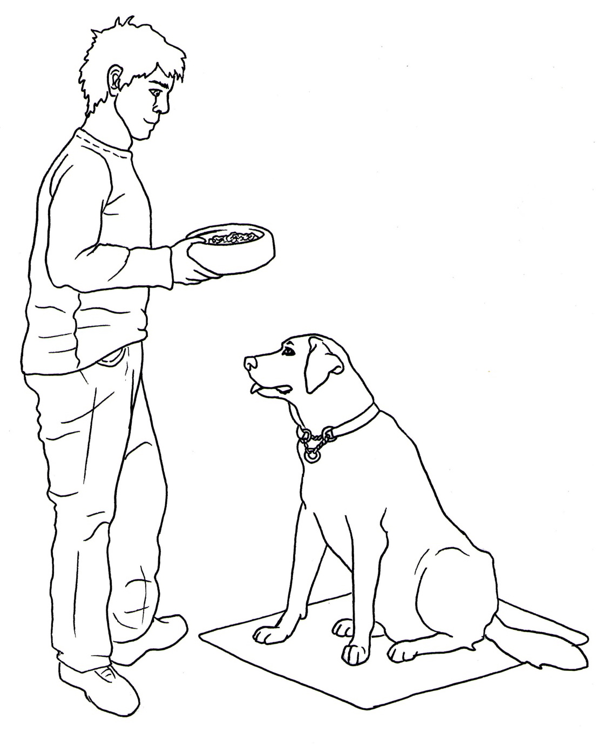Picture: Boy holding food bowl, dog sitting waiting for food.

Return to contents

Family corner: Ten ways to encourage and develop public transport skills

1. Use public transport for a trip instead of the car! The more experience your child has on public transport, the more confident they will become about using it in the future.
2. Show your child how to use a Myki card and ask them to validate or top up yours.
3. Talk about where it is safe to stand on platforms and at bus stops, as well as how to move safely towards the bus, train or tram.
4. Encourage your child to talk to the driver of the bus or tram to notify them of where you want to get off.
5. Encourage your child to sit at the front of the bus or tram.
6. Look out the windows and talk about what you are passing along the way (e.g. objects that are brightly coloured or large as these can help with orientation).
7. Talk about the corners, tunnels and underground sounds to help cue your child into changes you can feel and hear.
8. Ask your child to press the exit button and check for cars, people, and bikes when getting off public transport.
9. Take your child to a customer service desk at a train station and model how you seek assistance for timetable information or directions.
10. Practice crossing at level crossings.

Why not take a trip this weekend on public transport and give it a go!
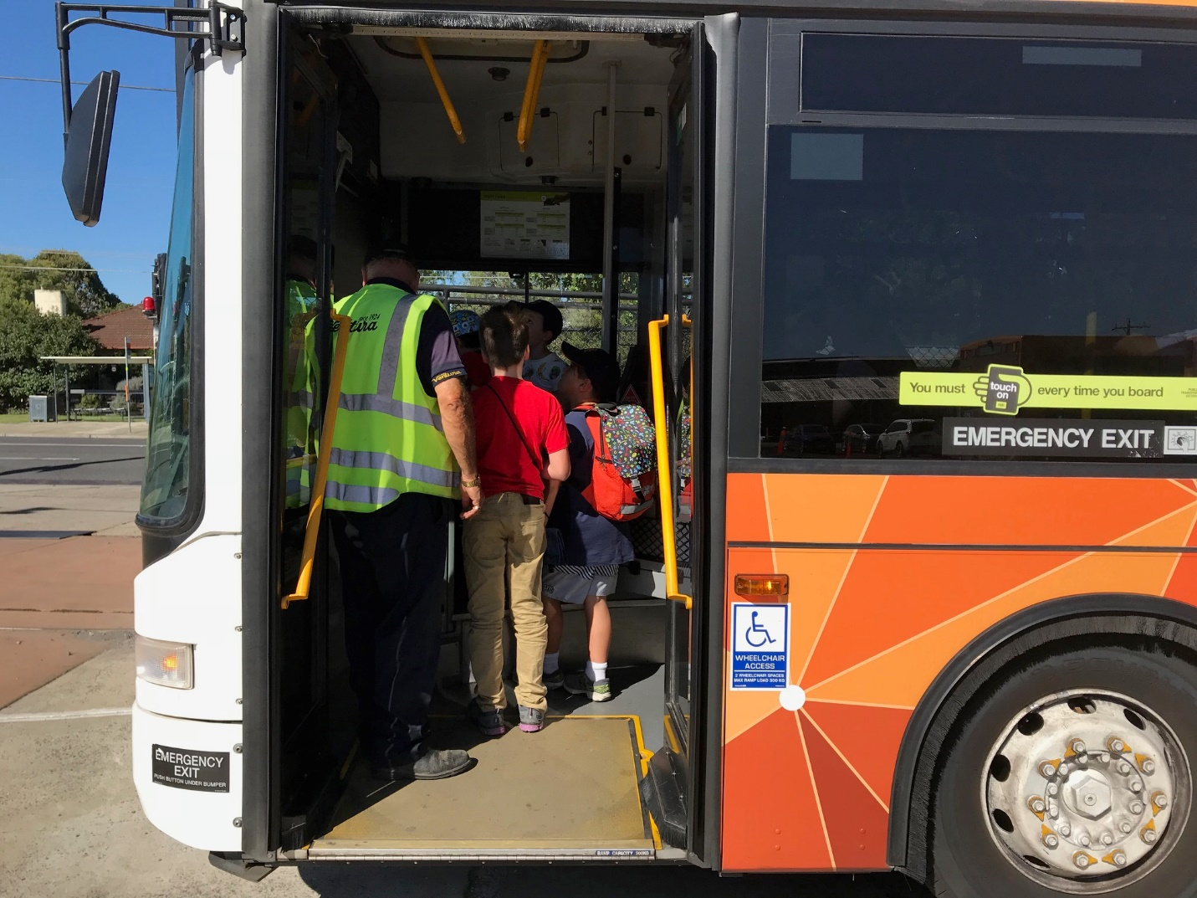

Photo shows children exploring a stationary bus on the recent Junior Group Program

Return to contents

Contact us: Client Service Update Reminder – 1800 804 805 for all enquiries

From now on, this one number – 1800 804 805 – should be used for ALL client enquiries – CMS, O&M, OT or Guide Dog. We will be able to make sure that your query gets through to the right person faster and is always followed up.

You can also contact us in writing:
Children’s Mobility Service
Private Bag 13, KEW, VIC, 3101
csadmin@guidedogsvictoria.com.au

Or visit our website at:
www.guidedogsvictoria.com.au

Return to contents

Feedback
If you have anything to contribute to this newsletter, please feel free to contact us with your piece. We welcome all contributions. Please either contact or email our client services administration team with your contributions as below: csadmin@guidedogsvictoria.com.au or Phone: 1800 804 805
GetAbout is now coming to you in a digital format. Going digital means our newsletter will be accessible, timely and environmentally friendly. The content of GetAbout has not changed: we will continue to let you know about our upcoming camps and group programs. GetAbout is also available on our website www.guidedogsvictoria.com.au
Alternative formats are still available in audio CD, large print and braille. Please contact us at CSadmin@guidedogsvictoria.com.au or via phone 1800 804 805 to request these formats.
Return to contents

