Perceptions November 2017

Your referral matters!

If this is your first Perceptions welcome! To past readers – we hope you like our new look. We are launching a new campaign aimed at explaining to professionals in healthcare, gateway services and education, how much your referral matters. It can make all the difference in the world to one of our clients many of whom experience long delays and uncertainties once they leave primary or secondary care with untreatable vision loss, and who often wait until a near miss or accident before seeking further help.

Many health professionals are unsure of when it is best to refer to Guide Dogs Victoria, or what services we can offer, over and above Guide Dogs. This issue of Perceptions focuses on the triggers for referral, and outlines the services involved in vision support – with a focus on Orientation & Mobility: the strategies we can use to train people to move around their environment.

You can find a set of videos which explain how our different vision support services operate, and how they complement the care you give a patient or client. These can be found on our new Professionals webpage at www.guidedogsvictoria.com.au:

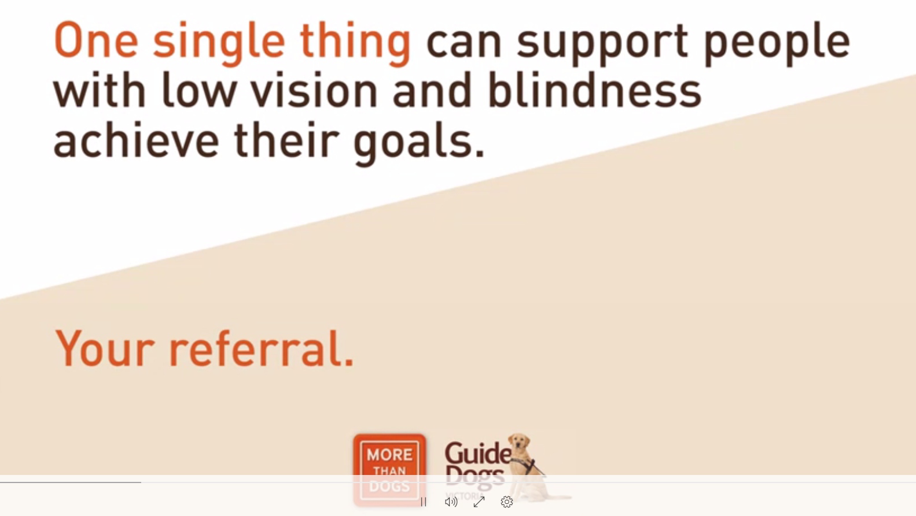

You can also easily refer online, via the ‘Request a Service form’ on www.guidedogsvictoria.com.au.

Remember, we always welcome your feedback, comments and contributions. You can contact us on CSAdmin@guidedogsvictoria.com.au.

Finally, you are welcome to forward this email on to your colleagues and members of your networks who can subscribe to our newsletter directly here.

Regards

Shelley Pannier
Client Services Manager

Dates for the Diary

International Day for People with a Disability – 3rd December. Watch out for the Dialogue in the Dark tram showcasing how Public Transport Victoria and Guide Dogs Victoria have partnered to improve accessibility for people with vision loss. Dialogue in the Dark is a unique experience offering an insight into living with vision loss. Go to www.dialogueinthedark.com.au for more information.

Acquired Brain Injury and vision loss – Professional’s Workshop: run regularly by Guide Dogs Victoria. Patients may have suffered a significant brain injury through a traumatic accident, health injury like meningitis or had post-operative damage; developed a degenerative condition that has affected their brain over time; or had a stroke that has affected the visual pathway within the brain. Such acquired brain injury can lead to temporary, permanent or fluctuating vision loss, requiring very specific strategies and tailored experience. Come and learn more at our Professionals Workshop.
Further information or to express your interest email CSAdmin@guidedogsvictoria.com.au or call 1800 804 805.

Patients and/or HealthCare Professionals: Our Choice Expo for Southern Metro & surrounds: 21st November 2017 10.am-4pm, Caulfield Racecourse. Designed to help people with disabilities make connections with a huge range of organisations that can support with equipment & assistive technology, therapeutic supports, accommodation & housing options, rights & complaints info, personal care & community access. The National Disability Insurance Agency will also have a display and be presenting. Healthcare professionals will also find the presentations and exhibitors informative. Entry is free.

We offer various programs to people experiencing vision loss from information sessions through individual programs, peer support and group camps. You can refer any of your patients to explore these programs, by advising them to email CSAdmin@guidedogsvictoria.com.au, or call 1800 804 805.

Low vision information sessions & screening. We are delighted to be able to offer a new low vision Orthoptist service (funded under NDIS, My Aged Care, or through philanthropy to unfunded clients). Our Orthoptists can come to your clinic/retirement village etc and can give low vision information sessions for staff and/or patients and run screening appointments, all free of charge! GDV Orthoptists Kate and Khoa have a combined 20 years of experience in low vision and can provide functional vision assessments, low vision aids and strategies. For further information please email csAdmin@guidedogsvictoria.com.au.

Do you have patients transitioning into primary school, secondary school or university? Now is the time to refer them for orientation and mobility support to help them transition smoothly in the new academic year. Our specialist team will develop a bespoke program to help them learn the new routes and environments they need to know.

Who and when to refer to a specialist vision support service like Guide Dogs Victoria…?

When you become concerned that vision loss is impacting daily life.

- When you diagnose a permanent, un-correctable eye condition, or glasses are no longer sufficient to correct vision.
- When you have concerns about someone’s safety due to vision loss
- When someone is becoming increasingly isolated because of their vision loss
- When you have concerns that a person is struggling emotionally to adjust to their vision loss
- If a person with vision loss is experiencing significant life transitions and might need new Orientation & Mobility or Occupational Therapy training to help them such as changing schools or moving out of the home.

How can Guide Dogs Victoria help?
We are More Than Dogs. We have a range of allied health practitioners who specialise in rehabilitation services for people experiencing vision loss, operating Statewide. Most referrals get seen with 1-2 weeks (less for urgent referrals).
- Specialist Occupational Therapists
- Orthoptists
- Orientation & Mobility practitioners
- Support Coordinators to help patients navigate funding like the National Disability Insurance Scheme and My Aged Care.

Spotlight on Orientation & Mobility
We often get asked what exactly Orientation & Mobility is!
With vision, travel is relatively straightforward. Maps are easy to use – be them printed, electronic, or just mental maps created using visual landmarks. Obstacles and signs are usually obvious.
Without vision, different strategies are required. These strategies are based around the science of Orientation & Mobility (O&M).
- Orientation: Establishing a person’s sense of position against objects in the environment
- Mobility: Moving through the environment

O&M is a specialised Allied Health field requiring a tertiary degree then ongoing specialisation. There is a shortage of O&M practitioners in Australia but GDV has led the specialised education in this field for the last 60 years, and can meet the Victorian demand of patients statewide. GDV has sponsored 2 cadetships in 2017 with more planned.
Sally Armstrong is the Team Leader of Adult Mobility Services, and an O&M Practitioner. Sally has a Bachelor of Health Science from Latrobe University and has worked with Guide Dogs Victoria for the past twelve years.Sally’s work revolves around helping people develop strategies like mental mapping, and using a long cane and technology, whilst making the most of any residual vision to the best of their ability.

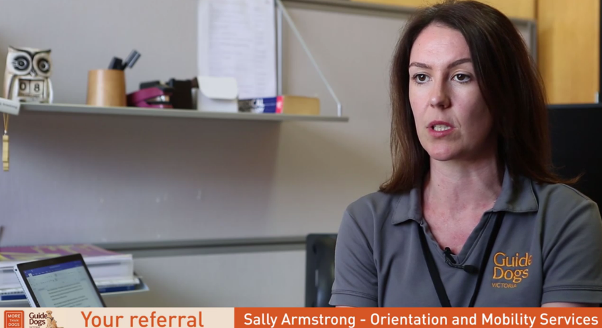
Sally meets with clients, understands their particular circumstances, and develops a framework that provides practical solutions to overcome orientation and mobility obstacles and empower them to be confident in their everyday journey.
Many of Sally’s clients suffer sudden or traumatic vision loss from circumstances like a stroke or a head injury. Often these clients struggle to come to terms with such a dramatic upheaval in life, and this struggle can come and go over several years. Sally plays an important part in supporting the client through a grieving process, and can bring in extra support services when needed.
Our practitioners are very much part of a client’s journey, and feel moments of a client’s achievement strongly. Sally remembers a particular client who only left the house to walk her dog part-way up the street so it could relieve itself. Other than taking the dog out, the woman never left her house. Slowly, as her vision had deteriorated, the boundaries of her life become smaller and her confidence spiralled lower. A social worker realised she was declining and referred her to GDV where she and Sally began to work on developing orientation and mobility skills. Fast forward some months later and Sally was in Southbank, enjoying a weekend breakfast out. She turned to see her client walking along Southbank Boulevard – an outing that previously would have been deemed impossible. 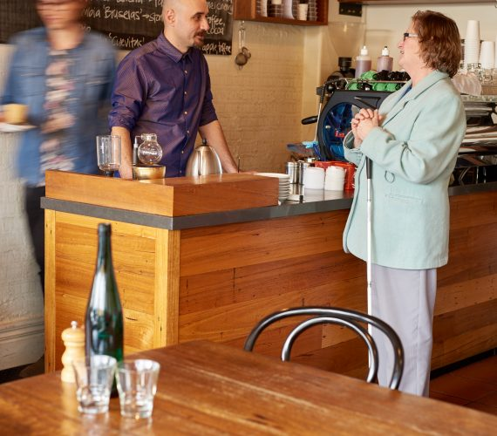
If you have patients you are concerned about, refer them now via www.guidedogsvictoria.com.au, or 1800 804 805. One of our friendly practitioners will call them to discuss their situation, and they are under no pressure or cost implications. It might be the turning point they need, and your referral really could change their life.

