‘Guide Dogs Victoria’s On the Move – March 2018 Bulletin

Tips for reading this newsletter

If you would like to increase the text size on your screen:
- Using the keyboard
    - Press ALT+W, and then press Q.
    - Press the TAB key repeatedly until the Percent box is selected, and then type a percentage or press UP ARROW or DOWN ARROW to select a percentage.
- Using the mouse
    - On the View tab, in the Zoom group, click Zoom.
    - Click the zoom setting that you want or type a percentage in the Percent box.

Editor’s update

Hi Everyone,
Just a short On The Move update this month, as we are all crazily Grand Prixing. A fuller On The move will be with you in April, but please look below for some important dates for your diary & event news.
Contact me on sophiew@guidedogsvictoria.com.au for more info.
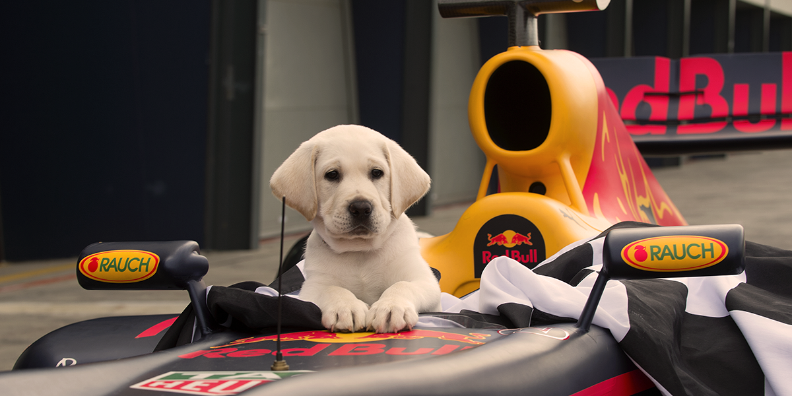

Hope to catch up with you soon!
Sophie Wild
Bulletin Editor

News & events for 2018

International Guide Dog Day. Please come and celebrate the change that our dogs bring to people's lives on Friday 27th April at the Auditorium, The Shrine of Remembrance, off St Kilda Road. This event will run from 1.30 - 3.30pm. Please arrive by 1.20pm as the event will commence at 1.30pm sharp, refreshments will be served towards the end of the event. Numbers are limited so RSVPs are essential - to csadmin@guidedogsvictoria.com.au or call 1800 804 805. Guide Dogs are most welcome of course! Also, if you have any good access nominations to submit for our awards please send them through by the end of March to sophiew@guidedogsvictoria.com.au

Regional Information Sessions:
Free information sessions with morning or afternoon tea covering the locally available services provided by GDV. Whatever your age, stage or cause of vision loss we can provide Mobility services, Occupational Therapy, Tech advice, Funding navigation support and low vision Orthoptic support at a time and place that’s right for you. Come and meet some of your local practitioners, have a look at some technology and see if we can offer you something new to help you meet your goals in life. Further info 1800 804 805.
- Ballarat Info Session: Bell Tower Inn, 1845 Sturt Street, Ballarat, Wednesday, 28th March 1.30 – 3.30pm. No booking necessary.
- Geelong Info Session: Geelong RSL, 50 Barwon Heads Road, Geelong, Thursday, 19th April 1.30 – 3.30pm. No booking necessary.

Group Programs:

Live Safe Travel Smart. October 2018: An opportunity to develop and practice your public transport and personal safety skills in a supportive team environment, over 3 days of training in a group, on and off our Kew campus. Sponsored by Boroondara City Council. Expressions of interest to
csadmin@guidedogsvictoria.com.au
The Magnificent Mobility Mission! Have tremendous fun and get a bit competitive while honing your mobility skills in this Amazing Race style challenge. We will hold 2 of these programs
- 24th May 2018 Boroondara Magnificent Mobility Mission
- 14th August 2018 Regional Magnificent Mobility Mission – exact location tbc depending on interest
Expressions of interest to
csadmin@guidedogsvictoria.com.au

Understanding Acquired Brain Injury and Low Vision – choose from either 30th May 8th August 28th November. The highly recommended one-day information program for people with vision changes secondary to an acquired brain injury (ABI). Gain essential understanding of:
- How vision can change following an ABI, such as stroke, accident, surgery, tumour or other brain injury.
- How changes to the brain’s function can impact on mobility in unexpected ways.
- Share experiences with people of all ages, and their families, who have low vision or blindness from an ABI.
Places are limited to so please book your place by emailing CSAdmin@guidedogsvictoria.com.au or call 1800 804 805.

Young Adults Program (YAP) - Connecting young people (approximate age 18-30) with low vision or blindness for discussions and fun activities. YAP sessions run bi-monthly throughout the year. Contact rachelh@guidedogsvictoria.com.au for more information.

Young Parents Group – a six session program to be held in the Frankston area. A safe and supportive environment for young parents (and grand parents!) with low vision or blindness and their children to learn from each other. Watch this space for more info!

2018 V/Line Accessibility Forum
This is an opportunity for you to help us improve our services for customers and develop our new Accessibility Action Plan for 2018-2021.
When: 18th, April 2018
Time: 11am – 2pm
Where: Auditorium, Ground floor, 750 Collins Street, Docklands
RSVP: 6 April 2018 (this is an RSVP only event)
Phone: Laura Hunt on 9619 5900
Email: accessibility@vline.com.au
This is an accessible event and carers are welcome, Lunch and refreshments will be provided. Please advise us of any special requirements.
Please forward this invitation on to others who may be interested in attending

You're invited! On going social events
- Coffee mornings every Friday in the Frankston area. If you enjoy having a cuppa and meeting new friends, please join our casual client run coffee mornings. New members always welcome. For details please contact Robert on 0409 685 606 or email
rgsblind@yahoo.com.au
- Rosebud Coffee Club. You may know that the Frankston Coffee Club is going strong and it’s time to branch out. We will be starting a Rosebud area coffee club in May 2018. Mobility support from public transport to the café will be supported by GDV O&M Specialists for the first 4 sessions, with meeting facilitation support also provided. Please call 1800 804 805 to register your interest. We hope to see you there!
- Cranbourne Coffee Club. If you are interested in us setting up a Cranbourne Coffee Club let us know – email csadmin@guidedogsvictoria.com.au.
- Ballarat Book Club – 3rd Thursday of the month. Lunch followed by discussion on our audio book of the month. If you are looking for interesting conversation, a diverse group, and good humour, join us! Our members have Guide Dogs and/or canes all of which are accommodated in a very friendly café atmosphere. Contact Janice on jannorth1@gmail.com
- Croydon Vision Impaired Table Tennis Club - Every Tuesday 6:00 pm to 8:30 pm. Table Tennis Stadium, Kilsyth Sports Centre, Liverpool Road Kilsyth Victoria 3137. This is an all-inclusive game of table tennis that has been specially adapted for people with low vision or blindness to play and is a fun game with plenty of laughter and good cheer so come along and join us. Contact Wayne Hyland by phone: 0497 905 638 or email: flinghyland@iinet.net.au
- A reminder that Guide Dog handlers in the Bendigo region meet together for a meal a couple of times year. Our next meal together will be on Friday evening 20th April. Location tbd, RSVP and more information please contact: Suzanne Gould 0408 179 382, bsgould@bigpond.net.au

Sports roundup

Royal Geelong 15th annual sailing day: Sunday 8th April: Anyone who is blind or who has low vision, and their companions, are invited to this wonderful day out.
- TIME: 9 – 9.15am (Sail starts at 9.30am sharp)
- CLOTHING Comfortable according to weather conditions with flat shoes
- FOOD: enjoy a free B.B.Q. Lunch generously provided by the Lions Club

Registration forms can be obtained by ringing Jan Jones 5248 8633; 0432 678548.

Blind Sports and Recreation Victoria Event Calendar 2018:
Download at https://www.guidedogsvictoria.com.au/news-events/?category=general-news or email info@blindsports.org.au

Guide Dog handlers - please remember to get or maintain pet insurance for your Guide dog
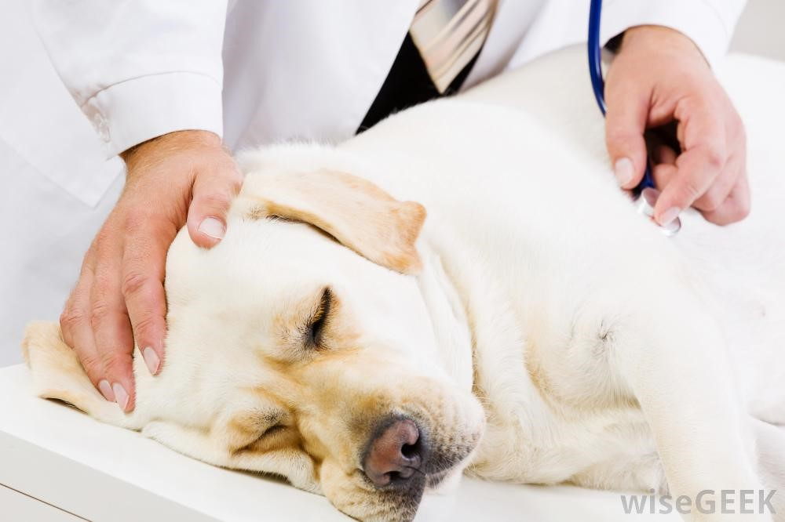
We are getting quite a few requests to help clients with costs of sick Guide Dogs - vet fees and surgery. This really stretches our resources and takes money from our funds to raise more Guide dogs. Please get Pet Insurance if you possibly can to alleviate this pressure. Remember GDV will pay your first year, and if you are on NDIS they will fund pet insurance premiums. My Aged Care will also fund this in some circumstances.

Share your story

If you have a story you’d like to share about your low vision or blindness, your achievements, your experiences with our services or being matched with your Guide Dog, we’d love to hear from you. The marketing team are always on the lookout to feature our client’s stories in the media, to help spread the word about the wonderful work of Guide Dogs Victoria and to increase public awareness about people living with low vision or blindness. If you are comfortable with sharing your story, please email the marketing team at marketing@guidedogsvictoria.com.au to get in touch.
Return to contents

Feedback

If you have anything to contribute to this newsletter, please feel free to contact us with your piece. We welcome all contributions.

Please either contact or email our client services administration team with your contributions as below:
csadmin@guidedogsvictoria.com.au or phone 1800 804 805.

