‘Guide Dogs Victoria’s On the Move – December 2017 Bulletin

Tips for reading this newsletter

If you would like to increase the text size on your screen:
- Using the keyboard
    - Press ALT+W, and then press Q.
    - Press the TAB key repeatedly until the Percent box is selected, and then type a percentage or press UP ARROW or DOWN ARROW to select a percentage.
- Using the mouse
    - On the View tab, in the Zoom group, click Zoom.
    - Click the zoom setting that you want or type a percentage in the Percent box.

Contents
Tips for reading this newsletter 1
Editor’s update 2
Upcoming programs and events for your diary 4
National Disability Insurance Scheme (NDIS) Pathway Pilot starting soon 8
Pet Insurance – new and improved 10
Guide Dog Healthcare Update: Christmas safety 11
Jobs at Guide Dogs Victoria 13
Guide Dog Mobility Instructor 13
Share your story 14
Feedback 15

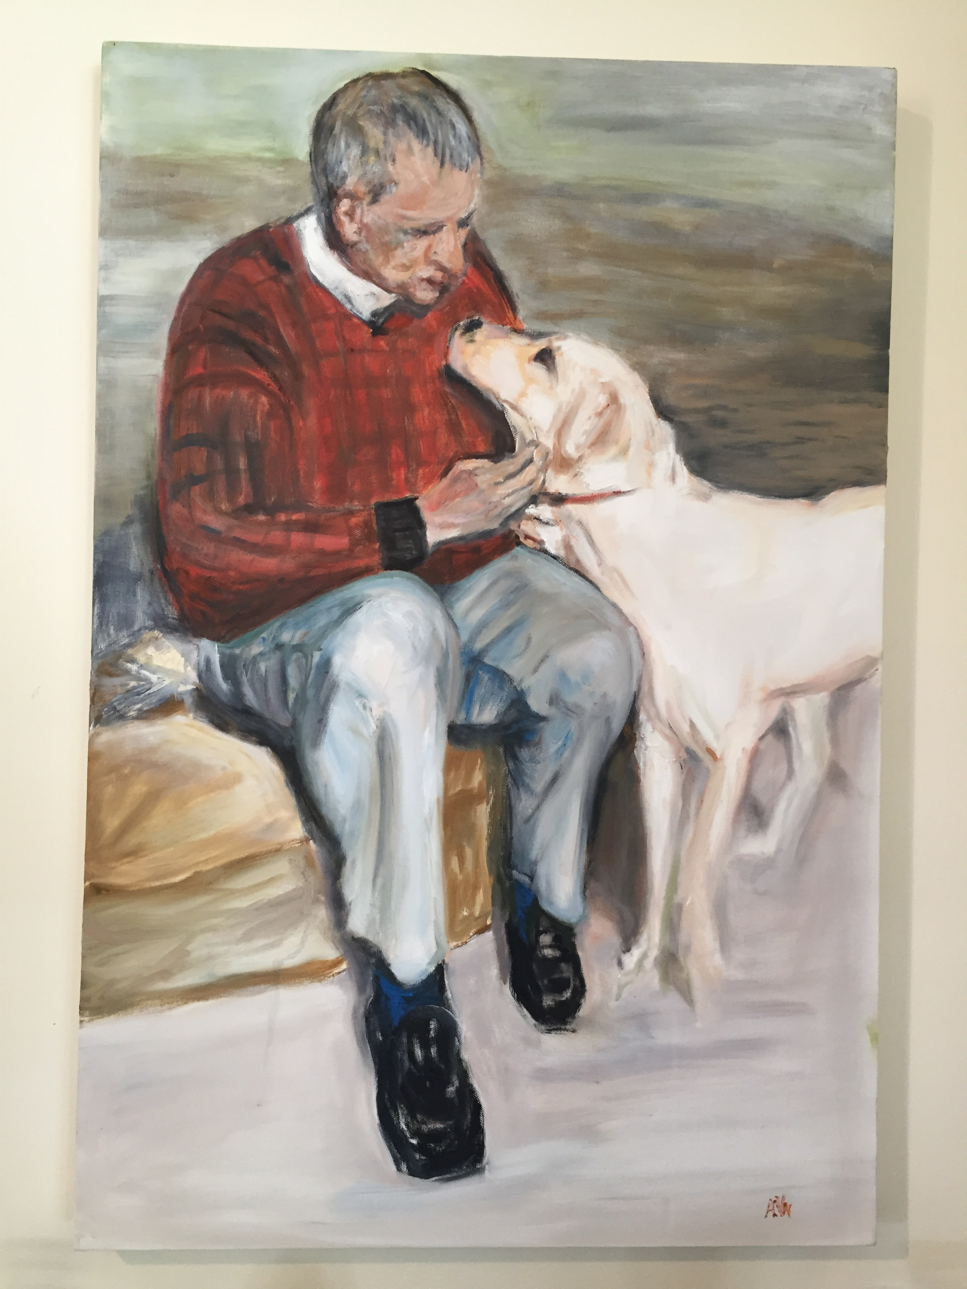
(Image – painting showing older gentleman in a red jumper sitting, looking lovingly at a yellow Labrador)

Editor’s update

Hello everyone, it’s nearly the Christmas break! I just can’t believe how fast the year has gone.

I have chosen a slightly different editor’s image this issue. The photograph above is of a painting one of our Orientation & Mobility Instructors spotted in a client’s home and captures wonderfully the bond between a Guide Dog and their handler. The picture is of client Barry Napthine and his dog Rhys, and is beautifully painted by his wife Angela. I have met so many of our clients and their families over the years and the level and variety of talent out there never fails to amaze me. It’s a real privilege for us here at GDV to be a part of your lives, the sense of welcome and community is something we really value, and we will seek to increasingly celebrate community in 2018 with far more regional activity and local events.

Unfortunately, we had to cancel our most recent community event – the client Christmas party – due to the dreadful weather forecast. But we WILL be rescheduling with a ‘Christmas in July’ celebration, watch this space! For the meantime enjoy ‘Christmas in December’ – stay safe, stay cool and have fun!

Sophie Wild
Bulletin Editor

Return to contents

Upcoming programs and events for your diary

- Christmas closure at GDV: 21st December – 2nd January inclusive.
- Requests for new services – Let us know as soon as you can! If you are transitioning to university, school, work or moving home, you may need Orientation & Mobility in January or February. The sooner we can be involved the better so please let your instructor know as soon as practicable. If you don’t have a current instructor call 1800 804 805 and our friendly customer support team and get everything underway for you.
- Eastern Melbourne Guide Dogs Victoria ‘pat and chat’ 20th January 7pm: we will be at the Skylark Room, Burrinja Cultural Centre Upwey, as part of the folk/pop music event with Canadian Band the Belle Miners. Come along for an evening of entertainment and say hello. Tickets are available at https://www.trybooking.com/book/event?eid=311901 . If you have any friends that you think could benefit from GDV services bring them along, we would love to chat with them. We have 2 pairs of general entry tickets to give away to this event, to the first 2 clients who email sophiew@guidedogsvictoria.com.au with subject line Belle Miners!
- GDV at MidSumma: 14th and 28th January: Join Goldie and Guide Dogs Victoria at Melbourne’s Midsumma Festival
As part of our commitment to positively celebrate diversity and to connect with community we are delighted to be involved this year with Melbourne’s Midsumma Festival. The flagship event of this festival is the Midsumma Pride March on Sunday 28th January. Guide Dogs Victoria will be in the parade with our Giant Guide Dog Goldie as a float. Clients and volunteers who identify or wish to support the LGBTIQ community are welcome to join us to walk alongside Goldie.

Details:
- You MUST RSVP to GDV to be part of this event: info@guidedogsvictoria.com.au
- The March takes place on Sunday 28th January, from 2-2.30pm, traveling from the Ian Johnson Oval to Catani Gardens, both in St Kilda.
- We have requested a position towards the front of the parade to ensure that our marchers do not have a long wait in the elements.
- GDV will be allocated a fixed assembly time at the oval in early Jan by the organisers. We will notify everyone who has RSVP’d of exactly where and when to meet in mid January, this is why you MUST RSVP if you want to join us.
- Guide Dogs are welcome but please carefully consider temperature and if the parade environment is suited to your dog. We will be walking on hot bitumen. If you can come with another person this may be preferable. Everyone should bring their long cane as a back up. If any dog starts to appear stressed we will transfer them to the air conditioned car pulling the float (limited space), and offer their handler a sighted guide. If it is over 28 degrees, please do not use your Guide Dog.
- GDV staff and volunteers will be on hand to assist with sighted guide as required, from 12.30-4pm.
- Be sunsmart – wear sunscreen and drink plenty of water. We will have a supply of GDV sunhats and Tshirts for people who register, with us on the day. We will carry water on the float for marchers and dogs.

For those of you who want to show support but can’t make it to the march, we will be gathered in Catani Gardens afterwards until 7pm (but please note sighted guide service finishes at 4pm).
We will also have a stall all day at the Midsumma Carnival on the 14th January at Alexandra Gardens, St Kilda Rd, so come and say hello

You’re invited! Ongoing social events
- Coffee mornings every Friday in the Frankston area. If you enjoy having a cuppa and meeting new friends, please join our casual client run coffee mornings. New members always welcome. For details please contact Robert on 0409 685 606 or email
rgsblind@yahoo.com.au
- Ballarat Book Club – 3rd Thursday of the month. Lunch followed by discussion on our audio book of the month. If you are looking for interesting conversation, a diverse group, and good humour, join us! Our members have Guide Dogs and/or canes all of which are accommodated in a very friendly café atmosphere. Contact Janice on jannorth1@gmail.com
- Croydon Vision Impaired Table Tennis Club - Every Tuesday 6:00 pm to 8:30 pm. Table Tennis Stadium, Kilsyth Sports Centre, Liverpool Road Kilsyth Victoria 3137. This is an all-inclusive game of table tennis that has been specially adapted for people with low vision or blindness to play and is a fun game with plenty of laughter and good cheer so come along and join us. Contact Wayne Hyland by phone: 0497 905 638 or email: flinghyland@iinet.net.au

Return to contents

National Disability Insurance Scheme (NDIS) Pathway Pilot starting soon

Many of you may be aware that the NDIS rollout has not been as smooth as everyone hoped for.

The NDIA has been listening to both participants and providers and is piloting a new pathway model that will improve the quality of plans and the experience of navigating the NDIS.

This pilot will start in mid-December in Victoria North and Victoria East. Key features of the pilot include face-to-face engagement for all NDIS plan development. Pathway initiatives include:
- Pairing participants with a consistent point of contact based on an individual’s needs
- A re-designed plan to make it easier for participants to see how their goals have been recorded and linked to community, other government services and funded supports
- Face-to-face planning meetings with a LAC, the participant and an NDIA planner to finalise their NDIS plan.
- Participants being able to see a working version of their plan as it is being developed and having the opportunity to ask questions and provide feedback during the planning meeting, to allow for any queries to be discussed and addressed before the plan is finalised.

Ongoing initiatives include:
- A simpler and quicker process to make minor changes to a plan
- Providing participants with the option to allow their providers to view their plan in the portal so providers can better understand their goals and tailor their services accordingly.

You can also find more information about the new NDIS participant and provider pathway on the NDIS website, including information in Easy English.

If you are eligible for the NDIS and it has rolled out in your area, but you haven’t felt up to facing the planning process yet, then 2018 might be the time to give it a go. And don’t forget we offer FREE pre-planning support, every step of the way. Clients who go on the NDIS do say it is worth it, and it’s your right to get the support you need.
You can contact our Support Coordinator team on 1800 804 805.
Return to contents

Pet Insurance – new and improved

(Logo Text Guide Dogs Pet Insurance on left with dark orange illustration of dog and light orange illustration of cat walking side by side)

Guide Dogs Australia have renegotiated our Pet Insurance offering with a new supplier, Greenstone. If you have an existing policy through PetPlan then you will be given the choice to stay with them on renewal or swap to the new supplier. It is entirely your choice, but note that the discounted annual rate for Guide Dogs will no longer apply with PetPlan.

Our new supplier has agreed to provide highly competitive rates for registered Guide Dogs and include Public Liability cover.

All new Guide Dogs will be provided 1 years pet insurance by GDV when they are supplied to a handler, at no charge unless you are on the NDIS in which case your plan will fund this.

We recommend that ALL Guide Dogs continue to have private insurance after this first year to provide peace of mind, and remember if you are on the NDIS it is an expectation that you do protect your dog’s health with insurance using your maintenance fund.

You can find out more about our new pet insurance at https://www.guidedogsinsurance.org.au/?pid=56279349-7A38-4DE5-9B64-214BBC090A33
Return to contents

Guide Dog Healthcare Update: Christmas safety

Christmas is generally a time of cheer and happiness for humans. But it can be a tricky of year for our four-legged friends. It is a time of change; there are more visitors, noises and busy shopping centres; there are new objects and smells in our homes. And some of these things can be dangerous to dogs.

Decorations: Even some of our older dogs can be tempted to give a new object a chew. To be on the safe side, keep tinsel and other garland materials out of reach and be aware that glass ornaments, whilst fun to crunch, will do considerable damage to mouth and feet.

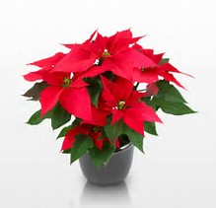
Many Christmas flowers and plants are also toxic to dogs e.g. poinsettia, Lilies etc.
(Image: red poinsettia plant)

Foods:
- Christmas cake and pudding are especially dangerous to dogs as they contains sultanas, currents and raisins, which can be toxic to dogs.
Chocolate is another toxic food that is often more present in a household at Christmas time. The compound in chocolate that is toxic to dogs is theobromine. The early (mild) symptoms of chocolate toxicity include vomiting, diarrhoea and hyperactivity. Severe toxicity can be fatal.
The type and the amount of chocolate consumed as well as the body weight of your dog will determine if the consumption of chocolate is a veterinary emergency (sse calculator at http://petsci.co.uk/chocolate-toxicity-calculator-dogs/. If in doubt call your vet.

Of course any food that is left unattended is an invitation to even the best behaved Guide Dog! If visiting, keep your dog beside you, and if entertaining make sure your visitors know not to feed your dog people-food!

Party tips
Keep your Guide Dog healthy and happy at parties or gatherings with these suggestions:
- Create a calm, quiet spot for your dog away from the noise and movement.
- Exercise/toilet your dog before any guests arrive.
- Keep some water nearby for your dog to drink.
- If you are outside and it is warm, make sure your dog is in the shade.

Return to contents

Jobs at Guide Dogs Victoria

Guide Dogs Victoria welcomes applicants who are blind or who have low vision to apply for vacancies. Summaries of current vacancies can be found below. If you are interested in applying then please view the detailed information on our website – links are given next to each job summary.

Guide Dog Mobility Instructor
Guide Dogs Victoria currently has a vacancy for an experienced professional to join our team in the role of Guide Dog Mobility Instructor on a full time permanent basis. The purpose of this role is to assess and train guide dogs and to provide mobility programs to people with low vision or blindness that meet the needs of the individual, while at the same time adhering to Guide Dogs Victoria and IGDF standards. You will need a Guide Dog Mobility Instructor qualification gained from a member school of the International Guide Dog Federation, and a recognized qualification as an Orientation and Mobility Instructor. Applications close 31st December 2017.
To apply, see full information and job requirements at https://www.guidedogsvictoria.com.au/careers/guide-dog-mobility-instructor/
Return to contents

Share your story

If you have a story you’d like to share about your low vision or blindness, your achievements, your experiences with our services or being matched with your Guide Dog, we’d love to hear from you. The marketing team are always on the lookout to feature our client’s stories in the media, to help spread the word about the wonderful work of Guide Dogs Victoria and to increase public awareness about people living with low vision or blindness. If you are comfortable with sharing your story, please email the marketing team at marketing@guidedogsvictoria.com.au to get in touch.
Return to contents

Feedback

If you have anything to contribute to this newsletter, please feel free to contact us with your piece. We welcome all contributions.

Please either contact or email our client services administration team with your contributions as below:
csadmin@guidedogsvictoria.com.au or phone 1800 804 805.

Return to contents

