Guide Dogs Victoria’s On the Move – October 2017 Bulletin

# 

# Tips for reading this newsletter

If you would like to increase the text size on your screen:

* Using the keyboard
  + 1. Press ALT+W, and then press Q.
    2. Press the TAB key repeatedly until the **Percent** box is selected, and then type a percentage or press UP ARROW or DOWN ARROW to select a percentage.
* Using the mouse
  + 1. On the View tab, in the Zoom group, click Zoom.
    2. Click the zoom setting that you want or type a percentage in the Percent box.

Contents

Tips for reading this newsletter 1

Editor’s update 2

Upcoming programs and events for your diary 4

Come and celebrate 60 years of Guide Dogs Victoria services at a special clients’ Christmas lunch 6

Some staffing changes at GDV to take us into 2018! 7

Proudly announcing our new Orthoptist Service 9

International Day of People with a Disability – 3rd December 11

International White Cane Day – the launch of the GDV Beacon Pilot at Southern Cross…now we need you! 12

My Aged Care Update 13

Let us entertain you! Audio Described events in Victoria: 17

Do you feel that your personal challenges are often overlooked by society? Focus group participants aged 18-34 needed… 18

Looking for artists! 20

Guide Dog Healthcare Update: Working with your Guide Dog in hot weather! 20

Jobs at Guide Dogs Victoria 23

Guide Dog Mobility Instructor 23

Share your story 24

Feedback 24



(Image – summer blue sky, white clouds, daisy flower in foreground)

# Editor’s update

Hello everyone, what a difference as I return from my holidays! The weather is giving us real glimpses of a hot summer to come, and with this in mind, we are re-running last year’s article on ‘Working your Guide Dog in Hot Weather.’

Thank you so much to everyone who contributed to the recent Eyes Up online survey looking at your experience of being bumped into. Sadly, the majority of respondents reported being bumped into at least once everytime they go out, and the majority of times these are because of the public being distracted by a smartphone. We released a campaign ‘Eyes Up’ to encourage people to look where they are going, and will continue this awareness campaign next year.

Guide Dogs Victoria’s Christmas closure is 21st December to 2nd January inclusive. If you think you may need a service between Jan-March 2018 – for example you are going to a new University or job, and need some Orientation & Mobility or Occupational Therapy to support the transition, please let us know ASAP. Even if you don’t have the full details, we can start to plan your program.

Finally, a reminder our client Christmas Party is on the 2nd December, this year it’s being held off site at Sophia’s Restaurant in Camberwell. Full details are in this newsletter – do get your RSVPs in by November 2017. I look forward to catching up with many of you there!

Sophie Wild

Bulletin Editor

Return to contents

# Upcoming programs and events for your diary

* **Requests for new services – Let us know as soon as you can!** If you are transitioning to university, school, work or moving home, you may need Orientation & Mobility in January or February. The sooner we can be involved the better so please let your instructor know as soon as practicable. If you don’t have a current instructor call 1800 804 805 and our friendly customer support team and get everything underway for you.
* **Understanding Acquired Brain Injury and Low Vision** – 8th November. A one-day information program for people with vision changes secondary to an acquired brain injury (ABI).  The day will aim to help you and your family gain an understanding of how vision can change following an ABI, such as stroke, accident, surgery, tumour or other brain injury.  It will investigate how changes to the brain’s function can affect mobility in unexpected ways.  The day will also provide an opportunity to share experiences with people of all ages, and their families, who have low vision or blindness from an ABI. Places are limited to so please book your place by emailing [CSAdmin@guidedogsvictoria.com.au](mailto:CSAdmin@guidedogsvictoria.com.au) or call 1800 804 805.
* **SOUTHERN METRO VALID Our Choice Expo** – 21st November 10am-4pm, Caulfield Racecourse via Gate 23, Station St, Caulfield East. Be informed and ready to transition to the NDIS. Explore a wide range of local services, and meet the NDIA.

**You’re invited! Social events**

* **Coffee mornings every Friday in the Frankston area.** If you enjoy having a cuppa and meeting new friends, please join our casual client run coffee mornings. New members always welcome. For details please contact Robert on 0409 685 606 or email   
  [rgsblind@yahoo.com.au](mailto:rgsblind@yahoo.com.au)
* **GDV Ballarat Book Club** – 3rd Thursday of the month. Lunch followed by discussion on our audio book of the month. If you are looking for interesting conversation, a diverse group, and good humour, join us! Our members have Guide Dogs and/or canes all of which are accommodated in a very friendly café atmosphere. Contact Janice on [jannorth1@gmail.com](mailto:jannorth1@gmail.com)
* **Croydon Vision Impaired Table Tennis Club** - Every Tuesday 6:00 pm to 8:30 pm. Table Tennis Stadium, Kilsyth Sports Centre, Liverpool Road Kilsyth Victoria 3137. This is an all-inclusive game of table tennis that has been specially adapted for people with low vision or blindness to play and is a fun game with plenty of laughter and good cheer so come along and join us. Contact Wayne Hyland by phone: 0497 905 638 or email: [flinghyland@iinet.net.au](mailto:flinghyland@iinet.net.au)

Return to contents

# Come and celebrate 60 years of Guide Dogs Victoria services at a special clients’ Christmas lunch



When: 2nd December - 12-2pm

Where: Sophia’s Restaurant, 857 Burke Road, Camberwell 3124. Tram route 72 or 200 metre walk from Camberwell Station

What: Sophia’s $22 menu of garlic & herb bread, salad, pasta & pizza choices, sweets, coffee, water.

Cost: GDV will subsidise costs so clients only have to contribute $10 each for the meal payable on the day (cash or eftpos). Family/friends welcome but will need to pay full menu cost of $22. Soft drinks and alcohol can be purchased separately at the venue by clients.

Booking: By 17th NOVEMBER, calling our Customer Support Team on 1800 804 805 or by email to [CSAdmin@guidedogsvictoria.com.au](mailto:CSAdmin@guidedogsvictoria.com.au).  Please advise any special dietary requirements at the time of booking.

Return to contents

# Some staffing changes at GDV to take us into 2018!

There have been quite a few changes in Client Services recently, so we thought it would be a good idea to get you all updated with ‘who’s who at GDV!’.

* Shelley Pannier – is now Client Services Manager
* Simon Mcdonald-Kerr – now Team Leader of Childrens’ Services, and we welcome new Graduate O&M Michael Evans
* Tim Carter – Team Leader Support Coordinator Services, and we welcome new Support Coordinators Leah McMahon and Taylah Snelling.
* Aaron Horsington – Acting Team Leader, Guide Dog Services with several new Team Members:
  + Anna Gigliotti-Skret and Lisa Dodds  - Guide Dog Mobility Instructors
  + Rachel Tung – Guide Dog Trainer
  + Rachael Hackney  and Christina Teng -  Cadet Guide Dog Trainer

Sally Armstrong continues to do a fantastic job as Team Leader Adult Mobility Services, and welcomes new Graduate O&M Kate Ford.

We also have expanded our support team to cope with the increasing admin workload and keep our Practitioners out doing what they do best – helping clients face to face.

We welcome Jo Oates as Customer Service and Innovation Manager. Jo is highly experienced in the healthcare industry and is very ably supported (pun intended!) by our front facing customer support team:

* Abe Ropitini, Customer Service Team Leader, and Customer Support Officers Rhiarna Noe and Becky Rowe.
* And of course our existing administration Gateway whom I’m sure you all know – Naomi, Tess and Lisa.

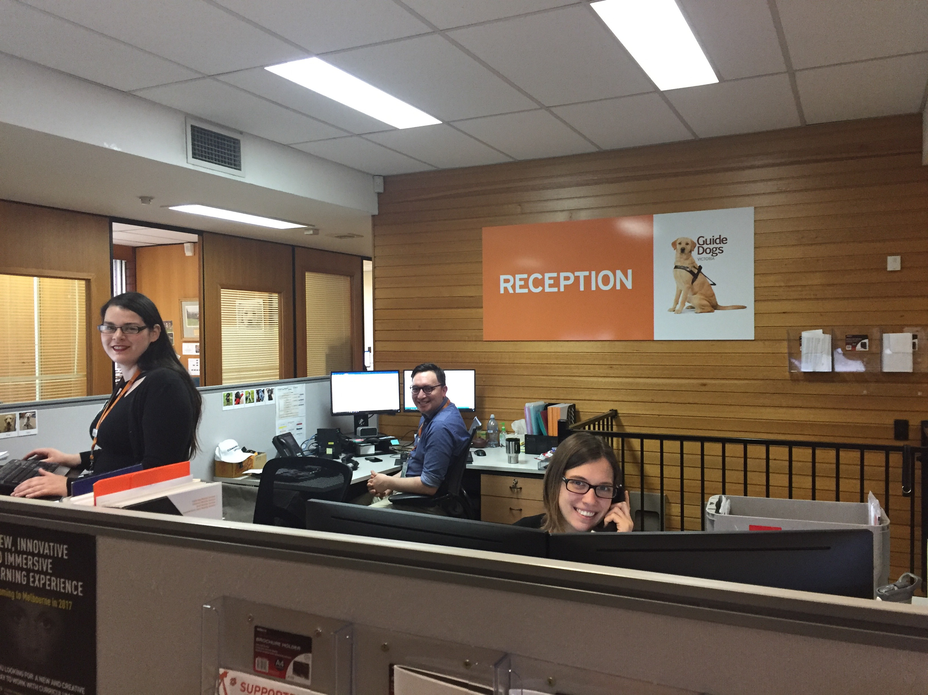

(photo – Customer Service Team Leader Abe with Support Officers Rhiarna (far left) and Becky (far right) in the new Reception area in the Client Services Building.).

Phew! Client Services have been busy!

Please don’t worry about remembering everyone, the main thing is that they are all here to ensure all our clients get a great service fast, and with a friendly smile!

If you are visiting us at Kew, remember to follow the road around to our new Reception area in what used to be the Resources Building. We have specially allocated Visitor Parking right next to Reception and taxi’s can easily drop off and pick up.

Return to contents

# Proudly announcing our new Orthoptist Service

There are two other new staff members to welcome, opening up a new Orthoptist service for Guide Dogs Victoria to offer clients.

Kate Clark and Khoa Nguyen are Orthoptists with a combined 20 years of experience in low vision who have started at GDV this week.

Kate and Khoa will be providing functional vision assessments, low vision aids and strategies to assist our clients utilise remaining sight.

They will be working with clients of all ages and across a variety of settings including; homes, schools, workplaces and in the clinic at GDV Kew.

Kate and Khoa are passionate about their profession and are excited to share their expertise and experience to support staff and clients of GDV.

As with all our services, the Orthoptists service is available to all our clients as required and at no charge, unless you are eligible for NDIS or My Aged Care Funding in which case it can be covered under these programs. If you are interested in accessing our Orthoptist programme please email [csadmin@guidedogsvictoria.com.au](mailto:csadmin@guidedogsvictoria.com.au).

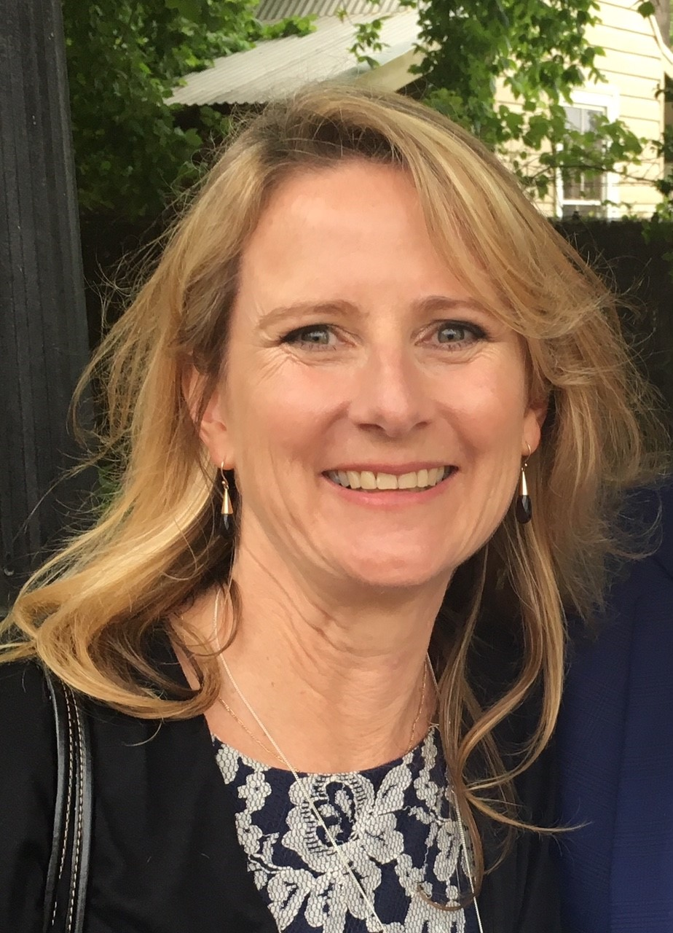

(picture: new GDV Orthoptist Kate)



(picture: new GDV Orthoptist Khoa)

Return to contents

# International Day of People with a Disability – 3rd December

International Day of People with a Disability aims to increase public awareness, understanding and acceptance of people with disability and celebrate the achievements and contributions of people with disability.

GDV along with partners Public Transport Victoria will be launching a special tram, promoting our program Dialogue in the Dark to encourage people to try the experience and meet some of our tour guides with vision loss. This exchange of experience is designed to facilitate communication and awareness the abilities of people living with low vision and blindness.

If you want to know more about Dialogue in the Dark go to <http://www.dialogueinthedark.com.au/>

Return to contents

# International White Cane Day – the launch of the GDV Beacon Pilot at Southern Cross…now we need you!

We marked International White Cane Day a little bit differently this year, launching our new Beacon technology pilot at Southern Cross Station with Lord Mayor of Melbourne, Roddy Doyle.

Beacons are a low-cost navigation and wayfaring solution. They are small wireless devices that emit a low-strength Bluetooth signal to nearby enabled receivers such as a smartphone. Strategically placed and coded with the right information, a user can obtain this relevant information about their surrounding and instructions on where they need to go, updated in real time to notify things like platform changes and escalator outages.

We are very excited about the potential for this new technology, and it certainly captured the attention of the public as well. We made the front page of The Age newspaper, had many members of the public stop, and ask us about the project while we were set up at the station.

The pilot is set to run for about 8 months. During this pilot stage the beacons are not available for general use, but we DO need client volunteers to be part of the pilot and test the system for us. If you are interested in participating, please email John-Ross on [JohnRB@guidedogsvictoria.com.au](mailto:JohnRB@guidedogsvictoria.com.au).

Return to contents

# My Aged Care Update

If you are aged 65 years or over you may be eligible for MY Aged Care funding, helping you get services that can assist you to stay independent at home and active in your community.

This can include things from help with meals, a cleaner, or some help with your garden, through to Allied Health practitioners like physios or Guide Dogs Victoria O&Ms, Occupational Therapists or our Orthoptist Service.

We can help you work out if you are eligible for My Aged Care. If you are, it is worth doing as people tend to find multiple funded supports open up for them.

Guide Dog Handlers may be eligible for help with the cost of their Guide dog’s food and grooming etc.

It is important to remember that, for people with low vision or blindness eligibility is not all about physical fitness. You might be very fit and active but struggle at shower times differentiating the shampoo from the conditioner; or you may find it tricky to identify the products you need at the supermarket.

How can GDV help?

1. We can link you in with My Aged Care to find out if you are eligible.
2. We can help you plan your goals and support needs.
3. If you are eligible you can be reassured GDV will not charge you any co-contribution for any services we provide, although other providers might.

If you want to find out more call 1800 804 805, our friendly Customer Support Team understand My Aged Care and can help you navigate the process. The client stories that follow (names changed) illustrate how we can help clients navigate My Aged Care.

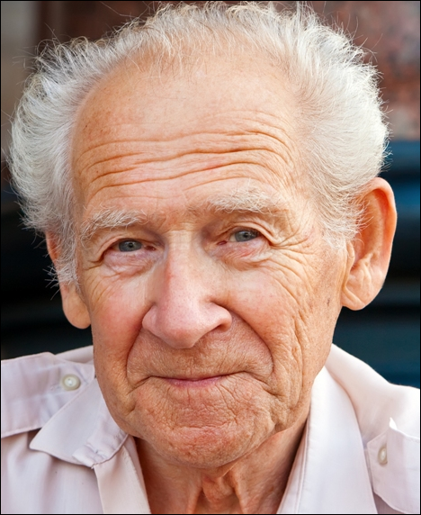Meet John (pictured left), a retired schoolteacher. John has Macular Degeneration and cataracts and has been struggling to read the paper recently. After a recent fall, John was admitted to Caulfield Hospital, where an Occupational Therapist put him in touch with us. He had never considered My Aged Care as he has always considered himself fit and able, and has his wife to help him at home. His son, Matthew, also lives nearby and usually pops around to take care of the home maintenance. With our help John was able to prepare for a My Aged Care assessor and got funding for extra Occupational Therapy to assess him for reading technology (SARA), and Orientation and Mobility training, allowing him to attend his scrabble club once a month.

Carol (pictured left), 65, is recovering from a stroke at the Peter James Centre. Prior to the stroke, she had never had any complaints about her vision, and lived independently as a successful HR manager in a large company. Her husband David has just retired and is becoming her full time carer. As Carol's vision has been impacted by the stroke, an OT urgently referred Carol to us for a functional vision assessment and to begin Orientation & Mobility. Because of the urgency, we began services ahead of the My Aged Care assessment, linking Carol in to the MAC portal at the same time to help accelerate the process.

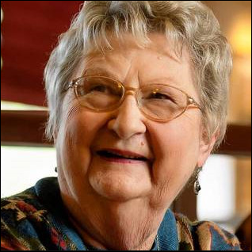Beryl (pictured left), aged 69, has a tribe of grandchildren and a busy life. But she is struggling to adjust to vision loss caused by glaucoma. She receives services from a gardener once a fortnight, arranged through her local council. Having recently added the wrong ingredients into a cake mixture, Beryl was prompted to seek out vision services. Her daughter found GDV on Google, and Beryl called 1800 804 805 to speak to someone about her situation. As Beryl is already receiving services from her local council, she might already be registered with My Aged Care. She wasn’t sure, but we helped Beryl confirm this by asking if there's a contact person at her local council who connects her to service providers. There is, and this person is able to refer Beryl straight into GDV services through the My Aged Care Portal. Beryl gets an assessment with our Orthoptist, and an Occupational Therapy program in her home to assist her with her goal of continuing to bake treats for her family.

Return to contents

# Let us entertain you! Audio Described events in Victoria:

If you love shows, the arts, or the theatre, then watch this space!

In every episode of On The Move we will update you on upcoming shows and events that are professionally audio described.

The following shows are audio described by Description Victoria.

* **Exhibition: Experimenta Make Sense International Triennial of Media Art** – Saturday November 4, 1-3pm, 3-5pm, RMIT City Gallery, 344 Swanston Street. Audio introduction: <https://descriptionvictoria.us15.list-manage.com/track/click?u=b24a8ce2cada0283b7d44e171&id=716f7ca551&e=72a7ee3ff7>  
  How to book: Contact Nicky Pastore from Experimenta on [nicky@experimenta.org](mailto:nicky@experimenta.org) or call 9650 9977 during business hours.
* **Event: Refuge by Arts House**. Join Arts House for Refuge, as the North Melbourne Town Hall is transformed into an emergency relief centre in the time of an imagined heat wave. Artists, community members and First Nations Elders will join with the emergency services sector, to transform Arts House into a place of safety. Audio intro: <https://soundcloud.com/user-564500617/audio-introduction-refuge-by-arts-house>

Tour: Saturday November 11, 3pm until 5pm, at Arts House, [521 Queensberry Street North Melbourne](https://maps.google.com/?q=521+Queensberry+Street+North+Melbourne&entry=gmail&source=g). More info: <http://www.artshouse.com.au/events/refuge/>, or email [will@descriptionvictoria.com.au](mailto:will@descriptionvictoria.com.au)

Return to contents

# Do you feel that your personal challenges are often overlooked by society? Focus group participants aged 18-34 needed…

Do you feel that the personal challenges of people who are blind or have low vision are often overlooked? Here is your chance to be involved in some research that hopes to make a difference to the well-being of people who are blind or vision impaired.

This focus group is the final stage of an online study investigating factors that influence how people who are blind or have low vision feel about themselves. It focuses upon late adolescence and early adulthood, as these are the times where many life choices occur (e.g., tertiary education, career, starting a family).This project is being conducted as part of the research for a PhD degree at Deakin University. The researcher, Paula Hobley, brings an understanding to this research as she is totally blind.

***Paula is looking for participants who are:***

* Aged between 18-34
* Considered legally blind, without any additional sensory physical or cognitive disabilities.
* Have had vision loss since birth or had your vision loss assessed by the end of primary school.
* Willing to agree that information provided in the focus group remains confidential and that you will not discuss information which would identify any participant.

The focus group will be held online using a conference platform called Zoom. There are several ways you can take part using this program. If you are interested the researcher can explain how to access Zoom. If you do not have access to a computer you can join in by telephone.

If would like to participate in this study please email Paula Hobley at [phobley@deakin.edu.au](mailto:phobley@deakin.edu.au) for further information.

Return to contents

# Looking for artists!

The Torball Society of the Blind, a non-profit society based in Malta, have contacted us about a Specially Abled Arts exhibition they are organising featuring the work of artists from all countries, who have a range of disabilities, including vision loss. The exhibition is set to run from November 2017-November 2018, and artists would be encouraged to attend in person at some point if they are able to travel to Malta. If you are interested in submitting art for this event please contact RUWAYDA ISAACS (BELLA), Honorary International Director for South Africa / Malta Torball Society of the Blind, email: [ruwayda.isaacs@yahoo.com](mailto:ruwayda.isaacs@yahoo.com)

Return to contents

# Guide Dog Healthcare Update: Working with your Guide Dog in hot weather!

With so many new graduates this year we a re-running an article about how to work your Guide Dog in hot weather. It is set to be a very warm summer and so it is important to remember the dangers of working with your Guide Dog in hot weather, and do what you can to reduce any risk. A fuller article can be downloaded from the GDV website at: <https://www.guidedogsvictoria.com.au/about-gdv/fact-sheet/>

**KEY POINTS TO REMEMBER:**

* In hot weather, dogs are at risk of dehydration, heatstroke and hyperthermia (elevated body temperature).
* Do not work your dog when it is over 32 degrees centigrade. You will need alternatives like your long cane.
* A simple test to determine if it is too hot to work your dog is to place your flat hand palm down on the pavement. If you cannot hold your hand there for longer than five seconds, it is too hot to work the dog.



(photo description – picture of person’s bare feet next to dog’s paws with caption “If it’s too hot for your feet it’s too hot for mine”

**STEPS TO PREVENT HEAT STROKE INCLUDE:**

* + - Modify your routes in hot weather to incorporate public transport and shaded areas.
    - Take a taxi to your destination if possible.
    - Always carry water with you in warmer weather and stop in shade to give the dog rest and an opportunity to drink.
    - Travel earlier in the morning or later in the evening on hot days.
    - If you must go out in the middle of the day and it is very hot, leave your dog at home with access to water and shade if possible or with a carer.
    - Restrict exercise activity in warmer weather.
    - Never leave your dog alone in a car.

**IF THE DOG DOES SHOW SIGNS OF HEAT STRESS:**

* + - Immediately remove the dog from the heat into air-conditioning or shade.
    - Wet the dog with cool but not chilled water and wet the area around the dog.
    - If the dog is showing severe signs of heat stress see the vet immediately.
    - Even if the dog shows signs of recovery after being cooled down, you should still see check with a vet as soon as possible.

Return to contents

# Jobs at Guide Dogs Victoria

Guide Dogs Victoria welcomes applicants who are blind or who have low vision to apply for vacancies. Summaries of current vacancies can be found below. If you are interested in applying then please view the detailed information on our website – links are given next to each job summary.

## Guide Dog Mobility Instructor

Guide Dogs Victoria currently has a vacancy for an experienced professional to join our team in the role of Guide Dog Mobility Instructor on a full time permanent basis. The purpose of this role is to assess and train guide dogs and to provide mobility programs to people with low vision or blindness that meet the needs of the individual, while at the same time adhering to Guide Dogs Victoria and IGDF standards. You will need a Guide Dog Mobility Instructor qualification gained from a member school of the International Guide Dog Federation, and a recognized qualification as an Orientation and Mobility Instructor. Applications close 31st December 2017.

To apply, see full information and job requirements at <https://www.guidedogsvictoria.com.au/careers/guide-dog-mobility-instructor/>

Return to contents

# Share your story

If you have a story you’d like to share about your low vision or blindness, your achievements, your experiences with our services or being matched with your Guide Dog, we’d love to hear from you. The marketing team are always on the lookout to feature our client’s stories in the media, to help spread the word about the wonderful work of Guide Dogs Victoria and to increase public awareness about people living with low vision or blindness. If you are comfortable with sharing your story, please email the marketing team at [marketing@guidedogsvictoria.com.au](mailto:marketing@guidedogsvictoria.com.au)to get in touch.

Return to contents

# Feedback

If you have anything to contribute to this newsletter, please feel free to contact us with your piece. We welcome all contributions.

Please either contact or email our client services administration team with your contributions as below:

[csadmin@guidedogsvictoria.com.au](mailto:csadmin@guidedogsvictoria.com.au) or phone 1800 804 805.

Return to contents