Guide Dogs Victoria’s On the Move – July 2017 Bulletin

Tips for reading this newsletter

If you would like to increase the text size on your screen:
- Using the keyboard
    - Press ALT+W, and then press Q.
    - Press the TAB key repeatedly until the Percent box is selected, and then type a percentage or press UP ARROW or DOWN ARROW to select a percentage.
- Using the mouse
    - On the View tab, in the Zoom group, click Zoom.
    - Click the zoom setting that you want or type a percentage in the Percent box.

Contents
Tips for reading this newsletter 1
Editor’s update 2
Upcoming programs and events for your diary 3
Aged 65 or older? Learn about MyAgedCare funding opportunities 8
Meet Nes – this girl can! 11
Let us entertain you! 14
The Real and Imagined History of the Elephant Man by Malthouse Theatre 15
Guru of Chai by Indian Ink Productions, presented by Arts Centre Melbourne 16
Regional audio described theatre: RICE - Hothouse Theatre Wodonga 19
News for Guide Dog Handlers 20
Get premium Guide Dog food delivered to your door 20
Interested to join a research study? 21
Jobs at Guide Dogs Victoria 23
Guide Dog Mobility Instructor 23
Support Coordinator Team Leader 24
Occupational Therapist Team Leader 24
Business Development Manager 25
Digital Fundraising Coordinator 26
Share your story 26
Feedback 27

Return to contents

Editor’s update

Welcome to July’s On The Move. The focus article this month will be of special interest for clients are aged 65 years or older, who aren’t eligible for NDIS funding, but may well be eligible for MyAgedCare funding.

We have been advocating for more equity for the over 65 age group, and whilst the MyAgedCare funding schemes have been designed differently to the NDIS, they do provide an opportunity to get a fairly wide set of services funded, including vision support services, and, for Guide Dog handlers – food and maintenance costs. It’s definitely worth exploring and our Customer Gateway can help you understand the schemes available and get the ball rolling.

There are also plenty of events on offer over the next few months in our ‘Dates’ section, so please do get involved if something takes your interest.

Try Before You Ride – the PTV program that gives people the opportunity to get a bit of experience on public transport in a safe space, is back, and in Gippsland. We are very aware that a lot of the programs and events have a Melbourne-centric focus, and would love to get to write more about regional issues and events. If you live regionally, and have an experience you want to share or an event to promote then get in touch, we want to hear about it!

Sophie Wild
Bulletin Editor

Upcoming programs and events for your diary

- Celebrating Albinism – the Albinism Fellowship Conference – 19th and 20th August at the Rendezvous Hotel, Melbourne. A full day conference (with youth program) looking at subjects like successful workplace participation, the latest in surgery, technology and software plus a coordinated social program. For more information go to http://albinismaustralia.org/melbourne-conference-2017/
- Indian Cooking session - Tuesday 22nd August at 1:30pm. Are you keen to learn how to cook Indian food from a talented Indian cook? Meena has worked in professional Indian kitchens preparing delicious food from all part of India, and is keen to share her skills. In conjunction with Occupational Therapists Krystle and Leah, Guide Dogs Victoria would like to offer up an opportunity for a small group of people to come in and increase their safe cooking skills, whilst preparing a simple Indian dish.
Location: Guide Dogs Victoria, 2-6 Chandler Highway Kew – Main reception
RSVP: by 17th August to 1800 804 805 or csadmin@guidedogsvictoria.com.au

- Understanding Acquired Brain Injury and Low Vision – 23rd August and 8th November. A one-day information program for people with vision changes secondary to an acquired brain injury (ABI). The day will aim to help you and your family gain an understanding of how vision can change following an ABI, such as stroke, accident, surgery, tumour or other brain injury. It will investigate how changes to the brain’s function can impact on mobility in unexpected ways. The day will also provide an opportunity to share experiences with people of all ages, and their families, who have low vision or blindness from an ABI. Places are limited to so please book your place by emailing CSAdmin@guidedogsvictoria.com.au or call 1800 804 805.

- Moreland and Hume NDIS information sessions – 23rd August and 6th September. Covering: What you need to know about the rollout of the NDIS in your area. Basics on the NDIS: what it is, who can benefit, what it funds and how it works. Hear from people who have transitioned to the scheme. Questions answered, both personal and technical. Contact for more information:
andrewtr@hume.vic.gov.au

- Try Before You Ride - 31st August, Gippsland. Boost your confidence by practising how to board and alight a V/Line coach and a low floor bus at Morwell Station. A V/Line train will also travel between Traralgon and Morwell stations with V/Line staff to assist you to board, alight and to answer any questions. A light lunch will be provided.
Morwell Station - Coach and bus: 11:00am to 2:00pm.
Traralgon Station - V/Line train: 11:00am for a 11:20am departure to Morwell Station. Return by train at 1:36pm.
RSVP: Thursday 24 August 2017, Tessa on 03 9619 5900 or
community.relations@vline.com.au. Please advise if you will be travelling with a mobility aid.
A further Try Before You Ride will be conducted in Eastern Melbourne at Box Hill Interchange on 17th October 2017, more details to come.
- Young Adults Program (YAP) Fitness and Recreation – 14th September. Connecting young people (approximate age 18-30) with low vision or blindness for discussions and fun activities. YAP sessions run bi-monthly throughout the year. Contact rachelh@guidedogsvictoria.com.au for more information.
- National Acquired Brain Injury Conference – 24th and 25th October, Rendezvous Hotel Melbourne: an opportunity to hear latest news and developments in research, advocacy, rehabilitation, treatment, case studies and policy from a wide range of perspectives. GDV’s Client Services Manager, Shelley Pannier, will present on rehabilitation for people with ABI-related vision loss. People with a disability, their family or carers can apply for concessional attendance rate of $100 for 2-day attendance. Go to https://www.informa.com.au/event/national-acquired-brain-injury-conference/ for more information.

- Stem Cell Community Forum – 17th August 11am, Royal Australasian College of Surgeons, Hughes Room, 250-290 Spring Street, East Melbourne. Imagine a world where inherited eye diseases are cured using your own cells. Being able to restore sight once it has been lost is an age-old dream, which seemed impossible until the discovery of stem cells. But what are stem cells, and why are they so important? What are the facts? What does stem cell science mean for eye disease? Come and learn about stem cells and understand the science behind them. All are welcome. Gold coin donation appreciated to help cover the cost of running forums. RSVP by 14th August to
cera-rsvp@unimelb.edu.au

You’re invited! Social events
- Coffee mornings every Friday in the Frankston area. If you enjoy having a cuppa and meeting new friends, please join our casual client run coffee mornings. New members always welcome. For details please contact Robert on 0409 685 606 or email
rgsblind@yahoo.com.au

Following on from the success of our Frankston Coffee Club, we are currently canvassing interest in similar programs being run in Mornington and Pakenham. These catch-ups are a great opportunity to meet up and discuss topics such as transport, technology, the NDIS roll-out as well as a great excuse to have a chat and great coffee! If you or someone you know might be interested or has any further questions, please contact Tim Carter on (03) 9854 4448 or by email at timc@guidedogsvictoria.com.au

Return to contents

Aged 65 or older? Learn about MyAgedCare funding opportunities
If you are aged 65 or older you might well be feeling that the current focus on NDIS funding across the sector is irrelevant, and not equitable.
In fact, there are funding options for people who are older than the NDIS cut-off of 65, but the system is different and has changed quite significantly in recent years. MyAgedCare is about supporting the needs of individuals over the age of 65 who need some level of help to maintain their independence within the community and stay at home.
(image: MyAgedCare logo)
There are two main funding options for people who need support or services, and are living at home. These are called:
- Commonwealth Home Support Program (CHSP): for people who only need low intensity help on a short term or ongoing basis, or high intensity delivered on a short term or episodic basis. The CHSP is about restoring a person’s ability to continue living independently.
- Home Care Package (HCP): for people who need ongoing high intensity support, funding is supplied as a package tailored to meet the individual’s goals.
In preparing to register with MyAgedCare it is important to think about your goals and needs for staying independent in the home. For example, you might need help cleaning your house or doing your garden, you might need extra Allied Health services (like physiotherapy or a podiatrist) over and above the five free visits you get through your GP. Guide Dog handlers can get help with ongoing Guide Dog costs like food or grooming if you have a HCP, as it’s part of maintaining your mobility equipment. It really depends on what you need to live well at home and in the community. So it’s definitely worth exploring!
What about the services I get from Guide Dogs Victoria? Guide Dogs Victoria is registered with MyAgedCare and can provide Specialised Vision Services under the funding options. These services include Occupational Therapy, Orientation and Mobility and in the near future we shall have an Orthoptist.

What’s the process?
- First you need to get registered with MyAgedCare. We can help you with this. Give us a call on 1800 804 805 and chat to our Customer Service Gateway. They can discuss your eligibility and register you with MyAgedCare.
- A MyAgedCare assessor will get in touch via phone and ask a series of questions as part of the registration process. They will then refer you to a Regional Assessment Service that may come out to your home and discuss your goals for staying independent in the home. This assessment will determine the funding stream allocated.
- Once services are identified to meet your goals, you can choose which provider you want to deliver the services you need.
It can seem daunting, but remember they are there to understand your needs and help you get the support and services you need to live well at home and get out in the community.
Our Customer Service Team are with you on the journey. We can help explain more about the funding, your eligibility, and register you for MyAgedCare. We can, with your consent, follow up with you to see how the process is going, once you have been assessed. We can provide mobility and daily living supports and services, and make recommendations/assessments for technology and equipment that can make your life easier.
So if you are 65 years old or over, get in touch about MyAgedCare – we are waiting for your call 1800 804 805.
Return to contents

Meet Nes – this girl can!

Our very own client Neslihan Sari has been in the news this week, as one of the go-getting women featured in the Australian version of the UK’s smash ‘This Girl Can’ fitness campaign.
Neslihan is a keen jogger, embracing the sport 10 months ago.
"I haven't really been very active throughout my life. It's only in the past couple of years I decided to do something about my health," she said. Both she and her parents were worried about her getting involved in sport as a child, for fear she would hurt herself.
"Throughout the years various things have happened throughout my life and I ended up hitting rock bottom and then I decided I needed to make a change. I needed to say yes to opportunities. I needed to take the steering wheel to my life."
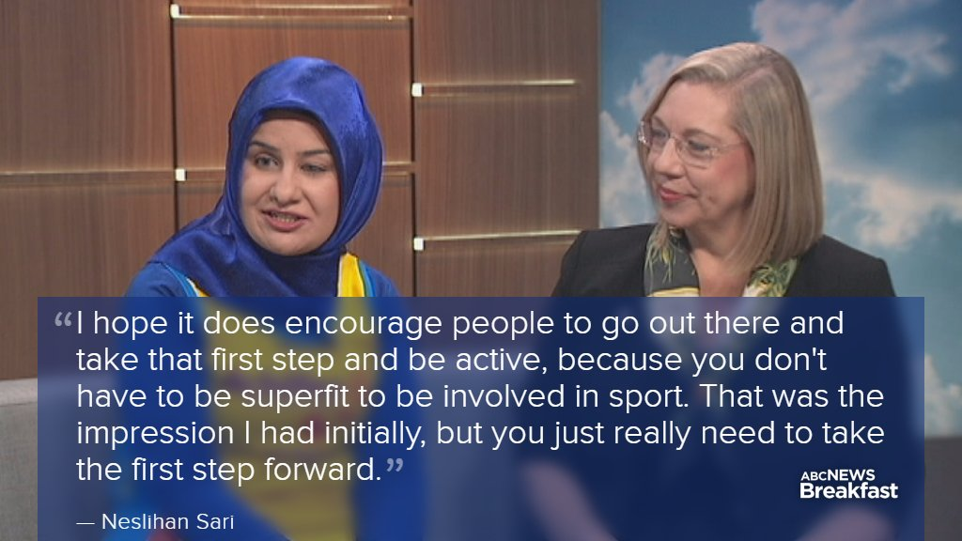
(Image: Neslihan sitting on the ABC News Breakfast sofa being interviewed on her involvement, overlaid text quoting her saying: “I hope it does encourage people to go out there and take that first step and be active, because you don’t have to be superfit to be involved in sport. That was the impression I had initially, but you just really need to take the first step forward.”)
The UK's viral This Girl Can campaign encouraging women to become more active is about to launch an Australian spin-off.
The organiser, Sport England, estimates the campaign inspired 2.8 million British women to get more active and hopes a partnership with VicHealth in Australia can produce similar results, following a worrying survey about women’s attitudes to exercise.
- 41% of women are too embarrassed to exercise in public
- 39% of women believed they were not coordinated when it came to physical activity
- 46% of women found gyms and fitness centres intimidating
- 30% of women were uncomfortable in exercise clothing
- 72% of women felt good about themselves when they did some exercise
Source: VicHealth survey of more than 2,500 Victorians
You can see Nes’s story at https://www.youtube.com/watch?v=6gLmMwbRgss , and if this inspires you to share your fitness story, VicHealth wants to know, go to https://thisgirlcan.com.au/ to find out how.
And if you are inspired to try a new sport or exercise then give it a go! You can find heaps of ideas at http://blindsports.org.au/

Return to contents

Let us entertain you!

If you love shows, the arts, or the theatre, then watch this space!
In every episode of On The Move we will update you on upcoming shows and events that are professionally audio described.
Audio description adds live or pre-recorded verbal information to performances, events, exhibitions, and moving images, making them accessible for people with low vision or blindness.
Describers come from a variety of backgrounds and disciplines in art, performance and media, combining their own expertise with expert training in description. GDV client and talented musician, Ross de Vent, has been working with Will McRostie from Description Victoria on professionalising audio description in Victoria.

The following shows are scheduled for August, described by Description Victoria.

The Real and Imagined History of the Elephant Man by Malthouse Theatre

Audio intro: https://soundcloud.com/user-564500617/elephant-man-intro
"I am the most extraordinary thing in this massive city
Yet when you look at me
You cannot see me"
Joseph Merrick, better known as the Elephant Man, is cast out. He survived circus ‘freak shows’ and the revulsion of a gawking public for years until a young doctor offered him asylum at the London Hospital in 1879.
So began a life of endless observation. But curiosity works both ways, and Merrick returned the horrified gaze of Victorian punters and nurses with wonder and optimism.
This story has inspired multiple theatrical adaptations, novels and a film by David Lynch. Now the team behind Malthouse Theatre’s Picnic at Hanging Rock, director Matthew Lutton and playwright Tom Wright, reunite to create a poignant new work that uncovers empathy in a world that rejects difference.
The Real and Imagined History of the Elephant Man will span across Joseph Merrick’s life, from birth to death, weaving through the bustling streets of London, the incurables ward of the city’s hospital and the theatrics of the English public arena. The Real and Imagined History of the Elephant Man is a remarkable tale of a city negotiating the discovery of a “new man”.
When: Friday August 18; Tactile Tour from 6.30pm; Performance at 7.30pm
Where: Merlyn Theatre, Coopers Malthouse, 113 Sturt St, Southbank
How much: Standard $69, Senior $64, Concession $49, Under 30s & Students $35.
How to book:
Contact Toby Sullivan on 03 9685 5165, email boxoffice@malthousetheatre.com.au, or visit the Malthouse website.

Guru of Chai by Indian Ink Productions, presented by Arts Centre Melbourne
Audio intro: https://soundcloud.com/user-564500617/the-guru-of-chai-intro
The contradictions of modern India with its iPhones and ancient gods come alive in this outrageously funny and heartbreakingly beautiful romantic thriller.
Amid the chaos of a bustling Bangalore railway station, a poor chai-wallah (tea-seller) has his life changed forever when an abandoned young girl brings the place to a standstill with the beauty of song. Our Guru of Chai (Jacob Rajan) is a bucktoothed chameleon, channelling seventeen different characters and dispensing spiritual wisdom – sometimes questionable – as he plays out this serpentine tale of impossible love and modern day magic. He is by turns charming, loathsome and absurdly profound.
From New Zealand to Edinburgh, Singapore and the US, genre-defying theatre company Indian Ink has been capturing hearts and busting box offices with this heady brew of soul-warming storytelling. Let the guru pour you a cup of his finest, and you'll find that you're the one being stirred. With two Edinburgh Fringe First awards, three Production of the Year awards, as well as achieving Best Play, Best Composer and Best Actor at the Chapman Tripp Theatre Awards, you're in good hands.
When: Sunday August 27, Tactile Tour from 4pm, Performance at 5pm
Where: Fairfax Studio, Arts Centre Melbourne, 100 St Kilda Road, Southbank
How much: Adult: $54, Concession: $45, Under 30s: $30
How to book: Contact the Arts Centre box office on 1300 182 183, or visit the Arts Centre Melbourne website.

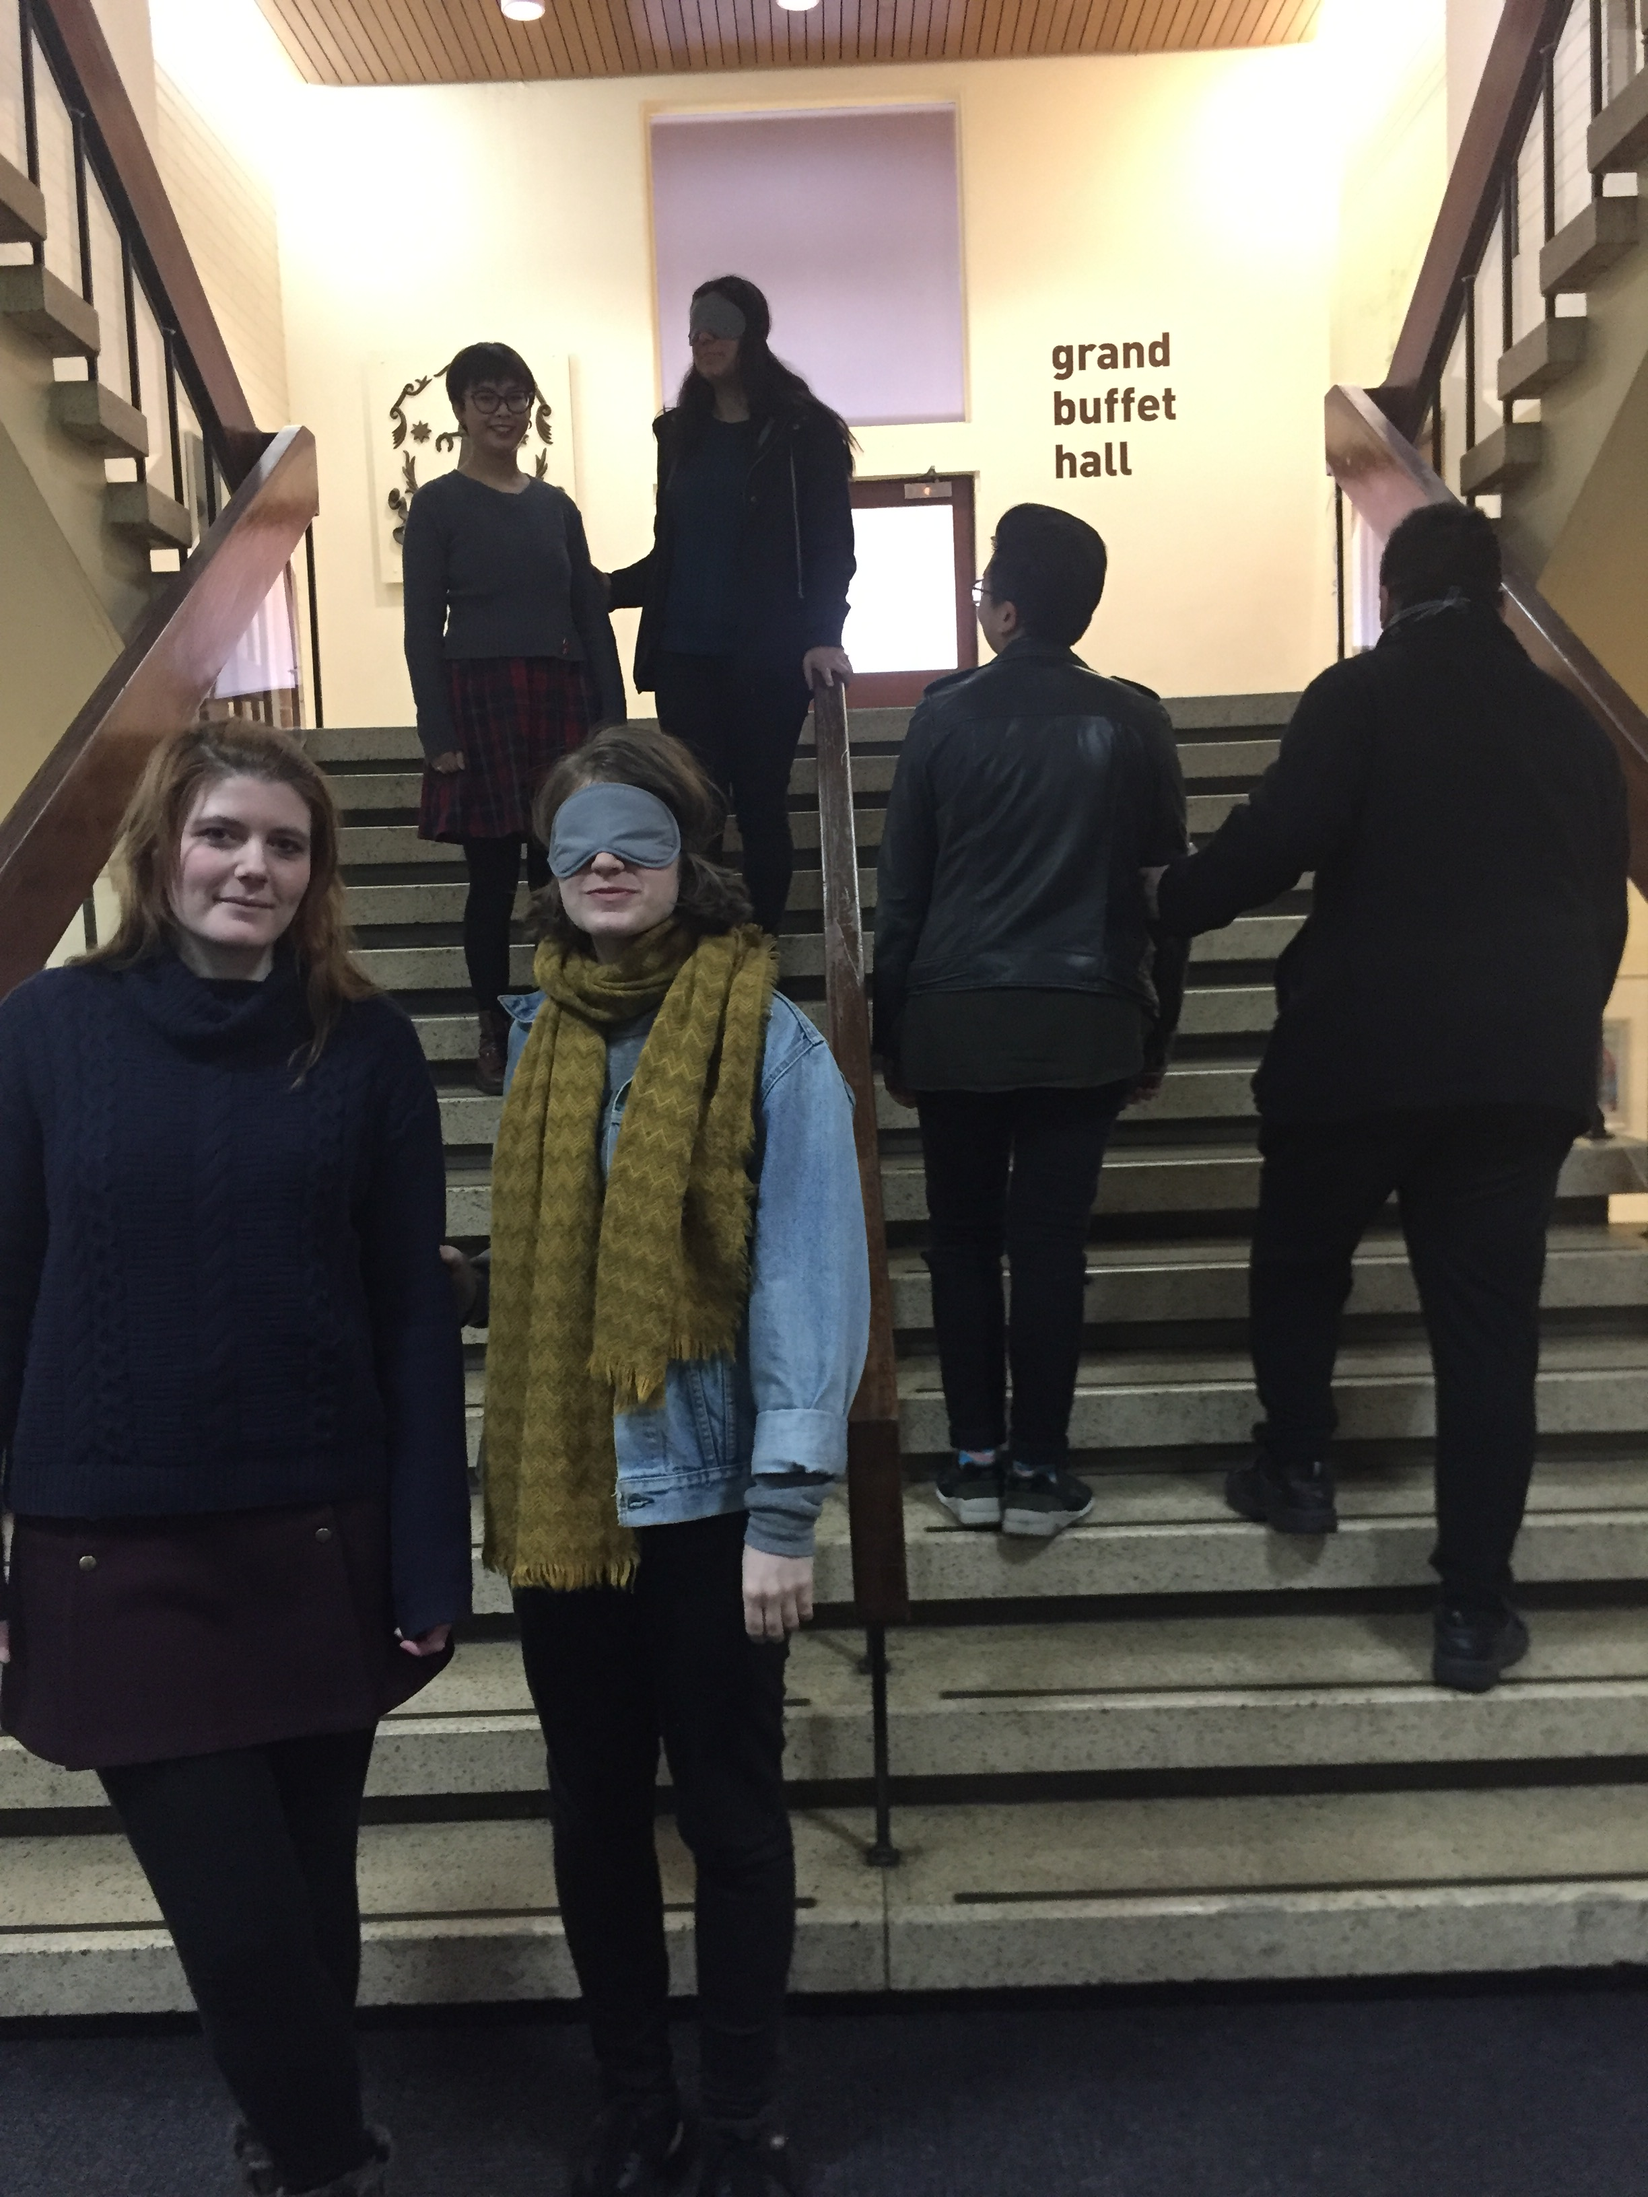
(Image: members of Description Victoria on theatre stairs having a blindfold experience)

Regional audio described theatre: RICE - Hothouse Theatre Wodonga
Working late, high up in a skyscraper, is Nisha, a business prodigy and second-in-command of an Australian rice company. Smart and sassy, she’s on the brink of closing a massive deal with the Indian government. Working later still is Yvette, the Chinese-Australian cleaner who clears up her take-away.
‘Indian princess’ and ‘Chinese cleaner’ is at first all they see when they face each other across the desk. They’re from different cultures and different generations – but as the nights wear on, and the women trade stories about their days, they discover the many ties that bind them.
Brimming with wickedly humorous observations on globalisation, power, politics and family, Rice recently won Michele Lee the Queensland Premier’s Drama Award 2016 – 2017. This terrific co-production from Queensland Theatre and Griffin Theatre Company is directed by Griffin’s Helpmann Award winning director Lee Lewis.
When: 29th August-2nd September
Tickets and more information:
https://www.hothousetheatre.com.au/rice/

Return to contents

News for Guide Dog Handlers

Get premium Guide Dog food delivered to your door

You may know that Guide Dogs Victoria is sponsored by MARS Australia who supply ADVANCETM dog food to all our puppies and Guide Dogs in training.
ADVANCETM is the most tested, super premium dog food in Australia. It is designed in Australia using the highest quality ingredients from approved suppliers and Hazard Analysis & Critical Control Points (HACCP) quality systems to ensuring Guide Dogs get the best possible food to lead a healthy long life.

We have secured access to the MARS Pro Store for our clients – meaning you can get ADVANCETM delivered right to your door with no delivery fee.

- To take advantage of this offer, go to
www.ADVANCEpet.com.au
- Click on the Log in to New Breeder Sign up
- Select Professional Groups, then Guide Dog
- Fill in your details – please use a street address only no PO Box deliveries
- You will receive a welcome email containing a password which you can alter the first time you log in

- Minimum order 2 bags
- Auto reorder service available if required.
- $5 per kg at $99.99 per 20 kg bag
- $5.29 per kg at $89.99 for 17kg bag of Weight Control
(Image: Blue bag of ADVANCETM adult Dog Food)

Interested to join a research study?

A researcher from Hungary has been in touch with us about her PhD dissertation on the acceptance of service dogs, their role in social integration and their additional effects.
Eszter Loványi is from Hungary, a teacher and researcher of the Bárczi Gusztáv Faculty of Special Education at the Eötvös Loránd University as well as doctoral candidate of the Faculty of Pedagogy and Psychology at the same university. She volunteers for the NEO Hungarian Non-Profit Service Dog Association, and has two service dogs for hearing, Kuku (retired) and the younger Mák.
Eszter writes:
My questionnaire can be found on this link till the 15th of August 2017.
Filling in the questionnaire would take about 10-12 minutes. Of course the procedure is completely voluntary and anonymous. Answers will be solely used for my work and will not be given to a third person. The content and methodology of the questionnaire was approved by the Research Ethics Committee of Bárczi Gusztáv Faculty of Special Education of Eötvös Loránd University on the 29th of June 2017.
Should you have any question or wish for further information about the aims and current research results of my work you may get in touch with me at one of the given contacts.
lovanyi.eszter@barczi.elte.hu, lovanyie@gmail.com

Jobs at Guide Dogs Victoria

Guide Dogs Victoria welcomes applicants who are blind or who have low vision to apply for vacancies.
Summaries of current vacancies can be found below. If you are interested in applying then please view the detailed information on our website – links are given next to each job summary.

Guide Dog Mobility Instructor
Guide Dogs Victoria currently has a vacancy for an experienced professional to join our team in the role of Guide Dog Mobility Instructor on a full time permanent basis.
The purpose of this role is to assess and train guide dogs and to provide mobility programs to people with low vision or blindness that meet the needs of the individual, while at the same time adhering to Guide Dogs Victoria and IGDF standards. You will need a Guide dog Mobility Instructor qualification gained from a member school of the International Guide Dog Federation, and a recognized qualification as an Orientation and Mobility Instructor. Applications close 31st December 2017.
To apply, see full information and job requirements at https://www.guidedogsvictoria.com.au/careers/guide-dog-mobility-instructor/

Support Coordinator Team Leader
Guide Dogs Victoria currently has a vacancy for an experienced professional to join our team in the role of Support Coordinator Team Leader, on a full time permanent basis.
The successful applicant will oversee a team of support coordinator professionals and work in conjunction with other teams across Guide Dogs Victoria in delivering holistic services; developing support coordination capabilities, policies and procedures. Relevant tertiary qualifications within a related field and a demonstrated track record in a similar leadership position are required. Applications close 11th August 2017.
To apply, see full information and job requirements at https://www.guidedogsvictoria.com.au/careers/support-coordinator-team-leader/

Occupational Therapist Team Leader
Guide Dogs Victoria currently has a vacancy for an experienced professional to join our team in the role of Occupational Therapist Team Leader, on a full time permanent basis. The responsibilities will include leading a team of occupational therapy professionals and working in conjunction with other teams across Guide Dogs Victoria in delivering holistic services; overseeing the caseload and developing policies and procedures. Relevant tertiary qualifications within a related field, eligibility for registration with OT Australia and current registration with AHPRA and a demonstrated track record in a similar leadership position are required. Applications close 11th August 2017.
To apply, see full information and job requirements at https://www.guidedogsvictoria.com.au/careers/occupational-therapist-team-leader/

Business Development Manager
We have a vacancy for an experienced professional to join our team in the role of Business Development Manager, building and managing a proactive and successful commercial sponsorship and partnership program.
Relevant qualifications in a relevant field such as marketing or business are required, along with ADVANCEd sales / account management experience and proven ability to develop and build partnerships. Applications close 11th August 2017.
To apply, see full information and job requirements at https://www.guidedogsvictoria.com.au/careers/business-development-manager/

Digital Fundraising Coordinator
Guide Dogs Victoria currently has a vacancy for dynamic and digital savvy professional to join our Fundraising Team in the role of Digital Fundraising Coordinator, initially on a part time basis, three days per week, but with the potential to move to full time.
This involves assisting with the development and implementation of an innovative digital fundraising strategy with a focus on increasing donor engagement and fundraising revenue for programs. Relevant qualifications within a related field such as multimedia or marketing (or currently completing qualifications) and a good working knowledge of digital technologies including content management systems, HTML and Google Analytics, are required. Applications close on 11th August 2017.
To apply, see full information and job requirements at https://www.guidedogsvictoria.com.au/careers/digital-fundraising-coordinator/

Return to contents

Share your story

If you have a story you’d like to share about your low vision or blindness, your achievements, your experiences with our services or being matched with your Guide Dog, we’d love to hear from you. The marketing team are always on the lookout to feature our client’s stories in the media, to help spread the word about the wonderful work of Guide Dogs Victoria and to increase public awareness about people living with low vision or blindness. If you are comfortable with sharing your story, please email the marketing team at marketing@guidedogsvictoria.com.au to get in touch.
Return to contents

Feedback

If you have anything to contribute to this newsletter, please feel free to contact us with your piece. We welcome all contributions.

Please either contact or email our client services administration team with your contributions as below:
csadmin@guidedogsvictoria.com.au or phone 1800 804 805.

Return to contents

