Guide Dogs Victoria’s On the Move – August/September 2017 Bulletin

Tips for reading this newsletter

If you would like to increase the text size on your screen:
- Using the keyboard
    - Press ALT+W, and then press Q.
    - Press the TAB key repeatedly until the Percent box is selected, and then type a percentage or press UP ARROW or DOWN ARROW to select a percentage.
- Using the mouse
    - On the View tab, in the Zoom group, click Zoom.
    - Click the zoom setting that you want or type a percentage in the Percent box.

Contents
Tips for reading this newsletter 1
Editor’s update 2
Upcoming programs and events for your diary 3
Self Advocacy Reminder 8
Clients wanted for project reference groups 9
Victorian Disability Awards honour GDV client Twanny and staff member Johann 10
Disability Leadership Program – Have a go! 12
Let us entertain you! Audio Described events in Victoria: 12
Participation in the Australian Marriage Law Survey 13
News for Guide Dog Handlers – the importance of preventative health 14
Jobs at Guide Dogs Victoria 17
Guide Dog Mobility Instructor 17
Share your story 18
Feedback 18

Image: Yellow trumpets of daffodils on a green background heralding Spring

Editor’s update

It’s nearly September already, and I can’t wait for the weather to turn! We keep getting glimpses of Spring and then the hail and cold returns!

There are plenty of upcoming events to take advantage of as Spring arrives. A fantastic group program in October will hone your orientation skills as you ‘Travel The Bay’, and PTV’s Try Before You Ride is back at Box Hill – our Adult’s Mobility Service Instructors will be on hand and we would love to get a group together to explore public transport options and have lunch on a train carriage.

There are also plenty of opportunities for people who want to get involved or get their voice heard in the sector. We are looking for GDV Customer Reference volunteers to act as sounding boards for a couple of projects, and the Victorian Disability Leadership Program is looking for applicants. If you are already a leader, or looking to develop leadership skills this might be for you.

Finally, thank you so much to everyone who has submitted their event or news to On The Move. We have heard from a Book club keen for members in Ballarat, and adapted Table Tennis in Kilsyth, and of course a wrap up of some audio described events from Description Victoria.

I’m actually off on annual leave for a few weeks mid September, so this will be a double issue of On The Move, and I’ll be back in October with the next issue. In the meantime keep the news coming in, we love to hear from you!

Sophie Wild
Bulletin Editor

Return to contents

Upcoming programs and events for your diary

- Understanding Acquired Brain Injury and Low Vision – 8th November. A one-day information program for people with vision changes secondary to an acquired brain injury (ABI). The day will aim to help you and your family gain an understanding of how vision can change following an ABI, such as stroke, accident, surgery, tumour or other brain injury. It will investigate how changes to the brain’s function can impact on mobility in unexpected ways. The day will also provide an opportunity to share experiences with people of all ages, and their families, who have low vision or blindness from an ABI. Places are limited to so please book your place by emailing CSAdmin@guidedogsvictoria.com.au or call 1800 804 805.

- Moreland and Hume NDIS information sessions –6th September. Covering: What you need to know about the rollout of the NDIS in your area. Basics on the NDIS: what it is, who can benefit, what it funds and how it works. Hear from people who have transitioned to the scheme. Questions answered, both personal and technical. Contact for more information:
andrewtr@hume.vic.gov.au

- Public Transport Victoria’s Try Before You Ride - Learn about how you can travel safely using our public transport system – Wednesday 11th October, approximately 10:00am-2:00pm. Adults Mobility Services will be in attendance and would like to support a small group of 10-15 people with low vision or blindness to explore the various modes of public transport with PTV, followed by additional travel discussions and lunch. This is a great opportunity to explore stationary public transport vehicles without any time pressure! If you’re interested in joining us, please RSVP by 22nd September to 1800 804 805 or
csadmin@guidedogsvictoria.com.au
Alternatively, if you’re interested in attending independently of Guide Dogs Victoria, further information and registration details can be found here: https://www.ptv.vic.gov.au/getting-around/accessible-transport/try-before-you-ride/

- Young Adults Program (YAP) Fitness and Recreation – 21st September. Connecting young people (approximate age 18-30) with low vision or blindness for discussions and fun activities. YAP sessions run bi-monthly throughout the year. Contact rachelh@guidedogsvictoria.com.au for more information.
- Travel The Bay – Adults Mobility Services Program: 23rd-26th October. Broaden your horizons and build your social networks in this action-packed group program, focused on navigating and travelling Port Phillip Bay on foot and using public transport. ‘Travel The Bay’ will provide a safe and fun environment to challenge and improve your mobility skills, travel planning as well as your independence and confidence. Places are limited and RSVPs are due by 5pm September 15th. To find more detail download the accessible flyer
here
or email
CSAdmin@guidedogsvictoria.com.au.
- HUME VALID Our Choice Expo – 23rd October 10am-3pm, Hume Global Learning Centre, 1073 Pascoe Vale Road Broadmeadows. Be informed and ready to transition to the NDIS. Explore a wide range of local services, and meet the NDIA. For further details contact:
christine@valid.org.au
- National Acquired Brain Injury Conference – 24th and 25th October, Rendezvous Hotel Melbourne: an opportunity to hear latest news and developments in research, advocacy, rehabilitation, treatment, case studies and policy from a wide range of perspectives. GDV’s Client Services Manager, Shelley Pannier, will present on rehabilitation for people with ABI-related vision loss. People with a disability, their family or carers can apply for concessional attendance rate of $100 for 2-day attendance. Go to https://www.informa.com.au/event/national-acquired-brain-injury-conference/ for more information.
- Southern Metro VALID Our Choice Expo –21st November, Caulfield Racecourse. Be informed and ready to transition to the NDIS in early 2019. Explore a wide range of local services, and meet the NDIA.
For further details contact:
christine@valid.org.au

You’re invited! Social events
- Coffee mornings every Friday in the Frankston area. If you enjoy having a cuppa and meeting new friends, please join our casual client run coffee mornings. New members always welcome. For details please contact Robert on 0409 685 606 or email
rgsblind@yahoo.com.au
- GDV Ballarat Book Club – 3rd Thursday of the month. Lunch followed by discussion on our audio book of the month. If you are looking for interesting conversation, a diverse group, and good humour, join us! Our members have Guide Dogs and/or canes all of which are accommodated in a very friendly café atmosphere. Contact Janice on jannorth1@gmail.com
- Croydon Vision Impaired Table Tennis Club - Every Tuesday 6:00 pm to 8:30 pm. Table Tennis Stadium, Kilsyth Sports Centre, Liverpool Road Kilsyth Victoria 3137. This is an all-inclusive game of table tennis that has been specially adapted for people with low vision or blindness to play and is a fun game with plenty of laughter and good cheer so come along and join us. Contact Wayne Hyland by phone: 0497 905 638 or email: flinghyland@iinet.net.au

Return to contents

Self Advocacy Reminder

Following our article in June’s On The Move we have uploaded our Self-advocacy Toolkit on our website, at
https://www.guidedogsvictoria.com.au/resources/access-and-advocacy/self-advocacy-toolkit/
GDV Policy is to encourage self-advocacy where ever possible. This is an important part of independence and often you have the best information and opportunity to self-advocate.

We support clients with self-advocacy resources:
  - Wallet Access Cards outlining Guide Dog & Pup in training access rights. We recommend all GD handlers & Puppy Raisers carry these and use them on-the spot when required
  - Self-advocacy toolkit available on our website and held at Client Services covering steps in self-advocacy, public transport feedback contacts, government/council feedback contacts, Disability Services Commissioner, Vic Equal Opportunity & Human Rights Commission, VCAT, various advice & legal support contacts, and finally the details for peak advocacy group Blind Citizens Australia, and their Victorian advocacy toolkit.

If you are still experiencing issues, or have concerns self-advocating then we can help further. Let Client Services on 1800 804 805 know and we will send out an Education Pack to the business concerned.

If the matter still isn't resolved we can refer you to Blind Citizens Australia for further assistance.
Return to contents

Clients wanted for project reference groups

One of the key pieces of feedback from our Stakeholder Survey earlier this year was to involve clients more in the planning of communications and future services.

We have a Consumer Advisory Council who meet quarterly to facilitate the exchange of information and ideas between clients and Guide Dogs Victoria, and provide a fantastic sounding board for projects and services. To complement their activity we would like to set up client reference groups focused on a specific projects.

There are two such projects we are looking for client volunteers to input into:
- Client experience surveys: looking across the board at the way we get your feedback – market research and satisfaction/feedback after delivering a service or program. How often should we be getting information, and what sort of questions should we be asking?
- Client online portal: we are looking to develop a special site for clients where they can go in under a password, to update their contact details, access program information or follow up notes, find education resources and information, and so on.

Your involvement would cover submitting your ideas into the project to help shape the scope, then reviewing our recommendations, and testing any resulting communications or platforms before they go live. If you would like to be involved in the Client reference groups for these projects, then please email sophiew@guidedogsvictoria.com.au

Return to contents

Victorian Disability Awards honour GDV client Twanny and staff member Johann

August 16th saw the 7th Victorian Disability Awards. There were hundreds of nominated people, 29 Finalists over 6 categories, 6 Winners and 3 inducted into the Lifetime Achievement Honour Roll.

Guide Dogs Victoria congratulates Johann Misso (Orientation & Mobility Practitioner) for his induction into the Lifetime Achievement Honour Roll.

Johann has worked at Guide Dogs Victoria for 45 years and changed hundreds of lives over this period. He received the award from Kym Peake, Secretary Department of Health and Human Services and from the Hon Martin Foley MP. The other 2 finalist were Karen Bloomberg from Scope and Louisa Di Pietro from Genetic Support Network Victoria.

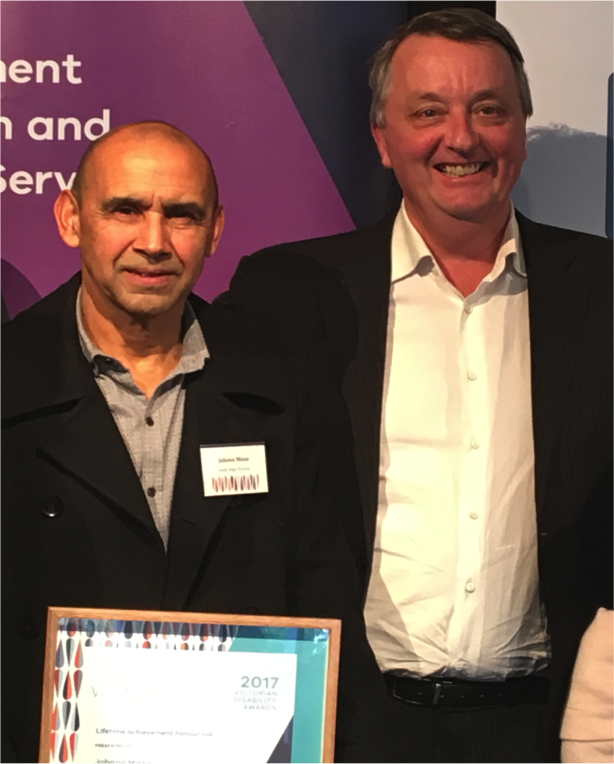
Image: Johan Misso collects his award from the Hon. Martin Foley MP.

We were also delighted to see client Twanny Farrugia receive the Highly Commended award for Volunteer Services to Monash Health. Volunteering is something many of our clients enjoy and we positively encourage as it builds social networks, confidence, and can be incredibly rewarding. It was wonderful to see Twanny accept the award, and we commend him for his community work.

Return to contents

Disability Leadership Program – Have a go!

If you feel inspired by Twanny’s volunteering (see last article) you may want to take a look at http://www.leadershipvictoria.org/programs/the-disability-leadership-program

This is an exciting new program for people with disability who want to grow their leadership, become better leaders, and help to change the way people think about disability in the community. You can choose from a range of training options whether you are new to leadership or an experienced leader. Provided at no cost direct to participants, you can chose from 5 training options such as Leadership Forum and Networking, Mentoring, Role Shadowing, Finding your Edge, and Women’s Leadership.

Return to contents

Let us entertain you!
Audio Described events in Victoria:

If you love shows, the arts, or the theatre, then watch this space!
In every episode of On The Move we will update you on upcoming shows and events that are professionally audio described.
The following shows are audio described by Description Victoria.
- Installation: Pivot by Melbourne Fringe – September 14 to October 1 / Tactile Tour Saturday September 23 [More Info]
- Theatre: Congress by Melbourne Fringe and All The Queen’s Men – Sunday October 1 [Book Tickets]
- Theatre: Hay Fever by Melbourne Theatre Company – Tuesday October 17 and Saturday October 24 [Book Tickets]

Regional audio described theatre: RICE - Hothouse Theatre Wodonga
When: 29th August-2nd September
Tickets and more information:
https://www.hothousetheatre.com.au/rice/

Return to contents

Participation in the Australian Marriage Law Survey

There have been significant concerns that the upcoming Marriage Law Survey (also described as the Same Sex Marriage Survey) may be inaccessible to people with low vision or blindness.

We can confirm that people unable to complete the hard copy postal vote can request a Secure Access Code from the ABS through the Information Line or the ABS website from 25 September to 20 October 2017 and complete the survey online, via the automated telephony service or via a call centre. The Information Line is also available to provide assistance.

The ABS website is www.abs.gov.au

Return to contents

News for Guide Dog Handlers – the importance of preventative health

It is very true that prevention is better than cure, and there are many things that Guide Dog Handlers can do to keep their dogs healthy and fit for work.

- Annual Health Check & vaccinations:
Vaccination is a very important and necessary part of your Guide Dog’s preventative health program. The immunity your dog gains from being vaccinated will diminish with time. Yearly vaccination is the best way we can protect against several life-threatening diseases: canine distemper virus, canine adenovirus and canine parvovirus. These are highly contagious, and usually fatal.

NEWS: There is evidence of a new aggressive strain of parvovirus in Australia, making it even more important to keep your Guide Dog up to date.

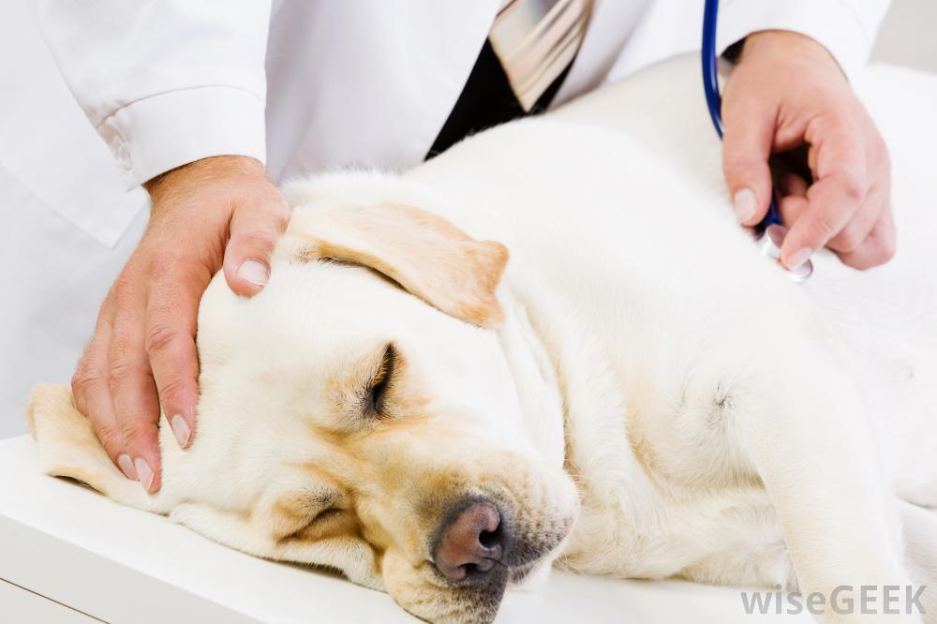
Image –blonde Labrador being examined at the vet

You may have heard that some dogs get triennial (3 year) vaccinations. Because of the important work Guide Dogs do, and the fact they can go anywhere they require yearly vaccinations to protect both themselves and other dogs. Yearly vaccination is mandatory if your Guide Dog is to associate with other Guide Dogs or come onto the Kew campus, due to the danger unvaccinated dogs pose to our pup colony.

Vaccinations are quick and simple, and also give your vet a great opportunity to give your Guide Dog a physical check-up every year.

- Monthly Flea and heartworm treatment:
We are very fortunate to be sponsored by NexGard and HeartGard– who supply all Guide Dog Handlers with free monthly flea/tick protection and Heartworm protection. Fleas can severely irritate both you and your dog, and ticks and heartworm can be fatal. All of this is entirely preventable by giving your dog 2 tasty chews on the first day of every month. Supplies of NexGard and Heartgard are sent out automatically to Guide Dog Handlers, if you have any queries please contact csadmin@guidedogsvictoria.com.au

- Pet Insurance:
A reminder that we recommend all Guide Dogs are covered by Pet Insurance, as this works out far less costly than vet bills if an illness or accident strikes. Clients who are on the National Disability Insurance Scheme must have Pet Insurance, the NDIS will not cover vet bills, but will pay for Pet Insurance premiums. For all non-NDIS clients, Guide Dogs Victoria funds the first year of Pet Insurance for your new Guide Dog. For full information on the importance of pet insurance you can download our recent full article in Issue 13 of On The Move at https://www.guidedogsvictoria.com.au/resources/publications/

Jobs at Guide Dogs Victoria

Guide Dogs Victoria welcomes applicants who are blind or who have low vision to apply for vacancies. Summaries of current vacancies can be found below. If you are interested in applying then please view the detailed information on our website – links are given next to each job summary.

Guide Dog Mobility Instructor
Guide Dogs Victoria currently has a vacancy for an experienced professional to join our team in the role of Guide Dog Mobility Instructor on a full time permanent basis.The purpose of this role is to assess and train guide dogs and to provide mobility programs to people with low vision or blindness that meet the needs of the individual, while at the same time adhering to Guide Dogs Victoria and IGDF standards. You will need a Guide Dog Mobility Instructor qualification gained from a member school of the International Guide Dog Federation, and a recognized qualification as an Orientation and Mobility Instructor. Applications close 31st December 2017.
To apply, see full information and job requirements at https://www.guidedogsvictoria.com.au/careers/guide-dog-mobility-instructor/
Return to contents

Share your story

If you have a story you’d like to share about your low vision or blindness, your achievements, your experiences with our services or being matched with your Guide Dog, we’d love to hear from you. The marketing team are always on the lookout to feature our client’s stories in the media, to help spread the word about the wonderful work of Guide Dogs Victoria and to increase public awareness about people living with low vision or blindness. If you are comfortable with sharing your story, please email the marketing team at marketing@guidedogsvictoria.com.au to get in touch.
Return to contents

Feedback

If you have anything to contribute to this newsletter, please feel free to contact us with your piece. We welcome all contributions.

Please either contact or email our client services administration team with your contributions as below:
csadmin@guidedogsvictoria.com.au or phone 1800 804 805.

Return to contents

