Guide Dogs Victoria’s On the Move – March 2017 Bulletin

Tips for reading this newsletter

If you would like to increase the text size on your screen:
- Using the keyboard
    - Press ALT+W, and then press Q.
    - Press the TAB key repeatedly until the Percent box is selected, and then type a percentage or press UP ARROW or DOWN ARROW to select a percentage.
- Using the mouse
    - On the View tab, in the Zoom group, click Zoom.
    - Click the zoom setting that you want or type a percentage in the Percent box.

Contents
Tips for reading this newsletter 1
Editor’s update 2
Upcoming programs and events for your diary 3
Meet Mathew Jones – the NDIS can make a difference. 5
Special NDIS watchouts for clients with Guide dogs 7
National Insurance Disability Scheme Update: 8
Guide Dogs Victoria are revving up in March to ‘Supercharge the senses’! 10
Stakeholder Survey – an Update! 11
Guide Dog Healthcare Update: Caring for your older Guide Dog 13
Personal Safety Concepts – essential learning! 18
Jobs at Guide Dogs Victoria 19
Share your story 21
Feedback 22

Return to contents

Editor’s update

March’s On the Move brings with it updates on our presence at the Grand Prix at the end of this month, and maybe less exciting, but just as important, reminders about the NDIS roll-out and Personal Safety training.

The NDIS rollout is speeding up, and it’s really important to get as prepared as you can to make sure that you have everything you need included in your plan. We know this isn’t always easy, and the red-tape can be frustrating, so we are here to help with preplanning Support Coordination, advice and resources. If you live in or around Bendigo, be sure to pop along to the VALID Our Choice expo on the 16th March at the Bendigo showgrounds. We will be there along with many other providers, the NDIA themselves, and expert speakers who can answer your questions.

Finally, a reminder to get booked into our Personal Safety Concepts session in Hawthorn on the 28th March. Everyone can benefit from this thorough, fun-filled session on how to be aware of your own safety and how to keep safer when you are out and about.

Have a lovely March, whatever you get up to!

Sophie Wild
Bulletin Editor

Upcoming programs and events for your diary

- Our Choice Expo for Bendigo & surrounds: 16th March 2017 10am-5pm, Bendigo Exhibition Centre, Prince of Wales Showgrounds. Run by VALID to empower people with disabilities to know what support is available in their community. Come and visit the Guide Dogs Victoria stand and talk with our experts about the upcoming NDIS and how we can help. Make connections with a huge range of organisations that can support with equipment & assistive technology, therapeutic supports, accommodation & housing options, rights & complaints info, personal care & community access. Entry is free and you can find out more at
http://www.valid.org.au/expo/ourchoice_bendigo_flyer.pdf
- Personal Safety Concepts: 28th March 2017, 9.30am-3.30pm. Aiki-Centre, 44 Lynch Street, Hawthorn. “A practical event facilitated by Catherine Schnell of Aiki-Centre, Hawthorn. An opportunity to understand, develop and practice personal safety skills to support safe independent mobility”.
Please reserve your place by emailing CSAdmin@guidedogsvictoria.com.au or call 1800 804 805.

- Meet Melbourne: 27 – 28th June. Lock this one in! Two days, one night, and a whole lot of Melbourne Mobility Mischief! Contact CSAdmin@guidedogsvictoria.com.au or call 1800 804 805.

- Come Fly with Me – sometime in August 2017 – a blue sky idea that we’re hoping to get off the ground!! Watch this air space…

- Understanding Vision Impairment and Acquired Brain Injury – 24th May, 23rd August and 8th November. A one-day information program for people with vision changes secondary to an acquired brain injury (ABI). The day will aim to help you and your family gain an understanding of how vision can change following an ABI, such as stroke, accident, surgery, tumour or other brain injury. It will investigate how changes to the brain’s function can impact on mobility in unexpected ways. The day will also provide an opportunity to share experiences with people of all ages, and their families, who have low vision or blindness from an ABI. Places are limited to so please book your place by emailing CSAdmin@guidedogsvictoria.com.au or call 1800 804 805.
- Young Adults Program (YAP): Connecting young people (approximate age 18-30) with low vision or blindness for discussions and fun activities. YAP sessions run bi-monthly throughout the year. Contact rachelh@guidedogsvictoria.com.au for more information.

You’re invited! Social events

- Coffee mornings every Friday in the Frankston area. If you enjoy having a cuppa and meeting new friends, please join our casual client run coffee mornings. New members always welcome. For details please contact Robert on 0409 685 606 or email rgsblind@yahoo.com.au

Following on from the success of our Frankston Coffee Club, we are currently canvassing interest in similar programs being run in Mornington and Pakenham. These catch-ups are a great opportunity to meet up and discuss topics such as transport, technology, the NDIS roll-out as well as a great excuse to have a chat and great coffee! If you or someone you know might be interested or has any further questions, please contact Tim Carter on (03) 9854 4448 or by email at timc@guidedogsvictoria.com.au

Return to contents

Meet Mathew Jones – the NDIS can make a difference.

Guide Dog Victoria client Mathew Jones is one of our first clients to go on the NDIS in the Central Highlands zone.
Mathew struggled with decreasing vision for many years, and then finally applied for a Guide Dog. Mathew was surprised to learn that you can be eligible for a Guide dog even with residual vision. This is an important message for the low vision community – Guide dogs are mobility aids, not vision aids. People with residual vision, or intermittent vision, or who struggle more when they are fatigued, can all benefit from the mobility support of a Guide Dog.
Guide Dog Petros joined Mathew last year and made a huge difference. Mathew could finally “do normal things” independently. Having Petros gave him his life back.
Now Mathew is once again venturing into new territory – the NDIS. It hasn’t been plain sailing; Mathew has had to do a lot of work to prepare for his plan, but has been ably assisted by GDV Support Coordinator Sabrina. Support Coordination is a new service that GDV is offering – post-plan Support Coordination needs are funded through the NDIS, but we believe that supporting clients with pre-planning Support Coordination (funded through philanthropy) is a vital service to help navigate this often baffling and complex system.
Mathew believes the results will be well worth the effort, providing technology such as electronic viewers and helping him access additional activities. He hopes the funding will enable him to seek part-time employment giving him a greater sense of purpose.

Mathew has kindly shared his story with his local paper, the Ballarat Courier. The full article can be accessed at http://www.thecourier.com.au/story/4497285/new-world-unleashed-for-mathew/

Return to contents

Special NDIS watchouts for clients with Guide dogs

Clients like Mathew, with Guide Dogs, will be pleased to know that the NDIS also funds:
- Help with dog maintenance costs such as food and vet bills. It is really important to make sure these are included in ‘Core Supports’ so that you can access the cash when you needed.
- Annual Guide Dog follow-up and training refresher – we recommend allocating 10 hours in your plan for this
- Once you are on the NDIS any new dogs will also be fully funded when your old dog retires (or if you don’t yet have a Guide dog but have applied for one).

It is extremely important to add these requests into your planning stage, to avoid the delay or hassle of reviewing or appealing a plan.
If you are a client with a Guide Dog (or expecting to receive a Guide Dog in the next 12 months), and living in one of the below NDIS roll-out zones please make an appointment to talk with your GDV Practitioner to discuss what you need to include in your plan.

- Barwon
- North East Melbourne
- Central Highlands
- Lodden
- Inner Gippsland
- Ovens Murray
- Wimmera South East
- Inner and Outer East Melbourne

Return to contents

National Insurance Disability Scheme Update:

The rollout is ramping up and we are seeing plans move through faster. So we would advise all clients who believe they are eligible to start to think about their support needs and goals.

We are doing all we can to help educate the NDIS Planners about the unique requirements of people with low vision and blindness. However, this is not a core area of knowledge for many NDIA Planners or Coordinators and so we are finding that many plans come through with important elements, like a Guide Dog, or Orientation and Mobility training, missed out!

What can you do?
- Prepare, and talk with us at GDV: The more prepared you can be for that first planning meeting the better. Whether your area rolls out this year or in 2019, it’s never too early to get in touch and start thinking about your ultimate plan goals. We have accessible information and workbooks on our website (https://www.guidedogsvictoria.com.au/resources/funding-options/national-disability-insurance-scheme-ndis/) and our experienced Support Coordinators can meet face to face or chat through your options on the phone.
- Speak up. When you are doing your plan make sure that your planner is listening and understands your needs.
- Review your plan thoroughly before you sign it – and if it’s not right, seek advice before you sign it.

You’re not on your own through this – we are here to help you, as much as you need. Support Coordination assistance before plan implementation is funded through our donors, and is delivered at no charge to you, as we believe it is a critical service to help our clients get the plans they need.

Contact csadmin@guidedogsvictoria.com.au or call 1800 804 805 to find out more.

No NDIS? No problem.

If you aren’t eligible for NDIS then it doesn’t matter. It is our mission to help all Victorians with low vision or blindness regardless of funding.

Our services certainly aren’t free to provide (our amazing dogs and practitioners take a lot of money to train and supply) but thanks to significant levels of public and corporate donations we can provide services to all those who need them.

Including your Guide Dogs Victoria services when preparing for your NDIS plan is important as it gives your planner a more complete understanding of your needs. And it helps us help others as it means we can use donated dollars to help more people.

Return to contents

Guide Dogs Victoria are revving up in March to ‘Supercharge the senses’!
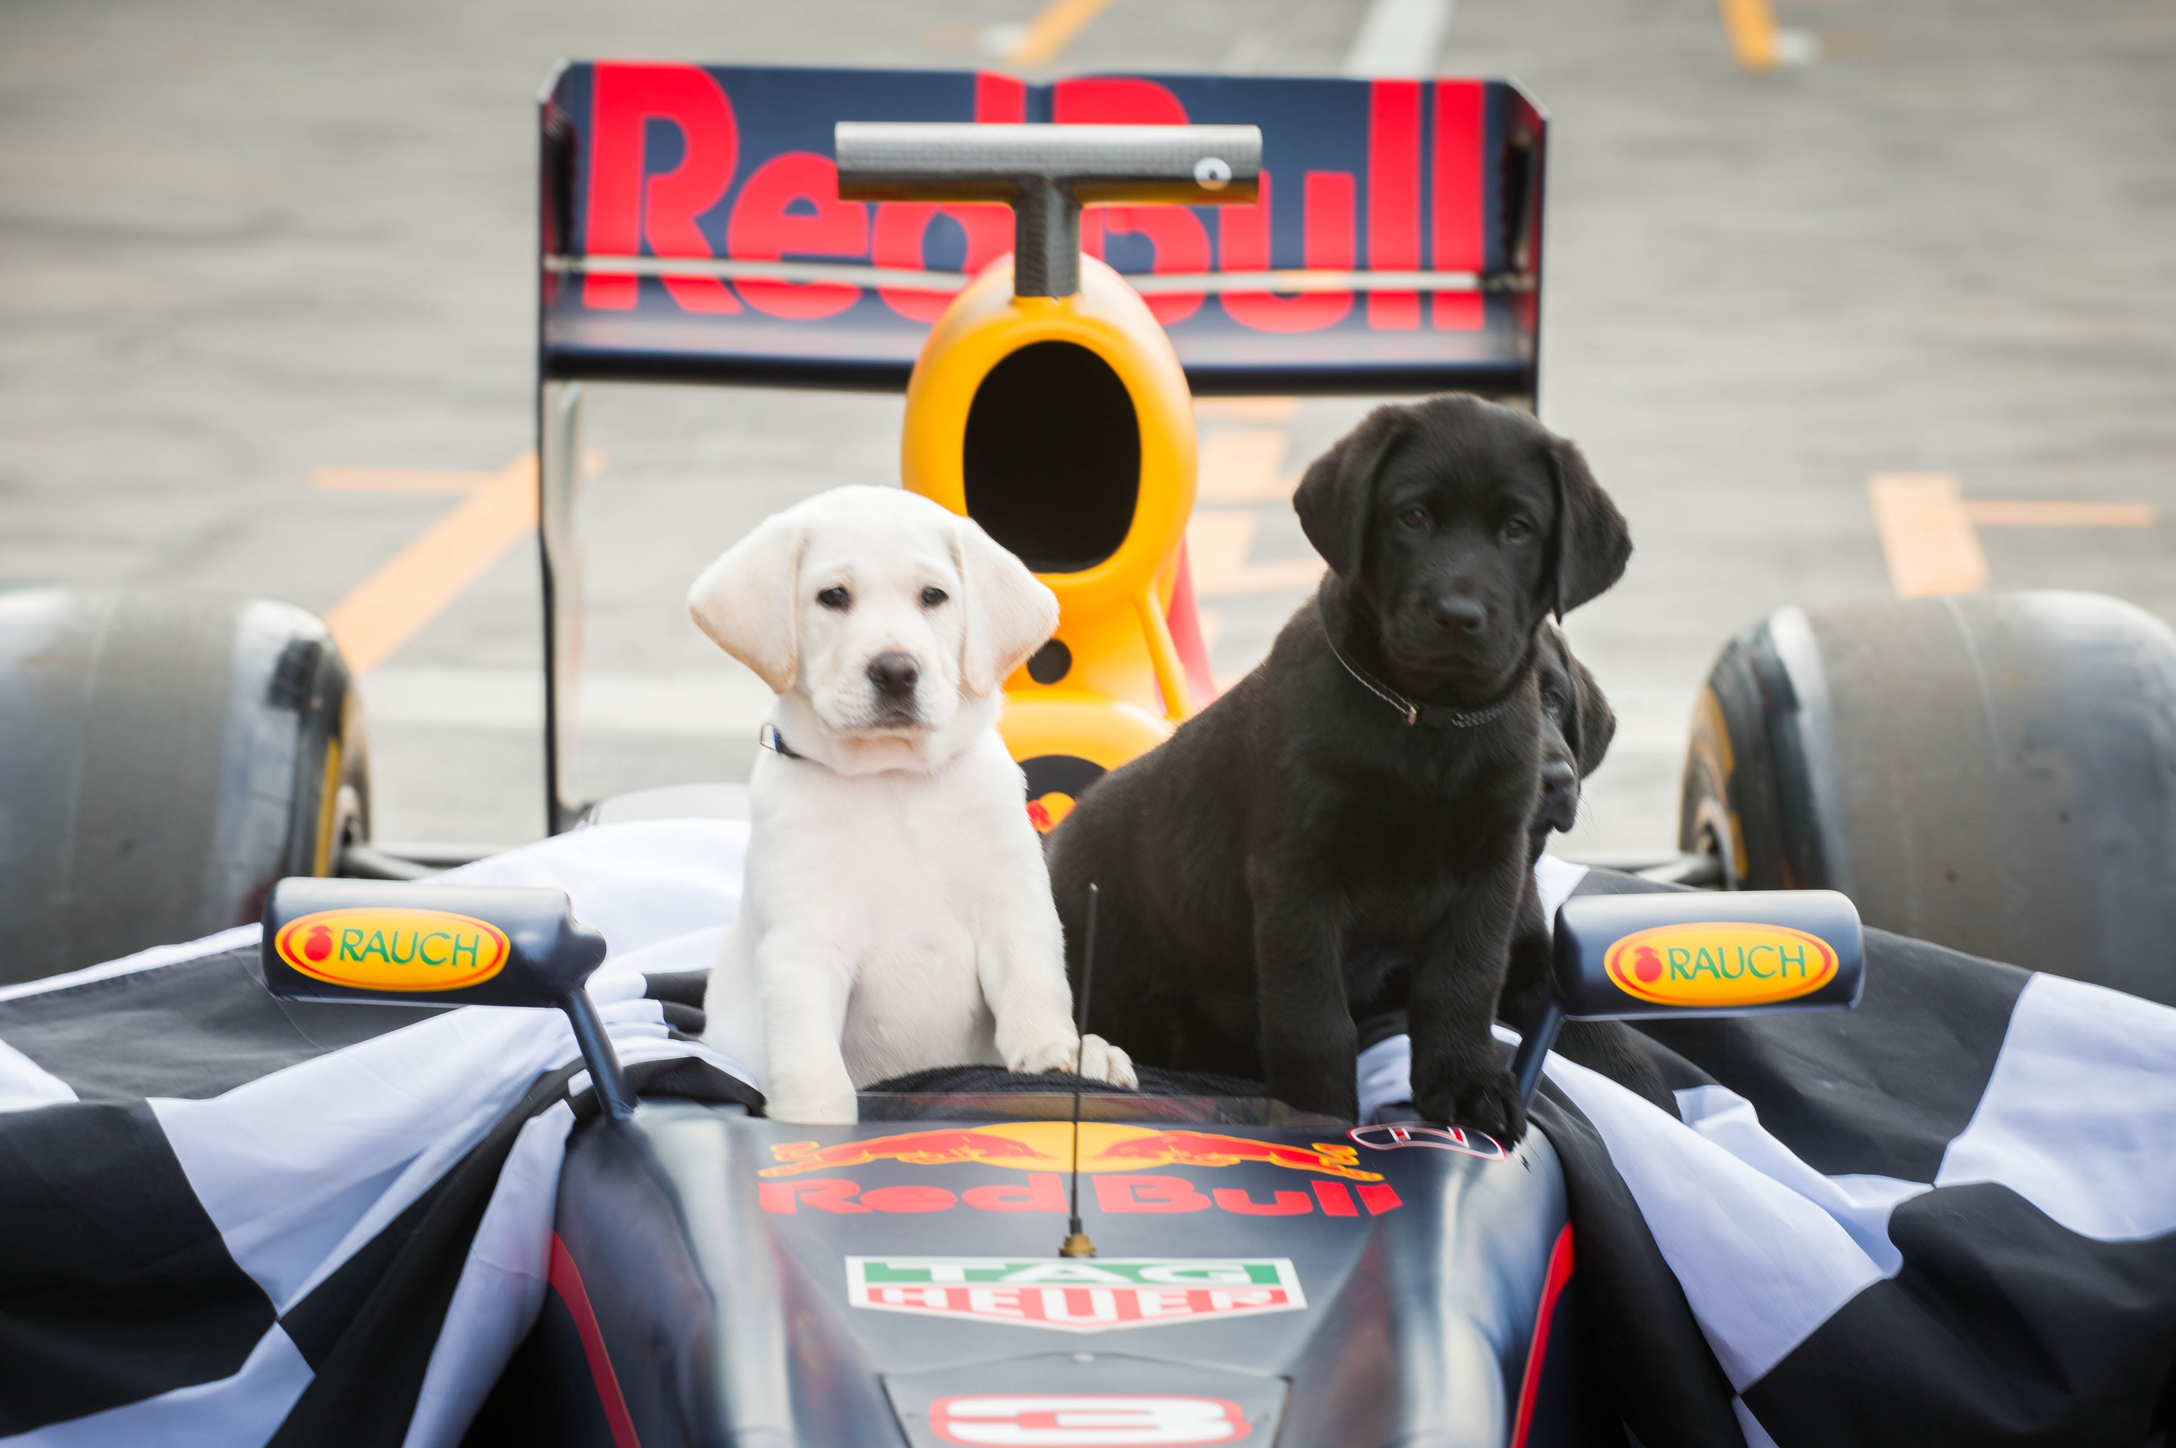
(photo description: blonde pup Kovu and black pup Kosta sitting in a Formula 1 car)
A reminder that we will be showcasing what we do and the amazing achievements of our clients at the upcoming 2017 Formula 1® Rolex Australian Grand Prix. We want to use this international, world-class event to drive awareness of the challenges faced by people with low vision and blindness, and to raise funds to help even more people with our support services. Every dollar raised will go directly towards the training of desperately needed ‘Orientation & Mobility’ Specialists – the wonderful practitioners who work with our clients and teach them the range of sensory techniques that make such a difference to their lives.
Find out what we will be doing, and how you can be involved at https://www.guidedogsvictoria.com.au/grand-prix/

Thank you to everyone who entered our competition to win one of 4 amazing Grand Prix experiences. The entries are all amazing and it will be a tough week of judging. Results will be announced shortly!
Return to contents

Stakeholder Survey – an Update!

Over the last couple of months many of you have been helping us build our plans for Guide Dogs Victoria for the next 5 years.
We have been seeking feedback from all the people involved with Guide Dogs Victoria – clients, volunteers, donors, staff, and leadership – to see what we need to change and improve as we evolve our services. We wanted to know what you think – what do we do well, what do we need to do better, what are the gaps in our services?
To ensure fair and robust insights we got an independent research company to help us with a survey. Thank you so much to everyone who filled it in – the response has been overwhelming with so many people giving their valuable time to contribute their feedback.
Many of you were happy to take part in follow-up research, and initial group discussions were held last week with a number of clients attending. The discussions were thorough and forthright, and gave us some excellent insights.
We really appreciate your contributions - it means that we know what you want, and we also know that you care and feel passionately about our direction. GDV is a unique community and we want you all to feel part of it, whether you are receiving a program or not.
We will keep you updated on the outputs of the research and our subsequent strategic direction in the coming months. In the meantime, if you have any further comments or feedback, please get in touch. Email marketing@guidedogsvictoria.com.au

Return to contents

Guide Dog Healthcare Update: Caring for your older Guide Dog

If your Guide Dog is aged 7 years or older, then you may be surprised to know he or she is classed as a ‘Senior’ dog. Happily though with a little extra care and attention, your Guide Dog should have several good years of working life left, and then can look forward to a healthy and happy retirement.
In this article, we look at how you can help your older Guide Dog enjoy life, and have a long and healthy old age.
Arthritis
Arthritis is a common condition amongst ageing Labradors and Retrievers. Osteoarthritis is particularly common and involves damage to the cartilage in joints. It is very painful, your dog will appear stiff and sore. (Rheumatoid arthritis is an immune condition and much rarer). Luckily, there are many things that can be done to lessen the likelihood of osteoarthritis, or lessen the symptoms if your dog does start to show signs discomfort.
Keep your dog slim:
One of the best things you can do for your Guide Dog of any age is to keep him slim. Any vet will tell you that most of the dogs they see are overweight, especially notorious food enthusiasts like Labradors. Carrying extra pounds is especially harmful to older dogs, as it puts a strain on their joints and makes arthritis much more likely.
If your Guide Dog is overweight, remember you are in charge of how much he or she gets to eat! You can get ‘low calorie’ or ‘senior’ dog foods that can help, but these are often padded with fillers. You control the food, so if he is piling on the pounds, the simplest thing is to just give him less of it.
When using primary positive reinforcement (piece of kibble) with your dog to assist with good choices in targeting and motivation remember to take the kibble out of your dogs daily ration, not add in extras.
Some people choose to give the Guide Dog daily fish oil to assist joint mobility. You don’t need to buy special ones from the pet shop, bulk pharmacy packs are just as good, just give half the human dose to account for the weight.
Keep your dog warm and dry:
With Melbourne’s autumn approaching who knows what the weather will bring! In the hot weather our Guide Dogs love to stretch out on cool tiles, but in winter they need to be kept away from draughts or damp. A raised bed is an excellent option, keeping them off the cold floor in winter, while letting air circulate in summer. Don’t put your dog’s bed right next to a heater or fireplace, as there is a risk of burning the dog. There are special heated dog beds available, but for most Guide Dogs just a couple of extra blankets will do on colder nights.
If your Guide Dog gets caught out in the rain then towel her off and pay special attention to her paws and pads as these can get cracked and chapped in colder weather.
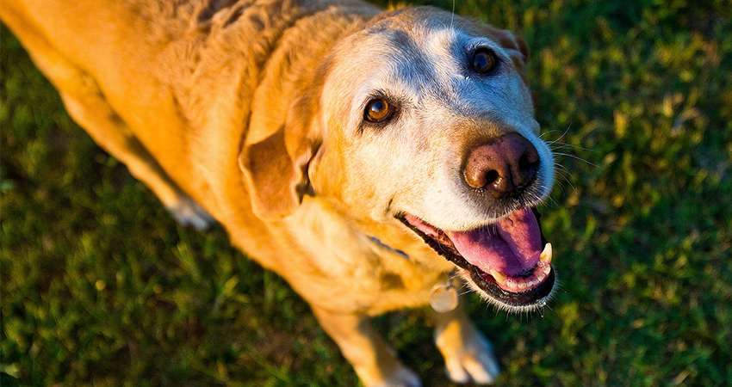(photo: grey muzzled older yellow labrador smiling up at camera)
Lumps and Bumps In Old Dogs
Older dogs are more likely to suffer from some serious health concerns, so it’s good to know what to look out for.
You may notice your older Lab start to get a bit lumpy in his old age! Harmless fatty lumps are very common in older dogs, but you should still get new ones checked over by your vet just in case. They might not always be immediately visible. Routinely give him a good rub along his flanks, belly, neck, shoulders and legs and check for anything new.

Keep up with your annual Guide Dog Follow-Up
The yearly Guide Dog follow-up is an essential part of having a working Guide Dog. The follow-up gives your Practitioner a chance to check that your needs are being met, that your dog is still working well and happily, and that the dog is healthy.
Your practitioner will also help you check your dog is currently vaccinated and parasite controlled ( round / tape and heart worm ) This is an essential part of health management for your dog and also part of your responsibility to meet legal access requirements.
As well as arthritis, older labs and retrievers can occasionally get hearing and vision problems, and it’s really important that these are identified and dealt with quickly for your safety. If you feel your Guide Dog is starting to slow down or you have any concerns at all please contact your Practitioner – it’s all part of the service!
Plan ahead for your next Guide Dog
Eventually it’s time for all of our Guide Dogs to put their paws up and finish working. It will take some time to match and train you with your new Guide Dog. It is really important that you contact your Practitioner about 12 months before you think you might need a new Guide Dog. Why ? Because it takes a year and half from the time the baby pups leave the nursery to grow up with our amazing puppyraisers and receive the training from our great team to become guides.
If you aren’t sure, check in with your Practitioner just to ask the question – we are happy to help.
You or your family may want to keep your retired dog, and this is perfectly possible. A new Guide Dog can be introduced into the household, and often the retired Guide Dog will help show them the ropes! Alternatively, we can find your retired Guide Dog a loving home through our Rehoming Officer Katrina.
Return to contents

Personal Safety Concepts – essential learning!
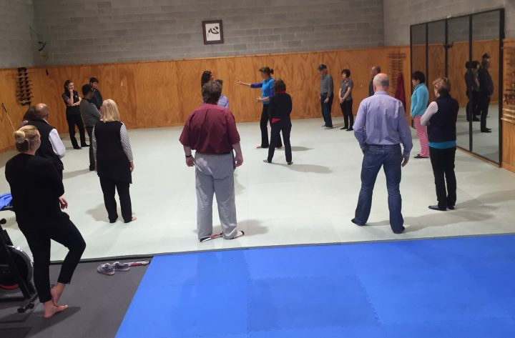

(photo of people in a large room on a floor mat, learning self-defence style actions)

Research and personal experience shows that people with low vision and blindness can feel a little vulnerable and at risk when out and about.

Personal security can be a concern for all of us anyone, but anxiety can be heightened when it’s difficult to see what is around you. There are some basic but important strategies that can help anyone – choosing well-lit routes with lots of people around, walking with confident body language, having a mobile phone with pre-programmed numbers to quickly call for assistance.

But there are a lot of other things that you can do to prepare, and one of the best is to attend a GDV Personal safety skills course.

In a fun group environment a qualified teacher can help you develop and practice personal safety skills to enhance safe independent mobility. The very act of practising these techniques helps ‘hard-wire’ them into your brain, helping you walk out with more confidence and feel more prepared should you ever need them.

Come along on the 28th March 9.30am-3.30pm. Aiki-Centre, 44 Lynch Street, Hawthorn. There is no charge for this activity but places are limited. Book yours through emailing CSAdmin@guidedogsvictoria.com.au or calling 1800 804 805.

Return to contents

Jobs at Guide Dogs Victoria

Guide Dogs Victoria welcomes applicants who are blind or who have low vision to apply for vacancies.
Summaries of current vacancies can be found below. If you are interested in applying then please view the detailed information on our website – links are given next to each job summary. Applications for all jobs listed below close 24th March.

Donor Database Administrator (Maternity Leave Cover)
Guide Dogs Victoria currently has a vacancy for an administration superstar to join our team in the role of Donor Database Administrator on a fixed term full time basis (12-month maternity leave cover).
The purpose of this role is to assist with the maintenance of an accurate donor database to support all the fundraising programs by daily processing of all donations received. Computer literacy is essential.
To apply see full information at
https://www.guidedogsvictoria.com.au/careers/donor-database-administrator-maternity-leave-cover/

NDIS Accounts Administrator
Guide Dogs Victoria currently has a vacancy for an administration superstar to join our team in the role of NDIS Accounts Administrator on a full time permanent basis.
The purpose of this position is to provide an administrative service to ensure effective and accurate invoicing and collection of all Fee for Service services provided to clients at Guide Dogs Victoria. The position will work closely with practitioners providing services as well as the Finance team and Fee For Service external providers. A Certificate III in Disability and /or Certificate IV in administration would be an advantage, as would knowledge of the NDIS and/or government funding.
To apply see full information at:
https://www.guidedogsvictoria.com.au/careers/ndis-accounts-administrator/

Senior HR Advisor (Parental Leave Cover)
Guide Dogs Victoria currently has a vacancy for an experienced professional to join our team in the role of Senior HR Advisor on a full time fixed term (9 months) basis.
The purpose of this role is to drive the Human Resource function at Guide Dogs Victoria by collaborating with the various business units to by undertaking projects and developing policies that assist in building a professional and motivated workforce that is committed to the organisation’s values and policies Relevant tertiary qualifications in Human Resources Management with five or more years’ experience working within a HR advisory position is essential.
To apply see full information at:
https://www.guidedogsvictoria.com.au/careers/senior-hr-advisor-parental-leave-cover/

Return to contents

Share your story

If you have a story you’d like to share about your low vision or blindness, your achievements, your experiences with our services or being matched with your Guide Dog, we’d love to hear from you. The marketing team are always on the lookout to feature our client’s stories in the media, to help spread the word about the wonderful work of Guide Dogs Victoria and to increase public awareness about people living with low vision or blindness. If you are comfortable with sharing your story, please email the marketing team at marketing@guidedogsvictoria.com.au to get in touch.

Feedback

If you have anything to contribute to this newsletter, please feel free to contact us with your piece. We welcome all contributions.

Please either contact or email our client services administration team with your contributions as below:
csadmin@guidedogsvictoria.com.au or phone 1800 804 805.

Return to contents

