Guide Dogs Victoria’s On the Move – April 2017 Bulletin

# 

# Tips for reading this newsletter

If you would like to increase the text size on your screen:

* Using the keyboard
  + 1. Press ALT+W, and then press Q.
    2. Press the TAB key repeatedly until the **Percent** box is selected, and then type a percentage or press UP ARROW or DOWN ARROW to select a percentage.
* Using the mouse
  + 1. On the View tab, in the Zoom group, click Zoom.
    2. Click the zoom setting that you want or type a percentage in the Percent box.

Contents

Tips for reading this newsletter 1

Editor’s update 2

Upcoming programs and events for your diary 3

International Guide Dog Day (IGDD), and International White Cane Day (IWCD) – a little extra special this year! 6

Client Service Update – 1800 804 805 for all enquiries 8

Aaron Horsington to become Team Leader – Guide Dog Client Team 9

Dialogue in the Dark opens in June – spread the word! 10

The Grand Prix – a great experience! 11

Looking after your Guide Dog's Ears 12

A reminder about chocolate and dogs... 16

Random acts of kindness! 17

Client notice board 18

Share your story 19

Feedback 19

Return to contents

# Editor’s update

Welcome to April’s On the Move.

April signifies the real start of GDV’s 60th Birthday celebrations with International Guide Dog Day on the 26th April. We are proud to have been the founding state of the National Guide Dog Breeding Centre (a world first) and providers of the first formal Orientation and Mobility Instructor training in Australia. We are still constantly reviewing and improving the standards of Guide Dog breeding and training, and our Orientation and Mobility instruction to improve the quality of the supports we can give our all clients – with or without Guide Dogs.

Thank you to everyone who has submitted nominations for our inaugural Community Access Awards, we have had so many lovely stories of support and people or businesses going ‘above and beyond’ to help our clients. We will be going through the nominations this week to decide on the 2016/17 Award winners, but every nominee will get a personalised certificate of appreciation signed by our CEO Karen Hayes. You can continue to submit stories of great community access throughout the year to [marketing@guidedogsvictoria.com.au](mailto:marketing@guidedogsvictoria.com.au), for the 2017/18 awards!

April of course also brings Easter and chocolate. Great for humans, poisonous to dogs! So please do enjoy the chocolate fun, but keep it out of reach of your Guide Dog!

Finally, a reminder to clients who are under 65 years old and live in local government areas of Campaspe, Central Goldfields, Greater Bendigo, Loddon, Macedon Ranges or Mount Alexander – the National Disability Insurance Scheme comes to your region from the 1st May 2017. If you haven’t already had a conversation with one our Support Coordinators about eligibility and how to get NDIS ready then please call 1800 804 805 to book an appointment.

Sophie Wild

Bulletin Editor

# Upcoming programs and events for your diary

* **Our Choice Expo for Eastern Melbourne & surrounds:** 7th June 2017 10.30am-4pm, State Basket Ball Centre, Wantirna. Run by VALID to empower people with disabilities to know what support is available in their community. Come and visit the Guide Dogs Victoria stand and talk with our experts about the upcoming NDIS and how we can help. Make connections with a huge range of organisations that can support with equipment & assistive technology, therapeutic supports, accommodation & housing options, rights & complaints info, personal care & community access. Entry is free.
* **Meet Melbourne Mobility Group Program**: 27 – 28th June. Lock this one in! Two days, one night, and a whole lot of Melbourne Mobility Mischief! Contact [CSAdmin@guidedogsvictoria.com.au](mailto:CSAdmin@guidedogsvictoria.com.au) or call 1800 804 805.
* **Understanding Vision Impairment and Acquired Brain Injury** – 24th May, 23rd August and 8th November. A one-day information program for people with vision changes secondary to an acquired brain injury (ABI).  The day will aim to help you and your family gain an understanding of how vision can change following an ABI, such as stroke, accident, surgery, tumour or other brain injury.  It will investigate how changes to the brain’s function can impact on mobility in unexpected ways.  The day will also provide an opportunity to share experiences with people of all ages, and their families, who have low vision or blindness from an ABI. Places are limited to so please book your place by emailing [CSAdmin@guidedogsvictoria.com.au](mailto:CSAdmin@guidedogsvictoria.com.au) or call 1800 804 805.
* **Young Adults Program (YAP):** Connecting young people (approximate age 18-30) with low vision or blindness for discussions and fun activities. YAP sessions run bi-monthly throughout the year. Contact [rachelh@guidedogsvictoria.com.au](mailto:rachelh@guidedogsvictoria.com.au) for more information.

**You’re invited! Social events**

* **30th April – Free movie tickets for ‘A Dog’s Purpose’ at Doncaster Village Cinema:** Join us for this special IGDD screening of the movie A Dog’s Purpose. From the makers of the Gilmore Girls, this movie is the soulful and surprising story of one devoted dog who finds the meaning of his own existence through the lives of the humans he teaches to laugh and love. GDV clients can apply for a maximum of 2 free tickets per client by emailing   
  [carolinep@guidedogsvictoria.com.au](mailto:carolinep@guidedogsvictoria.com.au), by 18th April. Guide Dogs are welcome of course!
* **Coffee mornings every Friday in the Frankston area.** If you enjoy having a cuppa and meeting new friends, please join our casual client run coffee mornings. New members always welcome. For details please contact Robert on 0409 685 606 or email   
  [rgsblind@yahoo.com.au](mailto:rgsblind@yahoo.com.au)

Following on from the success of our Frankston Coffee Club, we are currently canvassing interest **in similar programs being run in Mornington and Pakenham.** These catch-ups are a great opportunity to meet up and discuss topics such as transport, technology, the NDIS roll-out as well as a great excuse to have a chat and great coffee! If you or someone you know might be interested or has any further questions, please contact Tim Carter on (03) 9854 4448 or by email at [timc@guidedogsvictoria.com.au](mailto:timc@guidedogsvictoria.com.au)

Return to contents

# International Guide Dog Day (IGDD), and International White Cane Day (IWCD) – a little extra special this year!

# 

It’s our birthday and we will be celebrating all year! Guide Dogs Victoria, and Guide Dogs Australia, turn 60 this year.

Between them IGDD and IWCD provide us with a focus to celebrate our iconic dogs, and all our clients’ achievements – with or without a Guide Dog.

We will have our Birthday ‘puppy tram’ in service in the CBD network over the next 6 weeks – through the support of partners Public Transport Victoria. Tram 3536 (St Kilda Road) will feature beautiful photographs of our wonderful dogs celebrating our birthday, and we are hoping it will brighten the day of everyone who sees and rides on it.

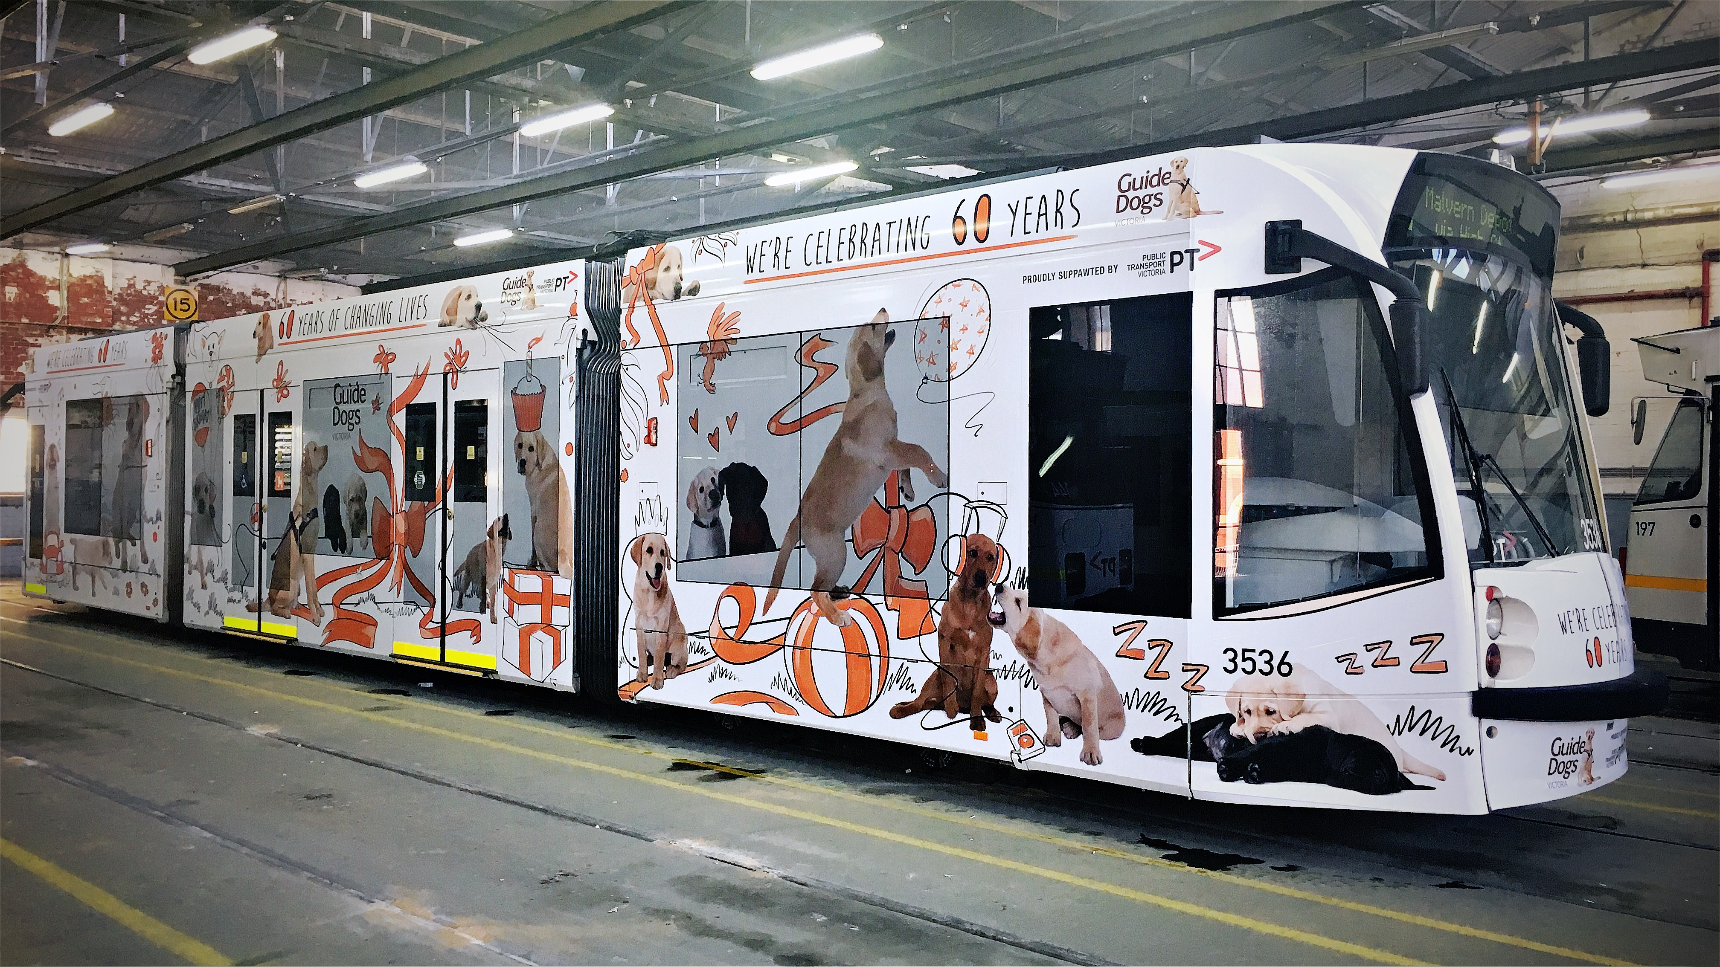

Photo – our birthday tram in the Depot waiting to go on the network – white tram decorated with dogs and puppies having a party – orange ribbons and balloons.

International Guide Dog Day – last week April

* Monday 24th April – 10-11am: Date & time confirmed. We will be holding a special media viewing of the tram for the CEO of Public Transport Victoria Jeroen Weimar, and our very own Karen Hayes. This will be near Queen Victoria Markets, and any Guide Dog Handlers and their dogs in the area are welcome to pop by and join us for a birthday cupcake. Please note that we will not be completing a client walk and no RSVP is necessary.
* Governor of Victoria Linda Dessau will host a thankyou afternoon tea for some of our volunteers at Government House.

International White Cane Day – mid October

* Full details are to be confirmed, but clients will be invited to a special event at our Dialogue in the Dark exhibition at Harbour Town, Docklands

All clients should look out over the next couple of months for their special GDV Birthday gift in the post; and there will be an extra special client Christmas/60th Birthday party in December.

Return to contents

# Client Service Update – 1800 804 805 for all enquiries

We are in the process of reorganising our Client Service Administration function, and increasing our staff numbers, to ensure more streamlined client contact so that you get quick responses and the answers you need. From June onwards, one client database system will be used across the organisation to ensure a consistent knowledge of preferred formats, contact details and program notes.

We are currently training up new staff as well as all staff learning a new CRM system (client database). During this time there have been a couple of times clients have been unfortunately sent out communication in nonprefered formats. We really apologise for any inconvenience this has caused and appreciate your patience and understanding while we work to improve on functionality and procedures. We welcome feedback and if you do receive a letter in the incorrect format, then please don't hesitate to let us know via email [csadmin@guidedogsvictoria.com.au](mailto:csadmin@guidedogsvictoria.com.au) or phone 1800 804 805.

From now on, this one number – 1800 804 805 – should be used for ALL client enquiries – general, O&M, OT or Guide Dog. We will be able to make sure that your query gets through to the right person faster and is always followed up.

Return to contents

# Aaron Horsington to become Acting Team Leader – Guide Dog Client Team

Many of you will know the indomitable Jenny Black. Jenny has decided that she has done a good stint in management and is ready to get ‘hands-on’ teaching O&M again!

Jenny leaves big shoes to fill having done a marvellous job co-ordinating our Guide Dog client training, and Arnold Cooke House. We are very pleased that experienced Guide dog Instructor Aaron Horsington has agreed to step into the role, and we are confident that Aaron will do an amazing job.

Aaron has been working as a Guide Dog Instructor for over twenty year, ten of those here with us at Guide Dogs Victoria. So he knows GDV and our clients incredibly well, and is really excited about his new role.

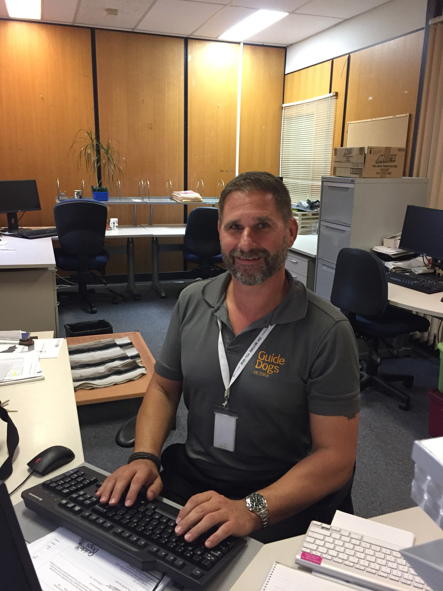

Photo: Aaron Horsington sitting at his desk.

Return to contents

# Dialogue in the Dark opens in June – spread the word!

Launching in Melbourne in June 2017, Dialogue in the Dark TM is an experience designed to build public awareness and open up communication with people with vision loss. Visitors tour a ‘Melbourne experience’ in total darkness, relying on their other senses, and some of our very own clients as tour guides. Whilst there is no doubt this is a brief snapshot, research has shown it increases awareness of vision loss, and showcases how clients learn to adapt and navigate their environments.

Please encourage your family, friends and work colleagues to come and give Dialogue a try. It’s an experience not to be missed!

Tickets are on sale at [www.ticketmaster.com.au](http://www.ticketmaster.com.au)

Return to contents

# The Grand Prix – a great experience!

To everyone who volunteered, donated, visited and supported us at this year's Formula 1 Rolex [Australian Grand Prix](https://www.facebook.com/ausgrandprix/), we want to thank you. With your help, we raised an outstanding $73,392.75 to train new Orientation and Mobility Specialists!

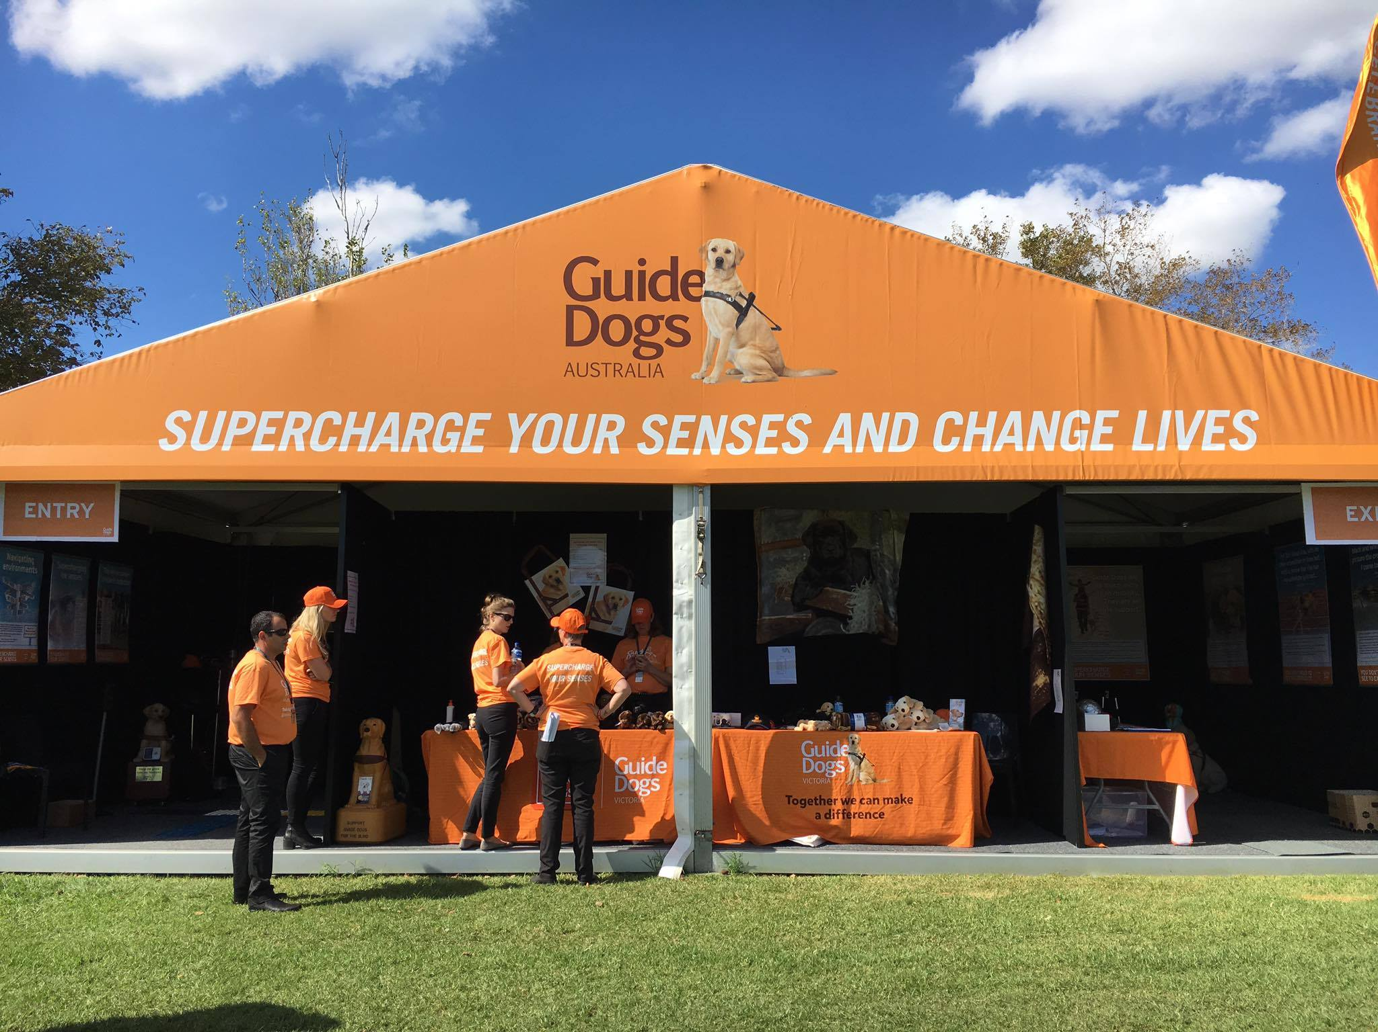

Photo – our bright orange Guide Dog tent getting ready to draw the crowds

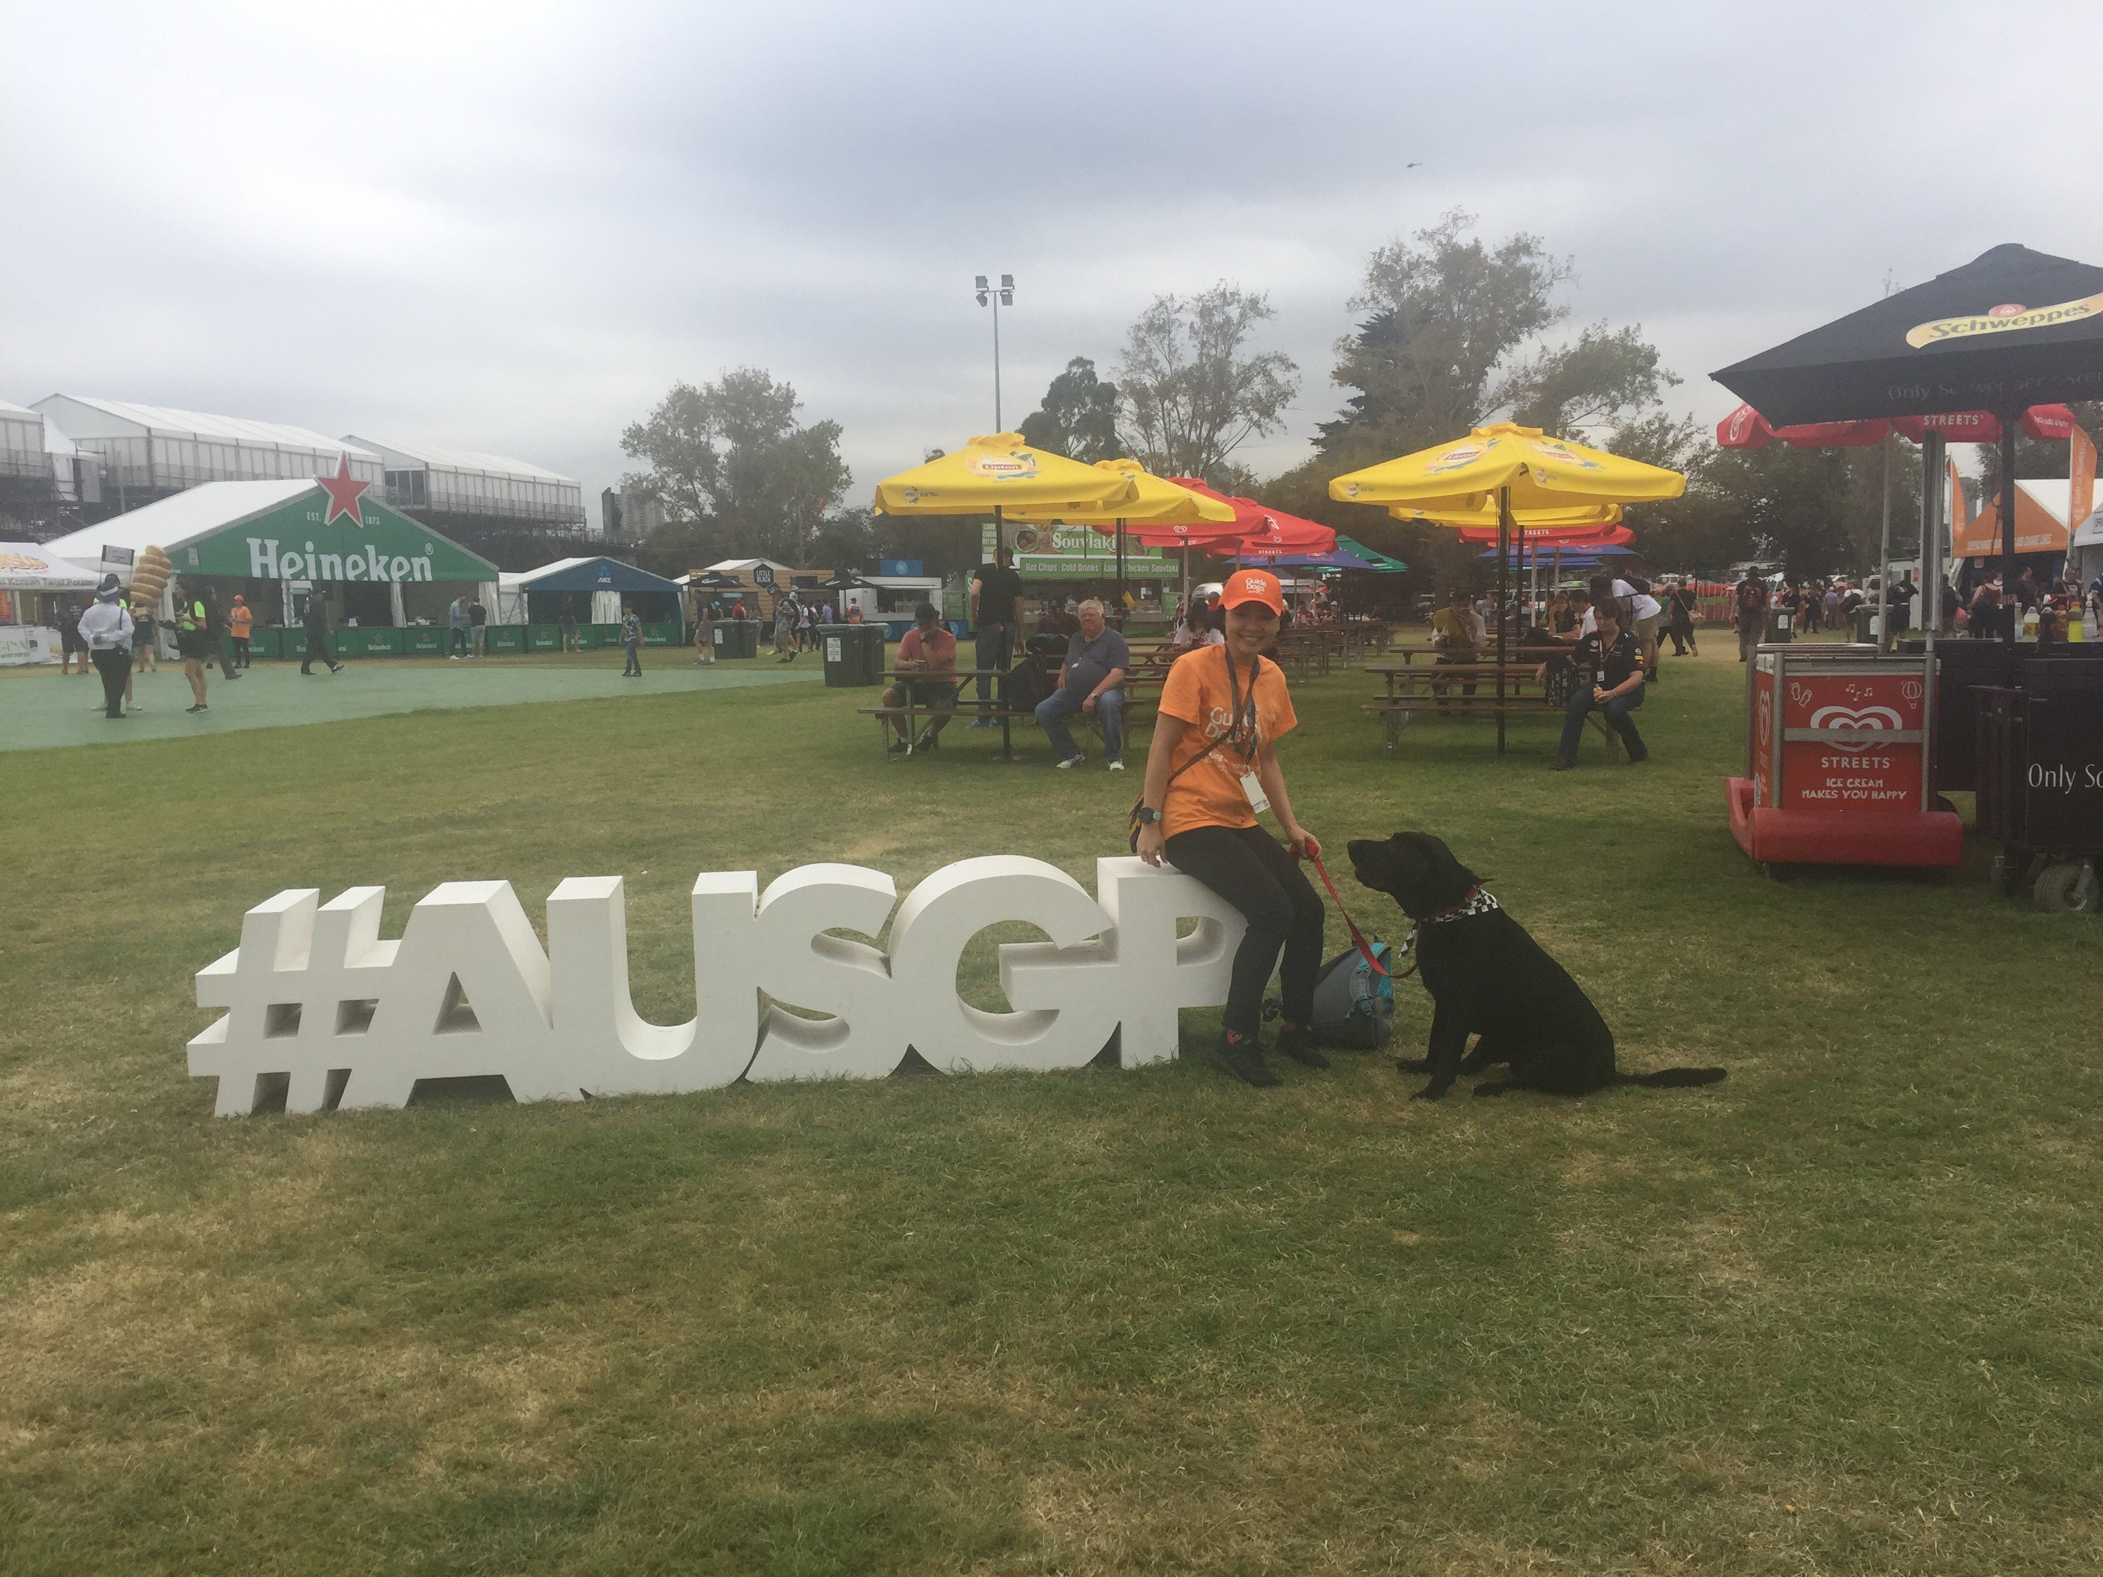

Photo – Guide dog staff member Linda with Maxwell, our positively reinforced noise desensitised Ambassador Dog in F1 Central. Learn more about positive reinforcement and the special training steps taken to prepare Maxwell for the Grand Prix in May’s On The Move.

Return to contents

# Looking after your Guide Dog's Ears

Ever wonder what is lurking beneath your Guide Dog's ears?

Dogs have L-shaped ear canals, making it very hard for moisture to get out and for air to get in. That moist, warm environment is great for bacteria and yeast, causing dogs to be prone to ear infections (*otitis*).  Regular cleaning of a dog’s ear canals may reduce the frequency of otitis, especially in dogs that frequently get ear infections or those that have narrow canals. The longer and floppier the ears are, the more prone to infection - golden retriever type Guide Dogs are especially more prone, as the ears have evolved over thousands of years to keep out water, but ear problems can occur in any breed.

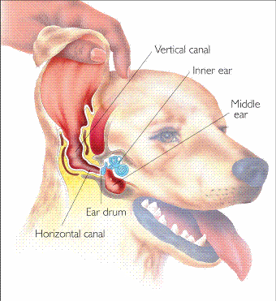

(image: drawing of a dog’s head with its ear flap lifted, and the ear structure drawn on top)

**Looking after your Guide Dog's Ears**

The L-shaped canal can also mean that things like grass seeds or pollen can get lodged in the ear and not come out - this is a common issue for many dogs, causing irritation or infection. Finally, if your Guide Dog loves a swim when he or she is relaxing, water can become lodged in the ear, causing a doggy version of swimmers ear.

The good news is that a little regular ear maintenance can prevent most of these issues.

**How to check if your Guide Dog's ears are healthy?**

* Have a smell! A healthy dog's ears won't smell unpleasant. A really strong 'doggy' odour might mean there is a problem.
* Your Guide Dog might scratch or rub their ear a lot, even whimpering when they do it.
* Lift your dog’s ear flap and place your hand on the ear entrance. If it feels unusually hot it might be infected.
* Ask a friend to look inside the ear - they might notice it is red or inflamed.

More seriously - if your Guide Dog seems to be unbalanced, walking in circles or constantly shaking / scratching tilting its head, or is not working as well as normal it may be experiencing ear pain; it needs an urgent ear check at your vet.

**Cleaning your Guide Dog's ears**

It is a good idea to clean your Guide Dog's ears every few weeks, and after swimming. If you get your Guide Dog groomed at a dog groomer then ask them to do this - most will after a bath as part of the service.

It is important to be gentle and careful when cleaning dogs’ ears, and to use an appropriate cleaning solution. You can get specially made dog ear cleaning solutions from your vet or pet store. If you want to use a homemade ear cleaner, you can make one by mixing equal parts distilled water and white vinegar.  Store it in a dropper or oil dispensing bottle to allow dispensing of small amounts into the ear.

 How to clean a dog’s ears:

* Prior to the exercise have your kit ready: food, medication and cleaning materials. It’s important the dog has choice in the exercise which will make it easier for the next time you need to clean the ears.
* Show the dog the medication bottle, let it choose to approach, investigate and smell the medication.
* Provide positive reinforcement (kibble etc) for the approach and interest.
* Hold up the ear flap (pinna) and drop a few drops of ear cleaner into the ear canal.
* Continue to provide reinforcement to the dog.
* Massage the ear canal through the skin.  The ear canal feels like a firm tube of cartilage under the skin.
* After you have massaged, let the dog have a shake if he/she wants to. This will help loosen up the wax or discharge in the ear.

If you feel confident you can clean inside the ear with cotton wool (never use cotton buds or tissues). But you must be very gentle and your Guide Dog will need to sit or lie still. If you are worried about doing this then ask a friend or local vet nurse/dog groomer to help. It is still best to have you as the person the dog knows and trusts present. One person can treat and the other person can provide positive reinforcement.

* Wear gloves and use cotton wool spread over your index finger.  Make-up remover pads are also ok to use, but never cotton-wool ear buds or tissues. Gently wipe into the ear opening with a cotton wool-covered finger.  In most dogs, you can insert your finger between 1 and 2 centimetres (about 1/2 inch) into the ear canal but you must BE GENTLE!! Continue wiping out the canal until you get no more   discharge or fluid on the   cotton wool.
* Finally, give your pet a little treat after ear cleaning- this will hopefully make them less likely to run away from you every time you pull out the ear cleaner and gloves!

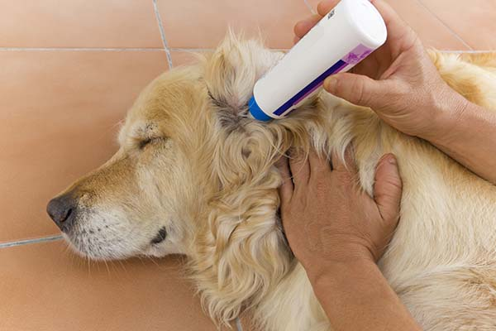

(photo – person putting ear drops into a yellow retriever’s ears while it lies on the floor)

Detail taken from assorted vet websites (green cross and gladesvillevet.com.au)

Return to contents

# A reminder about chocolate and dogs...



(photo- chocolate Easter Eggs)

With Easter around the corner, just a quick reminder to keep Easter eggs (and all chocolate, including cocoa powder and cooking chocolate) out of reach of your Guide Dog. Chocolate can be very dangerous for dogs as it contains a toxin (theobromine) which dogs process very slowly so it can build up to dangerous levels, and the dog an in fact die. Even a tiny amount of chocolate can give your Guide Dog an upset tummy and vomiting/diarrhoea. Don't risk it, keep the chocolate up high or out of their way. If you think your Guide Dog has eaten chocolate then take them straight to your local vet for treatment.

Return to contents

# Random acts of kindness!

We often hear about the problems and indeed prejudice our clients can face, but it’s so lovely to hear about the goodwill and kindness in the community as well. We hope our Community Access Awards will spread the word about great community role models, and encourage people and business to do the right thing.

There are some stories of community support where we can’t contact a nominee –random acts of kindness by members of the public. Shirley rang us to tell us about a lovely experience at Rosebud RSL. Shirley and her Guide Dog Edrick arrived for lunch on a hot day, and she realised she had forgotten to bring Edrick’s water bowl with her. She asked a waiter if there was a spare bowl he could bring, and a nearby lady with a pushchair overheard and produced a brand new, collapsing silicone travel dogs’ bowl from her bag, which she then insisted Shirley kept as a gift for Edrick, and the amazing work Guide Dogs do! Shirley was so grateful to this lady and her generosity, and so are we!

Return to contents

# Client notice board

Do you have a piece of mobility or OT technology to sell? Or an event you want to publicise? If so send your requests in to   
[marketing@guidedogsvictoria.com.au](mailto:marketing@guidedogsvictoria.com.au) and we can list it here.

**For sale: barely used Blaze device**

A pocket sized advanced multi player with OCR for books, music, documents, podcasts, recording, Daisy and more.

It includes a premium options pack.

Cost brand new $1240, will accept $500.

Please contact Dawn on   
[greyswannie@gmail.com](mailto:greyswannie@gmail.com). If you are unsure if a Blaze might be suitable equipment for you then you then please call GDV on 1800 804 805 for an assessment.

Please note that Guide Dogs Victoria has not vetted, checked or endorsed equipment in this notice section, and will not be responsible for any personal loss/liability, or the suitability of any equipment or event listed.

Return to contents

# Share your story

If you have a story you’d like to share about your low vision or blindness, your achievements, your experiences with our services or being matched with your Guide Dog, we’d love to hear from you. The marketing team are always on the lookout to feature our client’s stories in the media, to help spread the word about the wonderful work of Guide Dogs Victoria and to increase public awareness about people living with low vision or blindness. If you are comfortable with sharing your story, please email the marketing team at [marketing@guidedogsvictoria.com.au](mailto:marketing@guidedogsvictoria.com.au)to get in touch.

# Feedback

If you have anything to contribute to this newsletter, please feel free to contact us with your piece. We welcome all contributions.

Please either contact or email our client services administration team with your contributions as below:

[csadmin@guidedogsvictoria.com.au](mailto:csadmin@guidedogsvictoria.com.au) or phone 1800 804 805.

Return to contents